ReportBuilder
Developer’s Guide
Copyright © 1999 by Digital Metaphors Corporation

Overview

Introduction 13
The Basics 13
The Best Way to Learn ReportBuilder 16
A Quick Test Spin 17
Elements of the User Interface 20
Working with the Report Designer 23
Reporting Basics 28

ReportBuilder Fundamentals 34
Main 34
Introduction 34
The Delphi Components 36
Report Components 37
Smart Layouts 40
SubReports 48
Form Emulation 54
Data 60
Introduction 60
BDE Support 64
BDE Alternatives 66
Text Files 67
Delphi Objects 68
Native Access to Proprietary Data 69
Code 72
The Delphi Event Model 72
Dynamic Configuration 74
Performing Calculations 82
Create Reports in Code 100
Design 106
The Report Designer 106
Dialogs 108
Toolbars 114
Drag and Drop Support 128
The Report Wizard 130
Print 140
Introduction 140
Previewing 142
Custom Printer Settings 143
Report Archiving 144
Print to ASCII Text 146
Report Emulation Text File 148
RTF, HTML and Other Formats 149
Deploy 152
Introduction 152
Report Templates 154
As an EXE 158
As Packages 159
International Language Support 160

ReportBuilder Pro Fundamentals 168
Main 168
Introduction 168
The Delphi Components 174
Designer 176
Report Explorer 181
Data Dictionary 184
Putting it All Together 186
On-Line Help 187
Data 190
Introduction 190
Query Wizard 193
Query Designer 200
Configuring DADE 216
DADE Architecture 218
Extending DADE 221
Code 230
Introduction 233
Configuring RAP 240
Design 240
The Report Explorer 240
Print 244
End-User Options 244
Deploy 248
Introduction 248
International Language Support 250

Report Tutorials 257
Creating a Report via the Data Tree 257
Creating a Report via the Report Wizard 264
A Simple Report the Hard Way 271
Groups, Calculations and the Summary Band 279
Using Regions to Logically Group Dynamic Components 295
Forms Emulation with a WMF image 304
Master → Detail Report 313
Master → Detail → Detail Report 325
Interactive Previewing with Drill-Down Subreports 337
Hooking Reports together with Section-Style Subreports 339
Using Columns to Create Mailing Labels 348
Printing to a Text File 351
Printing from a Text File 355
Using the JITPipeline to Print from a StringGrid 359
Using the Rich Text Component for Mail/Merge 366

Application Tutorials 373
Building a Reporting Application 373
Building an End-User Reporting Application 380
Adding Data Dictionary Support to the End-User Application 386
Customizing the Report Explorer Form 392
Building an End-User Application using InterBase 394

Index 403

Contents
Introduction 10
The Basics 10
The Best Way to Learn ReportBuilder? 10
A Quick Test Spin 10
Elements of the User Interface 10
Working with the Report Designer 10
Reporting Basics 10
ReportBuilder Fundamentals 10
Main 10
Introduction 10
The Delphi Components 10
Report Components 10
Smart Layouts 10
One Memo in the Detail Band 10
One Memo with a Shape Background 10
One Memo with Label beneath 10
One Memo with Two Side-by-Side Memos below 10
Two Stacked Memos in the Detail Band 10
Two Side-by-Side Memos with Labels below 10
Child SubReports in Fixed Positions 10
SubReports 10
Single Data Source 10
Master Data Source with Single Detail Data Source 10
Master Data Source with Nested Detail Data Sources 10
Master Data Source with Multiple Independent Data Sources 10
Independent Data Sources 10
Form Emulation 10
Single Page Forms 10
Multi-Page Forms 10
Data 10
Introduction 10
BDE Support 10
BDE Alternatives 10
Text Files 10
Delphi Objects 10
Native Access to Proprietary Data 10
Code 10
The Delphi Event Model 10
Dynamic Configuration 10
Font Color 10
Address Squeeze 10
Continued Group 10
Regions 10
SubReports 10
Performing Calculations 10
Count 10
Count Master/Detail 10
Group Total 10
Grand Total 10
Conditional Group Total 10
Conditional Grand Total 10
Two-Pass Total 10
Create Reports in Code 10
Design 10
The Report Designer 10
Dialogs 10
Print Dialog 10
Print to File Setup Dialog 10
Data Dialog 10
Toolbars 10
The Report Tree 10
The Data Tree 10
Standard Component Palette 10
Data Component Palette 10
Advanced Component Palette 10
Standard Toolbar 10
Edit Toolbar 10
Format Toolbar 10
Align or Space Toolbar 10
Size Toolbar 10
Nudge Toolbar 10
Draw Toolbar 10
Drag and Drop Support 10
The Report Wizard 10
Report Wizard: Create a Simple Report 10
Report Wizard: Create a Group-based Report 10
Print 10
Introduction 10
Previewing 10
Custom Printer Settings 10
Report Archiving 10
Print to ASCII Text 10
Report Emulation Text File 10
RTF, HTML, and Other Formats 10
Deploy 10
Introduction 10
Report Templates 10
File-based Templates 10
Database Templates 10
As an EXE 10
As Packages 10
International Language Support 10
The Default Language 10
Custom Translations 10
ReportBuilder Pro Fundamentals 10
Main 10
Introduction 10
The Delphi Components 10
Designer Component 10
Report Explorer 10
Data Dictionary 10
Putting It All Together 10
On-Line Help 10
Data 10
Introduction 10
Query Wizard 10
Query Designer 10
Adding Search Criteria 10
Create a Group Sum 10
Concatenate Fields 10
Edit SQL 10
Configuring DADE 10
DADE Architecture 10
Extending DADE 10
DataView Templates 10
Support for Non-BDE Database 10
Ask at Run-time Support 10
Code 10
Introduction 10
Configuring RAP 10
Design 10
Report Explorer 10
Print 10
End-User Options 10
Deploy 10
Introduction 10
International Language Support 10
The Default Language 10
Custom Translations 10
Report Tutorials 10
Creating a Report via the Data Tree 10
Creating a Report via the Report Wizard 10
A Simple Report the Hard Way 10
Groups, Calculations and the Summary band 10
Using Regions to Logically Group Dynamic Components 10
Forms Emulation with a WMF image 10
Master → Detail Report 10
Master → Detail → Detail Report 10
Interactive Previewing with Drill-Down Subreports 10
Hooking Reports together with Section-Style Subreports 10
Using Columns to Create Mailing Labels 10
Printing to a Text File 10
Printing from a Text File 10
Using the JITPipeline to Print from a StringGrid 10
Using the Rich Text Component for Mail/Merge 10
Application Tutorials 10
Building a Reporting Application 10
Building an End-User Reporting Application 10
Adding Data Dictionary Support to the End-User Application 10
Customizing the Report Explorer Form 10
Building an End-User Application using InterBase 10
INDEX 10

Introduction
The Basics 13
The Best Way to Learn ReportBuilder 16
A Quick Test Spin 17
Elements of the User-Interface 20
Working with the Report Designer 23
Reporting Basics 28

Introduction

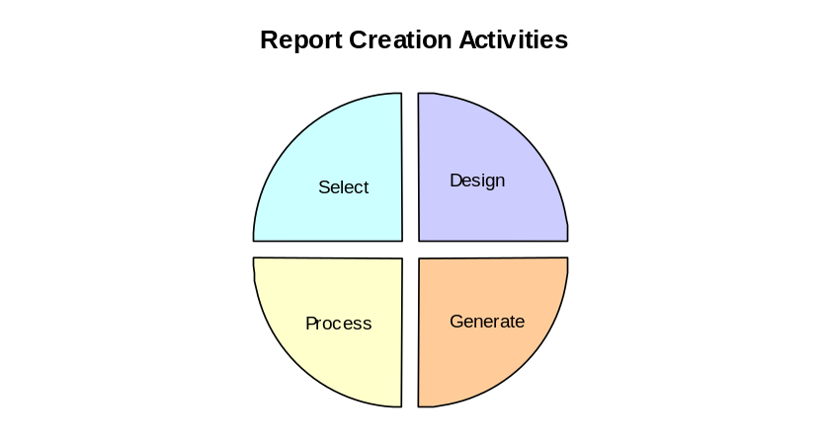The Basics
Report creation with ReportBuilder can be divided into four main activities.

- Select refers to the selection of data.
- Design means creating a layout that describes how the document should look.
- Process refers to the manipulation of the data or the layout in order to control the generation more precisely.
- And Generate refers to the creation of the actual document.
ReportBuilder handles the Generate step for you, and with my help you can certainly master the Select, Design and Process activities.
First, let’s get a better handle on these rather abstract concepts.
Select
Your data is probably not locked into disposable documents, it’s organized (one way or another) as data. That generally means a database. Organized data is the first key to creating recyclable documents. ReportBuilder expects data to take a tabular format. Yes, you can create reports based on less structured data, but in general it is most advantageous to have the data organized in a table. Here’s an example:

Customer No. | Company | Contact | State
3053 | American SCUBA Supply | Lynn Cinciripini | CA
3984 | Blue Glass Happiness | Christine Taylor | CA
3054 | Catamaran Dive Club | Nicole Dupont | CA
3051 | San Pablo Dive Center | Patricia O’Brien | CA
3052 | Underwater Sports Co. | Dave Walling | CA

This table contains customer information. In database terms, each row of the table is considered a record. Each column of the table is considered a field. The field names appear in the first row and are not considered part of the data. When you are working on the data selection, the goal is to create a table that will enable ReportBuilder to generate your document correctly. This means including all the fields you will need for the report, limiting the rows selected to only those which should appear in the report and sorting the rows so that they appear in the correct order.
Design
Once data has been selected, you can begin designing your report. You do this by creating a layout. A layout is a combination of objects that describe how the document should look.
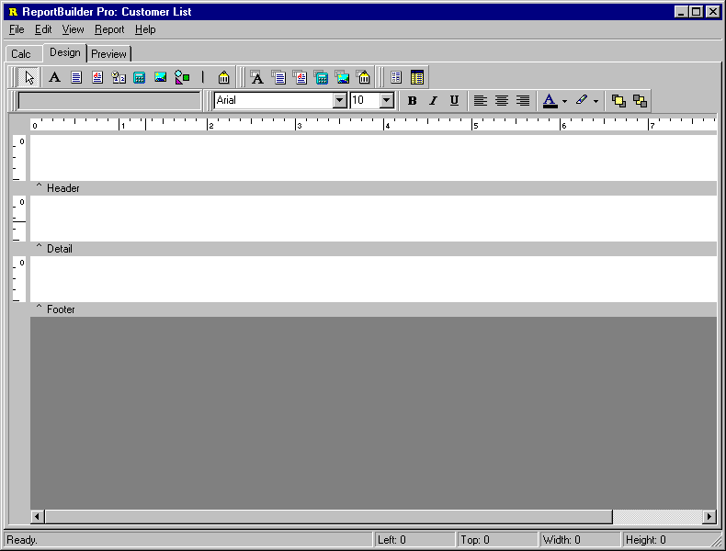
This is the Report Designer. As you can see, it looks like many of the other Windows applications you’re used to working with. The big difference is that the Report Designer does not contain a document, it contains a layout. The layout can be used to generate many different documents, all based on the data you’ve selected. The white rectangular areas with the gray bars below are called bands. This report has a Header, Detail and Footer band. When ReportBuilder generates a document from this layout, the objects in the Header band will appear at the top of each page. The objects in the Footer band will appear at bottom of each page. And the objects in the Detail band will repeat down the page, until no more page space is available, at which point a new page will be started. The Detail band prints once for each row of your data selection. This is how a document is created from the layout. You can generate a different document from the same layout by simply changing your data selection.
Process
When you create a layout, you are telling ReportBuilder exactly how you want the document to look. But what if your document is so complex that you can’t design a layout to describe it? Though ReportBuilder layouts are quite flexible and powerful, as you will soon see, even the most flexible layout is still fixed. The Process activity of document creation allows you to provide additional instructions to ReportBuilder regarding how the document should be created. This means you can change the report layout as the document is generating. You can also use the processes to format data and perform calculations. Processes are created using ReportBuilder’s native language. The language is called RAP (for Report Application Pascal.) It is easy-to-learn and fun to use especially when you see the cool effects you can create with it. Typical processes you would write using this language would be to combine the First and Last Name fields of a contact so the data is easier to read in the report, or calculating a weighted average to appear in the summary section at the end of a report.
Most reports do not require a process, so don’t worry about whether or not you can master this activity. I’ll teach you how to do simple calculations and even some fairly complex stuff, if you’re interested. Just remember that Process is the place you go when you can’t get a report to look exactly the way you want and all other avenues seem to be closed.
Generation
This is what happens when you click on the ‘Preview’ tab in the Report Designer. You see the generated document in the print preview window. It will either look right, or it won’t. If it doesn’t then it’s time to return to the Select, Design or Process area and make the changes necessary to get the document generating correctly. Sometimes you learn the most by tinkering with a data selection or layout and then checking to see how ReportBuilder generates the document differently.
We’ll, that’s ReportBuilder document creation in a nutshell. Now let’s jump in and create our first report! (Proceed to the ‘A Quick Test Spin’ section to create a report.)

The Best Way to Learn ReportBuilder?
Start simple, then go to the next easy level.
This is the secret of champions. If you work your way from one easy level to the next, then you can end up a very skillful developer. If you jump in at the top, you can end up quite overwhelmed. When you begin to use ReportBuilder, do the easiest report you can imagine. Even better, complete the ‘Quick Test Spin’ section of this manual – it will show you how to build a simple report (and it will only take about 5 minutes.) I know some of you will read this and say ‘But I don’t have time for that. I need to know if ReportBuilder will do my real reports.’ My answer to that is that you don’t have time to not do it. While you burn away hours attempting to complete real reports, you will be learning from experience. Not bad in and of itself, but fairly awful when compared with learning from the master. Give yourself at least 2-3 hours to go through the tutorials. They have been ordered from simple to complex. The first few tutorials are the easiest. The last few are the most difficult. It is hoped that this gradient approach will allow you to build up your ReportBuilder skills with a minimum of frustration. Regardless of whether you decide to use this manual or not, you should remember this important concept: start simple, then go to the next easy level.
Install the online help and use it.
When installed correctly, the help is accessible in three different ways. By accessing the Help | Contents menu option from the Delphi main menu (ReportBuilder Reference should be listed in the table of contents.), by selecting a component or property and clicking the F1 key (the appropriate help topic should automatically display), and by searching the help index for a topic. The help contains over 1,500 topics all written for the ReportBuilder developer. It’s worth installing correctly and using often.
Use this manual.
We did not write this manual for the joy of technical writing. It is designed to give you hands-on experience with report building and conceptual background material that should allow you to better utilize ReportBuilder.
Run the Demos, Study the Demos, Know the Demos
The demos that come with ReportBuilder are an invaluable part of the product. Sure they look nice and showcase many of the product’s features, but that is just the beginning. The demos were designed and constructed to show you how to build many different types of reports. Many of the demos were put together in direct response to questions developers have posed on how to use ReportBuilder. For example, there is a demo that shows you how to compile and use a report as a DLL. Study the demos thoroughly and use them as a reference when you are trying to build a report and are not quite sure how to put all the pieces together. If your having a problem getting something to work, refer to the demos and see whether there is an example of a similar report. Note: If you have completed all of the tutorials in this manual, you will be able to pick the demos apart and identify key techniques in short order.

A Quick Test Spin
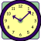5 minutes.
This tutorial will show you how to:
- configure Delphi data access objects for use by reports
- work with the Report Designer
- create and configure the most common report components
Create a new application
- Select the File | New Application menu option from the Delphi menu. This will create a new project and blank form.
Create a Table, DataSource and DataPipeline component
- Select the Data Access tab of the Delphi component palette.
- Add a Table component to the form.
- Configure the Table component:
DatabaseName DBDEMOS
Name tblCustomer
TableName CUSTOMER.DB
- Double-click the Active property in the Object Inspector to open the table.
- Add a DataSource component to the form.
- Configure the DataSource component:
DataSet tblCustomer
Name dsCustomer
- Select the RBuilder tab of the Delphi component palette.
- Add a ppBDEPipeline component to the form.
- Configure the Pipeline component:
DataSource dsCustomer
Name plCustomer
Create a report and connect it to the data
- Add a ppReport component to the form.
- Configure the Report component:
DataPipeline plCustomer
Name rbCustomerList
Invoke the Report Designer
- Double-click on the Report component to display the Report Designer.
- Size and Move the Report Designer window so that the Object Inspector is visible.
Place a label component in the header band.
- Right-click over the white space of the header band and access the Position… dialog.
- Set the Height value to 0.9167 and click the OK button (the header band should expand in height.)
You can also change the height of the header band by dragging the gray bar that appears below the white space of the header band. This method is quick and easy, but not as precise.
- Click the Label component icon on the Report Designer component palette.
- Click on the left side of the header band. (A label will be created in the header band and will become the current selection in the Object Inspector.)
- Locate the Edit box at the upper left corner of the Report Designer.
- Select the text inside it and replace it with the following text: Company
- Use the font controls to set the font to:
Font Name Times New Roman
Font Size 12
Font Style Bold & Italic (click the Bold and Italic icons.)
The font controls appear to the right of the Edit box and consist of a Font Name drop-down list, a Font Size drop-down list, Bold, Italic and Underline Font Style icons, text alignment icons and font and highlight color icons..
Place a DBText component in the detail band.
- Click the DBText component icon on the Report Designer component palette.
- Click in the detail band (a DBText component will be created.)
- Locate the two drop-down lists at the upper left-hand corner of the Report Designer. The list on the left contains a list of data pipelines (it should default to the Customer data pipeline – since this is the data pipeline for the report.) The list on the right contains a list of fields for the currently selected data pipeline.
- Select the Company field from the field list. (‘Kauai Dive Shoppe’ should be displayed in the DBText component. .
- Use the font controls to configure the font as follows:
Font name Times New Roman
Font size 10
Font color Black
Preview the report at design-time.
- Click the Preview tab in the Report Designer. You should get a four-page report.
Preview the report at run-time.
- Close the Report Designer.
- Select the Standard tab of the Delphi component palette.
- Add a Button component to the form.
- Configure the Button component:
Name btnPreview
Caption Preview
- Put the following code in the OnClick event handler of the button:
rbCustomerList.Print;
- Run the Project.
- Click on the Preview button. (The report should be displayed in the Print Preview form.)

Elements of the User Interface
The default configuration of the Report Designer is shown here. I’ve labeled some of the most important elements.
Status Bar
Edit Toolbar

Rulers
Format Toolbar
Footer band
Detail band
Header band
Component Toolbars
The Report Designer is your key to productivity when creating reports in Delphi. Every effort has been made to be consistent with the Delphi Form Designer and other similar Windows programs you’ve used before. The ReportBuilder Report Designer provides you with many powerful tools for maximizing your productivity:
Component Palette Toolbars
These toolbars are used to create new components. To create a component, click on the icon and then click in the white space of a band. There are three component toolbars: Standard, Data and Advanced. Use the Standard components to create text, lines, shapes, memos, richtext etc. and you want to assign the data to the components at design-time or run-time. Use the Data components when you want to assign the data from a database. Use the Advanced components when you need to create more complex reports using subreports or regions.
Edit Toolbar
The Edit toolbar allows you to set the most important property for a given component. For example, when a Label component is selected, an edit box appears allowing you to set the Caption. When a DBText component is selected, two drop-down lists appear, allowing you to set the DataPipeline and the DataField.
Format Toolbar
This toolbar appears to the left of the Edit. It’s used to configure the font of textual components and to control component layering via the Bring to Front and Send to Back icons.
Rulers
The horizontal ruler allows you to determine a component’s position on the page. The vertical ruler for each band allows you to determine a component’s position relative to the starting print position of the band.
All Bands
Notice the gray rectangular area below the white space of each band. This area is draggable, and allows you to redefine the height of the band.
Status Bar
Shows messages and object positions.
Other Report Designer Elements not pictured.
Align or Space Toolbar
Use to align objects in relation to the band and to each other.
Size Toolbar
Use to set the width or height of a set of components based on the largest or smallest component in the set. Provides an excellent means to size components in a uniform way.
Nudge toolbar
Use this toolbar to modify a component's position in one-screen pixel increments.
Draw toolbar
Used to set the color and border of shapes, lines and regions.
Standard toolbar
Used to create new reports, open existing reports, save modifications to reports, print reports to the printer or to a print preview window and for various clipboard operations.
Page Setup dialog
Accessible via the File | Page Setup menu option. Used to specify paper size and orientation and to control column layouts for newspaper style reports and mailing labels.
Print to File Setup dialog
Accessible via the File | Print to File Setup menu option. Use to specify settings for exporting report data to ASCII text. You can control what data from each band gets exported and the order of the output fields. Fixed length, tab-delimited, and comma-delimited record types are supported.
Groups dialog
Accessible via the Report | Groups menu option. Use to create, modify, and re-order report groups.
Display Format dialog
Accessible via the DisplayFormat option of the component’s speed menu. Used to set the format for the text (i.e. display a date as ‘Monday, October 9, 2030’).
Calculation dialog
Accessible via the Calculations… speed menu option of a TppVariable component. This dialog allows you to code the calculations for a variable. (only available when RAP is installed.)
Speed Menus
Speed Menus are pop-up menus that appear when you position your mouse cursor over an object and press the right mouse button. Windows '95 and many commercial Windows applications incorporate speed menus in their user-interface. ReportBuilder's Report Designer makes extensive use of speed menus to allow you to quickly set report component properties without having to access the Object Inspector. This allows you to maximize the Report Designer window when working on reports.

Working with the Report Designer
The Report Designer is actually a sophisticated component editor for the report component (other examples of component editors in Delphi are the Menu Editor of the TMenu component and the Fields Editor of the TTable and TQuery component.) The Report Designer enables you to quickly and easily layout complex reports in much the same way as the Delphi Form Designer.
In Delphi, when you place a component on a form several things occur:
- the component is drawn on your form
- the declaration of the component is added to your form unit (.pas file)
- the design-time properties and events of the component become visible in the Object Inspector.
When you place a ReportBuilder component from one of the Report Designer’s component palettes on a report band three things happen: 1. the component is drawn on your report layout, 2. the component is added to your form unit (.pas file), and 3. the design-time properties and events of the component become visible in the Object Inspector. In other words, report components are just like any other Delphi components. You can configure their properties and assign event handlers to them using the Object Inspector. Alternatively, you can use the Report Designer.
Here are some tips to help you get the most out of the Report Designer:

- Maximize the Report Designer window and use the speed menus as much as possible.
- Use the View | Show Data menu option to toggle between displaying live data and displaying the component names. Note: this is only relevant when you’re designing with an active dataset.
- Use the File | Save Form (or Ctrl + S) to save your Delphi form and thus the report your working on.
- To set display formats, make your dataset active and then use the speed menus to access the Format dialog. The Format dialog will determine the data type of the DataField assigned to the component and display several formats appropriate for that data type (for example a field of type date would provide a list of commonly used date formats.)
- To resize the bands using the mouse, position the mouse over the gray rectangular area below the white space of the band, press the left mouse button and drag.
- You can drag components from one band to another.
- To access online help for a component , select the component and Press F1.
- To make a particular band appear as the selected object in the Object Inspector, position your mouse cursor anywhere over the open white space of the band (not over a component in the band) and click the left mouse button.
- To make the report appear as the selected object in the Object Inspector, position your mouse in the top left corner of the report designer’s work area (to the left of the horizontal ruler and above the vertical ruler) and click the left mouse button.
- When working with the Report Designer in its “maximized” window state, you can bring the Object Inspector to the top by selecting the Report Designer’s View | Object Inspector menu item or by pressing F11.
- You can cut, copy, and paste one or more report components at a time either in the same report or between different reports.
- Avoid using the same DataSource for a ReportBuilder report and the data aware control on your Delphi form (for example a DBGrid). This is inefficient for reporting, because when ReportBuilder traverses the data set to generate a report, your data aware controls will be repeatedly notified that the current record in the data set has changed. And if you have any events attached to the data aware controls, the events will fire repeatedly also. This slows performance greatly and can cause unexpected results.
- Do not use the same data pipeline for two different subreports. Do not use the same data pipeline for a report and detail band. This will cause access violations or other strange behavior when you run the report. The Report, the DetailBand and any subreports are considered ‘traversing entities’. That is when a data pipeline is assigned, to traverse the data, going from first record to last record. Traversing entities cannot share data pipelines due to the caching scheme of the report engine.
- When working on long reports use the PageLimit property of the report to limit the number of pages previewed. In other words, if the report is 200 pages long, set PageLimit to 20 and only the first twenty pages will be previewed.
- Do not preview a report that has no data pipeline and no page limit assigned. A report in this configuration has no way to determine when to stop and will generate pages forever.
- Close the Report Designer window prior to closing your form or exiting Delphi. Otherwise an access violation may occur.
- Use all of the tools described in the previous section.

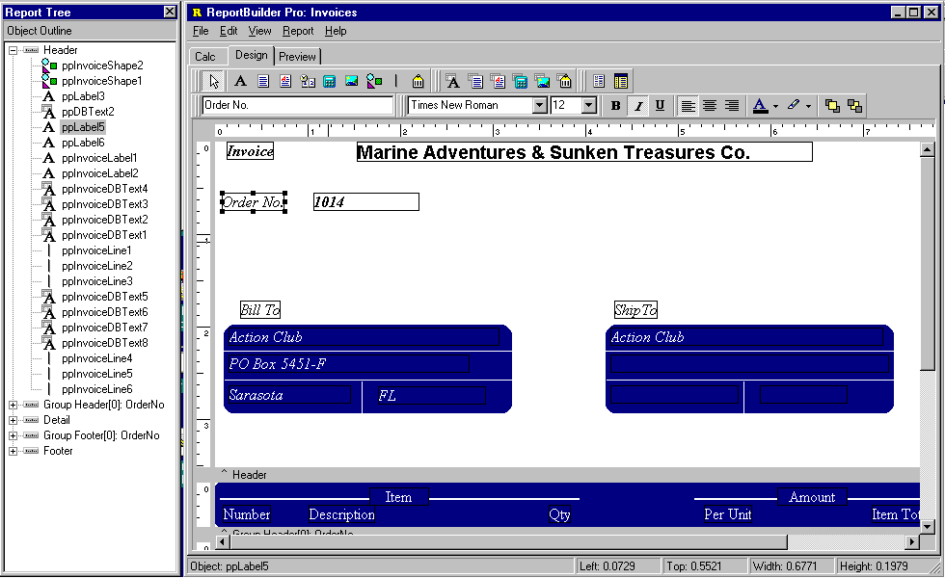
By selecting the View | Toolbars | Report Tree menu option you can display the Report Tree. The report tree shows all of the bands and components in the report. The components for each band are listed in layered order (that is the order established via the Bring to Front and Send to Back commands.) The bottommost component is listed first, the topmost component is listed last.
Report Tree
You can use the Report Tree to see exactly what components are contained in the report and to select individual components.
By right-clicking over the Report Tree, you can turn the Report Outline on. The Report Outline is useful when you have subreports in your report. You can select any subreport in the Report Outline and the bands and components for that subreport will appear in the Report Tree. (The subreport will also be displayed in the Report Designer.)
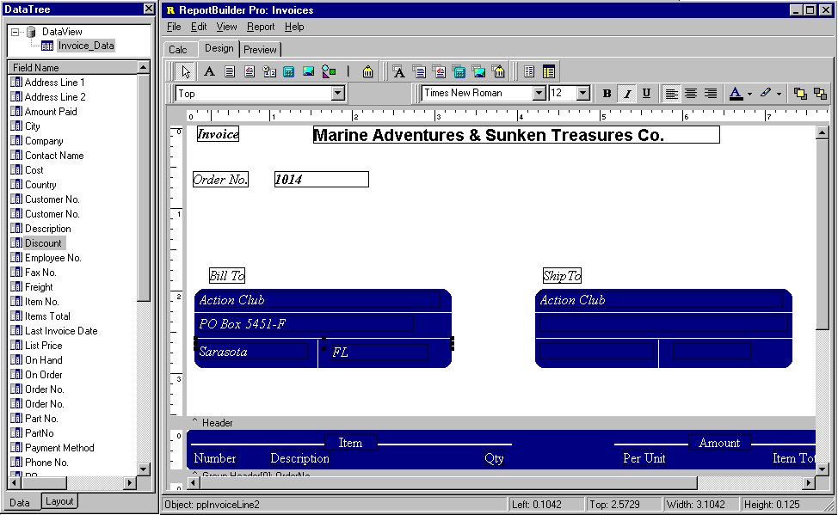
By selecting the View | Toolbars | Data Tree menu option you can display the data pipelines which can be used to create data-aware components within the report. The data tree shows a list of data pipelines in the top window and a list of fields for the currently selected data pipeline in the bottom window.
You can select multiple fields in the field list and drag them into any band. Data-aware components and corresponding labels will then be created. Notice the ‘Data’ and ‘Layout’ tabs at the bottom of the Data Tree. You can use the Layout tab to customize the behavior of the Data Tree’s drag-and-drop capabilities.
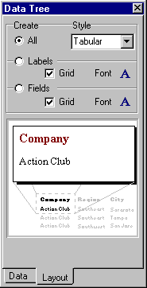
The Layout tab of the Data Tree contains many settings which you can use to customize the drag-and-drop capabilities of the Data Tree.
Control  All radio button  Labels radio button  Fields radio button  Grid check boxes  Style drop-down list  Font icons  Preview image | Description
All radio button | When selected both DBText components (assigned to the selected fields) and corresponding label components are created.
Fields radio button | When selected only DBText components (assigned to the selected fields) are created.
Label radio button | When selected only Label components (with the captions set to the field name) are created.
Style drop-down list | Controls whether the DBText and Label components are oriented in a columnar or stacked fashion.
Grid check boxes | Controls whether a shape is placed behind the DBText or Label component.
Font icons | Controls the font name, size, style and color via a standard font dialog.
Preview image | Shows how the created components will look.

Reporting Basics
Master/Detail Reports
Set the Report.DataPipeline property to the master data pipeline and the DetailBand.DataPipeline property to the detail data pipeline. Any data-aware component placed in the detail band will default to the data pipeline of the detail band. Any data-aware report component placed in any other band will default to the data pipeline of the report. You can change the default data pipeline of a component by using the drop-down list in the Edit toolbar or the Object Inspector.
Lookup Tables/Queries
A data-aware report component can be set to any data pipeline on your form. This means that if a lookup table or query is connected to your master or detail data, you can assign fields from the lookup data simply by creating a data pipeline for the lookup and then assigning that data pipeline to a component.
Filtering Data
Whenever you set a filter on data that is connected to a report, you need to call the Report.Reset method prior to calling Report.Print. This will notify ReportBuilder that it needs to re-access the data and regenerate the report pages, rather than use the internal engine cache. Calling Report.Reset is a good technique whenever it appears that a report is not regenerating in response to changes in the data.
Performing Calculations
There are a number of ways to perform calculations for reports: Delphi calculated fields, TppDBCalc components, and TppVariable components.
- Use Delphi calculated fields when you want to calculate a result for each record in the dataset based on the values of one or more fields in the record. You can create the TField objects by double-clicking on the dataset component (TTable, TQuery,..) and accessing the Fields Editor. Use the Fields Editor to create the calculated TField objects. Then in the OnCalcFields event for the dataset add the code to calculate the result and assign it to the TField component.
- Use TppDBCalc components when you need to calculate a SUM, COUNT, MIN, MAX, or AVG for a group or the entire report. The COUNT DBCalcType can also be used in the DetailBand to display the line number for each record in the report.
- Use the TppVariable component to perform calculations. Set the DataType property to the desired data type. Add code to the OnCalc event to perform calculations. Note: If calculations are based on the values of other variables it may be necessary to set the Calc Order of the variables. To do this, access the Calc Order dialog by right clicking over the white space of a band and selecting the Calc Order… menu option. You can then order by the variables for calculation. Return the value of the calculation in the Result parameter of the OnCalc event, or assign the result to one of the following properties: AsInteger, AsBoolean, AsString, AsFloat, AsDateTime, AsDate, or AsTime. The value of the Text property will reflect the calculated value.
Note: Always remember that Object Pascal event handlers do not execute at design-time, you must compile and run your project to see the results.
Display Formats
You can specify the formats of a DBText, DBCalc, Variable or SystemVariable component by setting the DisplayFormat property. DisplayFormat differs from the Delphi implementation in the case of string types. In order to format strings simply type a valid EditMask into the DisplayFormat property. ReportBuilder will then apply the EditMask to the string value.
Note: ReportBuilder ignores any display formats you specify within the TField objects of a Delphi dataset.
Dynamic Bands
Set the Band.PrintHeight property to phDynamic when you want the band to use page space on an as-needed basis, shrinking or stretching to accommodate the report components. When PrintHeight is set to phStatic, the band uses the exact amount of page space specified by the Height property (unless it is not Visible, in which case it uses zero page space.)
Stretching Memos and Shapes
Set the Stretch property of a Memo when you want the Height of the memo to automatically stretch to allow the entire contents of the memo to be printed. And if you are framing the memo with a Shape component set the Shape.StretchWithParent property to True and the Height of the shape will stretch to accommodate the height of the memo. Finally use the ShiftWithParent property of the other report components to determine whether the position of the report component should move as the memo stretches.
Controlling Component Visibility
You can use the BeforePrint event of a band to control which components appear when the band prints. To hide all the components in a band, set the Visible property of the band to False. To hide individual components set the Visible property of each component to False.

ReportBuilder Fundamentals
Main 34
Data 60
Code 72
Design 106
Print 140
Deploy 152

Main
Introduction 34
The Delphi Components 36
Report Components 37
Smart Layouts 40
SubReports 48
Form Emulation 54

ReportBuilder Fundamentals

Main

Introduction

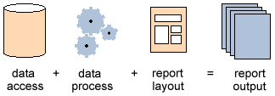
ReportBuilder is a development environment which can be used to construct reports, report components and reporting applications. Because reporting encompasses a very wide range of requirements, it is often difficult to put a limit on what should be expected of a reporting tool. The designers of ReportBuilder reduced this broad set of requirements down to the following equation:

Data Access is defined as the retrieval of data from a database table, text file, Delphi object or other data source in an organized fashion (structured as records and fields.)

Data Process refers to the calculation of intermediate results based on the data and to modification of the report layout as the report generates.

The Report Layout is a set of components which describe the look and feel of the report and define the behavior of components during report generation.

Report Output is defined as a set of components which describe the exact content of each page.

This equation covers, more or less, the entire area of development known as reporting. In terms of importance, each element of the equation is basically equal. If any one element of the equation is not supported or is weakly supported, than the utility of the reporting solution is greatly reduced.

Early versions of ReportBuilder focused on the report layout and report output elements, largely due to the fact that Delphi has abundant solutions for the data access (BDE, BDE replacements, FileStreams, StringLists, etc.) and for the data process (events and Object Pascal) elements. In fact, utilizing these solutions is still a quite valid and productive way for developers to use ReportBuilder. The developer can configure standard Delphi data access components, connect them to a report via the data pipeline component, design and preview the report at Delphi design-time, and, if necessary, code event handlers in Object Pascal to perform calculations or to modify the report layout during generation.
In the development of ReportBuilder Pro, it was discovered that solutions for the data access and data process elements were also needed for end-users who were utilizing the ReportBuilder Report Designer as part of a running application. Within the context of a running application, the Delphi developer has no way of providing access to the BDE or to Object Pascal as development environments. End-users could not therefore, avail themselves of these powerful tools. This situation eventually led to the development of DADE (the Data Access Development Environment) and RAP (the Report Application Pascal programming language) which gave end-users complete solutions to data access and data process respectively. Both DADE and RAP are available as part of the ReportBuilder Pro product.

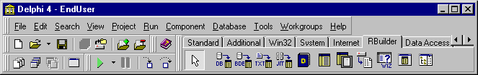
The Delphi Components

Component | Icon | Description
BDEPipeline |  | Used for accessing data via the BDE. The BDEPipeline can be connected to a DataSource via the DataSource property. In turn, the DataSource may be connected to either a TQuery or TTable.
DBPipeline |  | Used for accessing data via third party BDE replacement products or TDataSet descendants. The DBPipeline is connected via the DataSource property.
TextPipeline |  | Used to access comma, tab and fixed-length format text files. Set the FileName property to specify the file. Double-click on the component to define the field structure.
JITPipeline |  | Used to access any non-structured data stored in Delphi objects or other sources. Provides total control over the data-access process. All event handlers must be coded. Double-click on the component to define the field structure.
Report |  | The main object. Create one on a form and double-click to invoke the Report Designer. Assign the DataPipeline property so that the report can traverse data. Assign the DeviceType property to control where the output of the report is directed.
Viewer |  | This object is rarely used because you can replace ReportBuilder’s built-in print preview form with your own customized version very easily (check the Replacing the Print Preview Form section in Advanced Techniques.) If you must use this component an example is provided in the main report demo (\Demos\Reports\dmMain.pas directory.)
ArchiveReader |  | After you print a report to an archive file (.raf extension), you can read and preview the file via this component. Just assign the ArchiveFileName to the file and call the Print method. In terms of displaying a report, this component works much the same as the Report component.

Report Components

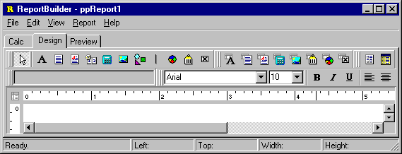
The ReportBuilder Report Component Library (RCL) provides a powerful, robust set of components which have been designed and optimized specifically for the reporting environment. The library includes over 20 components that enable you to put all types of data in your reports: Lines, Shapes, Text, Memos, RichText, Images, Charts, and BarCodes. Advanced components such as Regions and SubReports can be used to elegantly model complexity.

Component | Icon | Description
Label |  | Used to display text. Assign the Caption property to control the text value. You can have the label resize automatically to fit a changing caption if you set the AutoSize property to True.
Memo |  | Used to print multiple lines of plain text in a report. To set the value, assign a string list to the Lines property. To dynamically resize the memo during printing, set the Stretch property to True. Use the ShiftRelativeTo property to define dynamic relationships with other stretchable objects.
RichText |  | Used to print formatted text. To set the value, assign the RichText property or use the LoadFromFile or LoadFromRTFStream methods. Use the ShiftRelativeTo property to define dynamic relationships with other stretchable objects. At design-time you can use ReportBuilder's built-in RTF Editor to load, modify, and save rich text data stored in files.
SystemVariable |  | Used to display common report information such as page number, page count, print date and time, date, time, etc. The type of information displayed is controlled by the VarType property. The format is controlled by the DisplayFormat property.
Component | Icon | Description
Variable |  | Used for calculations via an Object Pascal event handler assigned to the OnCalc event or a RAP event handler assigned to the OnCalc event. Access the Calculations dialog (via the speed menu) or the Calc tab of the Report Designer to code a RAP calculation for this component.
Image |  | Used to display bitmaps and windows metafiles in reports. Assign the Picture property of this component in order to place an image in your report. Use the Report Designer's built-in picture dialog to load images at design-time
Shape |  | Use this component to print various shapes (squares, rectangles, circles, ellipses) Set the Shape property to select a type of shape. Use the Brush and Pen properties to control the color and border respectively.
TeeChart |  | Used to display standard (non-data-aware) TeeCharts. This component enables you to use TeeChart inside the Report Designer. You can access the TeeChart editor via a popup menu.
BarCode |  | Used to render barcodes. The string value assigned to the Data property is encoded based on the BarCodeType. If the data to be encoded is in a database, use DBBarCode. The following symbologies are supported: Codabar, Code 128, Code 39, EAN-13, EAN-8, FIM A,B,C, Interleaved 2 of 5, PostNet, UPC-A, UPC-E.
CheckBox |  | Displays a checkbox using the WingDings font.
DBText |  | Used for displaying values from all types of database fields. Use the DisplayFormat property to format the value.
DBMemo |  | Used to print plain text from a memo field of a database table. This control will automatically word-wrap the text. Set the Stretch property to True and the component will dynamically resize to print all of the text. Use the ShiftRelativeTo property to define dynamic relationships with other stretchable objects.
DBRichText |  | Used to print formatted text from a memo or BLOB field of a database table. This control will automatically word-wrap the text. Set the Stretch property to True and the component will dynamically resize to print all of the text. Use the ShiftRelativeTo property to define dynamic relationships with other stretchable objects.
Component | Icon | Description
DBCalc |  | Used for simple database calculations (Sum, Min, Max, Count and Average.) The value can be reset when a group breaks using the ResetGroup property.
DBImage |  | Used to print bitmaps or windows metafiles, which are stored in a database BLOB field.
DBBarCode |  | Used to render barcodes based on the BarCodeType and the value supplied via the DataField property. The following symbologies are supported: Codabar, Code 128, Code 39, EAN-13, EAN-8, FIM A,B,C, Interleaved 2 of 5, PostNet, UPC-A, UPC-E.
DBTeeChart |  | Allows data-aware TeeCharts to be placed within a report.
DBCheckBox |  | Displays a checkbox based on the value of the field specified in the DataField property. Can be used with a Boolean field (or any other type of field via the BooleanTrue, BooleanFalse properties.)
Region |  | Used to logically group components together. Use the ShiftRelativeTo property to move the region in relation to another dynamically resizing component (such as Memo, RichText or child-type SubReport.)
SubReport |  | Used to handle multiple master details, create side-by-side reporting effects and hook reports together as one. If you need a report to print within the context of a band, use a child-type subreport. If you need to hook reports together use a section type subreport. The PrintBehavior property determines the subreport type.

Smart Layouts

ReportBuilder allows you to create highly dynamic report layouts. The SubReport, Memo, RichText and Region components have the ability to expand or contract to accommodate the information which they contain. There are a host of properties designed to keep your reports looking good in the variety of situations these dynamic components can create.

Property | Description
StretchWithParent | Allows a shape or line to expand or contract based on the change in height of the band or region in which it is contained.
ShiftWithParent | Allows any non-stretching component to move up or down based on the change in height of the band or region in which it is contained.
ShiftRelativeTo | Used to specify the vertical positioning which should take place between multiple stretching components in a band.
StopPosition  (for subreports) | Used to set the position on the page where a child type subreport will stop printing. Allows a child type subreport to be confined to a rectangular area of the page.
BottomOffset | Used to create white space between multiple stretching objects which have been linked together using the ShiftRelativeto property.
OverFlowOffset | Controls the position where a stretching component will begin printing, when it is overflowing on additional pages. This property can be used to print an object at a different starting position when it overflows onto additional pages.
ReprintOnOverFlow | Used to print non-stretching components again when stretching components are printing on additional pages.

One Memo in the Detail Band

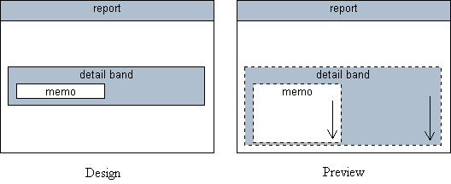
Here we have a single memo component in the detail band. The memo’s Stretch property has been set to True. Each time the detail band prints, the height of the memo is recalculated based on the amount of text which it contains. As a result, the memo may either grow or shrink in size and the detail band will grow and shrink with it. The memo may contain so much text that it cannot fit on a single page. In this case the memo will print on additional pages until it is complete. In ReportBuilder, this condition is referred to as overflow. Both the memo and band components have a boolean OverFlow property which can be checked while the report is generating to determine if the memo is printing on an additional page.

One Memo with a Shape Background

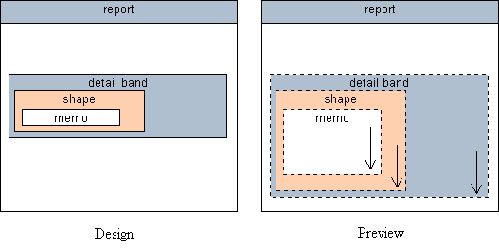
Here we have a single memo in the detail band with a shape behind it. The shape has the StretchWithParent property set to True. The ‘parent’, in this case, is the detail band. When the band generates, the memo will stretch based on the text it contains, the band will resize to accommodate the memo, and the shape will resize based on the change in height of the band. This creates the effect of a border and background for the memo. If
the memo overflows onto additional pages, we can instruct the shape to print also by setting the shape’s ReprintOnOverFlow property to True.

One Memo with Label beneath
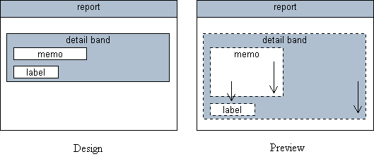
Here we have a single memo in the detail band with a label below it. The label has the ShiftWithParent property set to True. The ‘parent’, in this case, is the detail band. When the band generates the memo will stretch and band will increase or decrease in height accordingly. The label will shift based on the change in height of the band.

One Memo with Two Side-by-Side Memos below

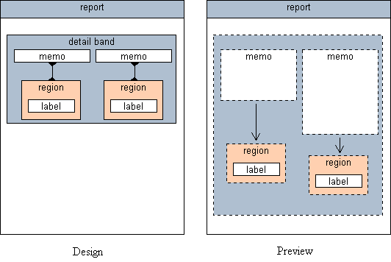
In this report we have a single stretching memo which needs to print to completion, then two additional memos need to print, starting immediately after the first. By placing the second two memos in a region and setting the region’s ShiftRelativeTo property to point at the first memo, we can achieve this effect.

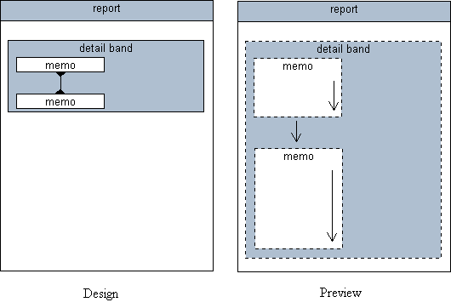
Two Stacked Memos in the Detail Band

This report requires two memos to be printed, one after the other. This is achieved by setting the ShiftRelativeTo property of the second memo so that it points at the first. With this configuration the first memo will print, stretching to accommodate the text it contains, and then the second memo will print to completion.

Two Side-by-Side Memos with Labels below

Here we have two memos in the detail band, each set to stretch. When the report generates, the band will grow or shrink to accommodate the memo which contains the most text. Each memo has an associated label below it. We want the labels to shift in relation to the memo above. In order to accomplish this, we place the labels in a region and then set the region’s ShiftRelativeTo property to point at the memo above. Now when the report is generated, each label shifts in relation to the associated memo.

Child SubReports in Fixed Positions

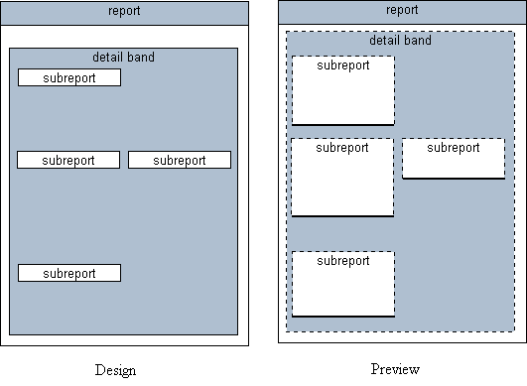
This report emulates a form which contains information in fixed rectangular areas of the page. By placing child type subreports at the beginning of each rectangular area and setting the StopPosition property equal to the bottom of the rectangular area we can get the report to ‘fill-out’ this form for us.

SubReports

In traditional banded-style report writers, reports which can be printed from a single source of data are quite easy to create. But if the content of the report consists of information from several different sources of data, the choices become quite limited. One option is to use SQL to join the data together into one ‘virtual table’, and then build the report based on this table. If many tables are involved, the performance of this approach can be prohibitive.

Delphi provides an alternative to this approach by allowing linkages to be established between data access objects. Within ReportBuilder we can use free-form subreports to take advantage of the many configurations these data access objects make possible.

Single Data Source

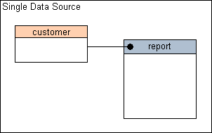
A single data source can be connected directly to the report via the DataPipeline property. When printed the report will generate one detail band for each record provided by the data source.

Master Data Source with Single Detail Data Source

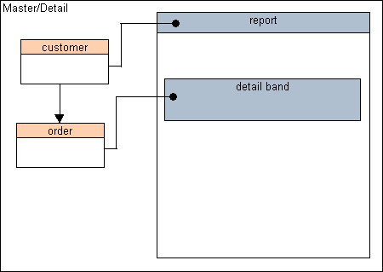
In this scenario, the master data is connected to the detail data via a field or set of fields. It is assumed that this connection results in multiple detail records being selected for each individual master record. The master data source is assigned to the report, the detail data source is assigned to the detail band of the report. The report steps through each of the master records and generates one detail band for each record in the detail data source. If there are no corresponding detail records for a given master record, the report generates a blank detail band.

Master Data Source with Nested Detail Data Sources

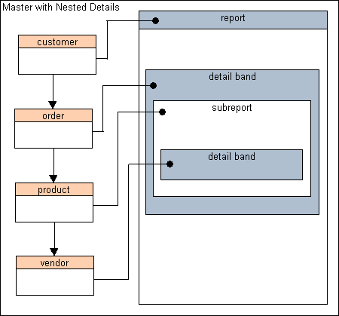
Here we have the master data source containing a list of customers. Each customer has multiple orders, each order has multiple products and each product has multiple potential vendors. This configuration is called ‘nested’ because each set of records is selected based on the linkage established with the previous data source.

The first two data sources can be handled as in the standard Master/Detail arrangement. The customer data source is assigned to the report, the order data source is assigned to the detail band. The next two data sources can be handled by a subreport. A subreport has all of the capabilities of a regular report – the only difference being that it can be placed within the band of another report. In this case, we place the subreport in the detail
band of the main report. It will then print once for each order record. Within the subreport we assign the report to the part data source and the detail band to the vendor data source.

By configuring the report in this manner, we get the following behavior – all of customers will be printed, all of the orders for each customer, all of the parts for each order and all vendors for each part.

Master Data Source with Multiple Independent Data Sources

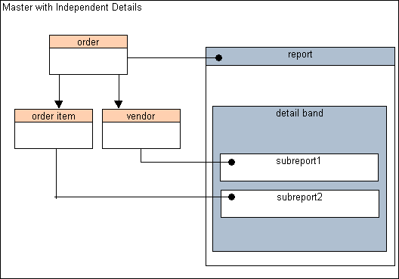
Here we have the order table. For each order there are many order items. For each order there is also a group of vendors which can supply the products for that order. Both of these data sources are linked to the master data source, as opposed to nesting them within one another, thus the term ‘independent.’ This type of data can be handled by placing two subreports in the detail band. The first subreport can be linked to the order item data source, the second subreport can be linked to the vendor data source. In order to print the vendor data after the order item data, we would link the vendor subreport to the order item subreport via the ShiftRelativeTo property.

Independent Data Sources

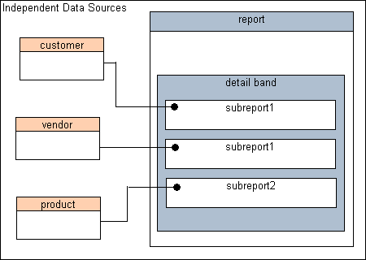
Here we have three sources of data with no linkages between them. In this report we want to print all of the customers, then all of the products and then all of the vendors. The report needs to fit together like a book, with each data source providing a ‘chapter’. Here we use the main report to launch a subreport for each of the data sources. The subreports would be set with a PrintBehavior of section, which means that each subreport would start a new page, generate a set of pages as necessary to traverse all of the data of the data source and then return control to the main report. The main report is not connected to any data source, so we would manually stop the report generation process by coding an event handler in the detail band AfterPrint event. This event handler would call the Report.Stop procedure, which would stop the report generation process after all of the subreports have completed printing.

Form Emulation

Form emulation is the process of taking a paper-based or electronic form and rendering a likeness of it. The likeness may include formatting of the form itself, or may only contain the data which will ‘fill-out’ the form. The two basic issues which a form emulation solution must resolve are:

- How will the formatting of the form be generated.
- How will the data which ‘fills-out’ the form be generated.

The first problem can be solved using either a page-sized band within the report or by utilizing a page style. A page style can be designed just like a band, but generates as a background to the bands of the report.

The second problem is resolved by either using simple data-aware components, or by using more complex region or subreport components.

In ReportBuilder, there are several approaches which can be used to achieve form emulation. These approaches are discussed in detail in this section.

Single Page Forms

Single page forms can be emulated in several ways using ReportBuilder. Several common approaches are:

- Expand the detail band to the printable height of the page, hide the header and footer bands and place all form formatting and data-aware controls in the detail band. This approach yields one form per record. The following diagram shows an entire form in the detail band.

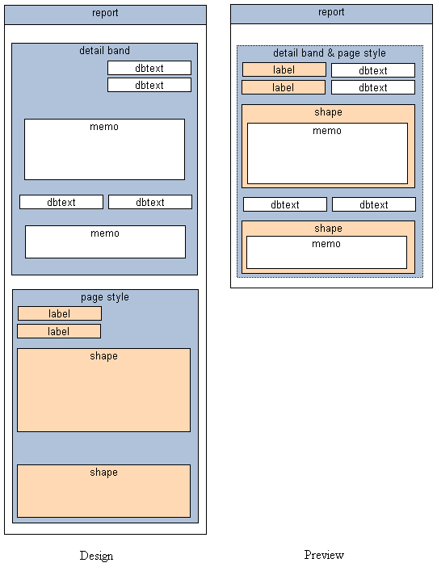
- Add a page style to the report, place all formatting for the form in the page style, place the data-aware controls in the bands as you would when building a normal report. This approach yields a variable number of records per form, depending on the height of the bands. In this approach the detail band is used to ‘fill-out’ the form. The following diagram shows how a detail band can ‘fill-out’ a page style.

- Expand the detail band to the printable height of the page, hide the header and footer band, and place all form formatting in the detail band. Place child-type subreports in different areas of the form where a table or particular source of data is needed to fill-out that part of the form. Place data-aware components in areas of the form where the master datapipeline supplies the data. This yields the most flexible and powerful form emulation solution, but is only needed when multiple data sources are used. The following diagram shows subreports filling out a form in the detail band.

The form itself may be too complex to recreate using report components. In this case it is recommended that you scan the form and convert it to a windows metafile. You can then place the windows metafile in the report as either a ‘background’ for the detail band or in the page style – where it will function naturally as a background for the report.

When you have a form in a WMF image, the end-user gets an excellent print preview capability. If you are printing on pre-printed forms, you can set the visible property to false when the report is sent to the printer. In this way you can provide a filled-out form in the print preview window, but only the text necessary to ‘fill-out’ the form is actually sent to the printer.

Converting a scanned form to a windows metafile image (WMF) can be accomplished via a product such as Transform Suite, by MIPS.

Multi-Page Forms

All of the approaches discussed in the single page form topic are applicable to the multi-page forms. The additional problem of organizing single-page forms into sets of multi-page forms can be resolved using section style subreports. When Section style subreports are rendered, they generate a new page within the parent report, continue generating pages until all data has been traversed (or they are stopped manually through a procedure call to the report engine) and then return control to the parent report. One special behavior of section type subreports is that the the parent report generates no pages when the section is placed in a dynamic height detail band. In this case, the main report is used as a launching pad for one to many sections. Since each section is a full-fledged report in its own right, all of the single page form approaches can applied to each section – thus creating a multi-page form solution.

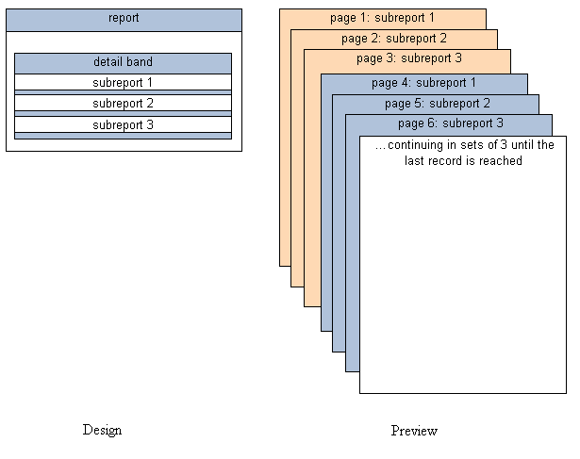
The diagram below shows three section type subreports in the detail band of the main report. The main report is assigned to a data pipeline, so the detail band will print once for each record. The subreports contain data-aware controls which point at this data pipeline. After the detail band of the subreports print, the Stop method of the report is called, manually stopping the report. This report provides three pages of content for each record, each page with it’s own unique format.

Data
Introduction 60
BDE Support 64
BDE Alternatives 66
Text Files 67
Delphi Objects 68
Native Access to Proprietary Data 69

Data

Introduction

In ReportBuilder, data access is provided via the data pipeline component.

ReportBuilder includes data pipelines for accessing data from a variety of sources:

Name | Description
BDEPipeline | Used to access data via the Borland Data Engine (BDE).
DBPipeline | Used to access data via a BDE replacement product or Tdataset Descendant.
TextPipeline | Used to access data in ASCII text files.
JITPipeline | Just-In-Time pipeline for accessing data in Delphi objects.

The data pipeline component has two basic purposes:

- Supply data
- Control data traversal

Regardless of the type of pipeline or the type of data being accessed, the purpose of the pipeline remains the same: supply data and control data traversal.
Supplying Data

Data pipelines provide data via field objects. For instance, the following code would retrieve the current field value of a field called ‘Company’:

lValue := DataPipeline1. [‘Company’];

Each time a data-aware report component prints, it uses this approach to retrieve the data from the data pipeline. Data-aware report components have two properties which determine the data that they will retrieve: DataPipeline and DataField. The name of the appropriate data pipeline component is assigned to the DataPipeline. The DataField property is assigned the name of the field which contains the data to be displayed. Once these two properties are assigned, the data-aware component has the ability to retrieve data directly from the data pipeline, independent of the report where the data-aware component resides.
Controlling Data Traversal

The second purpose of the data pipeline is to control data traversal. Data traversal is the act of moving from the first record of the data to the last record. When a report is printed, the report engine traverses the data in the following way:

- Opens the data pipeline.
- Goes to the first record.
- Begins printing the page and then gives the detail band the opportunity to print.
- Goes to the next record.
- Gives the detail band the opportunity to print.
- Continues steps 4 and 5 until there is no more page space.
- Completes the page.
- Continues steps 4 through 7 until all records have been exhausted.

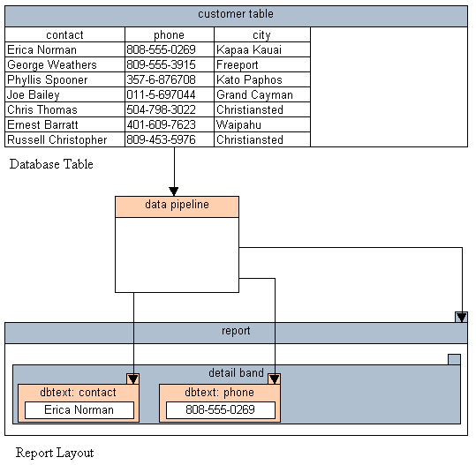
It is important to note that when the detail band is given the opportunity to print, the data-aware components within the detail band are rendered – at which point they retrieve the field value of the current record. The engine then moves to the next record and prints the detail band again. It is this combination of the report traversing the data and the data-aware components retrieving the data which create the pages of the report. If the data pipeline is not assigned to either of these entities (data-aware component or report) then the report will not work. So the report must be assigned to a data pipeline and each data-aware component must be assigned to a data pipeline and a datafield.
We’ve said that the report engine traverses the data. That isn’t completely true. The report engine makes requests of the data pipeline (such as open, first, next, last), and then relies on the data pipeline to do the work. This means that the data pipeline controls the data traversal, a fact which can be used to great advantage.

For instance, let’s say you are displaying a database grid on a form. The user has selected an individual record of the grid and wants to print that record. If you have a data pipeline pointed at the same data source as the grid – then it can access all of the records. However, we can instruct the data pipeline to traverse only the current record
by simply setting the RangeBegin and RangeEnd properties to CurrentRecord. When the report prints it will send traversal requests to the data pipeline and the data pipeline will traverse only one record. It will then inform the report engine that all records have been traversed and the report will print only one record.

Let’s take this example further and say that you let the user select multiple records from the database grid. You then want the report to contain only the selected records. In this case we can assign the Bookmarks from the grid to the BookmarkList property of the data pipeline. When the report prints the data pipeline will traverse only those
records which are in the list of bookmarks and only those records will appear in the report. Essentially the engine makes the same traversal requests of the data pipeline for every report, but it is the data pipeline which controls how the data is actually traversed.

BDE Support

BDE stands for Borland Database Engine. The Delphi development environment utilizes the BDE to access data in desktop database files (such as Paradox or Access) and in client-server databases (such as Oracle and Sybase.) The wide range of data sources which can be accessed via the BDE is definitely one of the reasons Delphi has been so successful. ReportBuilder leverages this powerful solution with standard support for the BDE.

In Delphi, data access via the BDE can be accomplished using a TTable or TQuery component. A TDatasource component is then connected to the table or query. A data-aware component can then be connected to the datasource. The following screen-shot shows a field value being retrieved into a data-aware memo component.

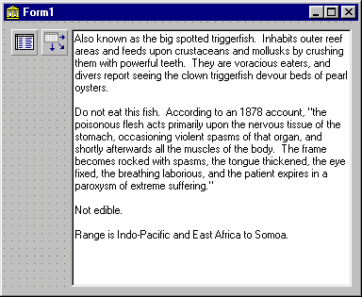
ReportBuilder augments this data access model by adding another component: the data pipeline. There are several different types of data pipelines, but for purposes of accessing data via the BDE, a BDEPipeline component can be used. The following screen shows a BDEPipeline retrieving the same field value.

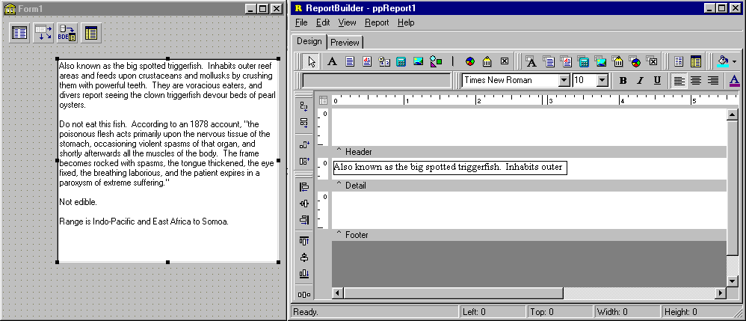
The value is displayed in a ReportBuilder data-aware memo component. You may notice that only the first line of the memo is shown in the ReportBuilder report designer. This is due to the fact that when the report generates the memo component will recalculate the height based on the text it contains. Therefore there is no reason to specify the height of the memo in the report layout, as it will automatically resize on the printed page.

BDE Alternatives

The Borland Database Engine (BDE) is what Delphi uses to access desktop and client/server databases. However, there are a number of BDE replacement products available. ReportBuilder's DBPipeline can be used with these products or any database that supports Delphi's TDataSource. Some of the more popular Delphi database add-on products used by our customers are listed below.

Advantage  by Extended Systems | Provides access to .DBF files. Desktop and high performance Client/Server versions available.  ReportBuilder allows the Advantage TDataSet descendant to plug in directly. The high-performance, low maintenance features of the Advantage Database Server and the extremely well designed architecture of ReportBuilder make this combination an excellent client/server reporting solution.
Apollo  by Luxent Software | Provides access to .DBF files.
Flash Filer  by Turbo Power Software | Compact database written in Object Pascal.
Opus  by Opus Software GmbH | Provides access to MS Access database files.
Titan  Reggatta Systems, Inc. | Several products are offered that provide access to BTrieve, MS Access, and SQLAnywhere.
ODBC Express  by DataSoft Pty. | Provides ODBC access without the overhead of the BDE.
ODBC98  by Kosta Corriveau | Provides ODBC access without the overhead of the BDE.
InfoPower  by Woll2Woll Software | Data access components used to filter, search etc. Although not a database engine like the products above, the components are widely used by Delphi developers everywhere.

Text Files

Reports can be printed directly from text files without using any database product. This functionality is provided via the TextPipeline component.

Formats Supported:

- Comma-delimited
- Tab-delimited
- Fixed-Length records
- Custom delimited (where you specify the delimiter)

The TextPipeline component is essentially a simple data retrieval engine that enables you to access data in text files in the same manner as data stored in a database table. You can even define master/detail relationships between data in two text files. The TextPipeline contains a Field Editor that is used to define the data fields for the text file. Once the data fields have been defined you can access the Report Designer and assign those fields to
ReportBuilder’s data aware components.

Each of the data pipelines in ReportBuilder has a Field Editor that is accessible by double-clicking on the pipeline component at design-time. The TextPipeline's Field Editor is pictured below. Notice that the View Data button has been activated to display the contents of the text file. This feature is a useful aid when defining the fields for the text file.
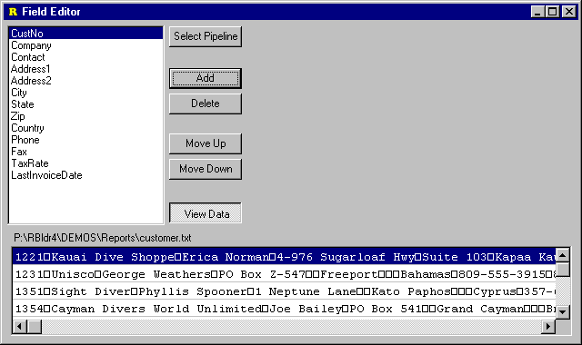

Delphi Objects

Data pipelines present a structured set of data to a report. This structure takes the form of records and fields. The report engine expects operations like open, first, next, and last to provide a certain response from the data pipeline. The data-aware components within the report expect field values to be retrievable by simply passing a field name to the data pipeline. In the DBPipeline component, this functionality is implemented by calling the methods of a TDataSet object. However, this is not the only way a data pipeline can provide the necessary data access functionality to a report. The JITPipeline (JIT stands for Just In Time) triggers events to accomplish the same results as the DBPipeline. That is, the JITPipeline provides a set of events, which when coded properly, allow reports to print from any source of data referenced by the event handlers. The following diagram shows a JITPipeline which is assigned to event handlers referencing a standard Delphi string grid. In the report, data-aware components are created just as they would be for any other database report, by assigning field names from the JITPipeline to the data-aware controls in the report. This results in a clean, maintainable implementation. If you later decide to provide data to the report via a text file or database table, you can simply swap out the JITPipeline with a new pipeline of the correct type.
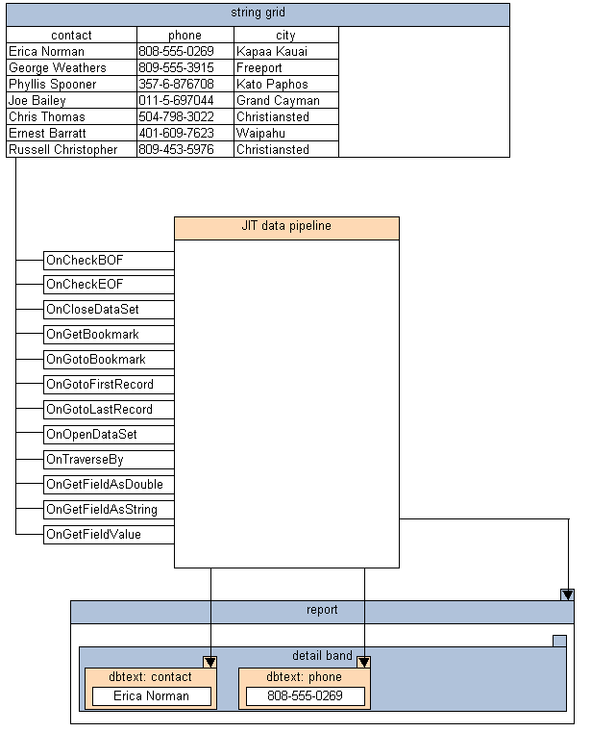

Native Access to Proprietary Data

If you have a considerable amount of data in a proprietary format, and many reports need to be created based on this data, the highest level of maintainability and ease of use will be provided by a custom data pipeline component. This type of component can be created by descending from the TppCustomDataPipeline class and implementing the necessary methods. The end-result of such an effort will be a new data pipeline component which can be installed into the Delphi IDE and used on the same basis as the other data pipelines which are provided with ReportBuilder.

An object model of the ReportBuilder DataPipeline classes is shown below.
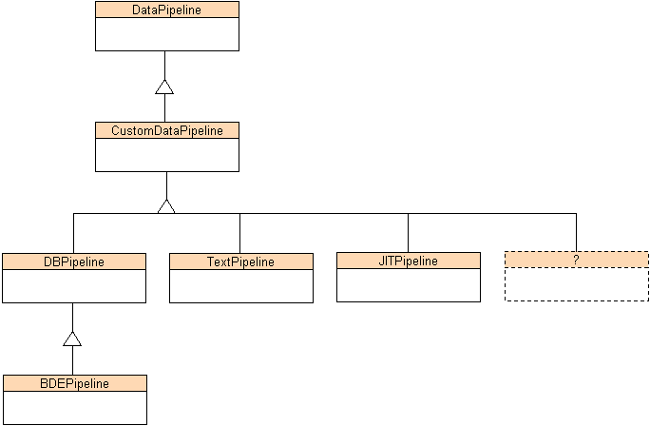

Code
The Delphi Event Model 72
Dynamic Configuration 74
Performing Calculations 82
Create Reports in Code 100

Code

The Delphi Event Model

In the context of Delphi components, events have two fundamental qualities:

- Events fire as the logical result of an action taken on or by a component.
- Events fire at a moment when a meaningful action can be taken.

An event is something which happens as the logical result of an action taken on or by a component. For instance, an action taken on a button control is a mouse-click. In response a TButton control will fire its OnClick event. An example of an action taken by a component would be the Next method of a TTable. When this method is called the OnCalcFields event (among others) fires.

Events fire at a moment when a meaningful action can be taken. In the case of a TButton.OnClick event the meaningful action would be the one intended by the developer as the basic purpose of the button. This purpose might be to launch another window or close the current form. But not every action is appropriate within the context of the event. Certainly freeing the button in the OnClick or calling the OnClick event handler from within itself are not appropriate. These calls might be exactly the thing to do from other events of the application, but not in the OnClick event.

Essentially, events have both a timing aspect and a significance aspect. Both of these must be taken into account when creating an event handler. The following table lists some of most important events of the ReportBuilder report component.

Event | Timing | Significance
AfterPrint | After the engine has completed generating the report, but before any supporting forms have been closed. | Allows print statistics to be increment or datasets to be closed.
BeforePrint | After all supporting forms have been created and displayed, but before the engine begins generation of the report. | Allows the report layout to be modified.
OnCancel | When printing to the printer fires when the Cancel button of the cancel dialog is clicked. | Allows cancelled print jobs to be tracked.
OnPreviewFormCreate | When the Print Preview form has been created, but before it has been displayed. | Allows the Print Preview form to be configured.
The significances of the events listed above are not exhaustive, but provide a guideline for the use of the event. Event handlers can do just about anything, but understanding the intended use of an event can definitely help in selecting the right event. Every component within ReportBuilder has a rich set of events. The exact timing and purpose of these events is provided in the on-line help.

Dynamic Configuration

Configure Reports During Generation

When we talk about configuring a report while it is generating, we mean anything from setting the caption of a label to conditionally controlling the visibility of an entire subreport. Always keep in mind that ReportBuilder reports are comprised of a collection of objects: Report.Bands[].Objects[]. The report object is the parent of a collection of band objects. Each band object represents a rectangular area of the page and contains a collection of printable objects such as text, images, memos, etc. All of these objects have properties and events. The events fire while the report is generating thus enabling us to manipulate the properties and control the behavior of the report.

In order to get a hands-on feel for how this really works, let’s code some event handlers which will give you an idea of what can be done while a report is generating.

Font Color
Setting the color of numeric DBText component based on the sign
procedure TForm1.ppDBText4Print(Sender: TObject);
begin

if (Table1.FieldByName('PRICE_CHG').AsInteger >= 0) then
ppDBText4.Font.Color := clBlack
else
ppDBText4.Font.Color := clRed;

end;

This event handler is assigned to the OnPrint event of a DBText component. When the component prints, the current value of the PRICE_CHG field is checked. If this value is less than zero, the component prints in red, otherwise the component prints in black.

It is important to note that the font color is set to the appropriate color every time the component prints. If the code above simply set the font color to red when the value was negative, then the first negative value would print in red and all subsequent values would print in red, regardless of the sign of the value. When setting report component properties remember to handle all cases, as components remain in any state to which they are set.
Concatenation
Using a label to display concatenated field labels

procedure TForm1.ppLabel3Print(Sender: TObject);
var
lsFirstName: String;
lsLastName: String;

begin
lsFirstName := Table1.FieldByName('FirstName').AsString;
lsLastName := Table1.FieldByName('LastName').AsString;

if (Length(lsFirstName) > 0) then
ppLabel3.Caption := lsFirstName + ' ' + lsLastName
else
ppLabel3.Caption := lsLastName;

end;

This event handler is assigned to the OnPrint event of a Label component. When the component prints, the current value of the FirstName and LastName fields are retrieved. If the FirstName has a length greater of zero, then it is included in the caption. The local variables used here are prefixed with ‘ls’ which stands for local string.

Address Squeeze
Using a memo to create dynamically sized address information

procedure TForm1.ppReport1DetailBand1BeforePrint(Sender: TObject);
var
lsLine: String;
lsState: String;
lsZIP: String;

begin

{clear memo}
ppMemoAddress.Lines.Clear;

{add contact}
lsLine := tblCustomer.FieldByName('Contact').AsString;

ppMemoAddress.Lines.Add(lsLine);

{add company}
lsLine := tblCustomer.FieldByName('Company').AsString;

ppMemoAddress.Lines.Add(lsLine);

{add address line1}
lsLine := tblCustomer.FieldByName('Addr1').AsString;

if lsLine <> '' then
ppMemoAddress.Lines.Add(lsLine);

{add address line2}
lsLine := tblCustomer.FieldByName('Addr2').AsString;

if lsLine <> '' then
ppMemoAddress.Lines.Add(lsLine);

{add city, state zip}
lsLine := tblCustomer.FieldByName('City').AsString;
lsState := tblCustomer.FieldByName('State').AsString;

if lsState <> '' then
lsLine := lsLine + ', ' + lsState;

lsZIP := tblCustomer.FieldByName('ZIP').AsString;

if lsZIP <> '' then
lsLine := lsLine + ' ' + lsZIP;

ppMemoAddress.Lines.Add(lsLine);

{add country}
lsLine := tblCustomer.FieldByName('Country').AsString;

ppMemoAddress.Lines.Add(lsLine);

end;

This event handler is assigned to the BeforePrint event of the detail band. In addition to the OnPrint event of a component, the BeforePrint event of a band is an acceptable place to configure any component within the band. Placing several different component configuration steps in a band level event handler can make for more maintainable code (as opposed to placing the code in the OnPrint of each component.) This event handler retrieves the appropriate field values from the database table, concatenates them in a local string variable, and then adds this variable as a line to the memo. Notice how the lines of the memo are cleared at the top of this routine. This is vital, as it removes the lines which were created for the previous address.

Continued Group
Placing a ‘Continued…’ label in a group header band

procedure TForm1.ppLabelContinuedPrint(Sender: TObject);
begin
if not(ppReport1.Groups[0].FirstPage) and

(ppReport1DetailBand1.Count = 1) then
ppLabelContinued.Visible := True

else
ppLabelContinued.Visible := False;

end;

This event handler is attached to the OnPrint event of a label in the detail band of the report. The ‘if’ statement checks to see if this is the first page of the group and the first detail band of the page. If it is not the first page of the group, that means that the group is printing on additional pages. In this case, the label is made visible. The label has the caption set to ‘Continued…’, so this creates the effect of labeling detail lines which
print on additional pages for the same group.

Regions
Controlling components using regions

procedure TForm1.ppGroupHeaderBand1BeforePrint(Sender: TObject);
begin

if ppGroup1.FirstPage then
begin
ppRegion1.Visible := True;
ppRegion2.Visible := False;
end
else
begin
ppRegion1.Visible := False;
ppRegion2.Visible := True;

if (ppRegion2.Left <> ppRegion1.Left) then
ppRegion2.Left := ppRegion1.Left;
end;

end;

The group header band in this report contains two regions. One region contains a detailed set of data, the other region contains a more summarized set of the same data. On the first page of the group, the detailed set of data (in region 1) is displayed. If the group continues onto additional pages, the more summarized version of the data (in region 2) is displayed. The FirstPage property of the group is used to determine if the report is on the first page or additional pages of the group. In the report layout, Region 2 has been placed to the right of Region 1 in order to make the report layout easier to maintain. Therefore the first time Region 2 is displayed, it must be moved into the same position as Region 1.

SubReports
Controlling the visibility of a subreport

procedure TfrmShowHideDetail.btnDetailClick(Sender: TObject);
begin
ppSubReport1.Visible := not(ppSubReport1.Visible);

if (ppSubReport1.Visible) then
btnDetail.Caption := 'Hide Detail'
else
btnDetail.Caption := 'Show Detail';

ppReport1.Print;

end;

This event handler is associated with a master/detail report. The report contains a subreport which prints the detail. This report resides on a form with a button captioned ‘Hide Detail’. When the button is clicked, the event handler toggles the value of the subreport’s visible property and then prints the report. As a result the report is either a high-level summary or a full detail listing, providing the functionality of two reports from only one layout.

Performing Calculations

Calculations are a vital part of reporting and ReportBuilder provides a rich set of components and events which allow you to perform a wide range of calculations. Simple calculations can be performed without any coding using the DBCalc component. This component provides Sum, Average, Minimum, Maximum and Count functions. The calculations can be group-based or report-based. More complex calculations can be achieved via the Variable component. At a minimum, the Variable component requires an OnCalc event handler to be assigned. The timing of this event can be correlated to any number of occurances within the report generation process (i.e. the component calculates once for each occurance of: the start of the report, a master record traversal, a detail record traversal, a group break, the start of a page, the start of a column, etc.) The Variable component also has an OnReset event which can be similarly correlated. This provides the utmost in calculation flexibility.

DBCalc component
- used to perform simple calculations without any coding
- provides Sum, Average, Minimum, Maximum and Count functions
- calculations can be group-based or report-based

Variable component
- used to perform more complex calculations
- requires an OnCalc event handler to be assigned
- contains properties to control the timing of the OnCalc and OnReset events
- contains a CalcOrder property to control the ordering of calculations

Count
Using a DBCalc component to number the detail bands

This is simply a matter of placing a DBCalc component in the detail band of a report. Right-click over the component and select the Calculations… menu item. A dialog will be displayed. Set the calculation type to Count and click OK. When you return to the Report Designer, the DBCalc will contain this caption: ‘Count(*)’. There is no need to select an individual field for the DBCalc since the Count function does not require one. Preview the report. Each detail band will be numbered. The two screen shots on the next page show the design view and preview.

Design View
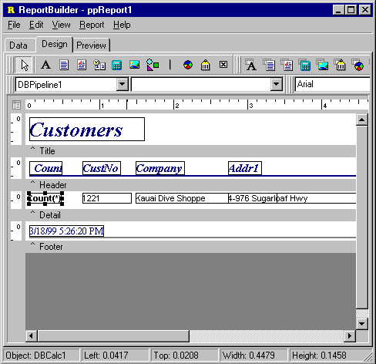
Preview

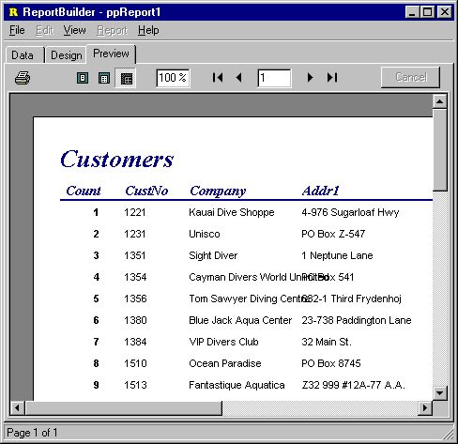

Count Master/Detail
Using a DBCalc component to number the master and detail records.

A master/detail report usually contains a group based on the key field in the master table. This allows the fields from the master table to be printed in the group header, as opposed to repeating in the detail band. In order to count the master records, we would place a DBCalc in the group header band and set the CalcType to count. Then we would access the Calculations… dialog and clear the Reset Group setting. (The ResetGroup is automatically assigned when a DBCalc is placed in a group band. When set, this property causes the DBCalc to reset to zero each time the group breaks. Here we want to count each group (not reset to zero when each group breaks) and so we clear this assignment.)

Next we would place a DBCalc component in the detail band and set the Calc Type to count. We would make sure that the DataPipeline property of this DBCalc is set to the detail data pipeline. And that’s it. When the report is previewed, the master records will be numbered and the detail records will be numbered. The screen shots on the next page show the design view and preview.

Design View

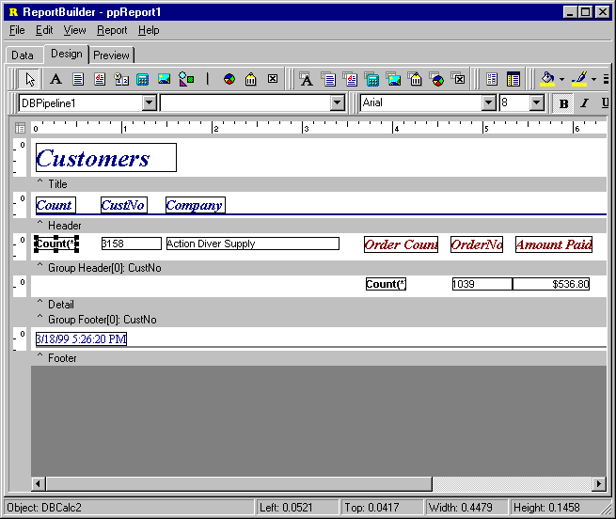
Preview
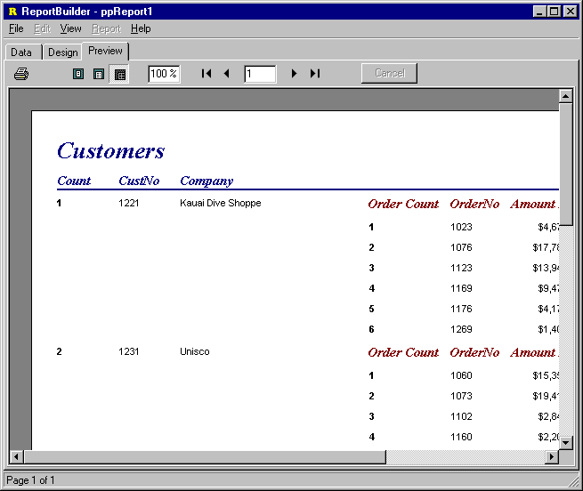

Group Total
Using a DBCalc to calculate a group total

Report group totals can be easily calculated by placing a DBCalc in the group footer band. The ResetGroup is automatically assigned when a DBCalc is placed in a group band. Thus each time the group breaks, the group total will be reset to 0. The screen shot below shows the total amount paid for each customer in the group footer band. The screen shots on the next page show the design view and preview.

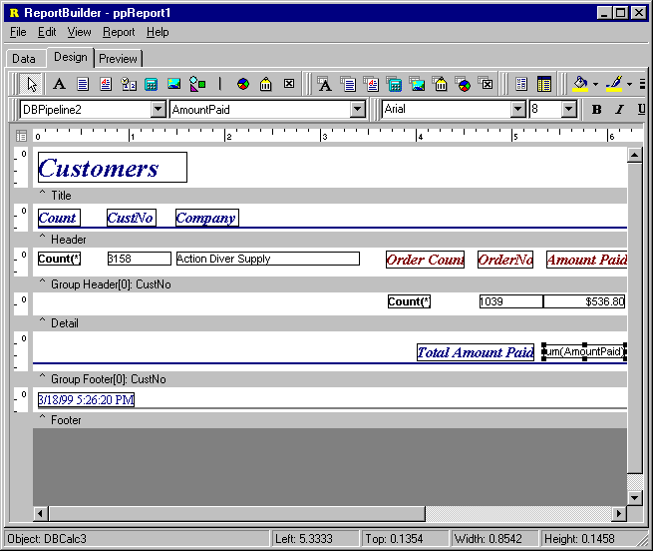
Design View

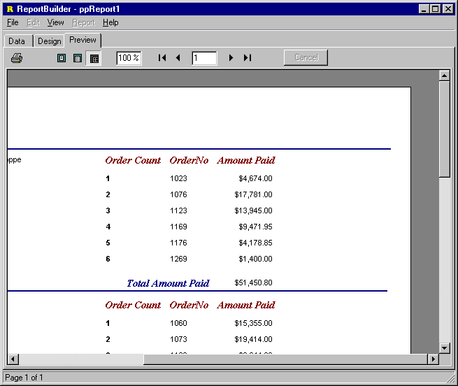
Preview

Grand Total
Using a DBCalc to calculate a grand total

This is simply a matter of adding a summary band to a report and placing a DBCalc in the summary band. The screen shot shows the total amount paid for all orders in this report. The screen shots on the next page show the design view and preview.

Design View
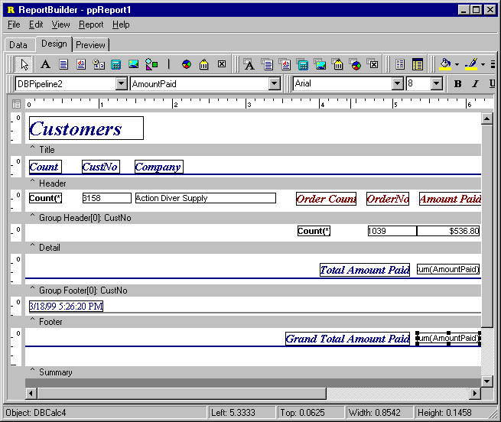
Preview
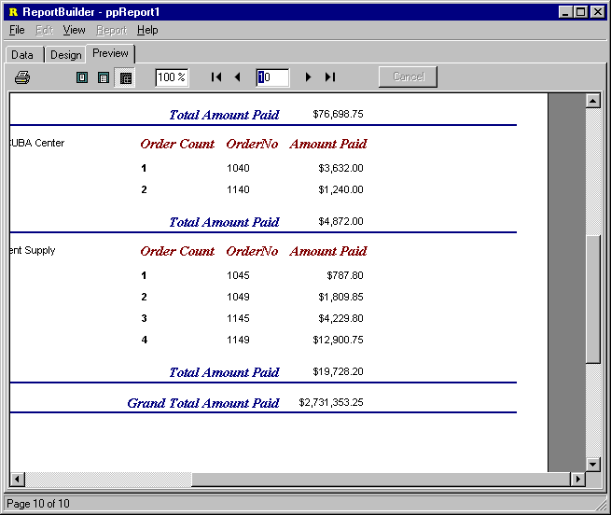
Cumulative Sum
Using a DBCalc to calculate a cumulative sum in the detail band.

This is simply a matter of adding a DBCalc in the detail band and assigning it to the appropriate data pipeline and field. The screen shot shows the total amount paid as a cumulative total. The screen shots on the next page show the design view and preview.

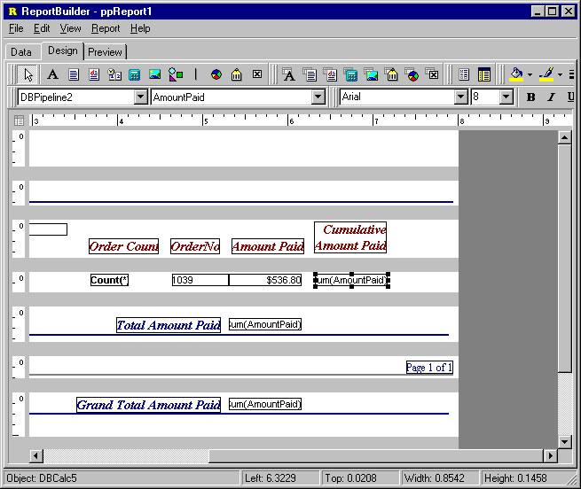
Design View

Preview
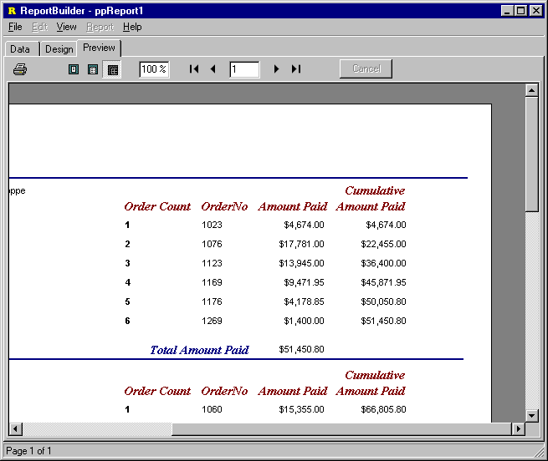

Conditional Group Total
Using a variable to exclude certain values from a group total

Here we would add a Variable component to the detail band. Access the Timing dialog and set the ResetType of the variable to Group Start and set the ResetComponent to the appropriate group. We would then code the OnCalc event handler as:

procedure TForm1.ppVariable1Calc(Sender: TObject; var Value: Variant);
var
lcValue: Currency;

begin
lcValue := Table2.FieldByName('AmountPaid').AsCurrency;

if (lcValue >= 5000) then
Value := Value + lcValue;
end;

This event handler will accumulate the value of the variable only when the amount paid is greater than $5,000. The screen shots on the next page show the design view and preview.
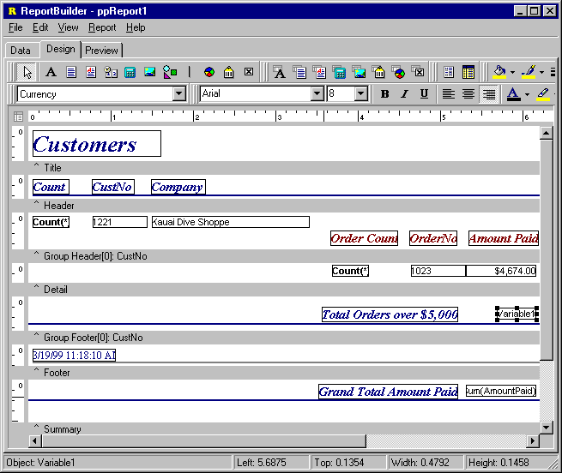
Design View

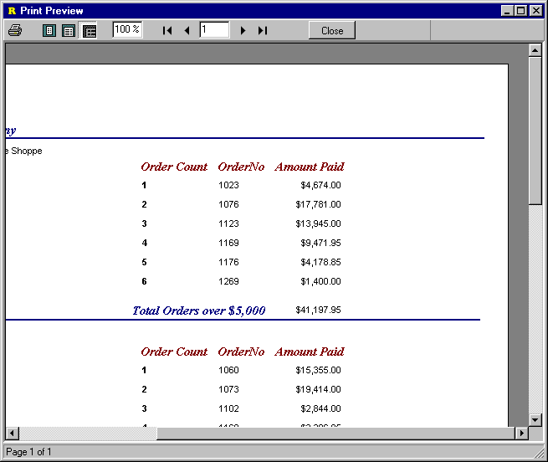
Preview

Conditional Grand Total
Using a variable to exclude certain values from a grand total

Here we would add a Variable component to a summary band. We would then code the OnCalc event handler as:

procedure TForm1.ppVariable2Calc(Sender: TObject; var Value: Variant);
var
lcValue: Currency;

begin
lcValue := Table2.FieldByName('AmountPaid').AsCurrency;

if (lcValue >= 5000) then
Value := Value + lcValue;
end;

This event handler will accumulate the value of the variable only when the amount paid is greater than $5,000. The screen shot below shows the result. Notice that this report also has a conditional group total in the group footer band. The screen shots on the next page show the design view and preview.

Design View

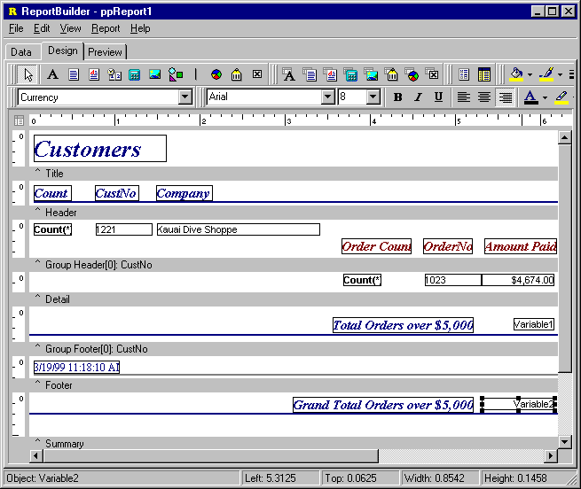
Preview
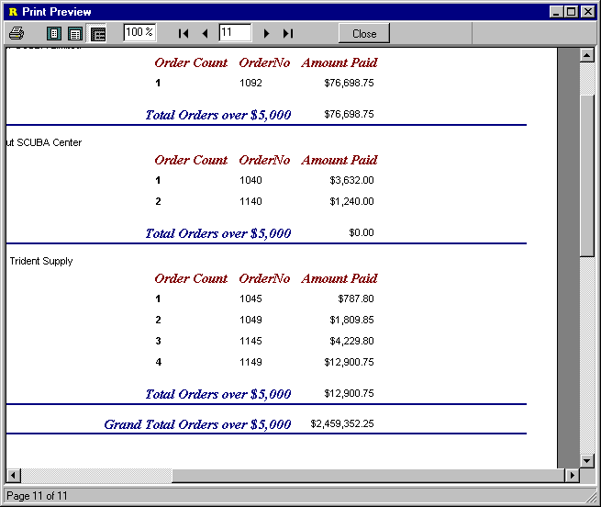

Two-Pass Total
Using a DBCalc and a variable to display a group total at the beginning of a group.

ReportBuilder has the flexibility to operate as a one pass or two pass report engine. This example shows how to calculate group totals in the first pass and then display them in the group header during the second pass.

- Declare a class to store the value. This declaration provides an object in which the current group total can be stored.

{used to save totals}
TTotal = class
Value: Double;
end;

- Declare a TList to store instances of the TTotal class in the private section of the form which contains the report:

private
FTotals: TList;

- Instantiate the TList when the form is created.

procedure TForm1.FormCreate(Sender: TObject);
begin
{list where totals will be saved}
FTotals := TList.Create;
end;

- Set the Report.PassSetting property to psTwoPass.

- Place a DBCalc component in the group footer.

- Place a Variable component in the group header.

- Save the DBCalc values during the first pass.

procedure TForm1.ppGroupFooterBand1BeforePrint(Sender: TObject);
var
lTotal: TTotal;
begin
{save the totals during the first pass}
if ppReport1.FirstPass and (FTotals.Count = ppReport1.Groups[0].BreakNo)
then
begin
lTotal := TTotal.Create;
lTotal.Value := ppDBCalc3.Value;

FTotals.Add(lTotal);
end;
end;
This event handler is attached to the BeforePrint event of the group footer band. It checks to make sure that the report generation process is in the first pass and that the value for the current group break has not yet been saved. ‘ppDBCalc3’ is the DBCalc component in the group footer band.

- Set the Variable value during the second pass.

procedure TForm1.ppGroupHeaderBand1BeforePrint(Sender: TObject);
var
lTotal: TTotal;
begin
{retrieve the saved total in the second pass}
if ppReport1.SecondPass and (FTotals.Count > ppReport1.Groups[0].BreakNo)
then
begin
lTotal := TTotal(FTotals[ppReport1.Groups[0].BreakNo]);
ppVariable1.AsFloat := lTotal.Value;
end;
end;

This event handler is attached to the BeforePrint event of the group header band. It checks to make sure that the report generation process is in the second pass and that a value for the current group break has been saved. It then retrieves the value and assigns to the variable component in the group header band.

- Free the TList and value objects when the form is destroyed.

procedure TForm1.FormDestroy(Sender: TObject);
begin
{free all totals before destroying form}
FreeTotals;
FTotals.Free;
end;

procedure TForm1.FreeTotals;
var
liIndex: Integer;
begin
for liIndex := 0 to FTotals.Count - 1 do
TTotal(FTotals[liIndex]).Free;

FTotals.Clear;
end;

When the form is destroyed, all of the instances of the TTotal class which have been created must be freed. Also, the TList containing the handles to these instances must be freed.
Design View

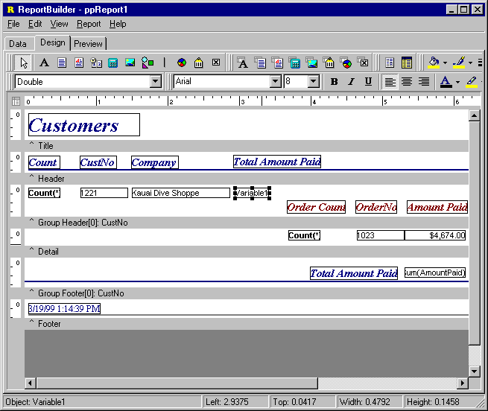
Preview
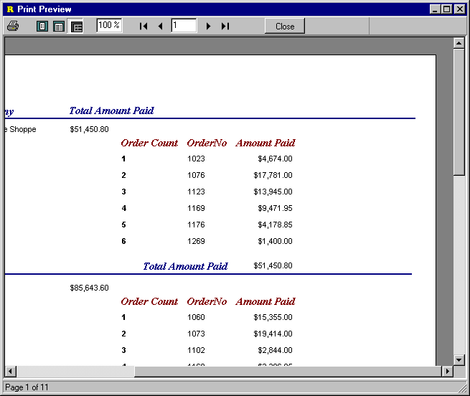

Create Reports in Code

A report layout is composed of a set of components. Like other standard Delphi components, the components which make up a report layout have a run-time interface. That is, they can be created and configured using Object Pascal code. This capability can be used to create entire reports dynamically. The process of creating a report in this way can be broken down into the following steps:

- Create data access components.

- Create the report.

- Create the report bands.

- Add data-aware components.

- Add formatting components.

These are the same steps you would follow to create a report using the Delphi IDE and the ReportBuilder report designer. Creating the components manually requires some additional knowledge of how the different parts of the report fit together. The following discussion steps you through the actual code necessary to build a simple report.

- Declare the necessary uses clause.

uses
DB, {contains TDataSource}
DBTables, {contains TTable}
ppReport, {contains TppReport}
ppDBBDE, {contains TppBDEPipeline}
ppBands, {contains all band classes}
ppCtrls, {contains standard components}
ppTypes, {contains all ReportBuilder enumerated types}
ppVar; {contains SystemVariable and Variable classes}

The types which are being used from each unit are documented in the comments of this code.

- Declare the local variables necessary to create the report.

procedure TForm1.Button1Click(Sender: TObject);
var
lTable: TTable;
lDataSource: TDataSource;
lDataPipeline: TppBDEPipeline;
lReport: TppReport;
lLabel1: TppLabel;
lLabel2: TppLabel;
lDBText1: TppDBText;
lDBText2: TppDBText;
lSysVar: TppSystemVariable;
The ‘l’ which prefixes each of these variable names stands for local. This coding standard makes local variables easily distinguishable from component level variables (which are prefixed with an ‘F’) and from proper component names (such as ‘Report1’).

- Create data access components.

lTable := TTable.Create(Self);
lTable.Name := 'tblCustomer';
lTable.DatabaseName := 'DBDemos';
lTable.TableName := 'customer.db';
lDataSource := TDataSource.Create(Self);
lDataSource.Name := 'dsCustomer';
lDataSource.DataSet := lTable;
lDataPipeline := TppBDEPipeline.Create(Self);
lDataPipeline.Name := 'plCustomer';
lDataPipeline.DataSource := lDataSource;

These are standard Delphi data access components. It is not necessary to assign the Name property of these components, but this has been done to give you an idea of how they would be named if they were created within the Delphi IDE.

- Create the report.

lReport := TppReport.Create(Self);
lReport.DataPipeline := lDataPipeline;

The data pipeline assignment is vital here. Without a data pipeline assigned, this report would generate an endless number of pages.

- Create the report bands.

lReport.CreateDefaultBands;

This method creates a header band, a detail band, and a footer band. It is also possible to create the bands individually and assign them to the report. A report must always have a detail band in order to generate properly.

- Add labels to the header band.

lLabel1 := TppLabel.Create(Self);
lLabel1.Band := lReport.HeaderBand;
lLabel1.spLeft := 2;
lLabel1.spTop := 2;
lLabel1.Caption := 'Customer No.';
lLabel2 := TppLabel.Create(Self);
lLabel2.Band := lReport.HeaderBand;
lLabel2.spLeft := lLabel1.spLeft + lLabel1.spWidth + 3;
lLabel2.spTop := 2;
lLabel2.Caption := 'Company Name';
These two labels will print at the top of each page. The ‘sp’ in the spLeft and spTop properties refers to screen pixels. All positional properties of the components within a report are expressed in the units of the report itself (i.e. the value of the Report.Units property.) Using the screen pixel version of these properties allows us to size and position components without concern for the current value of the Unit property.

- Add data-aware components to the detail band.

lDBText1 := TppDBText.Create(Self);
lDBText1.Band := lReport.DetailBand;
lDBText1.spLeft := lLabel1.spLeft;
lDBText1.spTop := lLabel1.spTop;
lDBText1.DataPipeline := lDataPipeline;
lDBText1.DataField := 'CustNo';
lDBText2 := TppDBText.Create(Self);
lDBText2.Band := lReport.DetailBand;
lDBText2.spLeft := lLabel2.spLeft;
lDBText2.spTop := lLabel2.spTop;
lDBText2.DataPipeline := lDataPipeline;
lDBText2.DataField := 'Company';

These components are positioned in the detail band, directly below their corresponding label components.

- Add page number and timestamp to the footer band.

lSysVar := TppSystemVariable.Create(Self);

lSysVar.Band := lReport.FooterBand;
lSysVar.VarType := vtPrintDateTime;

lSysVar.spLeft := 2;
lSysVar.spTop := 2;

lSysVar := TppSystemVariable.Create(Self);

lSysVar.Band := lReport.FooterBand;
lSysVar.VarType := vtPageNoDesc;
lSysVar.Alignment := taRightJustify;

lSysVar.spLeft := (lReport.PrinterSetup.PageDef.spPrintableWidth -
lSysVar.spWidth) - 2;
lSysVar.spTop := 2;

Notice how the second system variable component is right-justified. For system variables the AutoSize property defaults to True, so we need only set the Alignment property and component position. Here we set spLeft so that the component is flush with the right margin of the page (less 2 pixels for spacing). Because it is right-justified, this component will expand to the right when it prints. The PrinterSetup.PageDef object contains all of the dimensions of the page. The spPrintableWidth property contains the width of the paper less the left and right margins (in screen pixels.)
- Preview the report.

lReport.Print;

The DeviceType property of a report defaults to ‘Screen’, so calling print here causes the Print Preview form to be displayed.

- Free the report.

lReport.Free;

The ModalPreview property of the report defaults to True. So this line of code will only fire after the Print Preview form has been closed. When the report is freed, it will automatically free the bands and components it contains.
- Free the data access components.

lTable.Free;
lDataSource.Free;
lDataPipeline.Free;

The data access components are not freed by the report, and must be freed separately.

Design
The Report Designer 106
Dialogs 108
Toolbars 114
Drag and Drop Support 128
The Report Wizard 130

Design

The Report Designer

Design Tab

The design workspace is where the report layout is created. This workspace contains all of the menus, toolbars and dialogs which make up the Report Designer.

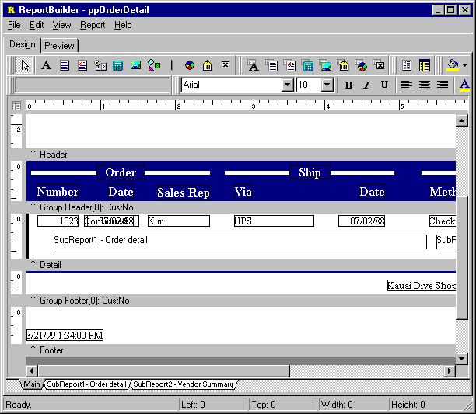
Preview Tab

The Preview workspace shows a representation of the report as it will appear when printed to the printer. The iterative process of perfecting a report is generally accomplished by moving back and forth between the Preview and Design tabs of the Report Designer.
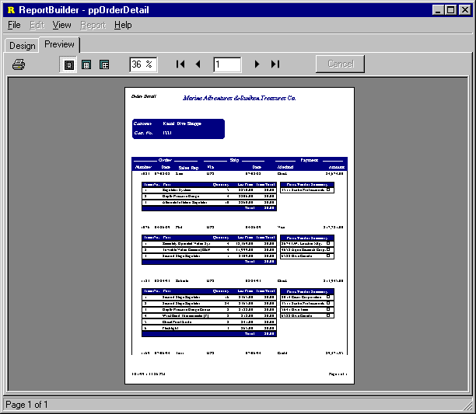

Dialogs

The various dialogs accessible from within the Design workspace are documented in this section.

Print Dialog

The Print Dialog is automatically displayed when the report is sent to the printer. This dialog allows you to select the pages, number of copies and printer for the report. When the AllowPrintToFile or AllowPrintToArchive properties of the Report are set to True, this dialog displays an additonal ‘File’ tab, where the various print to file options are displayed.

- The print job settings can be set via the ‘Printer’ tab.

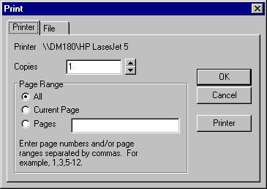
- Print to file options can be set via the ‘File’ tab.
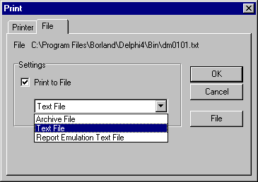
Page Setup

The Page Setup dialog can be accessed from the File | Page Setup menu option of the Report Designer. You set the following from within the PageSetup dialog:

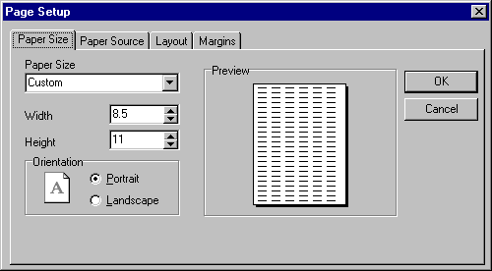
- Paper size and orientation

- Paper Source

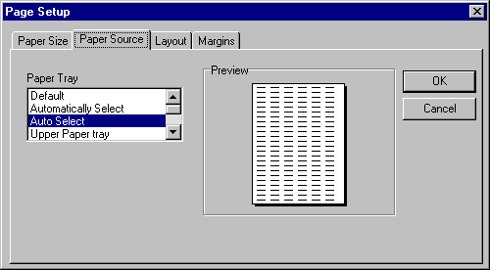
- Layout for Columnar Reports

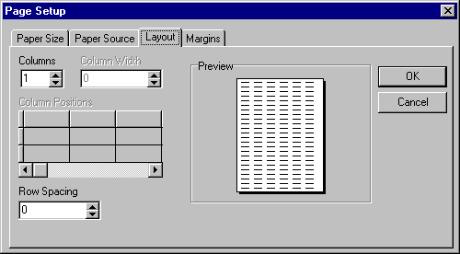
- Margins

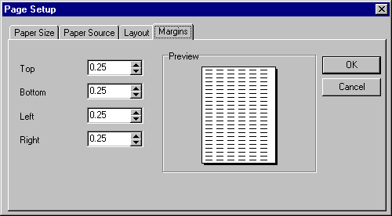
Groups Dialog

The Groups dialog is accessible via the Report | Groups menu option of the Report Designer. You can separate your report into different sections using groups. A number of options are available to control the behavior of each group. For example, you may want each group to start on a new page or to reprint the group header when the group continues on additional pages. Another powerful feature is the Keep group together option which can be used to ensure all of the information for a group fits on a page.

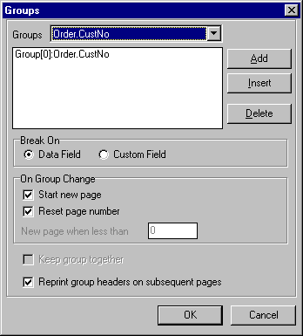

Print to File Setup Dialog

The Print to File Setup dialog is accessible via the File | Print to File Setup menu option of the Report Designer. This dialog is used to specify the format and content of the ASCII file which will be created if the report is printed to file.

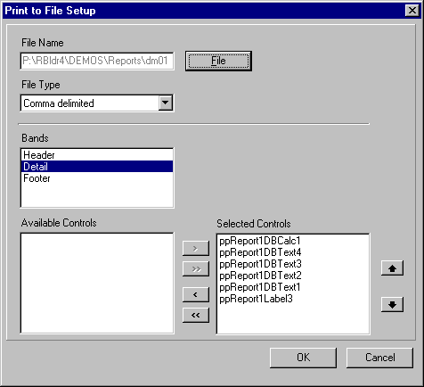

Data Dialog

The Data dialog can be accessed from the Report | Data menu option of the Report Designer. It can be used to specify the master and detail data pipelines for the report. Note: The detail data pipeline is optional.

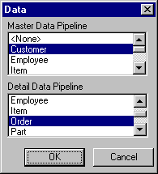

Toolbars

The various toolbars accessible from the design workspace are documented in this section. The toolbars are dockable and follow the Office97 interface style. The Toolbars are accessible from the View | Toolbars menu option of the Report Designer or by right-clicking on the docking area at the top of the Report Designer.

The Report Tree

To access this tool window, select the View | Toolbars | Report Tree menu option from the Report Designer main menu. This tool window is dockable only on the the left and right sides of the Report Designer. It can be used to organize components within each band. Components selected in the Report Tree are selected in the report layout. The upper portion of the Report Tree shows the main report object and any subreports nested within it. This can be helpful for organizing your subreports.

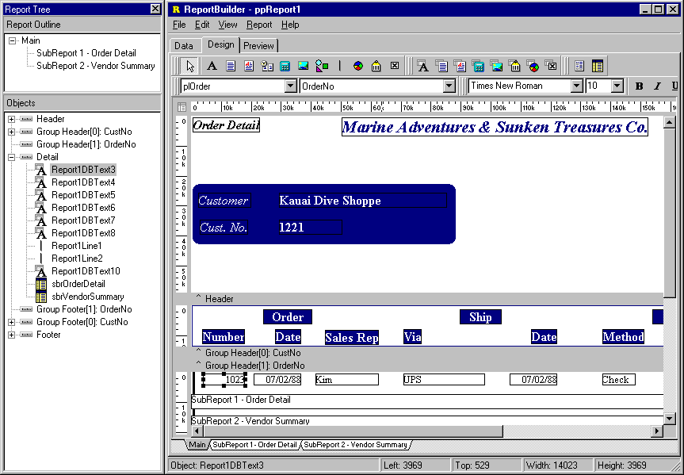

The Data Tree

To access this tool window, select the View | Toolbars | Data Tree menu option from the Report Designer main menu. This tool window is dockable only on the the left and right sides of the Report Designer. It can be used to create components within any band. Simply select a set of fields and drag the selection into the band. A set of corresponding data-aware components will be created.

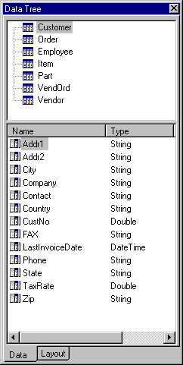

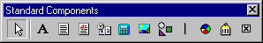
Standard Component Palette

To access this toolbar, select the View | Toolbars | Standard Components menu option from the Report Designer main menu. This toolbar will assist in creating the most commonly used report components.

Component | Icon | Description
Label |  | Used to display text. Assign the Caption property to control the text value. You can have the label resize automatically to fit a changing caption if you set the AutoSize property to True.
Memo |  | Used to print multiple lines of plain text in a report. To set the value, assign a string list to the Lines property. To dynamically resize the memo during printing, set the Stretch property to True. Use the ShiftRelativeTo property to define dynamic relationships with other stretchable objects.
RichText |  | Used to print formatted text. To set the value, assign the RichText property or use the LoadFromFile orLoadFromRTFStream methods. Use the ShiftRelativeTo property to define dynamic relationships with other stretchable objects. At design-time you can use the ReportBuilder's built-in RTF Editor to load, modify, and save rich text data stored in files.
SystemVariable |  | Used to display common report information such as page number, page count, print date and time, date, time, etc. The type of information displayed is controlled by the VarType property. The format is controlled by the DisplayFormat property.
Variable |  | Used for calculations via an Object Pascal event handler assigned to the OnCalc event or a RAP event handler assigned to the OnCalc event. Access the Calculations dialog (via the speed menu) or the Calc tab of the Report Designer to code a RAP calculation for this component.
Image |  | Used to display bitmaps and windows metafiles in reports. Assign the Picture property of this component in order to place an image in your report. Use the Report Designer's built-in picture dialog to load images at design-time
Component | Icon | Description
Shape |  | Use this component to print various shapes (squares, rectangles, circles, ellipses) Set the Shape property to select a type of shape. Use the Brush and Pen properties to control the color and border respectively.
TeeChart |  | Used to display standard (non-data-aware) TeeCharts. This component enables you to use TeeChart inside the Report Designer. You can access the TeeChart editor via a popup menu.
BarCode |  | Used to render barcodes. The string value assigned to the Data property is encoded based on the BarCodeType. If the data to be encoded is in a database, use DBBarCode. The following symbologies are supported: Codabar, Code 128, Code 39, EAN-13, EAN-8, FIM A,B,C, Interleaved 2 of 5, PostNet, UPC-A, UPC-E.
CheckBox |  | Displays a checkbox using the WingDings font.

Data Component Palette
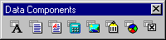
To access this toolbar, select the View | Toolbars | Data Components menu option from the Report Designer main menu. This toolbar will assist in creating data-aware report components.

Component | Icon | Description
DBText |  | Used for displaying values from all types of database fields. Use the DisplayFormat property to format the value.
DBMemo |  | Used to print plain text from a memo field of a database table. This control will automatically word-wrap the text. Set the Stretch property to True and the component will dynamically resize to print all of the text. Use the ShiftRelativeTo property to define dynamic relationships with other stretchable objects.
DBRichText |  | Used to print formatted text from a memo or BLOB field of a database table. This control will automatically word-wrap the text. Set the Stretch property to True and the component will dynamically resize to print all of the text. Use the ShiftRelativeTo property to define dynamic relationships with other stretchable objects.
DBCalc |  | Used for simple database calculations (Sum, Min, Max, Count and Average.) The value can be reset when a group breaks using the ResetGroup property.
DBImage |  | Used to print bitmaps or windows metafiles, which are stored in a database BLOB field.
DBBarCode |  | Used to render barcodes based on the BarCodeType and the value supplied via the DataField property. The following symbologies are supported: Codabar, Code 128, Code 39, EAN-13, EAN-8, FIM A,B,C, Interleaved 2 of 5, PostNet, UPC-A, UPC-E.
DBTeeChart |  | Allows data-aware TeeCharts to be placed within a report.
DBCheckBox |  | Displays a checkbox based on the value of the field specified in the DataField property. Can be used with a Boolean field (or any other type of field via the BooleanTrue, BooleanFalse properties.)

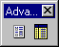
Advanced Component Palette

To access this toolbar, select the View | Toolbars | Advanced Components menu option from the Report Designer main menu. This toolbar will assist in creating advanced report components.

Component | Icon | Description
Region |  | Used to logically group components together. Use the ShiftRelativeTo property to move the region in relation to another dynamically resizing component (such as Memo, RichText or child-type SubReport.)
SubReport |  | Used to handle multiple master details, create side-by-side reporting effects and hook reports together as one. If you need a report to print within the context of a band, use a child-type subreport. If you need to hook reports together use a section type subreport. The PrintBehavior property determines the subreport type.

Standard Toolbar

To access this toolbar, select the View | Toolbars | Standard menu option from the Report Designer main menu. This toolbar will assist saving the report layout, accessing the print and print preview and cut and paste operations.

Component | Icon | Description
New Report |  | Creates a blank report layout.
Open Report |  | Displays the Open dialog, allowing you to open an existing report layout.
Save Report |  | Saves a report layout to file.
Page Setup |  | Displays the Page Setup dialog, allowing you to set the paper size and configure the layout for the report.
Print |  | Displays the Print dialog before sending the report to the printer.
Print Preview |  | Displays the Print Preview window.
Cut |  | Cuts the currently selected components into the clipboard.
Copy |  | Copies the currently selected components into the clipboard.
Paste |  | Pastes the components in the clipboard into the report.

Edit Toolbar

To access this toolbar, select the View | Toolbars | Edit menu option from the Report Designer main menu. This toolbar will assist in setting the most important property or properties for the currently selected component.

- No component selected.

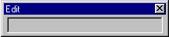
- Data-aware component selected.

This configuration allows the data pipeline and data field for the component to be set. The drop-down list on the left shows the data pipeline. The drop-down list on the right shows the field name.

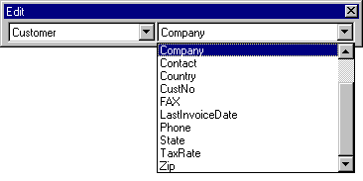
- Label component selected.

Here a label component has been selected in the Report Designer. The Edit toolbar displays an edit box from which the label’s caption can be set.

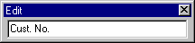
- Shape component selected.

Here a shape component has been selected in the Report Designer. The Edit toolbar displays the different shape types.

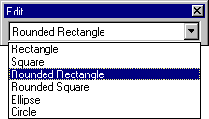

Format Toolbar

To access this toolbar, select the View | Toolbars | Format menu option from the Report Designer main menu. This toolbar will assist in setting the font, colors and layering of components.

Property | Icon | Description
Font Name | N/A | Select the font name for textual components. Use TrueType fonts (indicated by a icon) when possible. These render well on both the screen and printer. If you are using a dot-matrix printer, the print driver may supply printer fonts (indicated by a icon) which you can use to speed up the printing of the report. Finally fonts that have no icon to the left of the font name are screen fonts, and should not be used in reports where WYSIWYG is required.
Font Size | N/A | Select the font size. You can also type in this box to set the font size exactly.
Bold |  | Set the font to bold.
Italic |  | Set font to italic.
Underline |  | Set font to underline.
Left Justify |  | Left justify the text in the component.
Center |  | Center the text in the component.
Right Justify |  | Right justify the text in the component.
Font Color |  | Set the font color.
Highlight  Color |  | Set the background color of the textual component.
Bring to Front |  | Bring the component to the front. The components in the front print last, the components in the back print first. Use the Report Tree to see the exact layering of components within the band.
Sent to Back |  | Send the component to the back. The components in the front print last, the components in the back print first. Use the Report Tree to see the exact layering of components within the band.

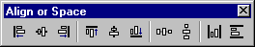
Align or Space Toolbar

To access this toolbar, select the View | Toolbars | Align or Space menu option from the Report Designer main menu. This toolbar will assist in positioning components relative to one another and relative to the band in which they appear.
Action | Icon | Description
Align Left Edges |  | Used to align a group of components with the leftmost position of the component that was selected first.
Align Horizontal Centers |  | Used to center a group of components based on the horizontal center of the component that was first selected.
Align Right Edges |  | Used to align a group of components with the rightmost position of the component that was selected first.
Align Top Edges |  | Used to align a group of components with the topmost position of the component that was selected first.
Align Vertical Centers |  | Used to align a group of components based the vertical center of the component which was first selected.
Align Bottom Edges |  | Used to align a group of components with the bottommost position of the component that was selected first.
Space Horizontally |  | Used to space a set of components based on the leftmost position of the first component selected and the rightmost position of the last component selected.
Space Vertically |  | Used to space a set of components based on the topmostposition of the first component selected and the bottommost position of the last component selected.
Center Horizontally in Band |  | Used to center a component horizontally within a band.
Center Vertically in Band |  | Used to center a component vertically within a band.

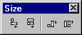
Size Toolbar

To access this toolbar, select the View | Toolbars | Size menu option from the Report Designer main menu.

Action | Icon | Description
Shrink Width |  | Determines the minimum width of all the selected components, and then sets  the width of the components to that value.
Grow Width |  | Determines the maximum width of all the selected components, and then sets  the width of the components to that value.
Shrink Height |  | Determines the minimum height of all the selected components, and then sets the height of the components to that value.
Grow Height |  | Determines the maximum height of all the selected components, and then sets the height of the components to that value.

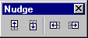
Nudge Toolbar

To access this toolbar, select the View | Toolbars | Size menu option from the Report Designer main menu.

Action | Icon | Description
Nudge Up |  | Moves all the selected components one pixel up.
Nudge Down |  | Moves all the selected components one pixel down.
Nudge Left |  | Moves all of the selected coponent one pixel to the left.
Nudge Right |  | Moves all of the selected components one pixel to the right.

Draw Toolbar
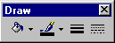
To access this toolbar, select the View | Toolbars | Draw menu option from the Report Designer main menu. This toolbar will assist in setting the colors and borders of components.

Action | Icon | Description
Fill Color |  | For shapes, lines and region components only. Sets the Brush.Color property. To set the color of a textual component, check the Highlight Color action of the Format toolbar.
Line Color |  | For shapes, lines and region components only. Sets the Pen.Color property.
Line Thickness |  | For use with a Line component only, sets the Weight property.
Line Style |  | For use with a Line component only, sets the Pen.Style property.

Drag and Drop Support

ReportBuilder contains a Report Wizard which allows you to quickly create an entire report layout. This is great for generating an entire report, but what if you need to create only a portion of a complex report? Drag and drop functionality is an ideal solution for this problem because it allows you to create a set of components within the context of an existing report layout.

In ReportBuilder, drag and drop support is provided via the Data Tree (pictured below)

Data Tree - Data tab

The Data Tree has two tabs. In the top tree view, the ‘Data’ tab contains a list of data pipelines to which the report has access. In the bottom list view, all of the fields for the currently selected data pipeline are displayed. Fields can be selected from the bottom list view and dragged to any part of the report layout. The data-aware component which is appropriate for the given field will then be created along with a label and border.
Data Tree - Layout tab

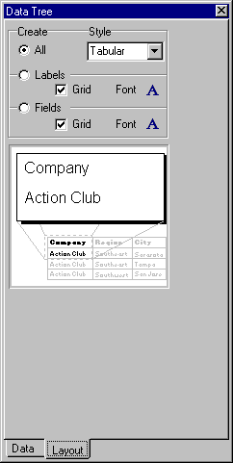

The second tab of the Data Tree is entitled Layout. This tab allows you to control the behavior of drag-and-drop. By default a label and border are created for each data-aware component. You can turn the label off, the border off, control the color of the label or border and control the font of the label and data-aware component from this tab. Once you’ve set the drag-and-drop behavior it will be retained for future design sessions

The Report Wizard

The Report Wizard is one of the many parts of ReportBuilder which reflect a level of professionalism and attention to detail found in no other reporting product. If you or your end-users have utilized standard Windows wizards in other products, then you will be able to quickly recognize and use the ReportBuilder Report Wizard.

The Report Wizard can be accessed via the File | New menu option of the report designer. A series of screens are presented, each requesting information about the report. When the last page is reached, either a preview or design option can be selected. Clicking the ‘Finish’ button causes a report to be created and displayed as requested.

Report Wizard: Create a Simple Report

The following screen shots step through the creation of a simple report via the Report Wizard.

- Select the fields.

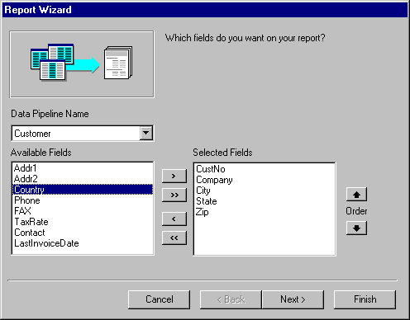
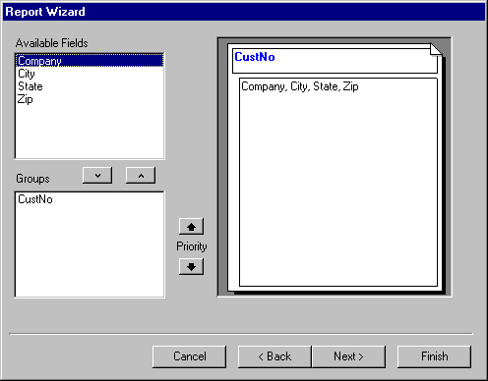
- Skip the groups page.
- Select the layout.

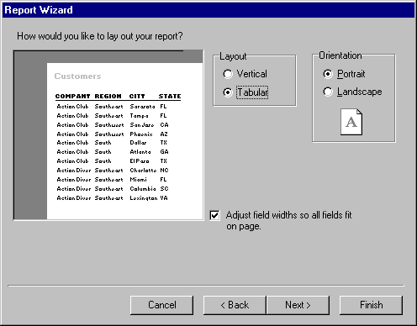
- Select the style.
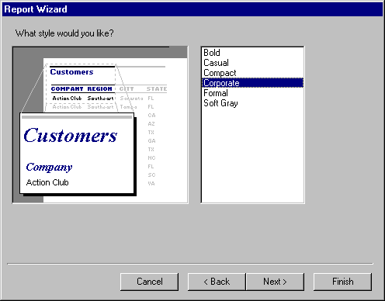

- Select Design or Preview and Finish.
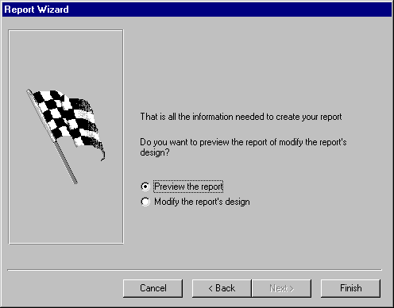
- Report as it appears in the Preview workspace.
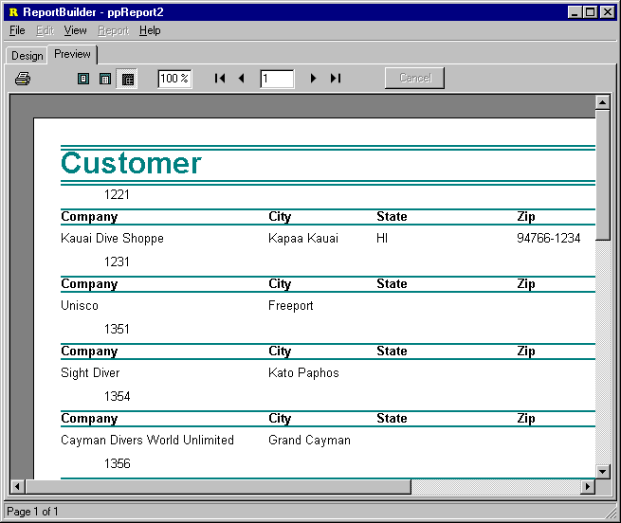

- Report as it appears in the Design workspace.
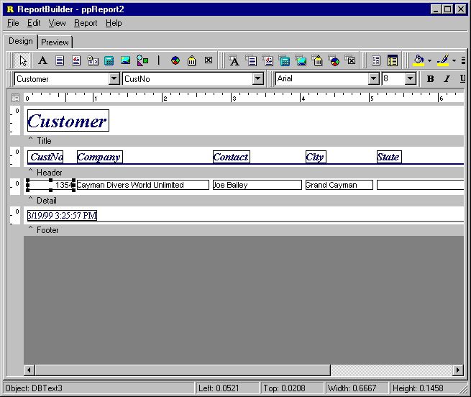

Report Wizard: Create a Group-based Report

The following screen shots step through the creation of a group-based report via the Report Wizard.

- Select the fields.

- Select a group field.
- Select the layout.

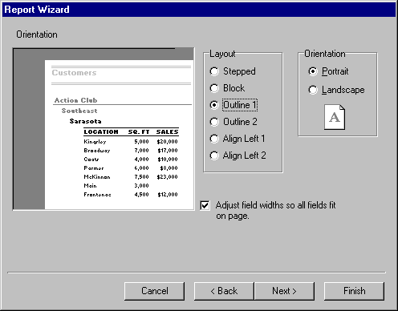
- Select the style.

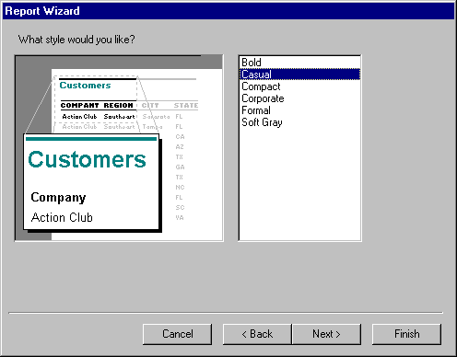
- Select Design or Preview and Finish.

- Report as it appears in the Preview workspace.
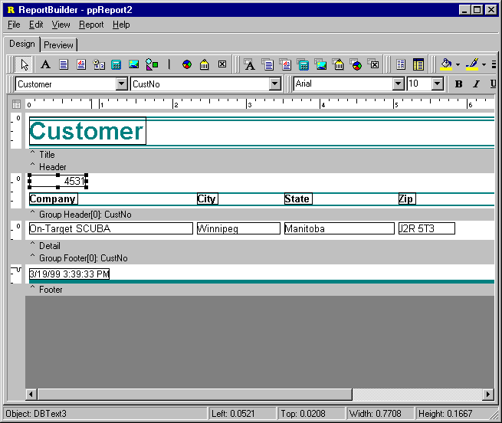
- Report as it appears in the Design workspace.

Print
Introduction 140
Previewing 142
Custom Printer Settings 143
Report Archiving 144
Print to ASCII Text File 146
Report Emulation Text File 148
RTF, HTML and Other Formats 149

Print

Introduction

The primary means by which report output is generated is via a call to the Print method of the report object.

- Print to Screen

The following code would cause the Print Preview form to be displayed and the first page of the report to be presented in this form

uses
ppTypes;

ppReport1.DeviceType := dtScreen;
ppReport1.Print;

- Print to Printer

This code would cause the Print dialog to be displayed. The report would then be sent to the printer:

uses
ppTypes;

ppReport1.DeviceType := dtPrinter;
ppReport1.Print;

As you can see, it is quite easy to generate report output using ReportBuilder. In order to use some of the more advanced features related to report output, you will need to understand a little bit more about what is happening behind-the-scenes to make all of this simplicity possible.

As you may already know, report output is one of the elements of the reporting equation. The reporting equation was described in the introduction to ReportBuilder and is as follows:

The native report output in ReportBuilder takes the form of page objects. Page objects contain draw commands, which describe what the page contains. Page objects are sent to devices, which then convert them to a format appropriate for the device. The following diagram shows page objects sent to the ScreenDevice which are then converted to a bitmap for display in the Print Preview form.
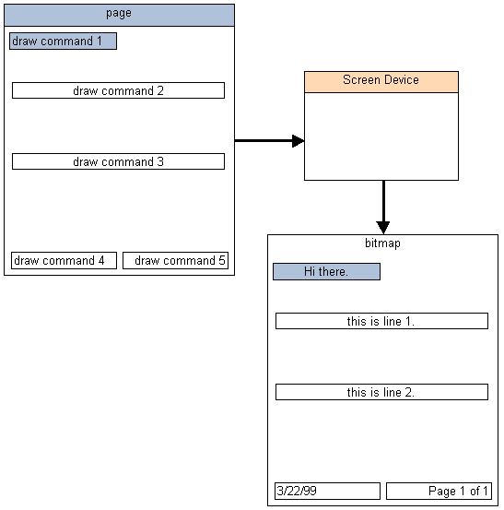
Several device classes are delivered standard with ReportBuilder. Each device class supports a different physical device or file format – but the purpose of the device remains the same: convert the native report output of ReportBuilder to the format appropriate for the given device. The remainder of the ‘Print’ section describes the different devices and their capabilities

Previewing

The most high-profile and oft used form of report output is contained in the Print Preview form. The Print Preview form is launched automatically when the Print method of report component is called (and the DeviceType property has been set to ‘Screen’.) It is pictured below.

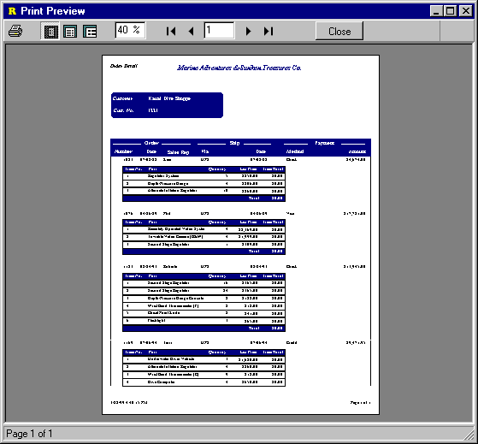
The user can preview any page of the report from this form, zoom the page to different levels and print the report to the printer.

While the Print Preview form provided with ReportBuilder looks and performs like a truly professional user-interface should, you may want to customize it to emulate the ‘look and feel’ of the rest of your application. This can be done by creating a special form which descends from the CustomPreviewer class and registering it as the ‘official’ print preview form. This process is fully described in the tutorials of this guide

Custom Printer Settings

ReportBuilder contains a host of properties which allow you to control various aspects of the print job.

Property | Description
BinName | The name of the bin (paper tray) containing the paper on which the report will be printed. A common use of this property is to set it to Manual Feed on mailing label reports. That way you can provide a means to load the special label paper without manually setting the printer.
Collation | When printing multiple copies of a report, this property determines whether each copy print as a separate set of pages.
Copies | The number of copies of the report which should be printed.
DocumentName | The name of the print job to be used when the report is printed – this name as it will appear in the Print Manager.
Duplex | For printers which support duplex, this setting determines the type of duplex printing which will occur.
Margins | The margin properties determine the left, top, right and bottom margins of the report.
Orientation | Either landscape or portrait
PaperHeight &  PaperWidth | The dimensions of the selected paper, based on the value of the PaperName property. If these values are entered manually and no corresponding paper size is found, the PaperName is set to 'Custom'.
PaperName | The name of the paper type, such as 'Letter', or ‘A4’
PrinterName | The name of the printer to which the report should be printed. This property defaults to ‘Default’ which will cause ReportBuilder to use the default printer declared on your system.

These properties are contained in the PrinterSetup property of the Report object and can be configured via the Object Inspector or the File | Page Setup dialog of the report designer.

Because all ReportBuildder reports contain a PrinterSetup object, it is possible to use section type subreports to achieve some fairly incredible levels of customization of the print behavior – such as different pages of the report printing from different bins of the same printer or printing to different printers entirely. Some of these features are showcased in the printer setting demos provided with ReportBuilder (check demos 121-124.)

Report Archiving

Archiving is a process by which an instance of report output is saved for future use. This capability is most often used to save a snapshot of a report as it appeared on a given day and at a certain time. If the data which was used to generate the report then changes, a representation of the report as it appeared at the given moment is still available. Archiving can also be used to generate daily or monthly reports during off peak hours and then enable users to preview or print the reports at a later time.

- Archiving a Report

A. Print directly to archive.

You can print a report directly to archive with the following code:

uses
ppTypes;

ppReport1.ShowPrintDialog := False;
ppReport1.DeviceType := dtArchive;
ppReport1.ArchiveFileName := ‘c:\test.raf’;
ppReport1.Print;

Here the Print dialog is hidden, the device type is set to ‘Archive’, the archive file name is specifed and the report output is generated. Archive files are usually given the file extension ‘raf’, which stands for Report Archive File.

B. Allow end-users to print to archive.

In order to give the end-user the opportunity to print the report to archive whenever the Print method is called, you would use the following code:

uses
ppTypes;

ppReport1.AllowPrintToArchive := True;
ppReport1.ShowPrintDialog := True;
ppReport1.DeviceType := dtPrinter;
ppReport1.ArchiveFileName := ‘c:\test.raf’;

ppReport1.Print;

When the print method is called, the Print dialog will be displayed. Because AllowPrintToArchive has been set to True, the Print dialog will contain two notebook tabs: ‘Printer’ and ‘File’. If the end-user clicks the ‘File’ tab, the archive file name will be defaulted.

- Using the ArchiveReader

Once archive files have been created, they can be read by the ArchiveReader component. The ArchiveReader component has a similar set of capabilities as the Report component. In fact, these two components descend from the same common ancestor. You can print the contents of an archive file to a standard Print Preview window with the following code:

uses
ppTypes;

ppArchiveReader1.ArchiveFileName := ‘c:\test.raf’;
ppArchiveReader1.DeviceType := dtScreen;
ppArchiveReader1.Print;

Print to ASCII Text

The TextFile device in ReportBuilder converts report output into an ASCII text file. The intent of this device is to create structured data which can then be imported into another application, such as a spreadsheet. The following text file formats are supported:

- comma-delimited
- tab-delimited
- fixed length records
- custom delimited

Because report output is essentially free-form and can contain many non-textual components, ReportBuilder provides a way for you to tightly control the format of the text file generated via this device. This control is provided via the Print to File Setup dialog (accessible from the File | Print to File Setup menu option of the report designer) This dialog is pictured below.

This dialog allows you to set the default file name, select the file format, and specify the textual components which will be saved to the file and the order in which they will be saved. When utilizing the TextFile device, it is mandatory that these settings be completed. If no components have been selected, then a blank text file will result.

- Print directly to ASCII text file

Once a report has been configured for ASCII text file output, the following code will generate the report directly to the file.

uses
ppTypes;

ppReport1.ShowPrintDialog := False;
ppReport1.DeviceType := dtTextFile;
ppReport1.Print;

- Allow the end-user to print to ASCII text file

The following code would give the end-user the option of printing to text when the print method is called

uses
ppTypes;

ppReport1.AllowPrintToFile := True;
ppReport1.DeviceType := dtPrinter;
ppReport1.ShowPrintDialog := True;
ppReport1.Print;

The report component has an OnSaveText event which fires each time a textual component is saved to the text file. This event can be used to customize the output generated to the text file. An example of what can be achieved via this event is provided in demo 106 (..\RBuilder\Demos\Reports\dm0106.pas)

Report Emulation Text File

The TextFile device discussed in the previous topic is used for ASCII text file output. This type of device is excellent for creating portable data from report output. However, the formatting of the report is lost in a tightly defined comma or tab-delimited data format. Where text file output is needed that retains the spacing of the original report, the ReportTextFile device can be used. Text files generated with this device are useful for
sending as e-mail attachments or directly to dot-matrix printers for high-speed output.

The ReportTextFile device does not require any special configuration in advance. All textual components (except memos and richtext) will be printed in the text file.

- Print directly to report emulation text file

The following code sends a report to a report emulation text file:

uses
ppTypes;

ppReport1.ShowPrintDialog := False;
ppReport1.DeviceType := dtReportTextFile;
ppReport1.TextFileName := ‘c:\test.txt’;
ppReport1.Print;

- Allow the end-user to print to a report emulation text file.

The following code would give the end-user the option of printing to a report emulation text file when the print method is called

uses
ppTypes;

ppReport1.AllowPrintToFile := True;
ppReport1.TextFileName := ‘c:\test.txt’;
ppReport1.DeviceType := dtPrinter;
ppReport1.ShowPrintDialog := True;
ppReport1.Print;

In order to get the free-form text of the report output to map correctly to the character grid of a text file, it is sometimes necessary to tweak the positions of the components within the report layout. An example of a report which has been configured for use with the Report Emulation Text File device is provided in demo 107 (..\RBuilder\Demos\Reports\dm0107.pas)

RTF, HTML, and Other Formats

By utlizing the highly extensible device architecture of ReportBuilder, it is possible to create your own device class descendants for converting the native output of ReportBuilder into any file format. Some developers have already done just that, and are offering device classes for some of the most popular file formats. These additional devices integrate seamlessly into ReportBuilder.

- TExtraDevices  by James Waler | Provides file device support for RTF, HTML, Excel, Lotus, and Quattro Pro. A Demo is available for download. Contact James Waler directly for more details.
- TcdHTML Device  by Cyberdyme Data Systems | Fully supports all JDK 1.1 enabled web browsers including MS Internet Explorer 4.0, Netscape 4.0, and HotJava 1.1. A Demo is available for download. Contact Cyberdyme Data Systems directly for more details.

Deploy
Introduction 152
Report Templates 154
As an EXE 158
As Packages 159
International Language Support 160

Deploy

Introduction

There are two totally different, but vital issues involved in deciding how you will deploy your application.

- How to deploy ReportBuilder as part of your application.

- How to deploy the reports created with ReportBuilder as part of your application.

Application Deployment

When creating your application exe, you can choose to either compile everything into one executable or you can choose to distribute the packages provided with Delphi, ReportBuilder and any other components you are utilizing in your application as separate files. The latter option is referred to as ‘distributing with packages’ (packages here refers to a Delphi compatible DLL) and results in a smaller, more efficient executable file.
These two approaches for deploying your application are discussed later in this section.

Report Deployment

The second part of deployment involves determining how to deploy the reports created with ReportBuilder as part of your application. ReportBuilder provides the most flexible deployment options of any reporting product on the market. The most commonly used deployment strategies are:

- Compile reports into the executable

Allow the report component to reside in an invisible form along with the necessary data access objects. When it is time to print the report, instantiate the form and call the Print method. A slight variation of this architecture would be to use a data module as a container for the data access objects.

- Compile reports into a package

Similar to option 1, but rather than compile the forms containing the reports into the executable, the report forms are compiled into a package. The advantage of this approach is that it optimizes the size of the executable and dynaimcally loads the package containing the reports as needed.

- Distribute report template files

Place all the data access components for the reports in a data module. Place a single report component on a form which ‘uses’ the data module. Create all of the report layouts via this one report component, saving each one down to a separate report layout file. When it is time to print the report, load the report from file and call the Print method.

- Distribute a report database

Use all of the same steps as option 3, but save the report definitions to a database BLOB field instead of separate files. With this approach you can save all of your report defintions in one database table.

A full-featured implementation of Option 1 above is provided in the ‘Building a Reporting Application’ tutorial in the Developer’s Guide. Option 1 has the advantage of requiring the least code. The main advantage of options 3 and 4 are that you can change report layouts and redeploy them to your end-users with regenerating your executable. Because Option 1 compiles the report layouts into the executable, it requires a recompile any time a report must be changed. In terms of report layout load time or print speed, all options are essentially equal.

Report Templates

‘Report Template’ refers to the binary image created when a report layout is saved to a file or to a database BLOB field. You can use report templates to free your report definitions from the confines of the executable in which they are being utilized. That means that if you need to make modifications to a report, you can do so without recompiling and redeploying your entire application. Simply send the new report layout file or database table containing the report layouts to your users.

Saving report layouts to files or database BLOB fields can be used to create a versioning system for reports, such that the original reports supplied with your application are never modified, but end-users can create versions of these reports. In order to allow end-users to modify the reports via the Report Designer, ReportBuilder Pro is required.

ReportBuilder report templates leverage technology already present in Delphi. The same logic which is used to save the state of objects as configured on a Delphi form (and stored in a dfm file) is used to save the components of a report layout (in an rtm file.) In order to view the content of an rtm file, set the Report.Template.Format to ftASCII and save the report. Then open the resulting rtm file in the Delphi code editor. You will be able to see the structure of this file format.

File-based Templates

You can load and save report layouts to files using the Report Designer. You can also accomplish this programmatically.

- Using the Report Designer

Set the Report.Template.SaveTo property to stFile (this is the default value).

- Saving a Report Layout

Select the File | Save As… menu option from within the Report Designer. The standard Windows file save dialog will be displayed enabling you to save the report template to a .rtm file.

B. Loading a Report Template

Select the File | Open… menu option from within the Report Designer. The standard Window file open dialog will be displayed enabling you to select and open a .rtm file.

- Programmatically

A. Saving a Report Layout

The following code save a report in the ‘test.rtm’ file:

ppReport1.Template.FileName := ‘c:\test.rtm’;
ppReport1.Template.SaveToFile;

B. Loading a Report Template

The following code opens a report layout and prints the report:

ppReport1.Template.FileName := ‘c:\test.rtm’;
ppReport1.Template.LoadFromFile;
ppReport.Print;

Database Templates

You can save and load data-based report templates by using the Report Designer or programmatically.

Defining the Database Table

Report definitions can be stored to any database table with the following structure.

Database Table Structure
Name | Char(40) | the name of the report is stored in this field
Template | BLOB or Memo | the report definition is stored in this field, if the format is binary, the field should be a BLOB, if the format is ASCII, the field should be a memo.

Connecting the Report object to the database

Once the database table has been defined the next step is to connect the report to the database table. This is accomplished by configuring the following properties of the Report.Template object. You can do this via the Delphi Object Inspector or programmatically.

Report.Template.DatabaseSettings.NameField := ‘Name’;
Report.Template.DatabaseSettings.TemplateField := ‘Template’;
Report.Template.DatabaseSettings.DataPipeline := plReports;

Loading and Saving Reports

- Using the Report Designer

Set the Report.Template.SaveTo property to stDatabase.

A. Saving a Report Layout

Select the File | Save As… menu option from within the Report Designer. A special Save dialog will be displayed showing all reports in the given database table. You can name the report and then save it to the table.

B. Loading a Report Template

Select the File | Save As… menu option from within the Report Designer. Once a report is saved you can load it by accessing the File | Open dialog.

- Programmatically

A. Saving a Report Layout

The following code save a report in the ‘test.rtm’ file:

ppReport1.Template.FileName := ‘Order Summary’;
ppReport1.Template.SaveToDatabase;

B. Loading a Report Template

The following code opens a report layout and prints the report:

ppReport1.Template. DatabaseSettings.Name := ‘Order Summary’;
ppReport1.Template.LoadFromDatabase;
ppReport.Print;

As an EXE

ReportBuilder can be deployed as part of your executable. Simply include the correct path to the compiled units (dcu files) of ReportBuilder in your Delphi Library Path. For example:

‘c:\program files\borland\delphi4\rbuilder 4\lib’

The ‘lib’ directory contains the compiled units of ReportBuilder. When you compile your application, necessary dcu files from this directory will be linked into the resulting executable file. Executable files created this way are stand-alone, that is, they can be distributed successfully without any supporting files.

Applications containing ReportBuilder will not compile correctly if the library path is not configured properly. If there are directories in the Library path pointing at old versions of ReportBuilder or at the Source directory of ReportBuilder problems will result.

Accessing the Delphi Libary Path

- Delphi 4

In order to access your Library Path in Delphi 4, select Tools | Environment Options from the Delphi main menu. The Environment Options dialog will be displayed. Click the Library tab. The Library Path is the first item. Click the dialog button to the left of the library path edit box. The directories which make up your library path will be displayed.

- Delphi 3

In order to access your Library Path in Delphi 3, select Tools | Environment Options from the Delphi main menu. The Environment Options dialog will be displayed. Click the Library tab. The Library Path is displayed in a drop-down combo-box near the bottom of this dialog. It is a good idea to scroll through this edit box character by character using the arrow keys when checking your library path, as highlighting
the text in this edit box causes the cursor jump to the end. This can cause you to miss duplicate or incorrect directories in the path.

As Packages

You can optimize the size of your executable by compiling your project with packages. To compile with packages, access the Project Options dialog, select the ‘Packages’ tab and click on the ‘Build with Packages’ check box. The list of package names which appear to the left of this check box should include the following ReportBuilder run-time packages.

ReportBuilder run-time packages
rbRCL44 | report components
rbBDE44 | BDE data access components
rbUSER44 | sample RCL components (checkbox)
rbTC41 | standard TeeChart wrapper
rbTDBC41 | data-aware TeeChart wrapper

A typical package list for a project containing a ReportBuilder report:

Vcl40;Vclx40;Vcldb40;vcldbx40;VclSmp40;rbDBDE44;rbRCL44;rbBDE44;rbTDBC41;rbUSER44; tee40;teeUI40;teedb40

These packages break down as follows:

Standard Delphi Packages | ReportBuilder Packages | TeeChart Packages
VCL40 | rbDBDE44 | TEE40
VCLX40 | rbRCL44 | TEEUI40
VCLDB40 | rbBDE44 | TEEDB40
VCLDBX40 | rbTDBC41
VCLSMP40 | rbUSER44

All of these packages would be distributed with your executable file in order for it to run properly. These packages are usually installed into the Windows\System directory of the target computer – since this is where most DLLs reside.

International Language Support

ReportBuilding includes support for 11 built-in languages. The strings for each language reside separate resource files. These files are located in the ..RBuilder\Languages directory, under a subdirectory named for the given language. Three letter codes are used to differentiate the language DLLs which are installed in the Windows\System directory.

Language | Enumerated Type | Folder/File Extension
Default | lgDefault | dft
English | lgEnglish | eng
Custom | lgCustom | cst
Danish | lgDanish | dan
Dutch | lgDutch | nld
French | lgFrench | fra
German | lgGerman | deu
Italian | lgItalian | ita
PortugueseBrazil | lgPortugueseBrazil | ptb
Portuguese | lgPortuguese | ptg
Spanish | lgSpanish | esp
Swedish | lgSwedish | sve
Norwegian | lgNorwegian | nor

Only those languages which are explicitly selected during install will appear in the Languages folder. The ‘cst’ folder will always appear in the Languages folder because it represents the custom language type. The cst folder contains the resource files which correlate to the lgCustom enumerated type. The custom language can be modified to contain your own translation, which will then appear in the ReportBuilder user-interface when the Report.Language property is set to lgCustom.

The Default Language

When ReportBuilder is installed, the installation program allows you to specify a default language and any additional languages you wish to use. The installation will then install the appropriate files onto your system. The Report.Language property defaults to the lgDefault language type. This type correlates to the language resource files located in the RBuilder\Lib directory and the language DLLs located in the Windows\System directory (the DLLs with the .dft extension.) The .res files are used when compiling stand-alone executables in Delphi. The DLLs are used to provide language support at Delphi design-time. When ReportBuilder installs, it copies these files to the appropriate directories.

The language DLLs which appear in Windows\System:

File Name | Description
rbPrint.dft | Strings used by ReportBuilder
rbIDE.dft | Strings used by the Report Designer

The resource files which appear in RBuilder\Lib:

File Name | Description
rbPrint.res | Strings used by ReportBuilder
rbIDE.res | Strings used by the Report Designer

You can change the default language used by ReportBuilder by copying the appropriate language files from the RBuilder\Languages directory to the RBuilder\Lib and Windows\System directories respectively. For the DLL files make sure you change the extension to .dft. The following copy commands issued at the MS-DOS prompt (from within the RBuilder\Languages\sve directory) will change the default language to Swedish:

copy rbPrint.res c:\progra~1\borland\delphi4\rbuilder\lib
copy rbIDE.res c:\progra~1\borland\delphi4\rbuilder\lib
copy rbPrint.sve c:\windows\system\rbPrint.dft
copy rbIDE.sve c:\windows\system\rbIDE.dft

Note: If you are using Windows NT you will need to copy the ‘sve’ files to Windows\System32.

Custom Translations

You can modify the .rc source files in the custom language folder in order to create your own custom translation. The rc files are named the same as their resource file counterparts:

File Name | Description
rbPrint.rc | Strings used by ReportBuilder
rbIDE.rc | Strings used by the Report Designer
rbDADE.rc | Strings used by the Data Access Development Environment (the ‘Data’ tab)

You can create a custom translation by completing the following steps:

- Run the Language Translation application

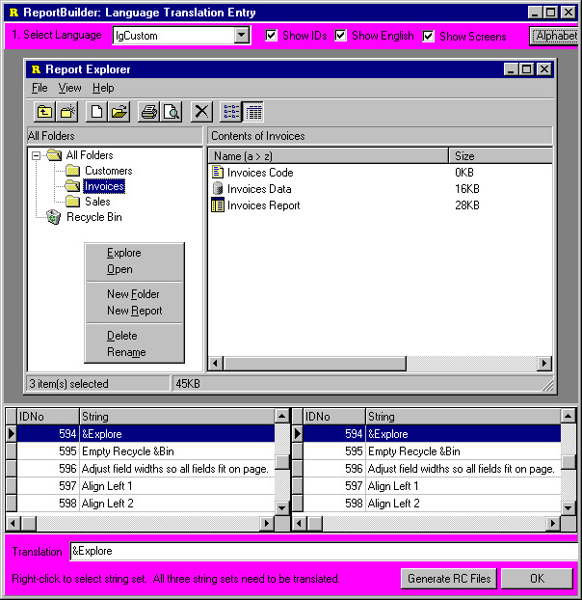
Create new rc files using the ReportBuilder Language Translation application. This application displays the strings used within ReportBuilder along with an associated screen-shot. It provides an edit box in which the translation for each string can be entered. When you complete the translation, click the ‘Generate RC Files’ button, and generate each of the three rc files. The language translation app is pictured below.
- Create new resource files

Compile the rc files into resource files by issuing the following commands at the MS-DOS prompt (from within the ‘cst’ folder):

c:\progra~1\borland\delphi4\bin\brc32 -r rbPrint.rc

c:\progra~1\borland\delphi4\bin\brc32 -r rbIDE.rc

c:\progra~1\borland\delphi4\bin\brc32 -r rbDADE.rc

After these commands have executed you should have three resource files in the cst folder: rbPrint.res, rbIDE.res and rbDADE.res.

- Create new resource modules

Compile the resource files into DLLs. The following commands will do this step:

c:\progra~1\borland\delphi4\bin\dcc32 rbPrint.dpr

c:\progra~1\borland\delphi4\bin\dcc32 rbIDE.dpr

c:\progra~1\borland\delphi4\bin\dcc32 rbDADE.dpr

After these commands have executed you should have three cst files in the cst folder: rbPrint.cst, rbIDE.cst and rbDADE.cst.

- Install new resource modules

The final step is to copy the new .res files and DLLs to the ..RBuilder\Lib and Windows\System directories respectively. The following commands will do this step:

copy rbPrint.cst c:\windows\system
copy rbIDE.cst c:\windows\system
copy rbDADE.cst c:\windows\system

Note: If you are using Windows NT you will need to copy these files to Windows\System32.

- Use the custom translation

Create a report within Delphi, select the lgCustom language type and double-click on the report to display the Report Designer. Your translation will be displayed

ReportBuilder Pro Fundamentals
Main 168
Data 190
Code 230
Design 240
Print 244
Deploy 248

Main
Introduction 168
The Delphi Components 174
Designer 176
Report Explorer 181
Data Dictionary 184
Putting it All Together 186
On-Line Help 187

ReportBuilder Pro Fundamentals

Main

Introduction

With ReportBuilder Pro you get everthing included in ReportBuilder plus a full set of components necessary to deliver a complete end-user reporting solution. In the introduction to ReportBuilder, the reporting equation is described. The reporting equation divides reporting into four main activities:
In ReportBuilder Pro, the goal is to deliver a full-fledged reporting solution to end-users. This is achieved by delivering visual, easy-to-use solutions in each of these four areas. This screen shot of the ReportBuilder Pro Report Designer shows the ergonomic design of the user-interface.
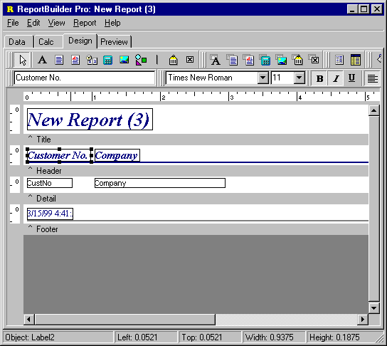
Each of the four areas of reporting has a representative notebook tab containing a visual environment for the creation and configuration of components within that area. The results of each area then become inputs to the next area: data feeds into calculations, calculations feed into components within the report layout and the report layout is rendered into a preview of the report. The implementation used by ReportBuilder Pro for each area of reporting is described on the following pages.

Data

Within the work environment of the Data tab, end-users can quickly create data views, which can then be used to supply data to reports. Data views are usually created via the Query Wizard or Query Designer. Both of these tools are visual, and allow the end-user to select the tables, fields, search criteria, and sort order necessary for the report they are creating. Behind the scenes an SQL statement is generated and used to retrieve the data from the database. A screen shot of a completed data view is shown on the next page.
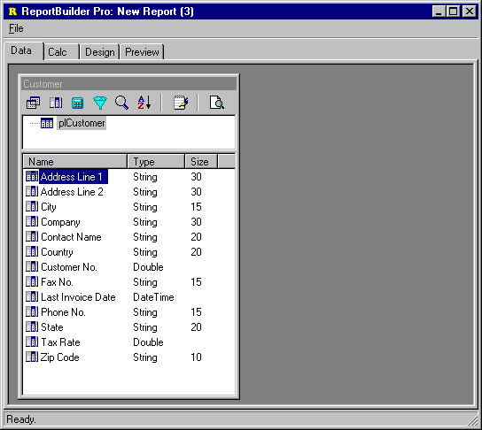

The solution described above is the standard behavior within the data workspace. However, the developer can customize this user-interface by registering a replacement query wizard or query designer, removing the query wizard or query designer, or creating new dataview template classes which can simplify the data selection process even further by establishing the relationship between the tables in the database and present an alternative user-interface (such as a single form which allows search/sort criteria to be entered.)

The bottom-line is that the Data area contains a turnkey solution which can be used out-of-the-box, but if customizations are needed, an architecture has been provided so that those customizations are possible.

Calc

This workspace contains a tree view of the report, all the bands within the report and all the objects within each band. When a band or component is selected, all the events for that component are shown in a list. The user can then select an event and code the event handler in the syntax-sensitive code editor at the bottom. The following screen shot shows an OnPrint event as coded for a Line component.
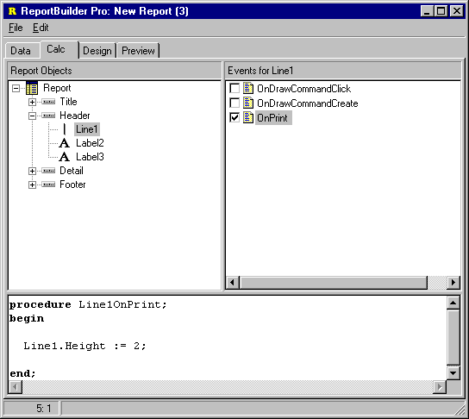
This screen shot shows the Calc workspace in its most feature-rich and complex configuration. Development work completed here can be passed on to end-users so that they can modify it, locked down so that end-users can only view it, hidden completely so that end-users do not know it is there. The most scaled down version of the Calc tab is provided by the dialog only interface, where no Calc tab exists at all, and a single syntax-sensitive code-editor dialog is accessible from the Calculations… menu option of the variable component. Here, again the user-interface and behind-the-scenes architecture has been made highly scalable in order to meet the various needs of developers.
Design

The Design workspace contains the actual layout of the report. The user-interface is identical to the one presented to developer’s using ReportBuilder at Delphi design-time, in other words, it is full-featured and professional. The Office97 interface-style makes the Design workspace especially easy-to-learn for end-users. A Report Wizard is available for creating reports quickly.. You can customize this interface by replacing any of the dialogs it uses and by registering your own report wizards.

Preview

The Preview workspace contains the rendered report. The report can be printed to the printer or to various file formats from this workspace.

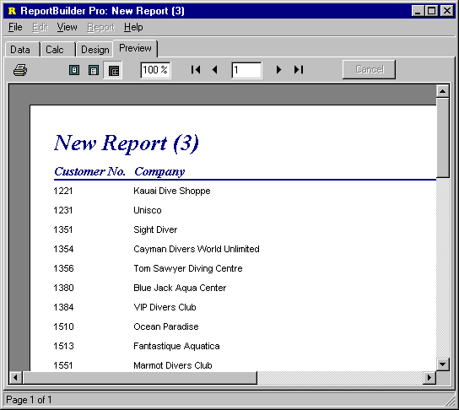

The Delphi Components

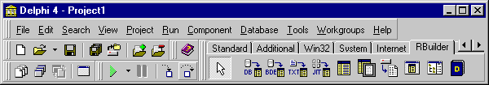
The following components appear on the RBuilder tab of the Delphi component palette when you install ReportBuilder Pro:

Component | Icon | Description
DBPipeline |  | Used for accessing data via third party BDE replacement products or TDataSet descendants. The DBPipeline is connected via the DataSource property.
BDEPipeline |  | Used for accessing data via the BDE. The BDEPipeline can be connected to a DataSource via the DataSource property. In turn, the DataSource may be connected to either a TQuery or TTable
TextPipeline |  | Used to access comma, tab and fixed-length format text files. Set the FileName property to specify the file. Double-click on the component to define the field structure.
JITPipeline |  | Used to access any non-structured data stored in Delphi objects or other sources. Provides total control over the data-access process. All event handlers must be coded. Double-click on the component to define the field structure.
Report |  | The main object. Create one on a form and double-click to invoke the Report Designer. Assign the DataPipeline property so that the report can traverse data. Assign the DeviceType property to control where the output of the report is directed.
Viewer |  | This object is rarely used because you can replace ReportBuilder’s built-in print preview form with your own customized version very easily (check the Replacing the Print Preview Form section in Advanced Techniques.) If you must use this component an example is provided in the main report demo (\Demos\Reports\dmMain.pas directory.)
Component | Icon | Description
ArchiveReader |  | After you print a report to an archive file (.raf extension), you can read and preview the file via this component. Just assign the ArchiveFileName to the file and call the Print method. In terms of displaying a report, this component works much the same as the Report component.
DataDictionary |  | Used by the QueryWizard component to convert raw table and field names into more usable aliases. This component is generally used only when you are creating an end-user reporting solution.
Designer |  | Used when you want to deploy the Report Designer to your end-users. See the End-User demo (Demos\EndUser directory.)
ReportExplorer |  | Used to provide a Windows Explorer style interface to End-User Reporting solutions developed using ReportBuilder Pro. See the End-User demo (..Demos\EndUser\1 Report Explorer\ directory.)

Designer Component

The Designer is a non-visual component which acts as a ‘wrapper’ around the report designer window displayed in the end-user reporting solution. By setting the various properties and events of the designer component, you customize the content and behavior of the report designer. The most commonly used properties of the designer component are listed below:

Property | Description
AllowDataSettingsChange | Used to control whether the DataSettings menu option appears in the File menu of the data workspace. Usually disabled to prevent end-users from changing the database settings.
AllowSaveToFile | When set to True, the File menu of the design workspace has ‘Load from File’ and ‘Save to File” menu options.
DataSettings | DADE only. Used to configure DADE (data workspace) for a given database.
Icon | The icon to be displayed on the report designer window.
RAPInterface | RAP Only. RAP configuration settings.
RAPOptions | RAP Only. Further RAP configuration settings.
Report | The report object which will be used to load and save reports. The configuration of the Report Template properties are used by the report designer to determine how reports will be loaded and saved.
ShowComponents | Determines which components will be displayed in the ReportBuilder component palettes. Sometimes used to disable advanced components such as regions or subreports.
TabsVisible | Determines whether the Design and Preview tabs will display. When set to false, the report designer becomes a ‘design only’ window, where the end-user can work on the layout, but cannot preview. If DADE or RAP is installed, then this property cannot be set to False.

A Simple End-User Report Solution

We can create a simple end-user reporting solution using just a designer component and a report.

- Create Report and Designer components

Place a designer component and a report component on a form, and connect the report to the designer by assigning the Designer.Report property.
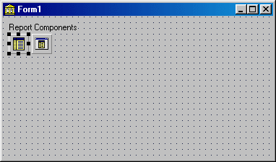

- Create data access components

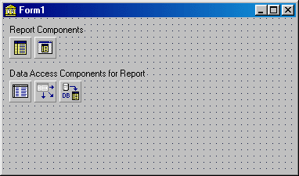
Create data access components to supply data to the report. Here we have created TTable, TdataSource and TBDEPipeline components. The TableName of the TTable component has been set to ‘customer.db’ so that the user can create a report based on the data in this table.

- Create a button to launch the report designer.
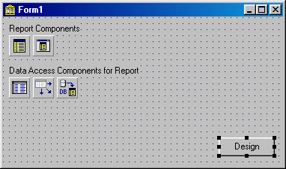

- Code the OnClick event of the button to launch the designer

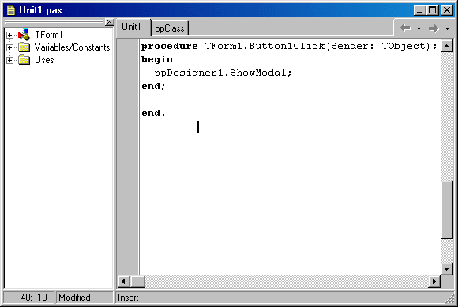
- Run the application
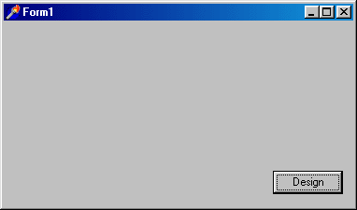

- Click the ‘Design’ button to launch the designer.

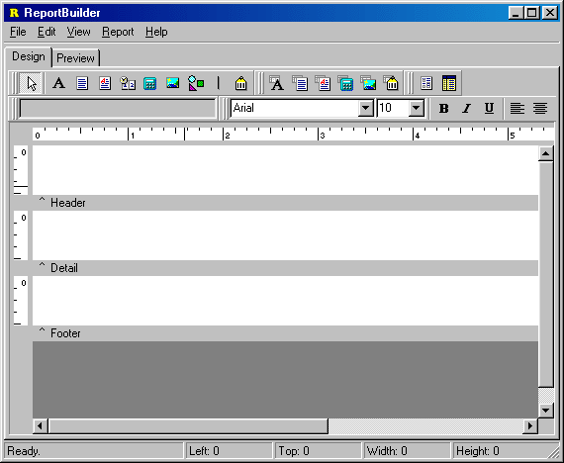
The user can now design a report based on the customer table. The report layout can be saved to a file, or pre-existing layouts can be loaded from file. Reports can only be created based on the customer table, since that is the only table available to the report.

While this end-user solution is simple and easy, it does have some limitations:

- This approach does not provide a data workspace where different data besides the customer table can be accessed.

- This approach does not provide a calc workspace, where custom calculations or event handlers can be assigned to the report.

- The ability to save the report layouts to file, or open the reports from file is dialog-based, and does not give the user a way to organize and keep track of the many reports they may create.

These three limitations can be addressed with additional functionality available in ReportBuilder Pro, namely (DADE, RAP and the Report Explorer.) These solutions are discussed at length throughout the ReportBuilder Pro section of this guide.

Report Explorer

The Report Explorer allows your end-users to use a Windows Explorer user-interface to manage reports stored in a database . The Report Explorer is a non-visual component which acts as a ‘wrapper’ around the explorer form which is displayed at run-time. You can set the value of various properties at design-time via this component, which will then effect the behavior of the report explorer form at run-time. The most commonly used properties are listed below:

Property | Description
Designer | The designer component which will be used to display the report designer window when report layouts are created or edited.
FolderFieldNames | The names of the fields to be used when storing a folder.
FolderPipeline | The data pipeline to be used when storing a folder.
ItemFieldNames | The names of the fields to be used when storing an item (i.e. report, code module or data module)
ItemPipeline | The data pipeline to be used when storing an item.
ModalForm | Whether or not the report explorer form should be displayed modally. Defaults to True.

The report explorer works on the concept of folders and items. 'Items' include report layouts, data modules or code modules. Report layouts consist of everything the end-users sees when designing a report – including the dataviews in the data workspace and the event handlers coded in the calc workspace. Data modules consist of dataviews which have been exported from the data workspace so that they can be imported for use in creating new reports. Code modules consist of event handlers which have been exported from the calc workspace so that they can be imported into other reports.

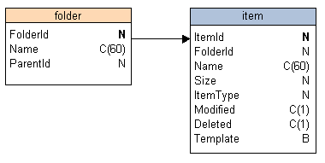
The items displayed in the explorer must belong to a certain folder. Folders may be nested within other folders, or they may be assigned to the global parent folder (entitled ‘All Folders’) which is always displayed. Both the folders and items are stored via data pipelines. The required structure of the database tables underlying these data pipelines is shown below.
The FolderId field of the Folder table is the key field and must always be unique. In Paradox this field is usually an AutoIncrement. In SQL database tables this field is usually a sequence number generated by a trigger. Both techniques are documented in the end-user tutorials. The relationship between the folder and item table is one to many. Note that the item table does not use the Name field as a key, but uses an ItemId field. This field is also an auto-generating sequence number. While it is usually true that two items with the same name cannot reside in the same folder (same name and folder id) this is not true for the recycle bin, which can contain multiple items with the same name. Thus the FolderId-ItemType-Name fields cannot form a unique key (the item type field indicates whether the item is a report layout, data module or code module.)

All items assigned to the recycle bin have a folder id of –2. All items assigned to the global folder ‘All Folders’ have a folder id of –1. Items assigned to any other folder have that folder’s id value in the folder id field. Neither the ‘All Folders’ folder nor the recycle bin actually appear in the folders table. These are automatically created by the report explorer.

Data Dictionary

The data dictionary is a non-visual component designed to provide the data workspace with the capability to replace the table names and field names retrieved from the database with more readable aliases that you provide. The most commonly used properties of the data dictionary are described below:

Property | Description
FieldFieldNames | The names of the fields to be used in accessing the field aliases.
FieldPipeline | The name of the data pipeline which has access to the field aliases.
TableFieldNames | The names of the fields to be used in accessing the table aliases.
TablePipeline | The name of the data pipeline which has access to the table aliases.

The data model for the database tables underlying the data dictionary is shown below:

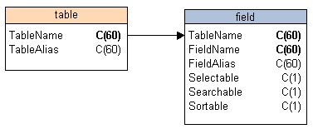
The TableName is the key field of the table table. The TableName and FieldName are the key fields of the field table. The Selectable field determines whether the field can be selected within the Query Wizard and Query Designer. The Searchable field determines whether the field can be used in search criteria. The Sortable field determines whether the field can be used to order the data.
Once the data dictionary tables have been created and populated, they can be assigned to a standard Delphi TTable or TQuery component, which can then be assigned to a data pipeline via a TDataSource. The pipelines are then assigned to the TablePipeline and FieldPipeline properties of the data dictionary. The diagram below shows a fully configured data dictionary component. The data dictionary component is assigned to the data workspace via the DataDictionary property of the designer component.

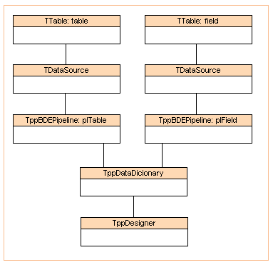

Putting It All Together

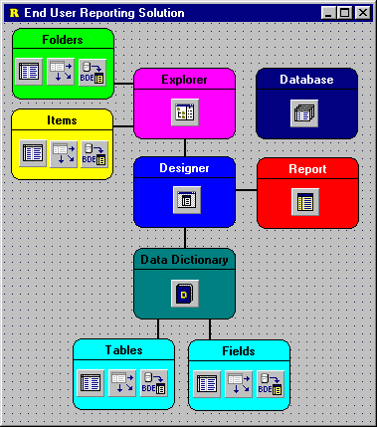
In order to create the most sophisticated and complete end-user reporting solution possible using ReportBuilder, we need to connect and configure all of the components available in ReportBuilder Pro. The screenshot below shows the configuration of a full-featured end-user reporting solution (the colored shapes and labels have been added for informational purposes only). A completed version of this solution is available in the.RBuilder Pro 4\Demos\EndUser\1. Report Explorer directory. Step-by-step instructions for creating this application are provided in the ‘Building an End-User Reporting Application’ tutorial of the Developer’s Guide.

On-Line Help

The ReportBuilder On-Line Help contains over 1,500 topics documenting the properties, events and methods of the various components which make up the product.

For maximum readability, the help follows the exact style of the Delphi help. It is designed to be integrated with the Delphi help, so that when you access the Delphi help (via the Help | Topics menu option), ‘ReportBuilder Reference’ appears as a single entry on the contents page. Topics from the ReportBuilder help will appear when you search the help from the ‘Index’ page. Also, when you create a component on a Delphi form, you can access the main help topic for that component by clicking F1. If you select a component property in the Object Inspector and click F1 the help for that individual property will be displayed.

The help is designed as a reference for those who have already mastered the basics of ReportBuilder. In order to get started using the product, consult the Developer’s Guide.

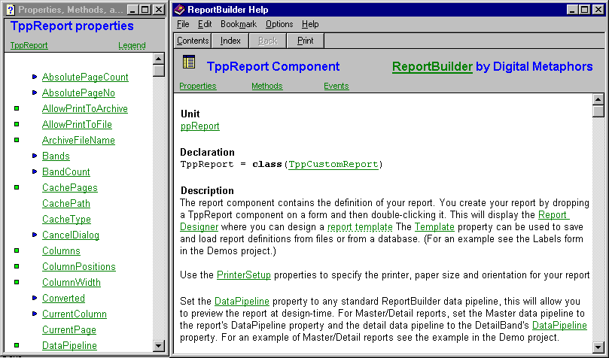

Data
Introduction 190
Query Wizard 193
Query Designer 200
Configuring DADE 216
DADE Architecture 218
Extending DADE 221

Data

Introduction

In the development of ReportBuilder Pro, it was discovered that a visual solution for data access was needed for end-users. This realization led to the development of DADE, the Data Access Development Environment. Though DADE consists of an extensive object-oriented architecture ‘under the covers’, it appears as a simple, easy-to-use data workspace within the Report Designer. Pictured below is the data workspace of the Report Designer, containing a completed dataview.

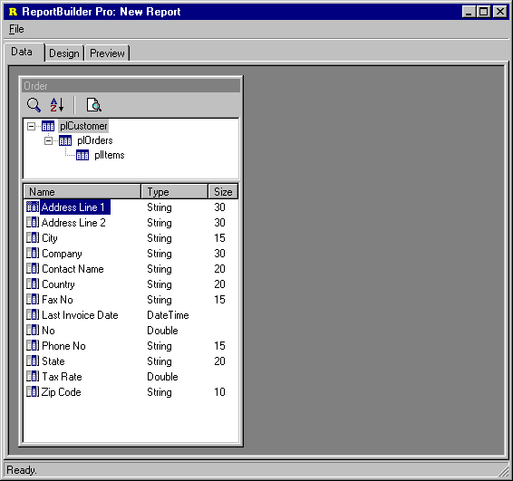
A dataview presents what appears to be a single a set of data to the end-user. In reality, the dataview may be composed of one or many Delphi data access components. The implementation of a dataview can be as simple as a single SQL query, or as complex as a
set of linked tables. Whatever the implementation, the dataview always appears the same to the end-user, and the implementation always depends upon the choices you make as a
developer.

Dataviews interface with the other workspaces within the Report Designer via the data pipeline or data pipelines which they contain. The diagram below shows a dataview which contains a set of master/detail tables. These tables feed data through standard Delphi TDatasource components, which in turn feed the data through data pipeline
components. When this dataview was first created, it assigned the customer data pipeline to the report and the order detail data pipeline to the detail band, so that the end-user does not have to manually connect the data to the report. The items pipeline was assigned manually by the end-user to a subreport placed in the detail band.

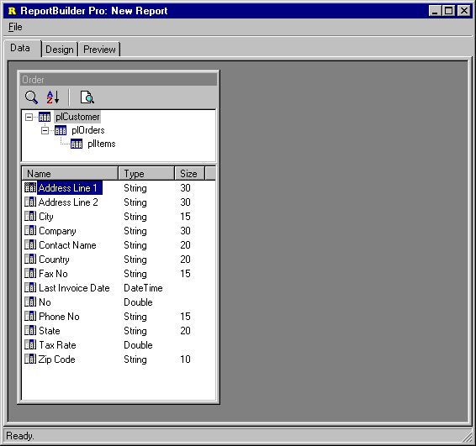
The data pipeline components within a dataview create the interface between the dataview and the other workspaces within the report designer. Within the design workspace, the datapipelines for all dataviews are listed in the data tree tool window, the drop-down list of the edit toolbar and in the data dialog accessible from the main menu. Within the calc workspace, the data pipelines appear in the object list and in the code toolbox – making it easier to code calculations involving field values.

In the following section, we will discuss DADE, dataviews and how you can use this part of ReportBuilder to maximize the productivity of your end-users.

Query Wizard

Within the data workspace, you can select data from your database using an SQL query. This functionality is provided via query-based dataviews, which can be visually created using the Query Wizard and visually maintained using the Query Designer. The following series of screenshots shows how to create a simple query-based dataview
via the Query Wizard.

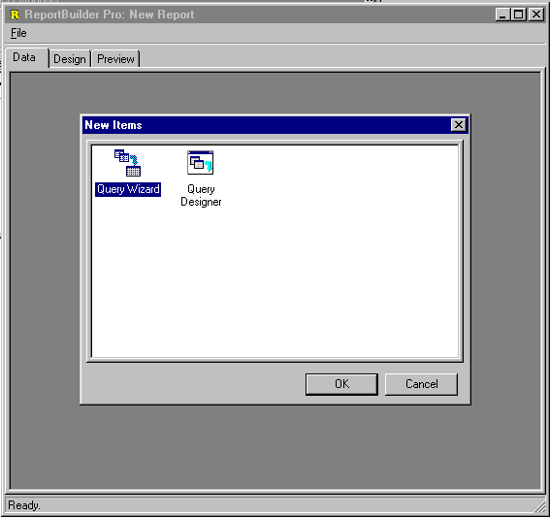
- Select File | New menu option from within the data workspace. The New Dialog will be displayed. Double-click the Query Wizard icon.

- Select the first table for the query. The customer table has been selected.

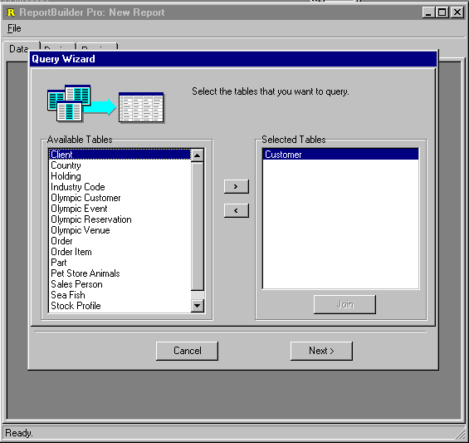
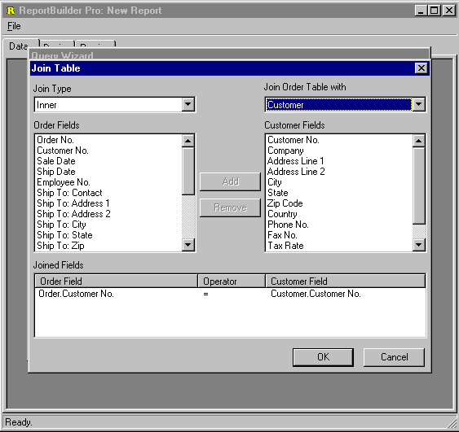
- Select the second table for the query. The order table has been selected and the Join dialog was automatically displayed. The dialog already contains the correct field linking (Customer No.) and so all we have to do is click OK.
- When we return to the query wizard, both tables are shown as selected.
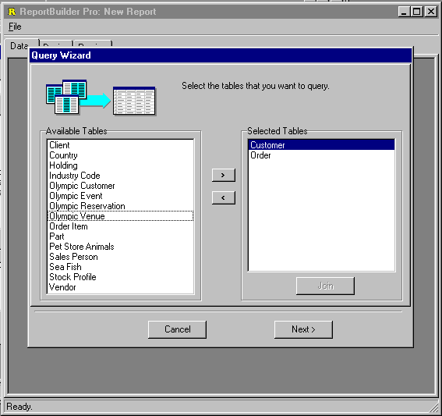
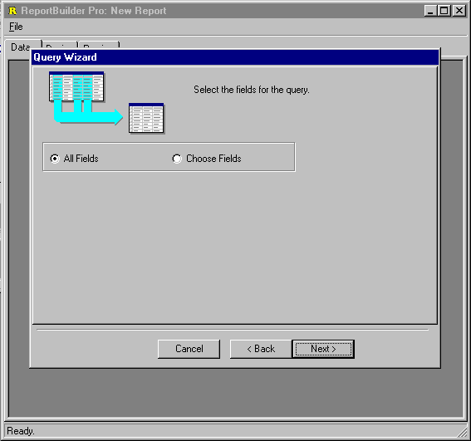
- Skip the fields page, since we want to select all fields.
- Skip the calculations page, since this query will not contain calculations.
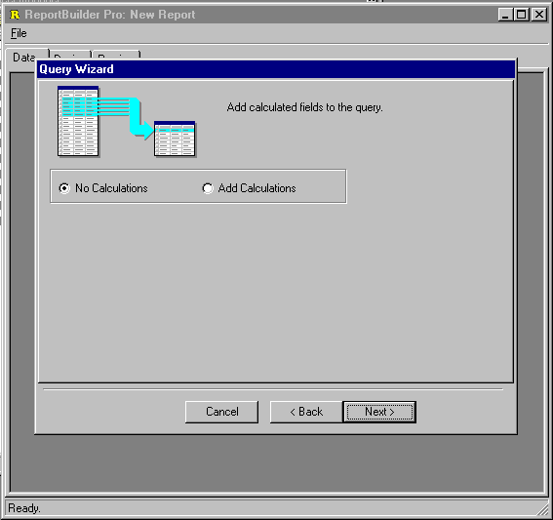
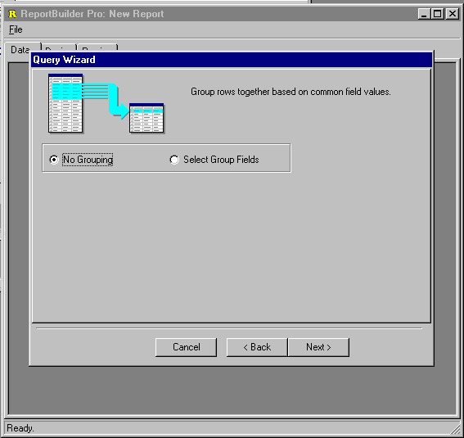
- Skip the groups page, since this query will not be grouped.
- Skip the search criteria page, all records will be selected.
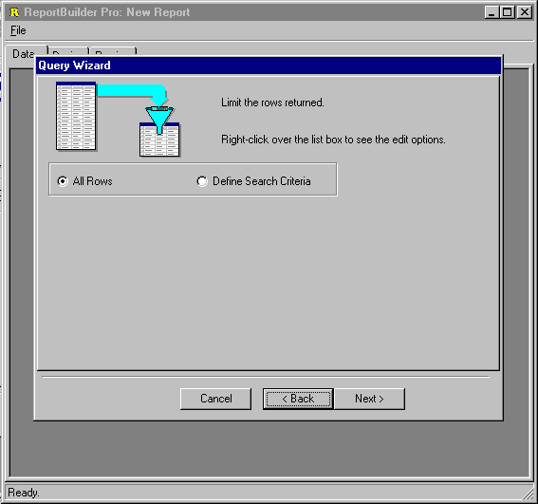
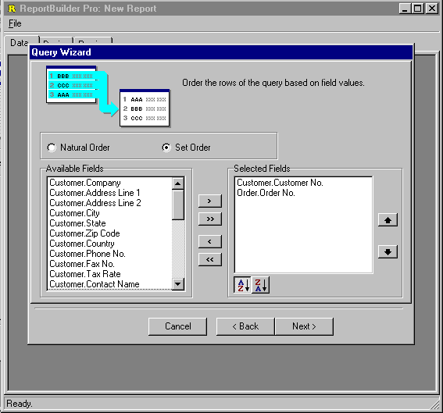
- Set the order to customer number, then order number.
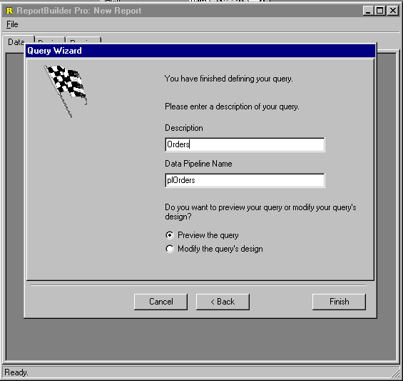
- Name the dataview. The datapipeline name is automatically generated when we name the dataview. The next action will be to preview the data.

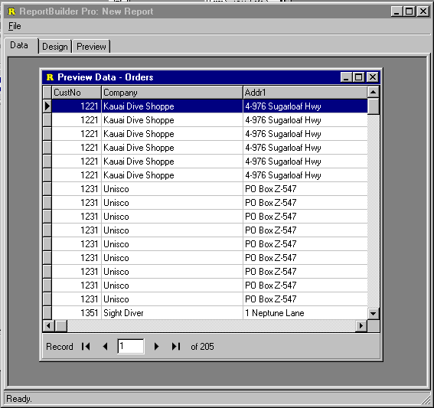
- View the data to make sure the correct records have been selected.
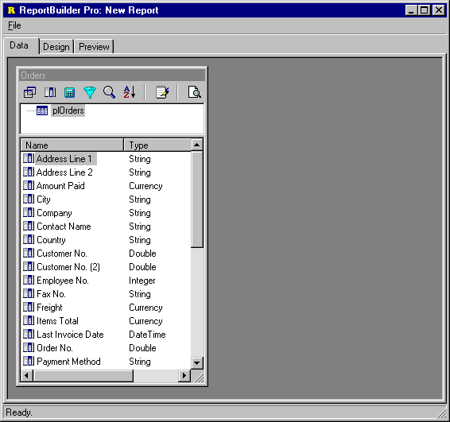
- Close the preview window. The dataview is then created and displayed in the workspace.

From here we could proceed to the design workspace where we could create a new report layout based on this dataview either manually or through the use of the Report Wizard.

Query Designer

The Query Designer is used to modify query-based dataviews. The query designer presents a series of notebook tabs, each tab representing a different part of the query. The last notebook tab in the Query Designer shows the generated SQL and allows the name of the dataview and datapipeline to be changed. The Query Designer is pictured below.

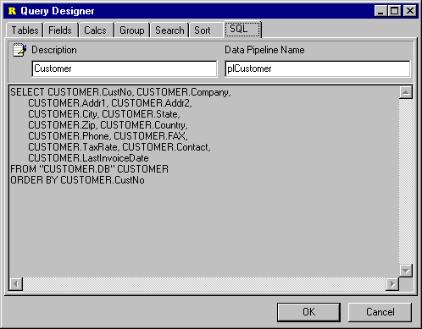

Adding Search Criteria

You can use the Query Designer to add or remove search criteria from your query. In order to add search criteria:

- Click on the Search icon of the dataview to launch the Query Designer.

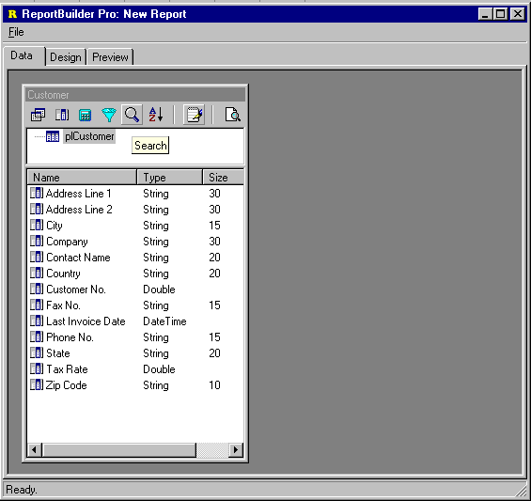

- From the list of fields at the top of the search page, double-click on the field for which criteria needs to be entered.
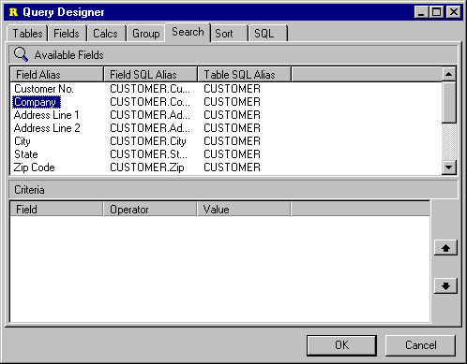

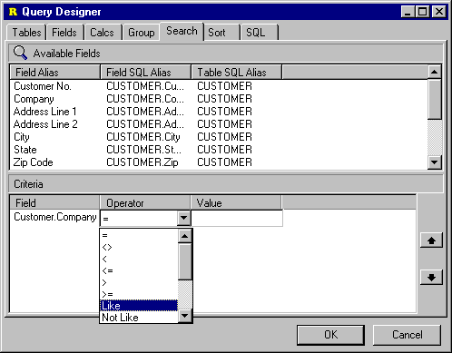
- Click on the field which has been added to the list of criteria at the bottom and select the operator.

- Click in the edit box and enter the search criteria value. This criteria will find all company names which begin with the letter ‘S’.

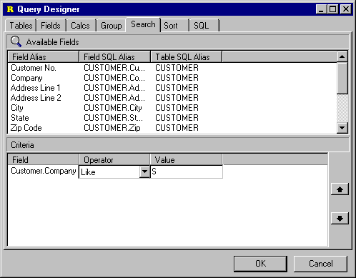
- Click on the SQL tab to make sure the criteria value is valid.

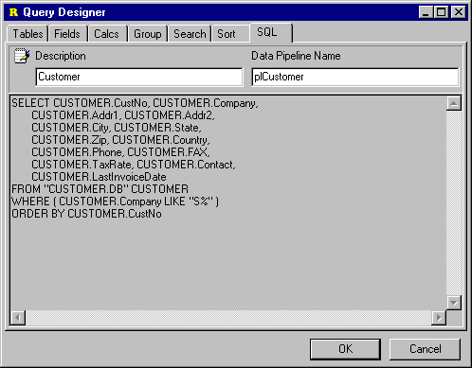
- Close the Query Designer and click on the preview icon.

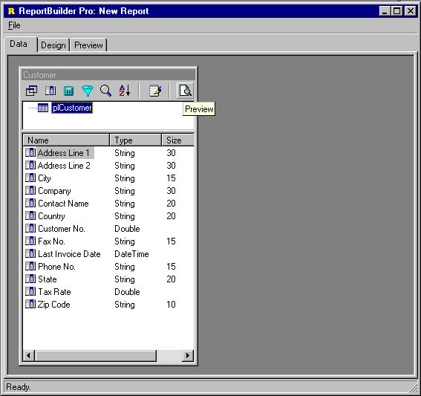
- Preview the data and make sure that the intended records are selected.
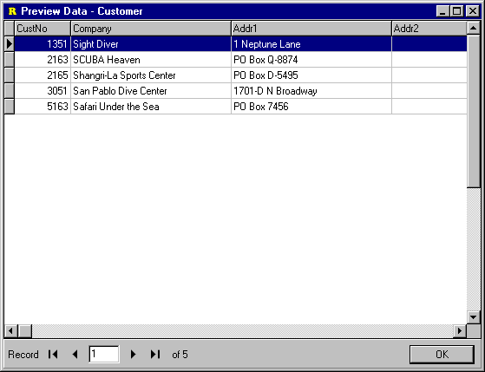

Create a Group Sum

The SQL ‘GROUP BY’ clause allows you to eliminate rows in your query where the field values repeat. For example, let’s assume we have a database table which contains order records. Each order record has the customer number and the amount paid. If we viewed the data in this table, we would see that the value in the customer number field repeats where there are multiple orders for a customer.

We can use SQL to select data from the orders table and calculate the total amount paid for each customer. We would do this by specifying a group on the customer number field. By specifying the group, we are saying to the SQL engine: create one row in the result set for each customer number found. When the SQL engine runs the query, it will find multiple records for some customers, these will be eliminated from the result set. SQL allows us to perform calculations on these repeated records and store the result in a new field of the result set.

These types of calculations can be created on the Calc tab of the Query Designer. In order to sum the amount paid for all customers in the orders table we would:

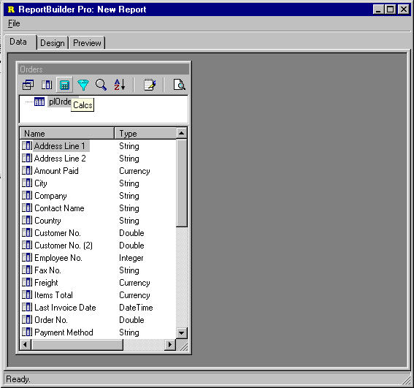
- Click the ‘Calc’ icon to launch the Query Designer.

- Double-click the ‘Amount Paid’ field from the selection list at the top of the page. Amount Paid will be added to the list of calculations.

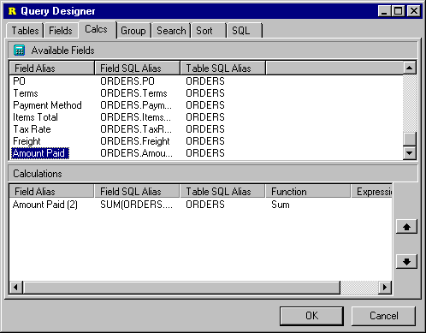
- Select ‘Sum’ as the function type for the calculation.

- Enter the Field Alias we would like to use for this calculated field.

- Click the SQL tab to make sure the generated SQL is valid.

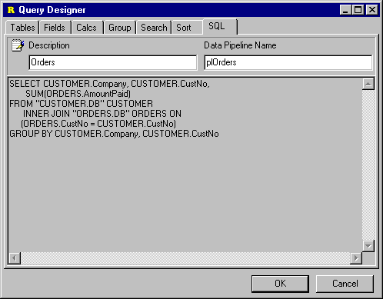

- Close the Query Designer and click the Preview icon to preview the data.
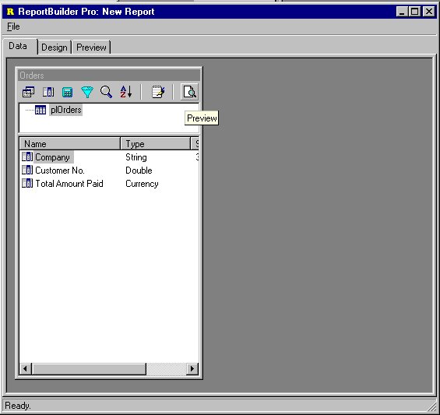

- Check the data to make sure the sum is being calculated as expected.

Concatenate Fields

From the Calc tab of the Query Designer, you can enter SQL expressions. The following query selects data from a table of employees. The table has a first name and last name field. In order to concatenate these two fields together using the Query Designer you would:

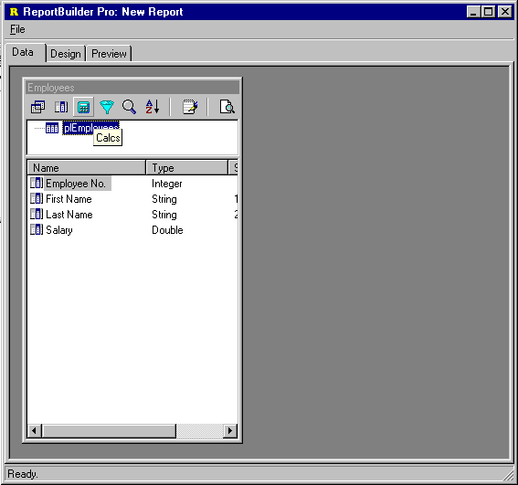
- Click the ‘Calc’ icon to launch the Query Designer.

- Double-click the ‘First Name’ field from the selection list at the top of the page. ‘First Name’ will be added to the list of calculations.

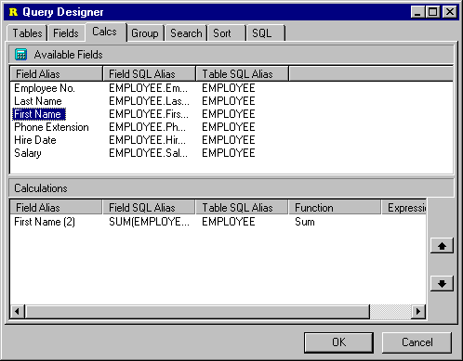
- Select ‘Expression’ as the function type for the calculation.

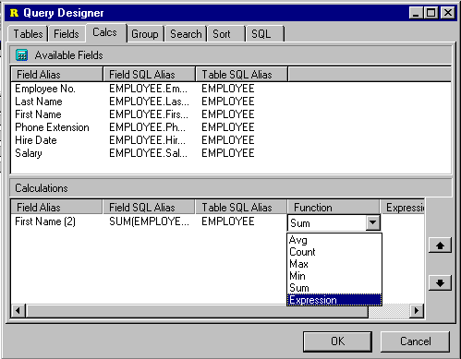

- Modify the widths of the ‘Field SQL Alias’ and ‘Table SQL Alias’ and ‘Expression’ columns in the calculations list at the bottom of the page so that there is enough space to enter the expression. Then enter the expression:

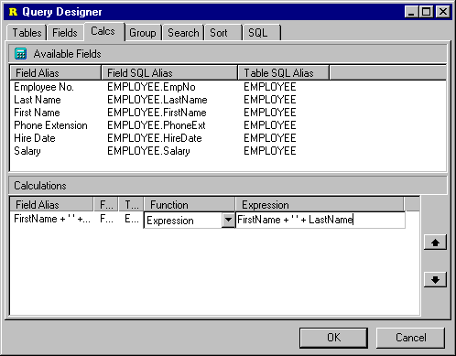
- Enter the Field Alias we would like to use for this calculated field.

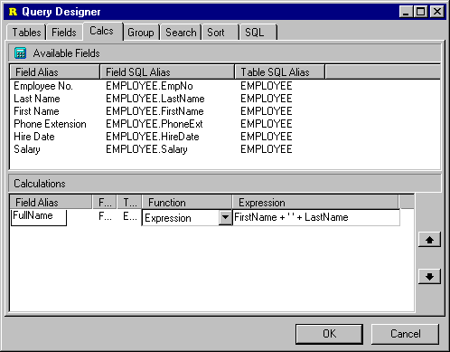
- Click the SQL tab to make sure the generated SQL is valid.
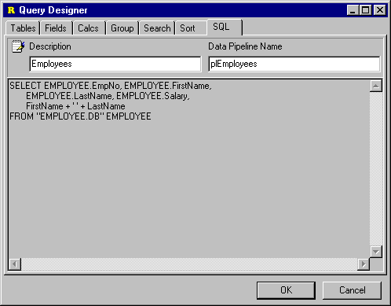

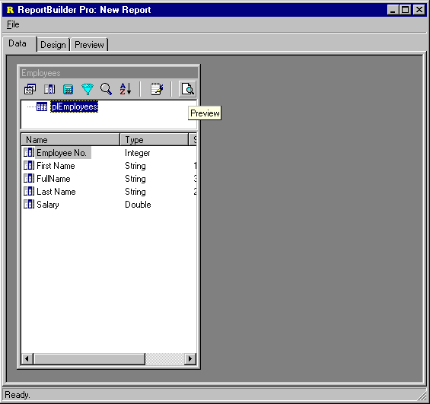
- Close the Query Designer and click the Preview icon to preview the data.

- Check the data to make sure the field is being calculated as expected.

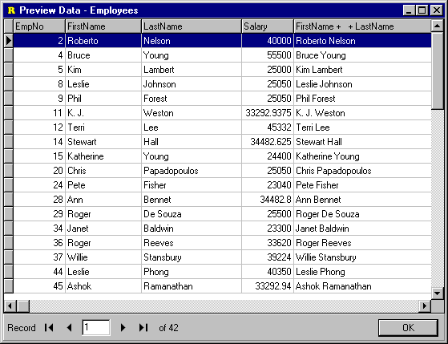

Edit SQL

There may be times when you need to utilize advanced features of SQL which cannot be accessed via the visual interface of the Query Designer. In these cases you can edit the SQL manually in the Query Designer. Once you have edited the SQL manually, you must always use the SQL tab of the Query Designer to make future modifications.

In order to edit the SQL generated by the Query Designer you would:

- Click on the SQL icon to launch the Query Designer.

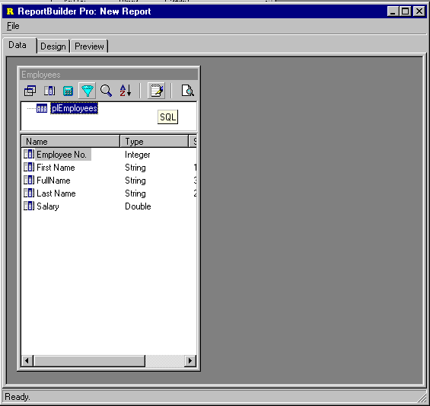
- Right-click over the SQL text to display the popup-menu.

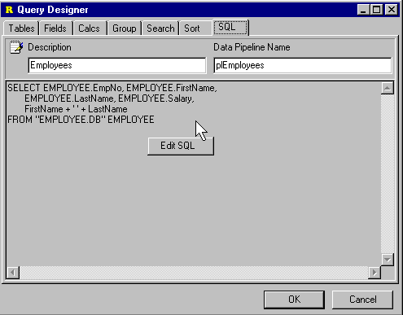
- Select the menu item. Click Yes to the message dialog. You can now edit the SQL.
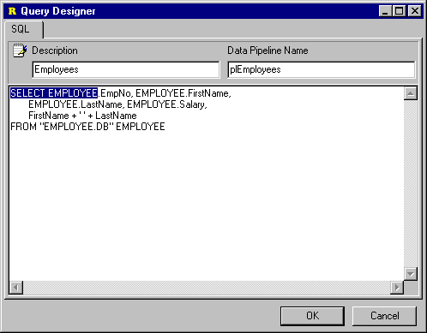

Configuring DADE

The first step in configuring DADE for your end-users involves setting the properties of the DataSettings object of the Designer component.

This object contains the following properties:

Property | Description
AllowEditSQL | Whether or not the end-user can edit the SQL in the Query Designer.
DatabaseName | The name of the database from which data will be retrieved when the query executes.
DataDictionary | The data dictionary object which will convert raw table and field names to aliases.
SessionType | Defaults to BDESession. Should only be changed if you have created your own Session class in order to use the Query Wizard with a proprietary database engine.
SQLType | Defaults to sqBDELocal. If you are not using dBase or Paradox tables then you should set this property to sqSQL1, as the Local SQL dialect is not supported by most other database types. If your database supports ANSI-92 SQL then you can set this property to sqSQL2 instead of sqSQL1.
UseDataDictionary | Determines whether the data dictionary object assigned to the DataDictionary property will be used.

If you intend to use the Query Wizard and Query Designer, then the SQLType is vital. The following table shows the recommended SQLType for a given database product.

Database Product | SQLType
Paradox | sqBDELocal
Interbase | SQL2
Oracle | SQL1
MS Access | SQL2
Sybase SQL Server | SQL1
Sybase SQL Anywhere | SQL2
MS SQL Server | SQL1
Once you have configured the data settings, you may notice that a Data Setttings menu option appears on the File menu of the data workspace when you run your application. This option displays a dialog which allows the end-user to modify the data settings. If you do not want the end-user to be able to change these settings, then you can set the AllowDataSettingsChange property of the Designer component to False.

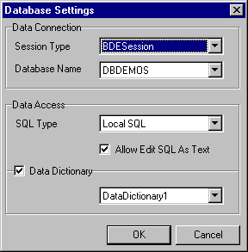

DADE Architecture

The Object Model containing the most important classes of DADE is pictured below.

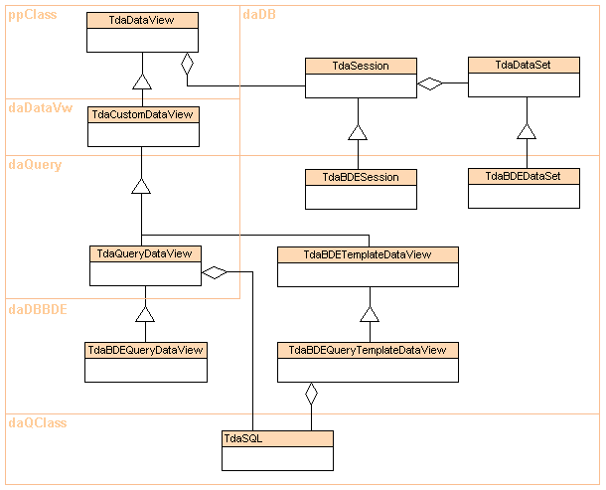
In this diagram, inheritance relationships are indicated by triangles. Where one class is associated with another class, a line is used. If the line terminates in a diamond shape, then this indicates that the class actually forms part of the internal implementation of the component. For instance, the TdaSQL class is part of the implementation of the TdaQueryDataView. The unit in which each class is declared is indicated by the text at the upper left corner of each containing shape.

Basic classes

The following classes represent the heart of DADE. By creating descendants of these classes, native support for any database product which supports SQL can be implemented.

Class | Description
TdaDataView | Dataviews represent a set of data, and are visually created and maintained in the data workspace of the report designer. Internally, a dataview creates the data access objects necessary to connect a report to data. The interface from the dataview into the other workspaces of the report designer is composed of the data pipelines which the dataview contains. A dataview must have at least one datapipeline. A typical dataview will contain one or more datapipelines, datasources and datasets.  TdaDataView contains the declarations of the methods which descendants must implement. It is in the ppClass unit because it declares a Report property which refers to TppCustomReport. If you need to know the main report with which a dataview is associated, you can always use this property.
TdaSession | Contains the methods needed by the TdaSQL class when editing (via the Query Wizard and Query Designer) and generating SQL. Provides the table names for a given database name and the database driver name (i.e. ‘Sybase’)
TdaDataSet | Contains methods needed by the TdaSQL class for generating SQL. Used to get the field names for a given table name and to check SQL statements for validity
TdaSQL | This is the main SQL editing and generation class. The Query Wizard, Query Designer and DataViews rely on this component. As the SQL is designed visually, the SQL component maintains an object-based description of the SQL query. This description is used to generate the SQL. The SQL object is saved as part of query-based dataviews.
TdaCustomDataView | This class further defines the dataview API and implements the capability to save the dataview as a set of objects.
TdaQueryDataView | This class contains the association to the TdaSQL class.

Implementation classes

The following classes are used to implement BDE support within DADE. Non-BDE database products which replace the BDE can also be used with these classes.

Class | Description
TdaBDESession | Passes the method calls of the TdaSession class through to the Delphi Session object.
TdaBDEDataSet | Passes the method calls of the TdaDataSet class through to standard Delphi TTable and TQuery components.
TdaBDEQueryDataView | This class stores the results of work completed in the Query Wizard and Query Designer via the SQL object which it contains. The SQL generated by the SQL object is assigned to a standard Delphi TQuery in this class.
TdaBDETemplateDataView | This class can be used when custom dataview templates are needed. Dataview templates utilize a developer supplied user-interface for the creation and modification of the dataview. This is generally done replace the Query Wizard and Query Designer with a totally customized user-interface.
TdaBDEQueryTemplateDataView | This class can be used when custom dataview templates which contain a query are needed.

Extending DADE

DADE is a flexible and extensible architecture which enables developers to tailor the functionality delivered to meet the requirements of a particular application. The most common ways in which DADE is extended are:

- Dataview Templates
Create dataview templates to customize the dataview creation process or to provide datapipeline configurations which cannot be created via the built-in query-based dataview.

- Support for Non-BDE Database
Create native support for a non-BDE database so that the Query Wizard and Query Designer can be used without the BDE.

- Ask at Run-Time Support
Replace the built-in query-based dataview class with one which provides ‘ask at run-time’ capabilities.

- New Data Wizard
Create a new data wizard.

DataView Templates

A dataview template is a special type of dataview class which has been declared by you, the developer. And while the visual representation of the dataview in the data workspace remains the same as any dataview, the user-interface used to create and modify the dataview is totally dependant on what you want to provide to end-users. Dataview templates can be used for anything from creating predefined relations between a set of tables to integrating a full-blown query builder. In this section, we will show how you can create a dataview template. But before we do, let’s take a look at what the end-user will see when they use a dataview template.

- DataView Template: the End-User View

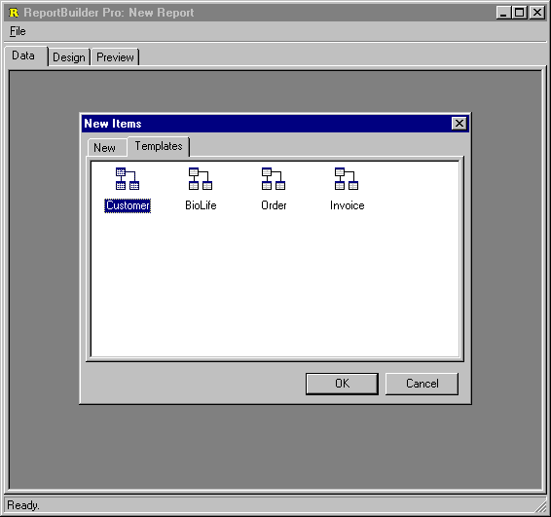
When dataview templates are registered with DADE, an additional tab is added to the New dialog. By accessing the File | New menu option within the data workspace we would see:

Here we can see that four different dataview templates have been registered. After double-clicking on the ‘Order’ template, we would see the following screen:
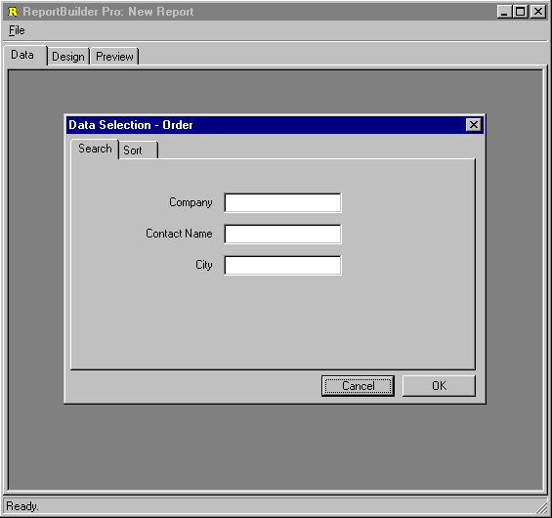

This is a custom dialog created by the developer of the Order dataview template. It allows the end-user to enter simple search and sort criteria. Once we’ve done this and click OK, the completed dataview will be displayed:

As you can see in the data pipeline list of this dataview, this template has declared relationships between the customer, order and order items tables. Each table is independent and has its own data pipeline. By clicking on the Design tab and accesing the Report | Data menu option, we can see how this dataview has assigned the data pipelines to the report:

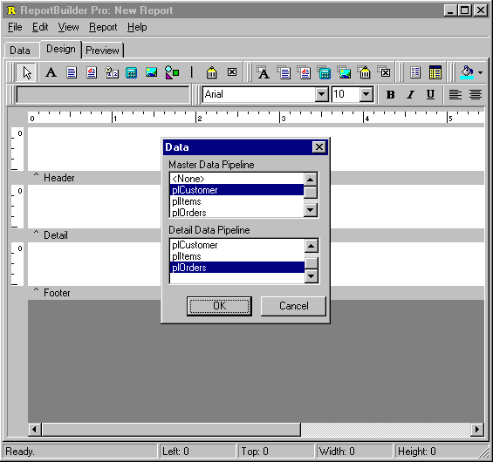
The customer data pipeline is assigned as the master and the orders data pipeline is assigned to the detail band. The items data pipeline is available, and we could create a subreport and assign it to this datapipeline. This sort of data pipeline configuration is not available from query-based type dataviews, so this is probably one of the reasons why the developer chose to create this dataview template.

- DataView Template: the Implementation

This dataview template is implemented as a SQL query on the customer table with nested detail tables on the order and items tables. Some of the fields from the order detail table are actually supplied from the employee table, which is configured as a lookup table:

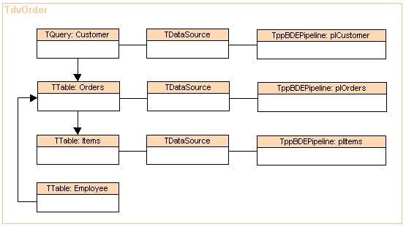
A completed and working version of the order dataview template is available in the Demos\EndUser\2. Custom DataView Templates\ directory within the main ReportBuilder directory.

Support for Non-BDE Database

DADE is built upon the concept of the dataview. A dataview is responsible for creating the data access objects required to connect a report to data. A dataview must contain at least one datapipeline. A typical dataview will contain one or more datapipelines, datasources and datasets. Dataviews are created and maintained visually in the data workspace of the report designer. By implementing new descendants of several classes within DADE, we can integrate a non-BDE database into DADE, so that the visual tools provided in the data workspace (i.e. the Query Wizard, Query Designer and custom dataview user-interfaces) can be used with that database.

In the course of normal operation, the Query Wizard and Query Designer require certain information from the database, such as a list of tables from which data can selected, or a list of fields for a given table. These visual tools never directly reference any database objects in obtaining this information, but instead rely on functionality provided by the dataview. This architecture enables these tools to be used without the BDE.

As an example we have created a dataview descendant that can be used with ODBC98.

ODBC98 is set of native Delphi data access components that provide direct access to ODBC databases without the BDE. The components for the most part mimic the BDE- based components found in Delphi (Session, Database, Table, Query, StoredProc, etc.) ReportBuilder is designed to access TDataSet descendants via the DBPipeline component. Therefore, it can work with ODBC98 seamlessly right out the box. ReportBuilder Pro however, contains the Query Wizard and Query Designer, which are designed to work with a special dataview class: TdaQueryDataView. We must therefore create a descendant of this class, in order to integrate ODBC98
with ReportBuilder Pro.

Implementing a QueryDataView descendant requires that we define the following set of classes:

Class Name | Description
TdaChildODBC98Query | - Descendant of TODBC98Query that can be achild of a DataView  - Override the HasParent method of TComponentto return True  - Must be registerd with the Delphi IDE via RegisterNoIcon
TdaChildODBC98Table | - Descendant of TODBC98Table that can be achild of a DataView  - Override the HasParent method of TComponentto return True  - Must be registerd with the Delphi IDE via RegisterNoIcon
TdaOBC98Session | - Descendant of TppSession  - Implements GetDatabaseNames,  - GetTableNames, etc.
TdaOBC98DataSet | - Descendant of TppDataSet  - Implements GetFieldNames for SQL
TdaOBC98QueryDataView | - Descendant of TppQueryDataView  - Uses the above classes to create the required Query -> DataSource -> Pipeline -> Report connection  - Uses the TdaSQL object built by the QueryWizard to assign SQL to the  - TODBCQuery etc.

If you have ODBC98, you can see these classes in action by installing the ODBC98 demo provided in the ReportBuilder Pro EndUser\Demos directory. Complete directions for installing these classes is provided in this directory.

Ask at Run-time Support

The built-in query-based dataview class provided with ReportBuilder, allows search criteria to be entered via the Query Wizard and Query Designer. This search criteria is static, that is, the search criteria values which were entered when the dataview was created are always used when the dataview is opened. It is possible to override this behavior such that a custom dialog can be displayed each time the report to which the dataview is connected is displayed, requesting the value of some criteria. This capability is called ‘ask at run-time’, because the value of some criteria is requested each time the report generates.

The following screen shot shows a customized ask at run-time dialog, which is displayed before the report is generated.

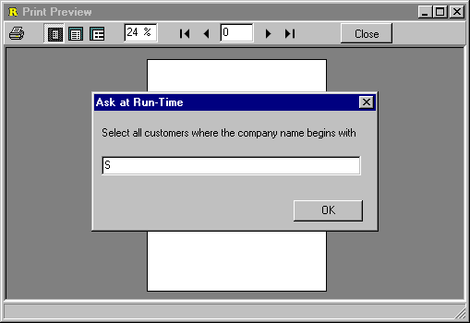

Code
Introduction 230
Configuring RAP 233

Code

Introduction

In the development of ReportBuilder Pro, it was discovered that a visual solution for data processing and calcuation was needed for end-users. This realization led to the development of RAP (Report Application Pascal) and the integrated development environment which can be used to create RAP programs. Though RAP consists of an object-oriented compiler and extensible architecture ‘under the covers’, it appears as a
simple, easy-to-use calc workspace within the Report Designer. Pictured below is the calc workspace of the report designer. The code editor window at the bottom of the workspace shows a simple event handler assigned to a line component.

The Report Application Programming language (or RAP for short), is designed to allow developers and end-users to code calculations, event handlers and stand-alone procedures for use with ReportBuilder Pro. RAP programs can be created, modified, compiled and executed at run-time.

RAP is easy to learn.

The RAP language is identical to Object Pascal. If you know how to code Delphi event handlers, you know how to code RAP. This means that the ‘learning curve’ for Delphi developers will be minimal.

RAP lets you work with objects and object properties.

RAP provides full access to the report, bands, groups, report components, datapipelines and any other objects you wish to pass along to the end-user. New objects can be created. Both the published and public properties of objects are accessible, so end-users can configure objects on-the-fly.

RAP is portable.

Once you’ve created a set of event-handlers or stand-alone procedures, you can save them as part of the report definition. You can export and import calculations from one report to another. You can even save calculations to a file or database BLOB field. And it can all be done at run-time, without recompiling your application.

RAP has a scalable user-interface.

- For casual end-users, a simple Calculations dialog is accessible from the speedmenu of the new TppVariable component. This dialog provides a place for calculations to be entered and returned via a single Result parameter. The calculation result is then displayed in the variable when the report prints.

- For more sophisticated users, RAP can be configured to display as an additional tab in the Report Designer. The new ‘Calc’ tab shows the bands of the report in a tree view, along with the associated variables. The end-user can click on the variables and code the calculation in a syntax-sensitive edit window.

- The highest level of functionality is provided by the ‘Event’ view. This capability shows all of the report components in a tree view. When a component is selected, all of the events for the component are displayed. The user can then select an event and code an event handler.

RAP is extensible.

RAP is delivered standard with the ability to compile the most often used ReportBuilder and Delphi objects. If you want end-users to access more than this, you can register additional RTTI information with RAP. RAP will then be able to compile your custom components. You can also extend the language by adding new ‘built-in’ functions and procedures which the users can call from their RAP programs. These procedures are written and compiled in Object Pascal and then registered with RAP.

RAP is optimized.

RAP is an add-on language for ReportBuilder Pro. However, ReportBuilder Pro does not require RAP in order to compile. You can install RAP and it will automatically appear in your Report Designer. The Delphi units which comprise RAP will only be added to your executable if you use RAP in your report.

RAP is cool.

The wide feature set, object-based functionality and professional user-interface makes RAP the language to beat for reporting applications.

Configuring RAP

The RAP user-interface can be configured to meet the needs of your end-users. There are three basic configurations available:

- Calculations Dialog

For casual end-users, a simple Calculations dialog is accessible from the speedmenu of the new TppVariable component. This dialog provides a place for calculations to be entered and returned via a single Result parameter. The calculation result is then displayed in the variable when the report prints.

In order to configure the user-interface to provide this level of functionality, set the RAPInterface riNotebookTab property to False and the riDialog property to True. When the end-user accesses the speed menu of a variable, a Calculations… option will be available:
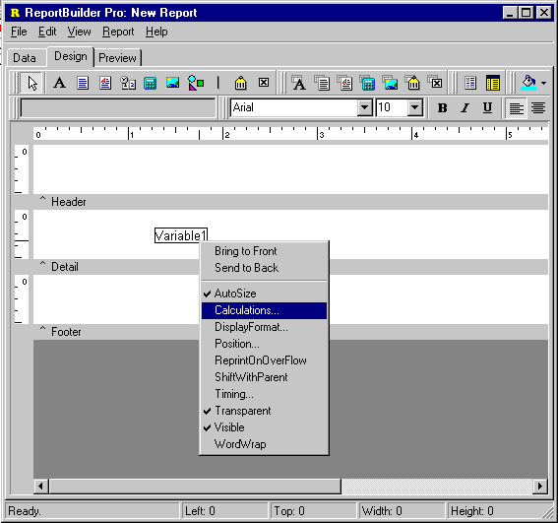

When this option is selected, the Calculation dialog is displayed. The end-user can then create code to assign the value of the variable.
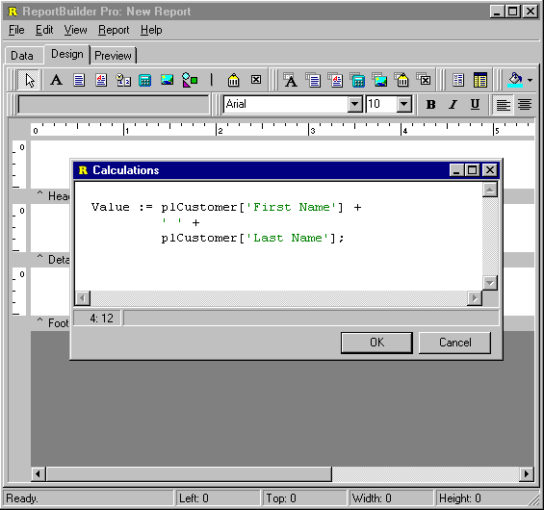

- Calc Tab with Variables

For more sophisticated users, RAP can be configured to display as an additional tab in the Report Designer. The new ‘Calc’ tab shows the bands of the report in a tree view, along with the associated variables. The end-user can click on the variables and code the calculation in a syntax-sensitive edit window.

In order to configure the user-interface to provide this level of functionality, set the RAPInterface riNotebookTab property to True. When the report designer is displayed, the Calc tab will be visible, and the variables within each band will be listed.
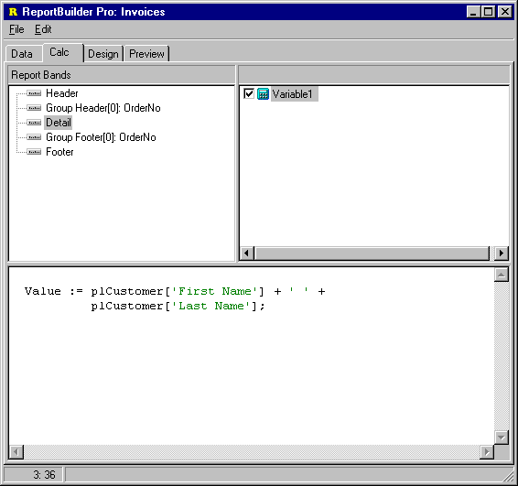
- Calc Tab with All Objects

The highest level of functionality is provided by the ‘Event’ view. This capability shows all of the report components in a tree view. When a component is selected, all of the events for the component are displayed. The user can then select an event and code an event handler.

In order to configure the user-interface to provide this level of functionality, set the RAPInterface riNotebookTab property to True and set all of the RAPOptions to True. When the report designer is displayed, the Calc tab will be visible. By right-clicking on the treeview on the left, a speed menu will be displayed showing the different views of calculations available:

- Variables

This view shows the variables in each band of the report.
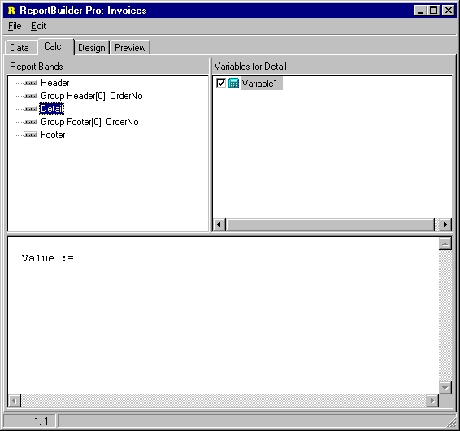

- Events

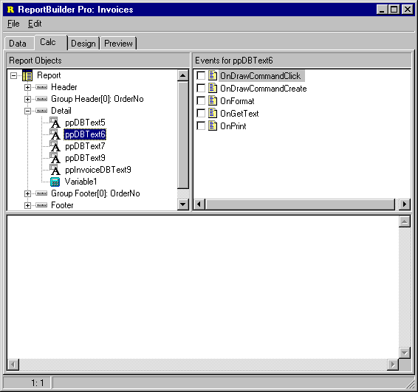
This view shows the report and all of the objects within it. An event handler can be coded for any object.
- Module
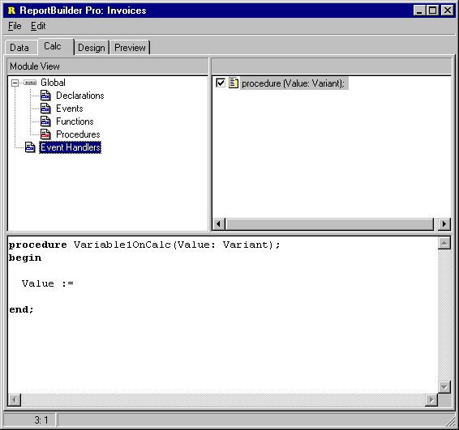

This view shows the global declarations, functions, procedures and events.

Design
The Report Explorer 240

Design

Report Explorer

The Report Explorer component allows you to deploy a Windows Explorer interface which your end-users can use to organize their reports. The Report Explorer handles all operations via datapipelines, so that the folder structure and all of items within it can be saved to database tables. This interface presents a minimal learning curve as most users are familiar with the operation of the Explorer. The Report Explorer user-interface is
pictured below:

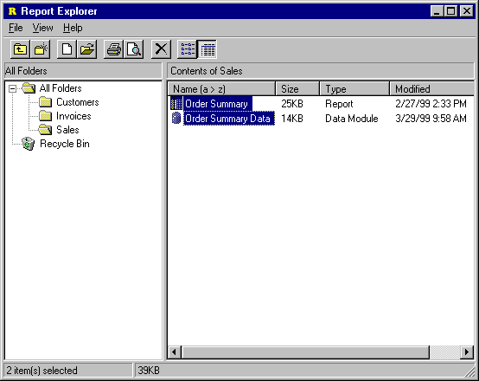
The action which each button on the Report Explorer toolbar performs is described below:

Button | Icon | Description
Up One Level |  | When a folder is selected, use this button to select the parent folder.
New Folder |  | Creates a new folder within the currently selected folder.
New Report |  | Creates a new report and displays the report designer.
Open Report |  | Opens the currently selected report and displays it in the designer
Print |  | Prints the currently selected report.
Print Preview |  | Opens the currently selected report and displays it in the print preview window.
Delete |  | Sends the currently selected item or items to the recycle bin. If the items are already in the recycle bin, deletes them.
List |  | Sets the list to display in columns and show the item name only.
Details |  | Shows one item per row, lists metadata about items: item type, item size, date last modified.

Print
End-User Options 244

Print

End-User Options

You can control whether end-users can Archive or Print to any of the supported file formats using the following properties of the Report object:

- AllowPrintToArchive
- AllowPrintToFile

Setting AllowPrintToArchive to True will enable end-users to archive reports. You would then need to provide a user-interface for previewing and printing the archived files using the ArchiveReader component. For an example of how to use the ArchiveReader see demo 151 (..\RBuilder\Demos\Reports\dm0151.pas)

Setting AllowPrintToFile to True will enable end-users to print to the any of the available file formats. You can control which file formats are available to end-users via the device class registration procedures. For example, the following code would remove the ReportTextFileDevice from the list of available file formats:

uses
ppDevice, ppFilDev;

ppUnRegisterDevice(TppReportTextFileDevice);

End-User Applications

In order to set the AllowPrintToArchive and AllowPrintToFile properties within the context of an end-user application, the OnNew and OnLoad events of the Report.Template object should be used to set the default properties of the report. For example, in the End-User demo application, you would add the following code to
the main form:

procedure TmyEndUserSolution.FormCreate(Sender: TObject);
begin

{assign event-handler to template events}
ppReport1.Template.OnNew := ReportTemplateEvent;
ppReport1.Template.OnLoadEnd := ReportTemplateEvent;

{remove the report text file device }
ppUnRegisterDevice(TppReportTextFileDevice);

end;

procedure TmyEndUserSolution.ReportTemplateEvent(Sender: TObject);
begin

{set default report properties}
ppReport1.AllowPrintToArchive := True;
ppReport1.AllowPrintToFile := True;

end

Deploy
Introduction 248
International Language Support 250

Deploy

Introduction

There are two totally different, but vital issues involved in deciding how you will deploy your application.

- How to deploy ReportBuilder as part of your application.

- How to deploy the reports created with ReportBuilder as part of your application.

Application Deployment

When creating your application exe, you can choose to either compile everything into one executable or you can choose to distribute the packages provided with Delphi, ReportBuilder and any other components you are utilizing in your application as separate files. The latter option is referred to as ‘distributing with packages’ (packages here refers to a Delphi compatible DLL) and results in a smaller, more efficient executable file.
These two approaches for deploying your application are discussed later in this section.

Report Deployment

The second part of deployment involves determining how to deploy the reports created with ReportBuilder as part of your application. ReportBuilder provides the most flexible deployment options of any reporting product on the market.

- End-User Reporting Solutions

The end-user reporting solution uses the Report Explorer to manage reports stored in a database. There are two deployment options for distributing the end-user database tables.

- Local End-User Database

In this scenario each end-user has a local copy of the end-user tables that are used as a personal database for storing reports.

- Shared End-User Database

In this scenario there is a single copy of the end-user tables that are used as a common database for storing all reports.

- Standard Reporting Solutions

A standard reporting solution refers to one in which the developer creates reports that may be executed by the end-user.

- Compile reports into the executable

Allow the report component to reside in an invisible form along with the necessary data access objects. When it is time to print the report, instantiate the form and call the Print method. A slight variation of this architecture would be to use a data module as a container for the data access objects.

- Compile reports into a package

Similar to option 1, but rather than compile the forms containing the reports into the executable, the report forms are compiled into a package. The advantage of this approach is that it optimizes the size of the executable and dynaimcally loads the package containing the reports as needed.

- Distribute report template files

Place all the data access components for the reports in a data module. Place a single report component on a form which ‘uses’ the data module. Create all of the report layouts via this one report component, saving each one down to a separate report layout file. When it is time to print the report, load the report from file and call the Print method.

- Distribute a report database

Use all of the same steps as option 3, but save the report definitions to a database BLOB field instead of separate files. With this approach you can save all of your report defintions in one database table.

A full-featured implementation of Option 'a' above is provided in the ‘Building a Reporting Application’ tutorial in the Developer’s Guide. Option 'a' has the advantage of requiring the least code. The main advantage of options 'c' and 'd' are that you can change report layouts and redeploy them to your end-users with regenerating your executable. Because Option 'a' compiles the report layouts into the executable, it requires a recompile any time a report must be changed. In terms of report layout load time or print speed, all options are essentially equal.

International Language Support

ReportBuilding includes support for 11 built-in languages. The strings for each language reside separate resource files. These files are located in the ..RBuilder\Languages directory, under a subdirectory named for the given language. Three letter codes are used to differentiate the language DLLs which are installed in the Windows\System directory.

Language | Enumerated Type | Folder/File Extension
Default | lgDefault | dft
English | lgEnglish | eng
Custom | lgCustom | cst
Danish | lgDanish | dan
Dutch | lgDutch | nld
French | lgFrench | fra
German | lgGerman | deu
Italian | lgItalian | ita
PortugueseBrazil | lgPortugueseBrazil | ptb
Portuguese | lgPortuguese | ptg
Spanish | lgSpanish | esp
Swedish | lgSwedish | sve
Norwegian | lgNorwegian | nor

Only those languages which are explicitly selected during install will appear in the Languages folder. The ‘cst’ folder will always appear in the Languages folder because it represents the custom language type. The cst folder contains the resource files which correlate to the lgCustom enumerated type. The custom language can be modified to contain your own translation, which will then appear in the ReportBuilder user-interface when the Report.Language property is set to lgCustom.

The Default Language

The Report.Language property now defaults to the lgDefault language type. This type correlates to the language resource files located in the RBuilder\Lib directory and the language DLLs located in the Windows\System directory (the DLLs with the .dft extension.) The .res files are used when compiling stand-alone executables in Delphi. The DLLs are used to provide language support at Delphi design-time. When ReportBuilder installs, it copies these files to the appropriate directories.
The language DLLs which appear in Windows\System:

File Name | Description
rbPrint.dft | Strings used by ReportBuilder
rbIDE.dft | Strings used by the Report Designer
rbDADE.dft | Strings used by the Data Access Development Environment (the ‘Data’ tab)

The resource files which appear in RBuilder\Lib:
File Name | Description
rbPrint.res | Strings used by ReportBuilder
rbIDE.res | Strings used by the Report Designer
rbDADE.res | Strings used by the Data Access Development Environment (the ‘Data’ tab)

You can change the default language used by ReportBuilder by copying the appropriate language files from the RBuilder\Languages directory to the RBuilder\Lib and Windows\System directories respectively. For the DLL files make sure you change the extension to .dft. The following copy commands issued at the MS-DOS prompt (from within the RBuilder\Languages\sve directory) will change the default language to Swedish:
copy rbPrint.res c:\progra~1\borland\delphi4\rbuilder\lib
copy rbIDE.res c:\progra~1\borland\delphi4\rbuilder\lib
copy rbDADE.res c:\progra~1\borland\delphi4\rbuilder\libcopy rbPrint.sve
c:\windows\system\rbPrint.dft
copy rbIDE.sve c:\windows\system\rbIDE.dft
copy rbDADE.sve c:\windows\system\rbDADE.dft

Note: If you are using Windows NT you will need to copy the ‘sve’ files to Windows\System32.

Custom Translations

You can modify the .rc source files in the custom language folder in order to create your own custom translation. The rc files are named the same as their resource file counterparts:

File Name | Description
rbPrint.rc | Strings used by ReportBuilder
rbIDE.rc | Strings used by the Report Designer
rbDADE.rc | Strings used by the Data Access Development Environment (the ‘Data’ tab)

You can create a custom translation by completing the following steps:

- Run the Language Translation application

Create new rc files using the ReportBuilder Language Translation application. This application displays the strings used within ReportBuilder along with an associated screen-shot. It provides an edit box in which the translation for each string can be entered. When you complete the translation, click the ‘Generate RC Files’ button, and generate each of the three rc files. The language translation app is pictured below.
- Create new resource files

Compile the rc files into resource files by issuing the following commands at the MS-DOS prompt (from within the ‘cst’ folder):

c:\progra~1\borland\delphi4\bin\brc32 -r rbPrint.rc

c:\progra~1\borland\delphi4\bin\brc32 -r rbIDE.rc

c:\progra~1\borland\delphi4\bin\brc32 -r rbDADE.rc

After these commands have executed you should have three resource files in the cst folder: rbPrint.res, rbIDE.res and rbDADE.res.

- Create new resource modules

Compile the resource files into DLLs. The following commands will do this step:

c:\progra~1\borland\delphi4\bin\dcc32 rbPrint.dpr

c:\progra~1\borland\delphi4\bin\dcc32 rbIDE.dpr

c:\progra~1\borland\delphi4\bin\dcc32 rbDADE.dpr

After these commands have executed you should have three cst files in the cst folder: rbPrint.cst, rbIDE.cst and rbDADE.cst.

- Install new resource modules

The final step is to copy the new .res files and DLLs to the ..RBuilder\Lib and Windows\System directories respectively. The following commands will do this step:

copy rbPrint.cst c:\windows\system
copy rbIDE.cst c:\windows\system
copy rbDADE.cst c:\windows\system

Note: If you are using Windows NT you will need to copy these files to Windows\System32.

- Use the custom translation

Create a report within Delphi, select the lgCustom language type and double-click on the report to display the Report Designer. Your translation will be displayed.

Report Tutorials

Report Tutorials

Creating a Report via the Data Tree
15 minutes.
This tutorial will show you how to:
- use the Data Tree
- work with the Report Designer
- create and configure the most common report components
Create a new application
- Select the File | New Application menu option from the Delphi menu. This will create a new project and blank form.
- Use the Object Inspector to set the Form name to ‘frmViaDataTree’.
- Select the File | Save As menu option from the Delphi menu and save the form under the name rbViaDT in the ..RBuilder Pro 4\Tutorials\Complete directory.
It is important to name the form and save the form’s unit using the names given above because the report will be used in later tutorials.
- Select the View | Project Manager option from the main menu.
- Right-click over the project name in the Project Manager (usually Project1.exe) and select the Save menu option.
- Save the project under the name rbDTProj in the Tutorial directory (usually C:\Program Files\Borland\Delphi4\RBuilder Pro\Tutorial)
Save your work frequently to avoid losing changes should your computer unexpectedly lose power or crash.
Create a Table, DataSource and DataPipeline component
- Select the Data Access tab of the Delphi component palette.
- Add a Table component to the form.
- Configure the Table component:
DatabaseName DBDEMOS
Name tblCustomer
TableName CUSTOMER.DB
- Add a DataSource component to the form.
- Configure the DataSource component:
DataSet tblCustomer
Name dsCustomer
- Select the RBuilder tab of the Delphi component palette.
- Add a ppBDEPipeline component to the form.
- Configure the Pipeline component:
DataSource dsCustomer
Name plCustomer
Create a report and connect it to the data
- Add a ppReport component to the form.
- Configure the Report component:
DataPipeline plCustomer
Name rbCustomerList
Invoke the Report Designer and set the paper orientation
- Double-click on the Report component to display the Report Designer.
- Size and Move the Report Designer window so that the Object Inspector is visible.
- Select the File | Page Setup option from the Report Designer main menu.
- Change the paper orientation from Portrait to Landscape and click the OK button.
Set the Header band height to 1 inch by dragging the header band control
- Place the mouse over the gray area entitled ‘^ Header’. The cursor should change to a double-arrow. Hold down the left mouse button and drag down a short distance and release the mouse button. Check the vertical ruler on the left and drag down until you can see the 2 inch mark.
- Drag the header band control up until the top guide indicates you have reached the 1 inch mark.
Note that as you drag the band downward to make it taller the length of the ruler grows with it. And as you drag the band upward there is a guide displayed on the ruler to indicate the current position.
- Right-click over the white space of the Header band and access the Position dialog. The value for the height should be 1.0.
Create labels in the header band
- Click the Label component icon on the Report Designer component palette.
- Click on the left side of the Header band. (A label will be created in the Header band and will become the current selection in the Object Inspector.)
- Locate the Edit box at the upper left corner of the Report Designer. Select the text inside it and replace it with the following: Customer List.
- Locate the font controls on the Format bar.
The font controls appear to the right of the Edit box and consist of a Font Name drop-down list, a Font Size drop-down list, Bold, Italic and Underline Font Style icons, Text Justification icons and Font and Highlight color icons.
- Use the font controls to configure the font:
Font name Times New Roman
Font size 12
Font style Bold & Italic
- Click on the Label and drag it to the top left corner of the workspace.
- Create another label near the center of the Header band.
- Configure the Label:
Caption Marine Adventures & Sunken Treasure Co.
Font name Times New Roman
Font size 16
Font style Bold & Italic
Justification Centered
- Set the Font color to Maroon by clicking on the right side of the Font Color icon to display the drop-down Color Palette, then click on the maroon colored square.
When you select a color via the Font or Highlight Color icons the selected color is displayed below the icon. You can then click on the icon directly (without re-displaying the drop-down color palette) and the currently selected component or components will be set to that color.
- Select the Marine Adventures label and drag it to the top of the Header band workspace area.
- Center the label by pressing the ‘Center Horizontally in Band’ icon on the Align toolbar.
Use the Data Tree to layout the customer information
- Select the View | Toolbars | Data Tree menu option. Position the Data Tree to the left of the Report Designer.
- Click the Layout tab at the bottom of the Data Tree and configure the drag-and-drop settings as follows:
Create All
Style Tabular
Label Grid True

Label Font Name Times New Roman
Label Font Size 12 point
Label Font Style Bold
Label Font Color Maroon
Field Grid True
Field Font Name Times New Roman
Field Font Size 10 point
Field Font Style Regular
Field Font Color Black
In the tutorial we are using the Tabular style to create a grid of labels and field components. After you have completed this tutorial, you should try it again using the Vertical style as well as various other combinations of the available layout settings.
- Click on the Data tab and select the Customer DataPipeline from the tree list at the top. The Customer fields will be displayed in the list at the bottom.
- Click on the CustNo field and then hold down the Control key and click on the following fields in the order specified:
Company
Contact
Phone
FAX
- Drag the selected fields onto the workspace, positioning the mouse at the bottom left corner of the header band. Release the mouse button. A grid of labels will be created at the bottom of the header band component and a corresponding grid of DBText components will be created at the top of the detail band.
The Data Tree has a built-in behavior for creating labels and dbtext. If the dbtext controls cannot fit in the band’s vertical space below the label, the dbtext controls are placed at the top of the next band.
The width assigned to each dbtext component is calculated using the DisplayWidth of the data pipeline’s field components. When using the DBPipeline or BDEPipeline, the field components are created automatically and use the DisplayWidth information of the fields in the dataset to which the pipeline is connected. You can override this information by setting the DataPipeline.AutoCreateFields property to False and using the DataPipeline’s Fields Editor to override the default DisplayWidth.
- Close the Data Tree window.
Adjust the layout
- Scroll right until you can see the right edge of the header band.
- Click in the white space of the header band to deselect the components.
- Scroll back to the left, select the CustNo Label and then shift-click the corresponding DBText component. Click on the Left Justify icon
The CustNo field is numeric. Therefore the label and dbtext component were right justified when created by the Data Tree.
- Click on the white space of the header band, just above the CustNo label. Hold down the mouse button and move the mouse cursor down to about the middle of the CustNo label and then move the mouse to the right - across all of the labels and shapes in the header band.
A dotted box will be drawn on the workspace as you move the mouse. When you release the mouse button, all objects that cross the boundary of the box will be selected.
If you cannot select all objects because you need to scroll to the right, then select as many as you can and release the mouse button. Now scroll to the right. Hold down the shift key and create another bounding box by pressing the left mouse button and dragging the mouse again. When you release the mouse button, the selected objects will be added to the list. (If you reselect any existing objects, they will de removed from the selection.)
- Release the mouse button to select the objects.
- Select the View | Toolbars | Draw menu option to display the draw toolbar.
- Press the right side of the Fill Color icon to display the drop-down Color Palette, then click on the light gray colored square. This will fill the shape components with light gray.
- Place the mouse over the gray area entitled ‘^ Detail’ and press the right mouse button. Select the Position… menu option. Set the Height to 0.2292.
The shapes in the detail band have their ParentHeight property set to True, and thus adjust automatically.
- Press Ctrl-S to save.
- Click the Preview tab in the Report Designer.
Layout the footer band.
- Click the SystemVariable component icon on the Report Designer component palette.
- Click on the far left side of the footer band. (A System Variable component should be created.) Drag the component to the bottom left corner of the workspace.
- Locate the drop-down list on the left-hand side of the Report Designer. It should contain a list of variable types for the component.
- Select the PrintDateTime item from this list. (The current date and time should be displayed in the component)
- Use the font controls to set the font to:
Font Name Times New Roman
Font Size 10
Font Color Black
The PrintDateTime variable type causes the SystemVariable to display the date and time when the report started printing. The same date and time is printed on every page – it is essentially an time stamp and can be used to track the moment the report was printed.
- Locate the horizontal scroll bar at the bottom of the Report Designer.
- Scroll right until the right edge of the bands is visible.
- Click the SystemVariable component icon on the Report Designer component palette.
- Click on the far right side of the footer band. (A SystemVariable component should be created.) Drag the component to the bottom right corner of the workspace.
- Use the drop-down list on the left-hand side of the Report Designer to select the PageSetDesc variable type. (Page 1 of 1 should be displayed in the component.)
- Right-justify the component by clicking on the right-justify icon on the Format toolbar.
- Click the Select Report icon, which appears at upper left corner of the Report Designer (where the horizontal and vertical rulers meet.) This will select the report object in the Object Inspector.
- Locate the PassSetting property of the Report.
- Set this property to psTwoPass. (This is required when using calculation components that contain the report page count value.)
Setting the report PassSetting on psTwoPass will cause the report engine to generate all of the pages automatically. One-pass reports only generate the first page, and then any pages requested after that. This does not allow the report to calculate the total number of pages. Two-pass reports are required whenever you are using the PageCount in a System Variable.
- Press Ctrl-S to save.
- Click the Preview tab in the Report Designer.
Preview the report at run-time.
- Close the Report Designer window.
- Select the Standard tab of the Delphi component palette.
- Add a Button component to the form.
- Configure the Button component:
Name btnPreview
Caption Preview
- Put the following code in the OnClick event handler of the button:
rbCustomerList.Print;
- Press Ctrl-S to save the form.
- Run the Project.
- Click on the Preview button. (The report should be displayed in the Print Preview form. This is due to the fact that the report object has the DeviceType property set to Screen.)

Creating a Report via the Report Wizard
30 minutes.
This tutorial will show you how to:
- configure Delphi data access objects for use by reports
- use the Report Wizard to create report layouts
- save and load report layouts to report template files (.rtm)
- add code to preview and print the report at run-time.
Create a new application
- Select the File | New Application menu option from the Delphi menu. This will create a new project and blank form.
- Use the Object Inspector to set the Form name to ‘frmViaReportWizard’.
- Select the File | Save As menu option from the Delphi menu and save the form under the name rbViaWiz.
It is important to name the form and save the form’s unit using the names given above because the report will be used in later tutorials.
- Select the View | Project Manager option from the main menu.
- Right-click over the project name in the Project Manager (usually Project1.exe) and select the Save menu option.
- Save the project under the name rbRWProj in the Tutorial directory (usually C:\Program Files\Borland\Delphi4\RBuilder Pro\Tutorial)
Save your work frequently to avoid losing changes should your computer unexpectedly lose power or crash.
Create a Table, DataSource and DataPipeline component
- Select the Data Access tab of the Delphi component palette.
- Add a Table component to the form.
- Configure the Table component:
DatabaseName DBDEMOS
Name tblCustomer
TableName CUSTOMER.DB
IndexFieldName Company
- Add a DataSource component to the form.
- Configure the DataSource component:
DataSet tblCustomer
Name dsCustomer
- Select the RBuilder tab of the Delphi component palette.
- Add a ppBDEPipeline component to the form.
- Configure the Pipeline component:
DataSource dsCustomer
Name plCustomer
Create a report and connect it to the data
- Add a ppReport component to the form.
- Configure the Report component:
DataPipeline plCustomer
Name rbCustomerList
Invoke the Report Designer and access the Report Wizard
- Double-click on the Report component to display the Report Designer.
- Select the File | New… menu option from the Report Designer’s menu.
- Double-click the Report Wizard icon (or optionally press the OK button while the icon is selected.)
Use the Report Wizard to layout a tabular style report
- Click on the Data Name drop down list and select the Customer table.
- Click on the Company row of the Available Fields list box and press the arrow button to move the field to the Selected Fields list box.
- Repeat this procedure to select the following fields:
CustNo
Contact
Phone
FAX
City
State
Country
- Press the Next button to access the next page of the Wizard.
- This page of the Report Wizard is used to define groups. For this example no groups are required – therefore press the Next button again.
- Click the Landscape radio button located in the Orientation group box.
- Press the Next button.
- Click on each of the style options in the list box to preview each of the available styles.
- Select the Corporate style and press the Next button.
- Press the Finish button. The report layout will be generated and the Preview tab of the Report Designer will be selected so that you can view the report.
Preview the report
- Press the Page Width and 100% buttons to zoom in and view the report on a larger scale.
- Type 80 in the % edit box and press enter. Type 120 and press enter again. The report can be scaled for viewing at any size up to 250%.
- Press the Page Width button to continue viewing the report.
- Press the Next and Prior page buttons to navigate through the pages of the report.
- Press the Print button to access the print dialog. From here you can print All, Current or a specified Range of pages.
- Press the Design tab located at the upper left-hand corner of the Report Designer and return design mode.
Set the report to Two-Pass mode.
- Select the System Variable component on far-right of the footer band.
- Use the drop-down list control in the far left corner of the Report Designer to change the variable type from PageDesc to PageSetDesc.
- Click the Select Report icon, which appears at upper left corner of the Report Designer (where the horizontal and vertical rulers meet.) This will select the report object in the Object Inspector.
- Locate the PassSetting property of the Report.
- Set this property to psTwoPass. (This is required when using calculation components that contain the report page count value.)
Setting the report PassSetting on psTwoPass will cause the report engine to generate all of the pages automatically. One-pass reports only generate the first page, and then any pages requested after that. This does not allow the report to calculate the total number of pages. Two-pass reports are required whenever you are using the PageCount in a System Variable.
Save the report layout to a template file.
- Press the Design tab located at the upper left-hand corner of the Report Designer and return design mode.
- Select the File | Save As menu option menu option from the Report Designer’s menu.
- Type CustTab in the File Name edit box and press the Save button. Be sure to save the template to the same directory as your project.
By default the report layout will be saved with the form on which the TppReport object resides. Saving the layout of a report to a template file is optional. However, for this example we want to create two report layouts for the same data. At run-time the user can choose which layout to print.
Therefore we will save the report layouts to .rtm files and load the appropriate layout at run-time.
Use the Report Wizard to layout a vertical style report
- Select the File | New… option from the Report Designer’s menu.
- Double-click the ReportWizard icon (or optionally press the OK button while the icon is selected.)
- Click on the Data Name combo box and select the Customer table.
- Click on the Company row of the Available Fields list box and press the arrow button ‘>’ to move the field to the Selected Fields list box.
- Repeat this procedure to select the following fields:
CustNo
Contact
Phone
FAX
City
State
Country
- Press the Next button to access the next page of the Wizard.
- This page of the Report Wizard is used to define groups. For this example no groups are required – therefore press the Next button again.
- Click the Vertical radio button located in the Layout group box.
- Press the Next button.
- Select the Soft Gray style and press the Next button.
- Press the Finish button. The report layout will be generated and the preview tab of the Report Designer will be selected so that you can view the report.
- Select the System Variable component on far-right of the footer band.
- Use the drop-down list control in the far left corner of the Report Designer to change the variable type from PageDesc to PageSetDesc.
- Return to the Design tab, click the Select Report icon, to select the Report component and set the PassSetting property to psTwoPass.
Modify the report layout to contain columns.
- Press the Design tab located at the upper left-hand corner of the Report Designer and return design mode.
- Select the File | PageSetup menu option from the Report Designer’s menu to access the Page Setup dialog.
- Select the Layout tab.
- Press the Up Arrow button located to the right of the Columns edit box. This should modify the number of columns from 1 to 2.
- Press the OK button.
- Right-click over the line component at the top of the detail band and set the ParentWidth property to True.
- Preview the report again. You should see two columns.
Quite, often you will want to use the Report Wizard to layout a report and then customize the report layout further using the Report Designer.
Save the report layout to a template file.
- Press the Design tab located at the upper left-hand corner of the Report Designer and return design mode.
- Select the File | Save As menu option from the Report Designer’s menu.
- Type CustVert in the File Name edit box and press the Save button. Be sure to save the template to the same directory as your project for this tutorial.
You can use the File | Open menu to access the file open dialog and load the CustTab.rtm and CustVert.rtm files at design-time. To save any changes use the File | Save menu option.
Add the run-time interface components.
- Close the Report Designer by selecting the File | Close menu option of the Report Designer’s menu.
You can also close the Report Designer by pressing X button located on the upper right corner of the Window Title bar or by double-clicking on the R icon located on the upper left hand corner of the Window Title bar.
- Select the Standard tab of the Delphi component palette.
- Add a Group Box component to the form.
- Configure the Group Box component:
Name gbReportStyle
Caption Report Style
Left 15
Top 11
Width 131
Height 82
- Add two Radio Button components to the Group Box:
Name rbTabular
Caption Tabular
Checked True
Left 18
Top 23
Width 65
Name rbVertical
Caption Vertical
Left 18
Top 50
Width 65
- Add two Button components to the form.
- Configure the Button components:
Name btnPreview
Caption Preview
Left 163
Top 28
Name btnPrint
Caption Print
Left 163
Top 56
Code the event handlers.
- In the private section of the form unit add the following declaration:
private
FPathName: String;
- Add an event handler for the Form OnCreate event:
procedure TfrmViaReportWizard.FormCreate(Sender: TObject);
begin
{get the path name for the this application}
FPathName := ExtractFilePath(ParamStr(0));

{set the initial report template file name}
rbCustomerList.Template.FileName := FPathName + 'CustTab.rtm';
end;
- Add event handlers for each Radio Button’s OnClick event:
procedure TfrmViaReportWizard.rbTabularClick(Sender: TObject);
begin
{set template file name for the tabular report}
rbCustomerList.Template.FileName := FPathName + 'CustTab.rtm';
end;

procedure TfrmViaReportWizard.rbVerticalClick(Sender: TObject);
begin
{set template file name for the vertical report}
rbCustomerList.Template.FileName := FPathName + 'CustVert.rtm';
end;
- Add event handlers for each Button’s OnClick event:
procedure TfrmViaReportWizard.btnPreviewClick(Sender: TObject);
begin
{load the template file and print to screen}
rbCustomerList.Template.LoadFromFile;
rbCustomerList.DeviceType := dtScreen;
rbCustomerList.Print;
end;

procedure TfrmViaReportWizard.btnPrintClick(Sender: TObject);
begin
{load the template file and print to printer}
rbCustomerList.Template.LoadFromFile;
rbCustomerList.DeviceType := dtPrinter;
rbCustomerList.Print;
end;
- Add ppTypes to the uses clause of your form’s unit.
Compile and run the application.
- Save the Form.
- Compile the project.
- Run the application.
- Press the Preview button to view the tabular style report.
- Click the Vertical radio button.
- Press the Preview button to view the vertical style report.
- Press the Print button to send the report to the printer. (optional)

A Simple Report the Hard Way
15 minutes.
This tutorial will show you how to:
- configure Delphi data access objects for use by reports
- work with the Report Designer
- create and configure the most common report components
Create a new application
- Select the File | New Application menu option from the Delphi menu. This will create a new project and blank form.
- Use the Object Inspector to set the Form name to ‘frmCustomerList’.
- Select the File | Save As menu option from the Delphi menu and save the form under the name rbCust.
It is important to name the form and save the form’s unit using the names given above because the report will be used in later tutorials.
- Select the View | Project Manager option from the main menu.
- Right-click over the project name in the Project Manager (usually Project1.exe) and select the Save menu option.
- Save the project under the name rbCSProj in the Tutorial directory (usually C:\Program Files\Borland\Delphi4\RBuilder Pro\Tutorial)
Save your work frequently to avoid losing changes should your computer unexpectedly lose power or crash.
Create a Table, DataSource and DataPipeline component
- Select the Data Access tab of the Delphi component palette.
- Add a Table component to the form.
- Configure the Table component:
DatabaseName DBDEMOS
Name tblCustomer
TableName CUSTOMER.DB
- Add a DataSource component to the form.
- Configure the DataSource component:
DataSet tblCustomer
Name dsCustomer
- Select the RBuilder tab of the Delphi component palette.
- Add a ppBDEPipeline component to the form.
- Configure the Pipeline component:
DataSource dsCustomer
Name plCustomer
Create a report and connect it to the data
- Add a ppReport component to the form.
- Configure the Report component:
DataPipeline plCustomer
Name rbCustomerList
Invoke the Report Designer and set the paper orientation
- Double-click on the Report component to display the Report Designer.
- Size and Move the Report Designer window so that the Object Inspector is visible.
- Select the File | Page Setup option from the Report Designer main menu.
- Change the paper orientation from Portrait to Landscape and click the OK button.
Layout the title labels in the header band.
- Right-click over the white space of the header band and access the Position… dialog.
- Set the Height value to 0.9167 and click the OK button (the header band should expand in height.)
You can also change the height of the header band by dragging the gray bar, which appears below the white space of the header band. This method is quick and easy, but not as precise.
- Click the Label component icon on the Report Designer component palette.
- Click on the left side of the header band. (A label will be created in the header band and will become the current selection in the Object Inspector.)
- Locate the Edit box at the upper left corner of the Report Designer.
- Select the text inside it and replace it with the following text: Customer List
- Locate the font controls on the Format bar. These appear to the right of the Edit box and consist of a Font Name drop-down list, a Font Size drop-down list, Bold, Italic and Underline Font Style icons, text alignment icons and font and highlight color icons.
- Use the font controls to set the font to:
Font Name Times New Roman
Font Size 12
Font Style Bold & Italic
- Locate the horizontal ruler (above the header band).
- Position the mouse over the ruler and right-click.
- Select the Millimeters option from the speed menu.
- Right-click over the label and select the Position… menu option.
- Enter the following values into the Position dialog:
Left 2.381
Top 1.323
Width 24.871
Height 5.027
- Click the OK button. The label should move to the upper left of the header band.
You can also change the position of a component by dragging it. The exact position of the component will be displayed in the status bar (at the bottom of the Report Designer) after it is dropped.
You can use any unit of measure (inches, screen pixels, millimeters, etc.) you prefer. Millimeters were used here just to show the feature.
- Click the Label component icon on the Report Designer component palette.
- Click somewhere near the center of the header band. (A label component will be created.)
- Select the text in the Edit Box and replace it with the following:
Marine Adventures & Sunken Treasures Co.
- Use the font controls to set the font to:
Font Name Times New Roman
Font Size 16
Font Style Bold & Italic
- Click the font color drop-down button and select the dark blue color (this color is on the top row, second from the right)
- Select the View | Toolbars menu option (a list of toolbar names should be displayed.)
- Select the Align or Space toolbar. The toolbar should appear as a floating window.
- Click and drag the toolbar window to the left side of the Report Designer and position it so that it docks in a vertical orientation.
- Click on the label component that was just created.
- On the Align or Space toolbar, click the Center Horizontally in Band icon (second icon from the bottom.) This should cause the label to be centered in the header band.
- Click on the Customer List Label.
- Hold down the shift key and click the report title label.
- On the Align or Space toolbar, click on the Align Top icon (the title labels should now be aligned.)
Layout column labels in the header band.
- Create six labels in the header band with the following captions (position the labels roughly left to right):
Company
Contact
Phone
Address
City
State
- Click on the Company label.
- Hold down the Shift key and click on the Contact label.
- Repeat this procedure until all six labels are selected.
- Use the font controls to set the font to:
Font Name Times New Roman
Font Size 12
Font Style Bold
Font Color Black
- Leave these labels at their current positions, we will align them later.
- Click the Line component icon on the Report Designer component palette.
- Click in the header band. (a line component will be created.)
- Right-click over the line component and select the ParentWidth menu option. (the line will be resized to the width of the header band.)
- Right-click over the ruler and change the unit of measure to Screen Pixels.
- Right-click over the line component and select the Position… menu item.
- Set the Height to 2.
- Select the View | Toolbars menu option from the Report Designer main menu and make the Draw toolbar visible.
- Drag the Draw toolbar window to the right side of the Report Designer, so that it docks horizontally, to the right of component palette toolbars.
- Position the mouse above the line and hold down the left mouse button.
- Drag down until the dotted bounding box overlaps some part of the line.
- Release the mouse button (the line should now be selected.)
- Click the Line Thickness icon on Draw toolbar and select the 1 pt thickness. (the line thickness should adjust accordingly.)
- Hold down the control key and press the down arrow key until the line is positioned at the bottom of the header band.
Layout the detail band.
- Click the DBText component icon on the Report Designer component palette.
- Click in the detail band (a DBText component will be created.)
- Locate the two drop-down lists at the upper left hand corner of the Report Designer. The list on the left contains a list of data pipelines (it should default to the Customer data pipeline – since this is the data pipeline for the report.) The list on the right contains a list of fields for the currently selected data pipeline.
- Select the Company field from the field list. (‘Kauai Dive Shoppe’ should be displayed in the DBText component.
- Use the font controls to set the font to:
Font name Times New Roman
Font size 10
Font color Black
- Create five more DBText components in the detail band. Assign them to the following fields:
Contact
Phone
Addr1
City
State
- Right-click over the DBText component assigned to the Company field and access the Position… dialog. Set the position values to:
Left 2
Top 4
Width 211
Height 15
- Select the Company DBText component.
- Hold down the shift key and click the remaining DBText components.
- Locate the Align or Space toolbar docked on the left side of the Report Designer.
- Click on the Align Top icon (the components should align with Company DBText component)
- Access the position dialog of each remaining DBText component and set the Left position to the following values:
Contact 219
Phone 378
Address 519
City 739
State 896
- Right-click over the white space of the detail band and access the Position… dialog.
- Set the Height value to 25. (the detail band should shrink in height.)
Align the header band labels vertically.
- Right-click over the Company label component in the header band and access the Position dialog.
- Set the Top position to 65.
- Hold down the shift key and select the remaining label components in the header band:
Contact
Phone
Address
City
State
- Click the Align Top icon on the Align or Space toolbar. (The labels should align with the top of the Company label)
Align the header band labels with the detail band DBText components.
- Select the Company DBText component in the detail band.
- Select the Company Label component in the header band.
- Click the Align Left icon on Align or Space toolbar (the Label and DBText component should now be aligned.)
- Repeat this procedure for the remaining DBText components and the corresponding Label components. Make sure to select the DBText component first. The first component selected determines the position used for alignment. Align each of the following component pairs:
Contact DBText Contact Label
Phone DBText Phone Label
Address DBText Address Label
City DBText City Label
State DBText State Label
Layout the footer band.
- Right-click over an open area (white space) of the footer band and access the Position… dialog.
- Set the Height value to 40. (the footer band should shrink in height.)
- Click the SystemVariable component icon on the Report Designer component palette.
- Click on the far left side of the footer band. (A System Variable component should be created.)
- Locate the drop-down list on the left-hand side of the Report Designer. It should contain a list of variable types for the component.
- Select the PrintDateTime item from this list. (The current date and time should be displayed in the component)
- Use the font controls to set the font to:
Font Name Times New Roman
Font Size 10
Font Color Black
- Right-click over the SystemVariable component and access the Position… dialog.
- Set the position values to:
Left 9
Top 22
- Locate the horizontal scroll bar at the bottom of the Report Designer.
- Scroll right until the right edge of the bands is visible.
- Click the SystemVariable component icon on the Report Designer component palette.
- Click on the far right side of the footer band. (A SystemVariable component should be created.)
- Use the drop-down list on the left-hand side of the Report Designer to select the PageSetDesc variable type. (Page 1 of 1 should be displayed in the component.)
- Right-click over the component and access the Position… dialog.
- Set the position values to:
Left 943
Top 21
- Right-justify the component by clicking on the right-justify icon on the Format toolbar.
- Click the Select Report icon that appears at upper left corner of the Report Designer (where the horizontal and vertical rulers meet.) This will select the report object in the Object Inspector.
- Locate the PassSetting property of the Report.
- Set this property to psTwoPass. (This is required when using calculation components that contain the report page count value.)
- Press Ctrl-S to save the form.
- Click the Preview tab in the Report Designer. You should get a three page tabular report.
Preview the report at run-time.
- Select the Standard tab of the Delphi component palette.
- Add a Button component to the form.
- Configure the Button component:
Name btnPreview
Caption Preview
- Put the following code in the OnClick event handler of the button:
rbCustomerList.Print;
- Run the Project.
- Click on the Preview button. (The report should be displayed in the Print Preview form. This is due to the fact that the report object has the DeviceType property set to Screen.)

Groups, Calculations and the Summary band
45 minutes.
This tutorial will show you how to:
- divide a report into sections using groups
- perform calculations within a report
- utilize a summary band
Create a new application
- Select the File | New Application menu option from the Delphi menu. This will create a new project and blank form.
- Use the Object Inspector to set the Form name to ‘frmStockSummary’.
- Select the File | Save As menu option from the Delphi menu and save the form under the name rbStock.
It is important to name the form and save the form’s unit using the names given above because the report will be used in later tutorials.
- Select the View | Project Manager option from the main menu.
- Right-click over the project name in the Project Manager (usually Project1.exe) and select the Save menu option.
- Save the project under the name rbSTProj in the Tutorial directory (usually C:\Program Files\Borland\Delphi4\RBuilder Pro\Tutorial)
Save your work frequently to avoid losing changes should your computer unexpectedly lose power or crash.
Create a Query, DataSource and DataPipeline component
- Select the Data Access tab of the Delphi component palette.
- Add a Query component to the form.
- Configure the Query component:
DatabaseName DBDEMOS
SQL SELECT * FROM master ORDER BY rcmndation
Name qryStock
- Open the Query by double-clicking on the Active property in the Object Inspector.
- Add a DataSource component to the form.
- Configure the DataSource component:
DataSet qryStock
Name dsStock
- Select the RBuilder tab of the Delphi component palette.
- Add a ppBDEPipeline component to the form.
- Configure the Pipeline component:
DataSource dsStock
Name plStock
Create a report and connect it to the data
- Add a ppReport component to the form.
- Configure the Report component:
DataPipeline plStock
Name rbStock
Invoke the Report Designer
- Double-click on the Report component to display the Report Designer.
- Size and Move the Report Designer window so that the Object Inspector is visible.
- Set the Orientation to Landscape.
Set the header band height to 1” by dragging the header band control.
- Place the mouse over the gray area entitled ↑ Header. The cursor should change to a double-arrow. Hold down the left mouse button and drag down about an inch or so.
- You should see a 1 (for 1 inch) on the horizontal ruler to the left of the white space of the band.
- Once again place the mouse over Header band control. Hold down the left mouse button and drag up until the top-most guide on the ruler is flush with the 1” marker line. The marker line will disappear when the guide is flush. Your band should now be 1” tall.
- Right-click over the white space of the header band and access the Position dialog. The value for the height should be 1.
Create labels in the header band.
- Click the Label component icon on the Report Designer component palette.
- Click on the left side of the header band. (A label will be created in the header band and will become the current selection in the Object Inspector.)
- Locate the Edit box at the upper left corner of the Report Designer.
- Select the text inside it and replace it with the following text: Gekko Investments
- Locate the font controls on the Format bar.
The font controls appear to the right of the Edit box and consist of a Font Name drop-down list, a Font Size drop-down list, Bold, Italic and Underline Font Style icons, text justification icons and font and highlight color icons.
- Use the font controls to configure the font:
Font Name Times New Roman
Font Size 20
Font Style Bold & Italic (click the Bold and Italic icons.)
- Select the Gekko Investments Label component.
- Hold down the Control key and press the C key. This will copy the component into the clipboard.
- Hold down the Control key and press the V key. This will paste a copy of the label into the header band.
- Set the caption of this label to: Stock Portfolio Analysis
- Configure the font:
Font name Times New Roman
Font size 12
Font style Bold & Italic (click the Bold and Italic icons.)
- Position the Gekko Investments Label at:
Left 0.0417
Top 0.0417
- Position the Stock Portfolio Label at:
Left 0.0417
Top 0.4063
Create a Group on the ‘rcmndation’ field.
- Access the Report | Groups… menu option on the Report Designer main menu. The Groups dialog will be displayed.
- The drop-down list at the top of the dialog contains a list of fields from the Query. Select the qryStock.RCMNDATION field and click the Add button. (A new entry entitled Group1: qryStock.RCMNDATION should be added to the list.)
- Locate the Start New Page check box near the middle of the dialog.
- Check this box. (This will cause the report to start a new page each time the RCMNDATION field changes value)
Because groups are based on a change in field value, the field on which a group is based should always be used to order the records. You may remember that the query for this report is ordered by the ‘rcmndation’ field. You must always order the records by the fields you intend to use for groups as ReportBuilder will not sort records for you.
- Click the OK button. You should see two new bands, one above and one below the detail band. These bands have no height and thus, no white space appears above their band controls.
- Right-click over the ↑ Group Header band control and select the Position… menu option.
- Set the Height to 0.6458.
Lay out the group header band.
- Click the Label component icon on the Report Designer component palette.
- Click on the left side of the group header band. (A label will be created in the header band and will become the current selection in the Object Inspector.)
- In the Object Inspector, set the Name of the component to: rlRecommendation.
- Configure the font:
Font name Times New Roman
Font size 14
Font style Bold (click the Bold icons.)
- Position the Label at:
Left 0.0417
Top 0.0937
- Click the Line component icon.
- Click near the bottom of the group header band. (A line component will be created.)
- Right-click over the line component and select the ParentWidth option.
- Locate the Line type drop-down list at the upper left corner of the Report Designer.
- Select ‘Bottom’ from this list. (This causes the line to be drawn at the bottom of the rectangular bounding shape.
- Click on the Line thickness icon and select 1 ½ point.
- Hold down the Control key and press the down arrow until the line is flush with the bottom of the group header band.
- Click in the white space of the group header band. The band should be selected in the Object Inspector.
Code the BeforeGenerate event of the group header band.
- Click on the Events tab of the Object Inspector and double-click on the BeforeGenerate event. Add the following code to the event handler:
procedure Tfrm0014.ppStockListGroupHeaderBand1BeforeGenerate(Sender: TObject);
var
lsRecommendation: String;
begin
lsRecommendation := qryStock.FieldByName('Rcmndation').AsString;

{determine the font color based on the value of Recommendation}
if lsRecommendation = 'BUY' then
FRecommendationColor := clRed

else if lsRecommendation = 'HOLD' then
FRecommendationColor := clGreen

else {lsRecommendation = 'SELL'}
FRecommendationColor := clBlue;

rlRecommendation.Font.Color := FRecommendationColor;

{check whether group first page of group or a continuation}
if rbStock.Groups[0].FirstPage then

rlRecommendation.Caption := 'Recommended ' + lsRecommendation + ' List'
else
rlRecommendation.Caption := 'Recommended ' + lsRecommendation + '''s continued...';

end;
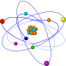This routine is retrieving the value of the recommendation field into a local string variable. It then assigns a color based on the value of the field. The color is stored in a private variable of the form so that all of the report event handlers can use it. The recommendation label in the group header band is set to the color. Finally, the recommendation label caption is set using the FirstPage property of the group. If FirstPage is False, then it means that the group has overflowed onto an additional page.
- Close the Report Designer.
- Select the View | Units menu option from the Delphi main menu.
- Select the rbStock unit.
- Scroll down in the Code Editor to the ‘private’ section of the form class declaration.
- Add the following code:
FRecommendationColor: TColor;
- Select the View | Forms menu option from the Delphi main menu.
- Select frmStockSummary.
- Select the Standard tab of the Delphi Component palette.
- Create a button on the form.
- Configure the button:
Name btnPreview
Caption Preview
- Add the following code to the OnClick event for the button:
rbStock.Print;
- Hold down the Control key and hit the ‘S’ key to save the form.
- Select the Project | Compile | Build Stock menu option. The project should compile.
- Select the Run | Run menu option to run the project.
- Click on the Last Page icon of the Print Preview window. (You should get an eight page report. The label in the group header should change color based on the group.)
Add the General data to the detail band.
- Right-click over the white space of the detail band and select the Position… menu option.
- Set the Height value to 1.8542.
- Select the View | Toolbars | Data Tree menu option. The Data Tree window should appear. Position it over the Object Inspector.
- Click the Layout tab at the bottom of the Data Tree. Set the Label font on Times New Roman 10 point regular black, set the Field font on Times New Roman 10 point bold. The Style drop-down should be set to ‘Tabular’. Grid style should be off.
- Click on the Data tab and use the Ctrl-click method to select these fields in order:
EXCHANGE
INDUSTRY
PROJ_GRTH
OUTLOOK
- Drag the selected fields onto the detail band. (Four DBText components and four associated labels will be created.)
- Hold down the control key and use the arrow keys to position the selection at:
Left1 0.2292
Top 0.3542
- Create a line above the components.
- Configure the line component:
Line Type Top
Thickness 1 ½ pt
Left 0.2292
Top 0.2083
Width 4.25
- Create a label component over the line.
- Configure the label component:
Caption General
Font Times New Roman 10, Bold & Italic
Justification Centered
Transparent False
Top 0.1146
- Select the Line component and the General label component.
- Click on the Align Middle icon of the Align or Space toolbar. The label should be centered horizontally in relation to the line.
Add the Vital Stats data to the detail band.
- Use the Ctrl-click method to select these fields in order from the Data Tree:
P_E_RATIO
RANK
RATING
BETA
- Drag the selected fields onto bottom left of the detail band. (Four DBText components and four associated labels will be created.)
- Hold down the control key and use the arrow keys to position the selection at:
Left 1.2292
Top 1.1875
- Select the line and General label (these are above the first group components which were created for this band.)
- Copy and Paste the selection (Hit Ctrl-C and then Ctrl-V.) A new line and label should appear just below the originals.
- Drag these two component until they are at a left of about 1.2 and a top of about .9
- Set the line top to: 1.0417
- Set the label top to: 0.9687
- Right-click over the label and select the Bring to Front menu item.
- Set the label Caption to: Vital Stats
- Select the Line and then the label.
- Click on the Align Middle icon of the Align or Space toolbar. The label should be centered horizontally in relation to the line.
Add the Pricing data to the detail band.
- Use the Ctrl-click method to select these fields in order from the Data Tree:
CUR_PRICE
YRL_HIGH
YRL_LOW
PRICE_CHG
- Drag the selected fields onto the upper right of the detail band. (Four DBText components and four associated labels will be created.)
- Hold down the control key and use the arrow keys to position the selection at:
Left 5.6250
Top 0.3542
- Right-click over each of the four DBText components and select the DisplayFormat menu option.
- Set the DisplayFormat to: $#,0.00;($#,0.00)
- Select the line and General label (these are above the first group components which were created for this band.)
- Copy and Paste the selection (Hit Ctrl-C and then Ctrl-V.) A new line and label should appear just below the originals.
- Drag these two components until they are at a left position of about 5.6 and a top of about 0.1
- Set the label Caption to: Pricing
- Select the CUR_PRICE DBText component and then the line component.
- Click on the Align Left icon of the Align or Space toolbar.
- Set the General label top to: 0.1354
- Select the General label and then the Pricing label.
- Click on the Align Top icon of the Align or Space toolbar.
- Select the line below the General label, then the line below the Pricing label.
- Click the Align top
- Select the Pricing Line and then the label.
- Click on the Align Middle icon of the Align or Space toolbar. The label should be centered horizontally in relation to the line.
- Set the line Width to 4.4583.
Add the Recommendation data to the detail band.
- Use the Ctrl-click method to select these fields in order from the Data Tree:
RCMNDATION
RISK
SAFETY
- Drag the selected fields onto the lower right of the detail band. (Four DBText components and four associated labels will be created.)
- Hold down the control key and use the arrow keys to position the selection at:
Left 5.6250
Top 1.1875
- Close the Data Tree window.
- Click in the white space of the band to deselect the components, then select the DBText component for the RCMNDATION field.
- Set the name of this component to dbtRecommendation. (We will use this name in an event handler.)
- Select the line and Vital Stats label (these are above the second group components which were created for this band.)
- Copy and Paste the selection (Hit Ctrl-C and then Ctrl-V.) A new line and label should appear just below the originals.
- Drag these two component until they are at a left of about 5.6 and a top of about 0.9
- Set the label Caption to: Recommendation
- Select the Vital Stats label and then the Recommendation label.
- Click on the Align Top icon of the Align or Space toolbar.
- Select the line below the Vital Stats label, then the line below the Recommendation label.
- Click the Align top icon of the Align or Space toolbar.
- Select the line and then the label.
- Click on the Align Middle icon of the Align or Space toolbar. The label should be centered horizontally in relation to the line.
Add the Stock symbol and company data to the detail band.
- Click on the DBText component icon and then click in the upper left of the detail band.
- Configure the DBText component:
DataPipeline plStock
DataField SYMBOL
AutoSize True
Name dbtSymbol
Font Times New Roman 14 Italic
Justification Left Justify
Left 0.0937
Top 0.0104
- Create another DBText component in the upper left of the detail band.
- Configure the DBText component:
DataPipeline plStock
DataField CO_NAME
Name dbtCompany
Font Times New Roman 8 Regular
Left 0.0000
Top 0.4167
Width 1.0000
Assign the BeforeGenerate event handler of the detail band.
- Click in the white space of the detail band.
- Click on the Events tab of the Object Inspector.
- Double-click on the BeforeGenerate event. (An event handler shell will be generated in your Delphi form.)
- Assign the following code to this event handler:
{set the font color of Symbol, Recommendation variables}
dbtRecommendation.Font.Color := FRecommendationColor;
dbtSymbol.Font.Color := FRecommendationColor;
This routine is sets the color of the stock symbol and the recommendation field to the color as defined in the BeforePrint event of the group header band.
- Hold down the Control key and hit the ‘S’ key to save the form.
- Select the Project | Compile | Build Stock menu option. The project should compile.
- Select the Run | Run menu option to run the project.
- Click on the Last Page icon of the Print Preview window. (You should get a thirty-seven page report. The label in the group header should change color based on the group. The stock symbol and recommendation fields should be color-coded.)
Layout the footer band.
- Activate the Report Designer window by clicking on the window or double-clicking on the report component.
- Click on the System Variable icon and then click on the left side of the footer band.
- Configure the SystemVariable component:
VarType PrintDateTime
Justification Right justified
Font Name Times New Roman
Font Size 10
Font Style Regular
Font Color Black
Left 0
Top 0.2292
- Scroll right until you see the right edge of the footer band.
- Create a SystemVariable component on the right of the footer band.
- Configure the SystemVariable component:
VarType PageSetDesc
Justification Right justified
Font Name Times New Roman
Font Size 10
Font Style Regular
Font Color Black
Left 9.9062
Top 0.2292
- Click the Select Report icon to select the report component. (This icon is located at the upper left of the Report Designer. (where the vertical and horizontal rulers meet.)
- In the Object Inspector, set the PassSetting property to psTwoPass
Setting the report PassSetting on psTwoPass will cause the report engine to generate all of the pages automatically. One-pass reports only generate the first page, and then any pages requested after that. This does not allow the report to calculate the total number of pages. Two-pass reports are required whenever you are using the PageCount in a System Variable.
- Save the report by hitting Ctrl-S.
- Preview the report by running the application.
Layout the summary band.
- Select the Report | Summary menu option. A summary band should appear as the bottommost band in the Report Designer.
- Right-click over the white space of the summary band and select the Position… menu option.
- Set the Height value to 3.4063.
- Scroll down until you can see the entire summary band.
- Create a label component on the left side of the summary band.
- Configure the label component:
Caption Summary Page
Font Name Times New Roman
Font Size 16
Font Style Bold
Font Color Black
Justification Left Justify
Left 0.0000
Top 0.0313
- Right-click over the white space of the summary band and select the NewPage menu option. (This will cause the summary band to print on a new page at the end of the report.)
- Create a label component near the center of the summary band.
- Configure the label component:
Caption Recommendations
Font Name Times New Roman
Font Size 16
Font Style Regular
Font Color Black
Justification Left Justify
Left 1.6250
Top 0.6667
- Create three label components near the center of the summary band.
- Set the captions to Buy, Hold and Sell respectively.
- Place the Buy label at the following position:
Left 2.8750
Top 1.0280
- Place the Sell label at the following position:
Top 2.0104
- Select the Buy, Hold and Sell labels (in that order.)
- Click the Right Align icon on the Align or Space toolbar.
- Click the Space Vertically icon on the Align or Space toolbar.
- Click the Right Justify icon on the Format toolbar.
- Create a label component near the bottom of the summary band.
- Configure the label component:
Caption Total Number of Stocks Analyzed
Font Times New Roman 16 Regular
Top 2.4896
- Click on the Sell label a then shift-click the label just created.
- Click the Align Right icon on the Align or Space toolbar.
- Create three Variable components near the center of the summary band.
- Set the names to vrBuyTotal, vrHoldTotal and vrSellTotal respectively.
- Use the drop-down list in the Edit toolbar to set the DataType of each of the variables to Integer.
- Set the vrBuyTotal variable component to a Left position of: 3.5521
- Shift-click to select the vrHoldTotal and vrSellTotal variable components.
- Click on the Right Align icon on the Align or Space toolbar.
- Click on the Right Justify icon on the Format toolbar.
- Select the Buy label component, then shift-click to select the vrBuyTotal variable.
- Click on the Align Top icon of the Align or Space toolbar.
- Select the Hold label component, then shift-click to select the vrHoldTotal variable.
- Click on the Align Top icon of the Align or Space toolbar.
- Select the Sell label component, then shift-click to select the vrSellTotal variable.
- Click on the Align Top icon of the Align or Space toolbar.
- Select the vrBuy variable and the corresponding Buy label and set the Font Color to Red.
- Select the vrHold variable and the corresponding Hold label and set the Font Color to Green.
- Select the vrSell variable and the corresponding Sell label and set the Font Color to Blue.
- Save the report.
Assign event handlers to the OnCalc events of the variable components.
- Select the vrBuyTotal variable.
- Click on the Events tab of the Object Inspector.
- Double-click on the OnCalc event. (An event handler shell will be generated in your Delphi form.)
- Assign the following code to this event handler:
if (qryStock.FieldByName('Rcmndation').AsString = 'BUY') then
Value := Value + 1;
- Assign the following code to the OnCalc event of the vrHold variable:
if (qryStock.FieldByName('Rcmndation').AsString = 'HOLD') then
Value:= Value + 1;
- Assign the following code to the OnCalc event of the vrSell variable:
if (qryStock.FieldByName('Rcmndation').AsString = 'SELL') then
Value:= Value + 1;
All three of these event handlers check the field value to make sure it corresponds to the total and then increment the total. The OnCalc event is a procedure where the Value parameter contains the current value of the variable. These particular variables are integers because we set the DataType to Integer when we created them.
- Hold down the Control key and hit the ‘S’ key to save the form.
- Select the Project | Compile | Build Stock menu option. The project should compile.
- Select the Run | Run menu option to run the project.
- Click on the Last Page icon of the Print Preview window. (You should get a thirty-eight page report. The label in the group header should change color based on the group. The stock symbol and recommendation fields should be color-coded and the summary band should contain totals for each recommendation type.)
This report must be compiled and run in order to see exactly what the report will look like. This is because event handlers have been assigned to the report. When event handlers are assigned, the report must be compiled and run within a project – otherwise the event handler code will not be used when generating the report and any changes made via the event handlers will not be reflected in the report.
Create the grand total.
- Click on the DBCalc component icon and then click at the very bottom of the summary band.
- Right-click over the component and access the Calculations… menu option.
- Select the Count function from the first drop-down list and click the OK button.
- Configure the component:
Font Name Times New Roman
Font Size 16
Font Style Bold
Font Color Black
Justification Right justify
- Select Total label and the DBCalc component.
- Click on the Align Top icon of the Align or Space toolbar.
- Click on the vrSellTotal Variable and the select the DBCalc component.
- Click on the Align Left icon of the Align or Space toolbar.
- Click on the Line component icon and then click at the very bottom of the summary band.
- Right-click over the line component and select the Double menu option. (The line should now appear as two parallel lines.)
- Configure the component:
Top 2.3437
- Select the View | Toolbars | Size menu option from the Report Designer main menu.
- Dock the Size toolbar on the lower left of the Report Designer.
- Click on the Grow Width to Largest icon of the Size toolbar. (The line should now be the same width as the DBCalc.)
- Hold down the Control key and hit the ‘S’ key to save the form.
- Select the Project | Compile | Build Stock menu option. The project should compile.
- Select the DBCalc component and then the line component. Click on the Align Right icon.
- Select the Run | Run menu option to run the project.
- Click on the Last Page icon of the Print Preview window. You should get an thirty-eight page report. The label in the group header should change color based on the group. The stock symbol and recommendation fields should be color-coded. The totals per recommendation should calculate and should be color coded. A grand total should appear at the bottom.

Using Regions to Logically Group Dynamic Components
20 minutes.
This tutorial will show you how to:
- use regions
- use a stretching memo
- position components in relation to a stretching memo
Create a new application
- Select the File | New Application menu option from the Delphi menu. This will create a new project and blank form.
- Use the Object Inspector to set the Form name to ‘frmRegions’.
- Select the File | Save As menu option from the Delphi menu and save the form under the name rbRegion.
It is important to name the form and save the form’s unit using the names given above because the report will be used in later tutorials.
- Select the View | Project Manager option from the main menu.
- Right-click over the project name in the Project Manager (usually Project1.exe) and select the Save menu option.
- Save the project under the name rbRGProj in the Tutorial directory (usually C:\Program Files\Borland\Delphi4\RBuilder Pro\Tutorial)
Save your work frequently to avoid losing changes should your computer unexpectedly lose power or crash.
Create a Table, DataSource and DataPipeline component
- Select the Data Access tab of the Delphi component palette.
- Add a Table component to the form.
- Configure the Table component:
DatabaseName DBDEMOS
Name tblBiolife
TableName BIOLIFE.DB
- Select the Table component and then double-click on the Active property in the Object Inspector to open the table.
- Add a DataSource component to the form.
- Configure the DataSource component:
DataSet tblBiolife
Name dsBiolife
- Select the RBuilder tab of the Delphi component palette.
- Add a ppBDEPipeline component to the form.
- Configure the Pipeline component:
DataSource dsBiolife
Name plBiolife
Create a report and connect it to the data
- Add a ppReport component to the form.
- Configure the Report component:
DataPipeline plBiolife
Name rbRegions
Invoke the Report Designer and set the paper orientation
- Double-click on the Report component to display the Report Designer.
- Size and Move the Report Designer window so that the Object Inspector is visible.
- Select the File | Page Setup option from the Report Designer main menu.
- Change the paper orientation from Portrait to Landscape.
- Click on the Layout tab and set the Columns to 2.
- Click the OK button to close the dialog.
Configure the header and footer.
- Right-click over the white space of the Header band and access the Position… dialog.
- Set the Height to 0.3 and click the OK button (the Header band should decrease in height.)
- Set the Height of the Footer band to 0.3.
- Use the scroll bar at the bottom of the Report Designer to scroll right. Scroll until you can see the edge of the footer band.
- Click the SystemVariable component icon on the Report Designer component palette.
- Click on the right side of the footer band. (A system variable component will be created in the footer band and will become the current selection in the Object Inspector.)
- Locate the drop-down list at the upper left corner of the Report Designer.
- Select the PrintDateTime option from this list. (This sets the VarType property of the component.)
The PrintDateTime variable type causes the SystemVariable to display the date and time when the report started printing. The same date and time is printed on every page – it is essentially an time stamp and can be used to track the moment the report was printed.
- Use the font controls to set the font to:
Font Name Arial
Font Size 12
Font Style Regular
Font Color Black
- Position the component:
Left 8.9583
Top 0.0917
Create a group on the ‘Category’ field.
- Select the Report | Groups… menu option from the Report Designer main menu.
- Select the ‘tblBiolife.Category’ field from the drop-down list at the top of the dialog.
- Click the Add button. A new group will be added to the list.
- Click on the Start New Column checkbox in the ‘On Group Change’ section of the dialog.
By checking this option, we are saying that each time the group changes (the category field changes value) we want to start a new column. This will allow each of the records from the Biolife table to appear in a separate column.
- Click the OK button to close the dialog.
You may notice that the group header and group footer bands created for the Category group are the same width as the column header, column footer and detail bands. This is due to the fact that group bands print before and after the group breaks. In order to print before and after the detail band, the group bands must be the same width as the detail band.
Create the image region.
- Right-click over the white space of the Detail band and set the height to: 3.5104.
- Click on the Region icon on the Advanced Components palette.
- Click near the top of the detail band. (A region will be created.)
A region is a special type of component which can contain other components. The region has the same printing behavior as a rectangular shape – that is it can print as a colored rectangle with a one pixel border. The gray shaded area you see around the edges of the region is not printed, but is provided so that you can distinguish a region from a standard shape component.
- Configure the region:
Name rgImage
Left 0
Top 0
Height 1.8021
Width 4
- Select the View | Toolbars | Data Tree menu option from the Report Designer main menu.
- Position the Data Tree window to the left of the Report Designer, in front of the Object Inspector.
- Click on the Layout tab of the Data Tree and select the Fields radio button.
- Click on the Data tab.
- Click on the plBiolife data pipeline in the tree view at the top of the Data Tree. The fields of the Biolife table will be listed in the list at the bottom.
- Select the Common_Name field and then Ctrl-click the Graphic field.
- Drag the selection into the white space of the Region.
- If the Image component is created outside of the region, drag it into the region below the DBText component.
- Click in the white space of the Region to deselect the components.
- Configure the DBText component:
AutoSize True
Font Name Arial
Font Size 20
Font Style Bold
Font Color Black
Left 0.8229
Top 0.0208
- Configure the DBImage component:
MaintainAspectRatio True
Left 1.125
Top 0.3854
Height 1.0313
Width 1.7604
- Select the Region and then Shift-click the DBText component.
- Click the Align Top and Align Middle icons of the Align or Space toolbar.
- Click in the white space of the Detail band to deselect the components.
- Select the Region and then Shift-click the DBImage component.
- Click the Align Center and Align Middle icons of the Align or Space toolbar.
- Press Ctrl-S to save your work.
Create the Memo region.
- Click on the Region icon on the Advanced Components palette.
- Click in the space immediately below the previous region.
- Configure the region:
Name rgMemo
Left 0
Top 1.8021
Height 0.4687
Width 4
Notice that the region has a one pixel wide black border. You can turn this border off by setting the Line Color to ‘No Line’ in the Report Designer or by setting the Pen.Style to psClear in the Object Inspector.
- Select the Notes field in the Data Tree field list.
- Drag the field into the white space of the region.
- Configure the DBMemo component:
Name dbmNotes
Stretch True
Font Name Arial
Font Size 10
Font Style Bold
Font Color Red
Left 0.0625
Top 1.8541
Height 0.2292
Width 3.8854
Bottom Offset 0.0208
- Press Ctrl-S to save your work.
By setting the Stretch property to True, we are telling the Memo to expand or contract it’s height based on the amount of text in the Notes field. The text will be wrapped within the width of the component. The Bottom Offset property determines the amount of white space which will appear below the memo after it has completed wrapping.
Create the Fields region.
- Click on the Region icon on the Advanced Components palette.
- Click in the space immediately below the previous region.
- Configure the region:
Name rgFields
Left 0
Top 2.2708
Height 1.2396
Width 4
- Click on the Layout tab of the Data Tree.
- Configure the Layout settings:
Create All
Style Vertical
Label Font Name Arial
Label Font Size 10
Label Font Name Bold
Label Font Color Black
Field Font Name Arial
Field Font Size 10
Field Font Name Regular
Field Font Color Black
- Click on the Data tab to return to the field listing
- Select the following fields and then drag the selection into the white space of the region.
Category
Common_Name
Species Name
Length_In
- Hold down the Ctrl key and use the arrow key to position the selection at:
Left 0.1771
Top 2.4166
- Close the Data Tree.
- Right-click over the ‘Length_In’ DBText component and set the DisplayFormat to: ‘#,0;-#,0’ (This is the first DisplayFormat in the list.)
- Select the ‘Length_In’ DBText component and click on the Left Justify icon on the Format toolbar.
- Select all of the components in this region.
- Set the AutoSize property to True in the Object Inspector.
- Right-click over the white space of the Region and select the ShiftRelativeTo… menu option.
- In the drop-down list at the top of the dialog, select the rgMemo region and then click the OK button.
We set the Stretch property of the DBMemo component to True. That means that each time the memo prints, the height will expand or contract based on the amount of text in the Notes field. Because the memo is contained within a region, that region will also stretch to accommodate the memo. When that happens we want to position the Region containing our DBText components immediately below the memo region. We do this by setting the ShiftRelativeTo property of the Fields region to the Memo region.
- Press Ctrl-S to save your work.
- Close the Report Designer.
Add the color-coding event handler.
- Add the following variable to the private section of the form class declaration.
FColors: TList;
- Add the following code to the OnCreate event of the form:
procedure TfrmRegions.FormCreate(Sender: TObject);
begin
FColors := TList.Create;
FColors.Add(TObject(clYellow));
FColors.Add(TObject(clRed));
FColors.Add(TObject(clLime));
FColors.Add(TObject(clAqua));
FColors.Add(TObject(clRed));
FColors.Add(TObject(clSilver));
FColors.Add(TObject(clYellow));
FColors.Add(TObject(clRed));
FColors.Add(TObject(clBlack));
FColors.Add(TObject(clGreen));
FColors.Add(TObject(clOlive));
FColors.Add(TObject(clBlack));
FColors.Add(TObject(clSilver));
FColors.Add(TObject(clMaroon));
FColors.Add(TObject(clSilver));
FColors.Add(TObject(clAqua));
FColors.Add(TObject(clRed));
FColors.Add(TObject(clSilver));
FColors.Add(TObject(clAqua));
FColors.Add(TObject(clMaroon));
FColors.Add(TObject(clBlack));
FColors.Add(TObject(clBlue));
FColors.Add(TObject(clYellow));
FColors.Add(TObject(clRed));
FColors.Add(TObject(clSilver));
FColors.Add(TObject(clMaroon));
FColors.Add(TObject(clYellow));
FColors.Add(TObject(clSilver));
end;
- Add the following code to the OnDestroy event of the form:
procedure TfrmRegions.FormDestroy(Sender: TObject);
begin
FColors.Free;
end;
- Double-click on the Report component to display the Report Designer.
- Click in the white space of the Detail band.
- Select the Events tab of the Object Inspector and double-click on the BeforeGenerate event. Code the following:
procedure TfrmRegions.rbRegionsDetailBeforeGenerate(Sender: TObject);
var
lColor: TColor;
begin

if not(rbRegions.DetailBand.OverFlow) then
begin
lColor := TColor(FColors[plBiolife.TraversalCount]);

rgFields.Brush.Color := lColor;
dbmNotes.Font.Color := lColor;
end;

end;
This event handler is setting the color of the Fields region and the Memo font. The colors were hand-picked to ‘match’ the bitmap images. Because there is only one record per column, the DataPipeline.TraversalCount property (which tracks the number of records traversed) can be used to map the color from the TList object to the column.
Preview the report at run-time.
- Select the Standard tab of the Delphi component palette.
- Add a Button component to the form.
- Configure the Button component:
Name btnPreview
Caption Preview
- Put the following code in the OnClick event handler of the button:
rbRegions.Print;
- Run the Project.
- Click on the Print Preview button. (The report should be fourteen pages, with two fish per page. The Memo font and the bottommost region should be color-coded.)

Forms Emulation with a WMF image
15 minutes.
This tutorial will show you how to:
- emulate forms using Windows metafiles
- perform calculations at the DataSet level
- dynamically format an address using a memo
Create a new application
- Select the File | New Application menu option from the Delphi menu. This will create a new project and blank form.
- Use the Object Inspector to set the Form name to ‘frmFormsEmulation’.
- Select the File | Save As menu option from the Delphi menu and save the form under the name rbFormE.
It is important to name the form and save the form’s unit using the names given above because the report will be used in later tutorials.
- Select the View | Project Manager option from the main menu.
- Right-click over the project name in the Project Manager (usually Project1.exe) and select the Save menu option.
- Save the project under the name rbFEProj in the Tutorial directory (usually C:\Program Files\Borland\Delphi4\RBuilder Pro\Tutorial)
Save your work frequently to avoid losing changes should your computer unexpectedly lose power or crash.
Create a Table, DataSource and DataPipeline component
- Select the Data Access tab of the Delphi component palette.
- Add a Table component to the form.
- Configure the Table component:
DatabaseName DBDEMOS
Name tblCustomer
TableName CUSTOMER.DB

- Open the Table by double-clicking on the Active property in the Object Inspector.
- Add a DataSource component to the form.
- Configure the DataSource component:
DataSet tblCustomer
Name dsCustomer
- Select the RBuilder tab of the Delphi component palette.
- Add a ppBDEPipeline component to the form.
- Configure the Pipeline component:
DataSource dsCustomer
Name plCustomer
Create a report and connect it to the data
- Add a ppReport component to the form.
- Configure the Report component:
DataPipeline plCustomer
Name rbFormEmul
Create calculated fields
- Double-click on the Customer table component. The Field Editor will be displayed.
- Right-click over the white space of the Field Editor and select the Add Fields… menu option. Add all of the fields listed.
- Right-click over the white space of the Field Editor and select the New Fields… menu option.
- Type Wages in the Name Edit Box. Set the DataType to Currency. The Field Type should be set to Calculated.
- Repeat step three, creating fields named SSWages, MedicareWages, FederalTaxWithheld, SSTaxWithheld and MedicareTaxWithheld.
- Close the Field Editor. Select the Customer Table component.
- Click on the Events tab of the Object Inspector.
- Double-click in the OnCalcFields Edit Box. An event handler procedure will be generated. Add the following code to this procedure:
procedure TfrmFormsEmulation.tblCustomerCalcFields(DataSet: TDataSet);
begin
tblCustomerWages.AsCurrency := 40000;
tblCustomerSSWages.AsCurrency := tblCustomerWages.AsCurrency;
tblCustomerMedicareWages.AsCurrency := tblCustomerWages.AsCurrency;

tblCustomerFederalTaxWithheld.AsCurrency := tblCustomerWages.AsCurrency * 0.2;
tblCustomerSSTaxWithheld.AsCurrency := tblCustomerWages.AsCurrency * 0.05;
tblCustomerMedicareTaxWithheld.AsCurrency := tblCustomerWages.AsCurrency * 0.01;
end;
This event handler executes every time the OnCalcFields event of the DataSet fires. The calculations must always be intra-record – meaning the values are calculated from other values in the record or (as in this case) are hard-coded. This event is most often used for concatenating string fields.
Invoke the Report Designer
- Double-click on the Report component to display the Report Designer.
- Size and Move the Report Designer window so that the Object Inspector is visible.
Configure the page size and bands.
- Select the Report | Header menu option. The Header band will disappear.
- Select the Report | Footer menu option. The Footer band will disappear.
- Click the Report selection icon located at the intersection of the horizontal and vertical rulers. (The report will be selected in the Object Inspector.)
- Double-click on the PrinterSetup property and set the all of the margins (MarginTop, MarginBottom, etc.) to zero.
- Return to the Report Designer. Right-click over the white space of the Detail band and select the Position… dialog.
- Set the Height to 11.
Create the Image component.
- Click the Image component icon on the Report Designer component palette.
- Click on the left side of the detail band. (An image will be created in the detail band and will become the current selection in the Object Inspector.)
- Configure the Image component:
Center False
DirectDraw True
MaintainAspectRatio True
Stretch True
Here we want the form image to be scaled because it’s a little too big to fit on the page – even with zero margins. We do not want to distort the form in any way though, so MaintainAspectRatio must be True. Center is not needed because we want to print the form at a position of 0,0 (this image already contains white space around the edges.) Finally the DirectDraw property will force the image to be printed directly to the printer, without going to an intermediate canvas – which usually means higher quality output.
- Right-click over the Image component and select the Picture… menu option.
- Find the W2.WMF file. This file should be located in the ReportBuilder\ Tutorials directory.
- Set the Image component position:
Left 0
Top 0
Width 7.8125
Height 10.9792
Create the Wages DBText components.
- Select the View | Toolbars | Data Tree menu option.
- Position the Data Tree to the left of the Report Designer (over the Object Inspector.)
- Click on the Customer DataPipeline in the tree list at the top of the Data Tree. The fields will be displayed in the bottom list.
- Click on the Layout tab of the Data Tree and configure it as follows:
Create Fields
Style Vertical
Field Font Name Courier New
Field Font Size 10
Field Font Style Regular
Field Font Color Black

- Click the Data tab. Select the Wages field, then Ctrl-click the SSWages field and the MedicareWages field.
- Drag the fields onto the detail band, positioning the mouse over part of the form labeled ‘1 Wages, tips and other compensation’. Release the mouse button.
- Close the Data Tree.
- In the Object Inspector, set the Width property to 1.5208.
- Right-click over the Wages DBText component and select the DisplayFormat menu option.
- Select the fourth display format ‘$#,0.00;($#,0.00)’ and copy it into the clipboard.
- In the Object Inspector, click on the DisplayFormat property. The selected DisplayFormat should appear. Paste the DisplayFormat in the clipboard into this field anyway and then click off of the property.
- Click on the Image and then click on each the DBText components in succession, checking to make sure that the DisplayFormat has been set.
- Set the position of the Wages DBText component:
Left 4.4583
Top 0.8333
- Set the position of the SSWages DBText component:
Left 4.4583
Top 1.1667
- Set the position of the MedicareWages DBText component:
Left 4.4583
Top 1.5104
Create the Withholding DBText components.
- Select the Wages, SSWages and MedicareWages components.
- Copy and Paste the selection. (Press Ctrl-C then Ctrl-V)
- Drag the selection to approximately Left of 6.2 and a Top of 0.8.
- Hold down the Ctrl key and use the arrow keys to position the components at a Left of 6.2083 and a of Top 0.8333.
- Click on the Image to deselect the components.
- Select the newly created Wages DBText component.
- Locate the drop-down lists at the top left of the Report Designer. Using the drop-down list on the right, set the DataField to ‘FederalTaxWithheld’.
- Set the SSWages DBText component to the SSTaxWithheld field.
- Set the MedicareWages DBText component to the MedicareTaxWithheld field.
Create the duplicate DBText components.
- Select all of the DBText components.
- Copy and Paste the selection.
- Drag the selection to the bottom of the Report Designer workspace.
- Scroll down until the top part of the duplicate form is visible.
- Drag the components down until they are positioned approximately correct within the form’s grid.
- Hold down the Ctrl key and use the arrow keys to position the selection at a Left of 4.4583 and a Top of 6.3646 exactly.
Create the address information.
- Scroll to the top and left until the entire left corner of the image is clearly visible.
- Click on the Label component icon and create a label in the upper left of the Detail band.
- Configure the Label:
Caption 78-5676-809898
Left 0.5729
Top 0.8333
- Click on the Memo component icon and create a memo in the Employer’s address box of the form (box ‘c’)
- Set the memo position:
Left 0.5729
Top 1.2292
Width 3.5521
Height 0.7708
- Right-click over the Memo component and access the Lines… menu option. Enter the following text into the Memo Editor:

Digital Metaphors Corporation

16775 Addison Rd., Suite 613

Addison, TX 75001
- Select the memo component.
- Copy and Paste the selection.
- Drag the new memo component to the Employee’s address box. (box ‘f’)
- Set the memo position:
Left 0.5729
Top 2.7813
- Set the memo name to: mmEmployeeAddress1
- Click on the DBText component icon and create a component in the Employee’s social security number box (box ‘d’)
- Configure the DBText component:
AutoSize True
DataField CustNo
DisplayFormat 000-00-0000
Left 0.5729
Top 2.1771
- Click on the DBText component icon and create a component in the Employee’s name box (box ‘e’)
- Configure the DBText component:
AutoSize True
DataField Contact
Left 0.5729
Top 2.5208
- Click on the Label component icon and create a label in box ‘15’ of the form. Set the Label Caption to ‘X’.
- Place the label at:
Left 4.3437
Top 3.6979
Create the duplicate address information.
- Select the components in box b, c, d, e, f and the ‘X’ label in box 15 of the form.
- Copy and Paste the selection.
- Drag the selection to the bottom of the Report Designer workspace.
- Scroll down in the Report Designer.
- Drag the selection until it is positioned within the appropriate boxes on the duplicate form.
- Hold down the arrow keys and position the selection at a Left of 0.5417 and a Top of 6.3646.
- Select the memo in the Employee’s Address box of the duplicate form (box ‘f’)
- Set the memo name to: mmEmployeeAddress2.
Write the ‘address squeeze’ routine.
- Close the Report Designer.
- Locate the drop-down list of components at the top of Object Inspector.
- Locate the Detail band in this list (it should be named something like ppDetailBand1.)
- Select the Events tab and double click on the BeforeGenerate event.
- In the event handler place the following code:
BuildEmployeeAddress(mmEmployeeAddress1.Lines);
BuildEmployeeAddress(mmEmployeeAddress2.Lines);
In this event handler we need to build the same address for two different memo components. One approach is it create a general routine (BuildEmployeeAddress) which we can call for each component. Another approach would be to build the address in a local string variable and then assign it to both components. This approach was chosen for readability.
- Scroll up to the form class declaration. Replace the {private declarations} comment with the following procedure declaration:
procedure BuildEmployeeAddress(aStrings: TStrings);
- Scroll down below the DetailBand BeforeGenerate event handler and insert the following code as the BuildEmployeeAddress procedure:
procedure TfrmFormsEmulation.BuildEmployeeAddress(aStrings: TStrings);
var
lsLine: String;
lsState: String;
lsZIP: String;

begin

{clear memo}
aStrings.Clear;

{add contact}
lsLine := tblCustomer.FieldByName('Contact').AsString;
aStrings.Add(lsLine);

{add address line1}
lsLine := tblCustomer.FieldByName('Addr1').AsString;
if lsLine <> '' then
aStrings.Add(lsLine);

{add address line2}
lsLine := tblCustomer.FieldByName('Addr2').AsString;
if lsLine <> '' then
aStrings.Add(lsLine);

{add city, state zip}
lsLine := tblCustomer.FieldByName('City').AsString;

lsState := tblCustomer.FieldByName('State').AsString;

if lsState <> '' then
lsLine := lsLine + ', ' + lsState;

lsZIP := tblCustomer.FieldByName('ZIP').AsString;

if lsZIP <> '' then
lsLine := lsLine + ' ' + lsZIP;

aStrings.Add(lsLine);

end;
This routine simply retrieves each element of the Employee’s address, concatenating and storing the result in the TStrings object passed in the parameter. The ‘if’ statements check for empty strings, ensuring that no blank lines will appear in the address.
Preview the report at run-time.
- Bring the Form to the front.
- Select the Standard tab of the Delphi component palette.
- Add a Button component to the form.
- Configure the Button component:
Name btnPreview
Caption Preview
- Put the following code in the OnClick event handler of the button:
rbFormEmul.Print;
- Run the Project.
- Click on the Print Preview button. The report should be displayed in the Print Preview form.

Master → Detail Report
30 minutes.
This tutorial will show you how to:
- configure Delphi data access objects for use in a master/detail report
- configure Delphi data access objects for use as a lookup table
- layout a master/detail report
- define a group break
Create a new application
- Select the File | New Application menu option from the Delphi menu. This will create a new project and blank form.
- Use the Object Inspector to set the Form name to ‘frmMasterDetail’.
- Select the File | Save As menu option from the Delphi menu and save the form under the name rbMD.
It is important to name the form and save the form’s unit using the names given above because the report will be used in later tutorials.
- Select the View | Project Manager option from the main menu.
- Right-click over the project name in the Project Manager (usually Project1.exe) and select the Save menu option.
- Save the project under the name rbMDProj in the Tutorial directory (usually C:\Program Files\Borland\Delphi4\RBuilder Pro\Tutorial)
Save your work frequently to avoid losing changes should your computer unexpectedly lose power or crash.
Create the Table, DataSource and DataPipeline for the master table
- Select the Data Access tab of the Delphi component palette.
- Add a Table component to the form.
- Configure the Table component:
DatabaseName DBDEMOS
Name tblCustomer
TableName CUSTOMER.DB
- Add a DataSource component to the form.
- Configure the DataSource component:
DataSet tblCustomer
Name dsCustomer
- Select the RBuilder tab of the Delphi component palette.
- Add a ppBDEPipeline component to the form.
- Configure the Pipeline component:
DataSource dsCustomer
Name plCustomer
Create the Table, DataSource and DataPipeline for the detail table
- Add a second set of Table, DataSource, DataPipeline components to your form.
- Configure the Table component:
DatabaseName DBDEMOS
Name tblOrder
TableName ORDERS.DB
- Configure the DataSource component:
DataSet tblOrder
Name dsOrder
- Configure the Pipeline component:
DataSource dsOrder
Name plOrder
Create the Table, DataSource and DataPipeline for the lookup table
- Add a third set of Table, DataSource, DataPipeline components to your form.
- Configure the Table component:
DatabaseName DBDEMOS
Name tblEmployee
TableName EMPLOYEE.DB
- Configure the DataSource component:
DataSet tblEmployee
Name dsEmployee
- Configure the Pipeline component:
DataSource dsEmployee
Name plEmployee
Define the relationship between the Customer and Order table
- Click on the Table named tblOrder to view its properties via the Object Inspector.
- Set the MasterSource property to dsCustomer.
- Select the MasterFields property in the Object Inspector and press the “…” button. This displays the Field Link Designer.
- Click on the Available Indexes drop-down list and select CustNo.
- Click on the CustNo item in the Detail Fields list box.
- Click on the CustNo item in the Master Fields list box.
- Press the Add button. A new item (CustNo → CustNo) will be added to the Joined Fields list box.
- Press the OK button to close the dialog.
- Note that the IndexName property is now set to CustNo. This property was set when we selected the CustNo index in step 4 above.
To establish a master → detail relationship the detail table must be indexed on the linking field value or values. You can think of an Index as defining the sort order for the table. Thus, if we need to link the Order table to the Customer table based on CustNo, the Order table must have an index (i.e. sort order) based upon CustNo.
Define the relationship between the Order and Employee table
- Click on the Table named tblEmployee to view its properties via the Object Inspector.
- Set the MasterSource property to dsOrder.
- Select the MasterFields property in the Object Inspector and press the “…” button.
- Click on the EmpNo item in the Detail Fields list box.
- Click on the EmpNo item in the Master Fields list box.
- Press the Add button. A new item (EmpNo → EmpNo) will be added to the Joined Fields list box.
- Press the OK button to close the dialog.
In this example you will notice the fields being linked have the same name. This is a good standard to follow when designing a database. However, it is not a requirement for linking fields.
Create a report and connect it to the data
- Add a ppReport component to the form.
- Configure the Report component:
DataPipeline plCustomer
Name rbOrderSummary
- Double-click on the Report component to display the Report Designer.
- Position the Report Designer so that the Object Inspector is also visible.
- In the Report Designer, click on the workspace area of the Detail band. The workspace area is the white space just above the long gray rectangle entitled ‘^ Detail’.
- The properties of the Detail band should now be visible in the Object Inspector.
- Set the DataPipeline property to plOrder.
When we initially set the DataPipeline property of the report to the customer table, we were telling the report ‘Print one detail band for each customer.’ Now that we’ve set the DataPipeline property of the Detail band we’re saying ‘Traverse each customer and print one detail band for each corresponding order.’ The only time you need to set the DataPipeline property of the Detail band is when you need this master → detail traversal behavior.
- In the Report Designer select the Report | Data menu option from the main menu. plCustomer should be selected as the Master Data Pipeline. plOrder should be selected as the Detail Data Pipeline.
The Data dialog can be used as a convenient way to set the DataPipeline property of the Report and the Detail band respectively. You may notice that the plEmployee DataPipeline is not assigned to anything. That is because this pipeline represents a lookup table. A lookup table is usually connected to one of the tables which is being traversed and has a one-to-one relationship with the connected table.
Set the header band height to 2.5” by dragging the header band control.
- Place the mouse over the gray area entitled ‘^ Header’. The cursor should change to a double-arrow. Hold down the left mouse button and drag down until you can see the 3 inch mark on the vertical ruler.
- Drag the header band control up until the top guide indicates you have reached the 2.5 inch mark.
Note that as you drag the band downward to make it taller the length of the ruler grows with it. And as you drag the band upward there is a guide displayed on the ruler to indicate the current position.
- Right-click over the white space of the Header band and access the Position dialog. The value for the height should be 2.5.
Create labels in the header band.
- Click the Label component icon on the Report Designer component palette.
- Click on the left side of the Header band. (A label will be created in the Header band and will become the current selection in the Object Inspector.)
- Locate the Edit box at the upper left corner of the Report Designer. Select the text inside it and replace it with the following: Order Summary.
- Locate the font controls on the Format bar.
The font controls appear to the right of the Edit box and consist of a Font Name drop-down list, a Font Size drop-down list, Bold, Italic and Underline Font Style icons, Text Justification icons and Font and Highlight color icons.
- Use the font controls to configure the font:
Font Name Times New Roman
Font Size 12
Font Style Bold & Italic
- Click on the Label and drag it to the top left corner of the workspace.
- Create another label near the center of the Header band.
- Configure the Label:
Caption Marine Adventures & Sunken Treasure Co.
Font Name Times New Roman
Font Size 16
Font Style Bold & Italic
Justification Centered
- Set the Font color to Navy. Click on the right side of the Font Color icon to display the drop-down Color Palette, then click on the dark blue square.
When you select a color via the Font or Highlight Color icons the selected color is displayed below the icon. You can then click on the icon directly (without re-displaying the drop-down color palette) and the currently selected component or components will be set to that color.
- Select the Marine Adventures label and drag it to the top of the Header band workspace area.
- Center the label by pressing the ‘Center Horizontally in Band’ icon on the Align toolbar.
- Select the Shape component from the Report Designer component palette and click on the left side of the header band workspace.
- Click on the drop-down list located at the top left corner of the Report Designer and select ‘Rounded Rectangle.’
The top left corner of the Report Designer normally displays a control, which can be used to set the main property for the currently selected component. An Edit box is displayed when a label is selected. For data-aware components two drop-down lists are displayed (one to select the DataPipeline and one to select the DataField).
- Use the Draw toolbar to set the Fill and Line color of the shape to Navy.
Select the View | Toolbars menu option or position the mouse over the top docking area and press the right mouse button to display a menu of available toolbars.
- Drag the Shape to the left edge of the band workspace. Position the top even with the 1 inch mark on the vertical ruler.
- Resize the shape to about 3.5” wide and 0.8” tall. You can resize the shape by dragging the lower right sizing handle, by using the Position dialog, or by holding down the Shift key and simultaneously pressing the arrow keys.
- Select the View | Toolbars | Data Tree menu option. Position the Data Tree to the left of the Report Designer.
- Click the Layout tab at the bottom of the Data Tree and configure the drag-and-drop settings as follows:
Create All
Style Vertical
Label Font Name Times New Roman
Label Font Size 12 point
Label Font Style Italic
Label Font Color White
Field Font Name Times New Roman
Field Font Size 12 point
Field Font Style Bold
Field Font Color White
- Click on the Data tab and select the Customer DataPipeline from the tree list at the top. The Customer fields will be displayed in the list at the bottom.
- Click on the Company field and then hold down the Control key and click on the CustNo field.
- Drag the selected fields onto the workspace, positioning the mouse just inside the top left corner of the Shape. Release the mouse button. Two DBText components and corresponding labels will be created.
- Hold down the control key and use the arrow keys to position the selection at:
Left 0.1458
Top 1.1875
- Click in the white space of the header band to deselect the components.
- Select the CustNo Label and then shift-click the corresponding DBText component. Click on the Left Justify icon on the Format toolbar.
- Select the Company and CustNo DBText components and set the AutoSize property to True.
Create a Group on the ‘CustNo’ field.
- Access the Report | Groups… menu option from the Report Designer main menu. The Groups dialog will be displayed.
- The drop-down list at the top of the dialog contains a list of fields from the tables. Select the tblCustomer.CustNo field and click the Add button. (A new entry entitled Group1: tblCustomer.CustNo should be added to the list.)
- Click the Start New Page and Reset Page Number check boxes near the middle of the dialog. This will cause the listing for each customer to start on a new page.
Because groups are based on a change in field value, the field on which a group is based should always be used to order the records. Report cannot sort records. Therefore you must order the records using an Index for a table or by using an Order By clause for a query.
- Click the OK button. You should see two new bands, one above and one below the detail band. These bands have no height and thus, no white space appears above their band controls.
- Right-click over the Group Header band control and select the Position… menu option. Set the Height to 0.5 inches.
Layout the Order information components.
- Select the Shape component from the Report Designer component palette and click on the left side of the Group Header band workspace.
- Use the Draw toolbar to set the Fill and Line color of the shape to navy.
- Right click over the Shape to display the popup menu. Select the ParentHeight and ParentWidth options. The Shape will be resized to cover the entire Group Header band.
- If the Data Tree is not visible, select the View | Toolbars | Data Tree menu option from the Report Designer main menu. Position the Data Tree to the left of the Report Designer.
- Click the Layout tab at the bottom of the Data Tree and configure the drag-and-drop settings as follows:
Create All
Style Tabular
Label Font Name Times New Roman
Label Font Size 12 point
Label Font Style Bold
Label Font Color White
Field Font Name Times New Roman
Field Font Size 10 point
Field Font Style Bold
Field Font Color Black
- Click on the Data tab and select the Order DataPipeline from the tree list at the top. The Order fields will be displayed in list at the bottom.
- Use the Ctrl-click method to select the OrderNo field followed by the SaleDate field.
- Drag the selected fields onto the workspace, positioning the mouse at the bottom left corner of the Shape. Release the mouse button to create the components.
When using the DataTree to layout a Tabular set of Label and DBText components, you can position the mouse at the bottom of the header or group header band to cause the Labels to be created in that band and the DBText components to be created in the band directly below (normally the detail band.)
- Hold down the control key and click the right arrow key until the selection is positioned about 0.13 from the left edge of the workspace.
- Modify the Label captions to read ‘Number’ and ‘Date’ respectively.
- Left justify the OrderNo and SaleDate DBText components.
- Right-click over the SaleDate DBText component and choose the DisplayFormat... menu option. From the Display Format dialog select the ‘mm/dd/yyyy’ format.
The Display Format dialog automatically checks the data type of the component being edited and displays a list of appropriate formats. For the example above, a list of date display formats.
- Modify the width of the Date Label and the corresponding DBText component to about 0.8 of an inch.
- Select the plEmployee DataPipeline in the DataTree.
- Click on the FirstName field displayed in the lower list of the DataTree and drag it onto the workspace – just to the right of the Date Label. Release the mouse button. A Label and corresponding DBText component will be created.
- Set the Label Caption to: Sales Rep
- Create a Shape component on the left side of the group header band.
- Align the left edge of the shape with the Number Label and stretch the width until the right edge is flush with the right edge of the Sales Rep Label.
- Configure the Shape as follows:
Height 0.08
Top 0.1
Fill Color White
Line Color White
- Create a Label component positioned directly on top of the shape near its midpoint.
- Configure the label:
Caption Order
Font Name Times New Roman
Font Size 12
Font Style Bold
Font Color White
Highlight Color Navy
Justification Centered
AutoSize False
Transparent False
Width 0.55
When using the Component popup menus, a check mark next to a menu option indicates the property is set to True. Selecting the menu option toggles the property from Checked to Unchecked (i.e. True to False) and vice-versa.
- Select the Shape component and then shift-click to select the Order Label. Click on the Align Middle and Align Center icons of the Align or Space toolbar.
Align Middle and Align Center will center one or more components vertically and horizontally in relation to the first component selected.
- Press Ctrl-S to save your work. Then select the Preview tab to view the report. Press the next page buttons to preview several pages. When you are done previewing, click the Design tab to return to the report layout.
Layout the Shipping information components.
- Use the DataTree to select the ShipVia and ShipDate fields from the Order DataPipeline. Drag and drop these fields to the immediate right of the Sales Rep Label.
- Set the label captions to ‘Via’ and ‘Date’.
- Set the width of the Date Label and corresponding DBText component to 0.8 inches. Set the Display Format of the DBText component to ‘mm\dd\yyyy’
- Select the Order label and then shift-click the white shape behind it.
- Copy and paste the selection. (Press Ctrl-C, then Ctrl-V) Drag the new components to a position above the Via and Date Labels.
- Set the width of the shape to 1.61”.
- Right-click over the label and select the Bring to Front menu option.
- Set the Label caption to: Ship
- Select the Shape component and then shift-click the Ship label. Click on the Align Middle and Align Center icons of the Align or Space toolbar.
- Press Ctrl-S to save your work. Preview as desired.
Layout the Payment information components.
- Use the DataTree to select the PaymentMethod and AmountPaid fields from the Order DataPipeline. Drag and drop these fields to the immediate right of the ShipDate Label.
- Set the label captions to ‘Method’ and ‘Amount’.
- Right-click over the Amount DBText component and set the DisplayFormat to ‘$#,0.00;($#,0.00)’
- Select the Ship label and shift-click the white shape behind it.
- Copy and paste the selection. (Press Ctrl-C, then Ctrl-V) Drag the new components to the right and align the left edge of the shape with the left edge of the Method label.
- Right-click over the label and select the Bring to Front menu option.
- Set the width of the shape to 1.9 inches.
- Configure the Label:
Caption Payment
Width 0.7
- Select the shape and then shift-click the label. Click on the Align Middle and Align Center icons of the Align or Space toolbar.
- Press Ctrl-S to save your work. Preview as desired.
Complete the Detail band.
- Create a Line component in the top left corner of the Detail band.
- Locate the Line Position drop-down list at the top left of the Report Designer.
- Select ‘Left’ from this list. A vertical line will appear on the left side of the line component.
Configure the Line:
Color Navy
Thickness 1½ point
Width 0.10
ParentHeight True
- Copy and paste the Line component.
- Select ‘Right’ from the Line Position drop-down list at the top left of the Report Designer. A vertical line will appear on the right side of the line component.
- Drag the new line until it is flush with the right edge of the Detail band.
- Set the Height of the Detail band to 0.25 inches.
- Press Ctrl-S to save your work. Preview as desired.
Layout the Group Footer band components.
- Set the Height of the Group Footer band to 0.3125.
- Add a DBCalc component to the Group Footer band.
- Configure the DBCalc component:
DataPipeline plOrder
DataField Amount Paid
Font Name Times New Roman
Font Size 10
Font Color Black
Top 0.083
AutoSize True
DisplayFormat $#,0.00;($#,0.00)
Justification Right
- Select the AmountPaid DBText component and then shift-click the DBCalc component. Clickon the Grow Width to Largest icon of the Align or Space toolbar. Click on the Align Right icon of the Align or Space toolbar.
- Create a line directly below the DBCalc component.
- Configure the Line:
Position Bottom
Style Double
Width 1.18
ParentHeight True
To set the style of a line, right-click over the line component and the select either the Single or Double menu option. Single lines draw only one line. Double lines draw two parallel lines.
- Align the right edge of the line with the right edge of the DBCalc.
- Create a Label to the left of the DBCalc component. Set the Caption to ‘Total’ and align the top with the top of the DBCalc.
- Create a DBText component to the left of the Label. Set the DataPipeline to plCustomer and the DataField to Company. Align the top of the DBText component with the top of the Label.
- Create a Line component in the top left corner of the Group Footer band. Right-click to set the ParentWidth property to True. Use the Draw toolbar to set the Line Color to Navy and the Line Thickness to 2 ¼ point.
- Press Ctrl-S to save your work. Preview as desired.
Layout the Footer band components.
- Create a SystemVariable component in the lower left corner of the Footer band.
- Locate the drop-down list at the top left of the Report Designer. (This list contains the different SystemVariable types.)
- Select ‘PrintDateTime’ from the list. (This sets the VarType property of the SystemVariable component.)
- Set the Font:
Font Name Times New Roman
Font Size 10
Font Color Black
- Create another System Variable component and in the lower right corner of the Footer band.
- Set the VarType to PageNoDesc.
- Set the Font:
Font Name Times New Roman
Font Size 10

Font Color Black
- Press Ctrl-S to save your work. Preview the completed report.
- Close the Report Designer.
Preview the report at run-time.
- Select the Standard tab of the Delphi component palette.
- Add a Button component to the form.
- Configure the Button component:
Name btnPreview
Caption Preview
- Put the following code in the OnClick event handler of the button:
rbOrderSummary.Print;
- Run the Project.
Click on the Preview button. (The report should be displayed in the Print Preview form. This is due to the fact that the report object has the DeviceType property set to Screen.)

Master → Detail → Detail Report
30 minutes.
This tutorial will show you how to:
- configure Delphi data access objects for use in a master/detail/detail report
- configure Delphi data access objects for use as a lookup table
- use a subreport to print detail data
- perform calculations
- define a group break
Create a new application
- Select the File | New Application menu option from the Delphi menu. This will create a new project and blank form.
- This tutorial builds upon the Customer → Order master-detail report created in the previous section. You can either complete the Customer → Order tutorial or copy form rbMD from the RBuilder\Tutorial\Complete directory.
- Open the form containing the completed Customer → Order report and set the form name to ‘frmMasterDetailDetail’.
- Select the File | Save As menu option from the Delphi menu and save the form under the name rbMDD.
It is important to name the form and save the form’s unit using the names given above because the report will be used in later tutorials.
- Select the View | Project Manager option from the main menu.
- Right-click over the project name in the Project Manager (usually Project1.exe) and select the Save menu option.
- Save the project under the name rbMDDPrj in the Tutorial directory (usually C:\Program Files\Borland\Delphi4\RBuilder Pro\Tutorial)
Save your work frequently to avoid losing changes should your computer unexpectedly lose power or crash.
Update the report title
- Double-click on the Report component to display the Report Designer.
- Locate the Order Summary label in the top left corner of the Header band.
- Set the caption to ‘Order Detail.’
- Close the Report Designer.
Add the Table, DataSource and DataPipeline for the Items detail table
- Add a fourth set of Table, DataSource, DataPipeline components to your form.
- Configure the Table component:
DatabaseName DBDEMOS
Name tblItem
TableName ITEMS.DB
- Configure the DataSource component:
DataSet tblItem
Name dsItem
- Configure the Pipeline component:
DataSource dsItem
Name plItem
Create the Table, DataSource and DataPipeline for the Parts lookup table
- Add a fifth set of Table, DataSource, DataPipeline components to your form.
- Configure the Table component:
DatabaseName DBDEMOS
Name tblPart
TableName PARTS.DB
- Configure the DataSource component:
DataSet tblPart
Name dsPart
- Configure the Pipeline component:
DataSource dsPart
Name plPart
Define the relationship between the Order and Items table
- Click on the Table named tblItem to view its properties via the Object Inspector.
- Set the MasterSource property to dsOrder.
- Select the MasterFields property in the Object Inspector and press the “…” button. This displays the Field Link Designer.
- Click on the Available Indexes drop-down list and select ByOrderNo.
- Click on the OrderNo item in the Detail Fields list box.
- Click on the OrderNo item in the Master Fields list box.
- Press the Add button. A new item (OrderNo → OrderNo) will be added to the Joined Fields list box.
- Press the OK button to close the dialog.
- Note that the IndexName property is now set to ByOrderNo. This property was set when we selected the ByOrderNo index in step 4 above.
To establish a master → detail relationship the detail table must be indexed on the linking field value or values. You can think of an Index as defining the sort order for the table. Thus, if we need to link the Items table to the Order table based on OrderNo, the Items table must have an index (i.e. sort order) based upon OrderNo.
Define the relationship between the Item and Parts table
- Click on the Table named tblPart to view its properties via the Object Inspector.
- Set the MasterSource property to dsItem.
- Select the MasterFields property in the Object Inspector and press the “…” button. This displays the Field Link Designer.
- Click on the PartNo item in the Detail Fields list box.
- Click on the PartNo item in the Master Fields list box.
- Press the Add button. A new item (PartNo → PartNo) will be added to the Joined Fields list box.
- Press the OK button to close the dialog.
In this example you will notice the fields being linked have the same name. This is a good standard to follow when designing a database. However, it is not a requirement for linking fields.
- Press Ctrl-S to save your work.
Create the SubReport and connect it to the data
- Double-click on the Report component to display the Report Designer.
- Position the Report Designer so that the Object Inspector is also visible.
- Set the Height of the Detail band to 0.6125 inches.
- Add a SubReport component to the detail band – just below the DBText components that are already there.
When you add the subreport, two tabs will be displayed at the bottom of the workspace: Main and SubReport1. Whenever you use subreports there is a separate workspace for the main report and for each subreport. You access the workspace for any given report by clicking on the tabs.
- Select the SubReport1 component (if it is not already selected.) In the Edit box at the top left corner of the Report Designer, modify the text to read SubReport1 – Order Detail. The caption displayed in the SubReport control and in the tab at the bottom of the workspace will reflect the modification.
- Click on the SubReport1 tab at the bottom left corner of the Report Designer and access the SubReport’s workspace.
The selected object in the Object Inspector will change from SubReport1 to ChildReport1. The subreport component is a container for the child report and has properties for controlling the print behavior of the report and the relationship to other components within the parent report. The child report contains the actual report layout (bands, labels, etc.) and is accessible via the Report property of the subreport component (i.e. SubReport1.Report.)
- Access the Report | Data dialog and set the Master Data Pipeline to Item. You can also set this property via the Object Inspector. Leave the Detail Data Pipeline set to <none>.
Here the term Master refers to the child report’s DataPipeline property. Each time the detail band of the main report prints the subreport will print all of the items for the current order. Thus, the child report is connected to the Item table only. The appropriate items will be printed because the item table is linked to the order table.
- Press Ctrl-S to save.
Remove the Title and Summary band.
- Select the Report | Title Band menu option to delete the Title band.
- Select the Report | Summary Band menu option to delete the Summary band.
Within the context of a child subreport, the title band would print once at the beginning of the report and the summary band would print once at the end. This would be fine for our purposes except that all of the items for a particular order may not fit on a single page – and so the subreport may overflow onto additional pages. When this happens we want to reprint the header labels for the item fields. The ReprintOnSubsequent property of Group Header bands will work nicely for this requirement, so we will be using a group header and group footer band instead of the title and summary band.
Create a Group for the SubReport on the ‘OrderNo’ field.
- Access the Report | Groups… menu option from the Report Designer main menu. The Groups dialog will be displayed.
The options on the main menu apply to the active workspace. Therefore, when the SubReport1 workspace is active the Groups dialog applies to the subreport rather than the main report.
- The drop-down list at the top of the dialog contains a list of fields from the item table. Select the plItem.OrderNo field and click the Add button. (A new entry entitled Group1: plItem.OrderNo should be added to the list.)
- Click the OK button. You should see two new bands, one above and one below the detail band. These bands have no height and thus, no white space appears above their band controls.
Because groups are based on a change in field value, the field on which a group is based should always be used to order the records. Report cannot sort records. Therefore you must order the records using an Index for a table or by using an Order By clause for a query.
- Set the Height of the Group Header band to 0.30 inches and the Height of the Group Footer band to 0.45 inches.
A subreport can have a standard Header and Footer band only when its PrintBehaviour is set to pbSection. For this example we are using the default PrintBehaviour, pbChild, to print the detail data on the same page as the main report. We could use the a title band and summary band, but we want the headings to reprint when a page break occurs in the middle of a listing. Therefore a group header band and group footer are used.
- Press Ctrl-S to save.
Layout the Group Header band for the SubReport.
- Create a Shape component and place in the top left corner of the Group Header band.
- Configure the Shape Component:
Left 0
Height 0.2
Width 6.25
Fill Color Navy
Line Color Navy
- Hold down the Ctrl key and use the down arrow key to move the Shape until the bottom is flush with the bottom of the band’s workspace.
Layout the Items information components for the SubReport.
- Select the View | Toolbars | Data Tree menu option to make the Data Tree visible. Position the Data Tree to the left of the Report Designer.
- Click the Layout tab at the bottom of the Data Tree and configure the drag-and-drop settings as follows:
Create All
Style Tabular
Label Font Name Times New Roman
Label Font Size 10 point
Label Font Style Bold
Label Font Color White
Field Font Name Times New Roman
Field Font Size 10 point
Field Font Style Regular
Field Font Color Black
- Click on the Data tab and select the Item DataPipeline from the tree list at the top. The Item fields will be displayed in the list at the bottom.
- Select the ItemNo field.
- Drag the selected field onto the workspace and position the mouse just inside the top left corner of the Shape. Release the mouse button. A DBText component and corresponding Label will be created.
- Hold down the Ctrl key and use the arrow keys to position the selection at:
Left 0.1042
Top 0.1354
- Click on the Left Justify icon of the Format toolbar.
- Set the Label caption to ‘Item No.’
- Select the Part DataPipeline from the tree list at the top of the Data Tree. The Part fields will be displayed in the list at the bottom.
- Select the Description field.
- Drag the selected field onto the workspace and position the mouse to the right of the ‘Item No.’ label. Release the mouse button. A DBText component and corresponding label will be created.
- Hold down the control key and use the arrow keys to position the selection at:
Left 1.125
Top 0.1354
- Hold down the Shift key and use the left arrow key to decrease the width to 1.7083 inches.
- Use the Data Tree to create a label and dbtext component for the Qty field of the Item data pipeline.
- Hold down the control key and use the arrow keys to position the selection at:
Left 2.8646
Top 0.1354
- Set the Label caption to ‘Quantity.’
- Use the Data Tree to create a label and dbtext component for the List Price field of the Part data pipeline.
- Hold down the control key and use the arrow keys to position the selection at:
Left 3.8646
Top 0.1354
- Set the Label caption to ‘List Price.’
- Set the Display Format to the DBText component to $#,0.00;($#,0.00)
- Create a label component to the right of the List Price label.
- Configure the label:
Caption Item Total
Font Name Times New Roman
Font Size 10 point
Font Style Bold
Font Color White
Left 4.8646
Top 0.1354
- Create a Variable component in the Detail band just below the Item Total label.
- Use the Object Inspector to set the Name to vrItemTotal.
- Use the drop-down list in the Edit toolbar to set the DataType of the variable to Currency.
- Use the Format toolbar to set the Font to Times New Roman 10 point black.
- Click on the Right Justify icon on the Format toolbar.
- Right-click over the vrItemTotal variable and choose the DisplayFormat… menu option. From the Display Format dialog select the ‘$#,0.00;($#,0.00)’ format.
- Select the Item Total label and then shift-click to select the vrItemTotal variable. Click the Align Right icon on the Align or Space toolbar.
- Select the ListPrice DBText component and then shift click to select the vrItemTotal variable. Click on the Align Top icon of the Align or Space toolbar.
- Press Ctrl-S to save.
Complete the Detail band for the SubReport.
- Create a Shape component in the top left corner of the Detail band.
- Configure the Shape component:
Left 0.0
Top 0.0
Width 6.25
Height 0.2187
Line Color Black
Fill Color None
- Right-click over the Shape and choose the SendToBack menu option.
- Set the Height of the Detail Band to 0.2083.
Notice how the bottom of the shape extends one screen pixel beyond the end of the detail band. This technique allow the shapes to overlap when rendered on the page, creating the effect of a single line betweeen detail bands.
Layout the Group Footer band for the SubReport.
- Select the Shape component in the Group Header band.
- Copy and Paste the selection. (Press Ctrl-C, then Ctrl-V.) Drag the new shape down to the Group Footer band and position at the top left corner:
Left 0.0
Top 0.0
- Select the Item Total label in the Group Header band.
- Copy and Paste the selection. (Press Ctrl-C, then Ctrl-V.) Drag the new label down to the Group Footer band.
- Set the label Caption to ‘Total.’
- Select the List Price label in the Group Header band and then shift-click to select the Total label. Click the Right Align icon on the Align or Space toolbar.
- Select the Shape in the Group Footer band then shift-click to select the Total label. Click the Align Center icon on the Align or Space toolbar.
- Select the vrItemTotal variable in the Detail band.
- Copy and Paste the selection. (Press Ctrl-C, then Ctrl-V.) Drag the new variable down to the Group Footer band.
This technique of Copy/Paste is much more efficient than creating a new component because the DisplayFormat and Font properties are already configured.
- Set the Name to vrOrderTotal.
- Set the Font Color to white.
- Use the Align or Space toolbar to Right Align the vrOrderTotal variable with the vrItemTotal variable.
- Use the Align or Space toolbar to Align Top the vrOrderTotal variable with the Total label.
- Press Ctrl-S to save.
Code the Calculations for the SubReport
- Select the vrItemTotal variable in the Detail band.
- Select the Events tab of the Object Inspector.
- Double-click on the OnCalc event. (An event handler shell will be generated in your Delphi form.)
- Assign the following code to this event handler:
Value := tblItem.FieldByName('Qty').AsInteger *
tblPart.FieldByName('ListPrice').AsCurrency;
This event handler is retrieving the quantity and list price of the item and returning the total amount via the Value parameter. The result will become the value of the variable component. The OnCalc event will fire once for each item record.
- Select the vrOrderTotal variable in the Group Footer band.
- Add the following code to the OnCalc event handler:
Value := vrOrderTotal.Value + vrItemTotal.Value;
This event handler is retrieving incrementing the total for the order and assigning the Value parameter. This parameter will then become the value of the Variable component. The OnCalc event will fire once for each item record.
- Right-click over the vrOrderTotal variable and select the Timing… menu option.
- Select ‘GroupEnd’ from the Reset On drop-down list. Select ‘Group1: tblItem.OrderNo’ from the Group drop-down list.
The Timing dialog allows you to control when the OnCalc event will fire and when the variable value will be reset. For OrderTotal we want to calculate the value each time a record is traversed and we want to reset the value after the group footer has completed printing.
- Press Ctrl-S to save your work.
Complete the layout for the main report
- Select the ‘Main’ tab at the bottom left corner of the Report Designer to make the main report’s workspace active.
- Right-click over the ItemNo DBText component located on the left side of the Detail band. Select the ReprintOnOverFlow menu option to toggle the value to True.
OverFlow occurs when the detail band runs out of page space on the current page and must complete printing on the next page. For this report we want to print the ItemNo followed by ‘Continued…’ at the top of the page when the Detail band has overflowed.
- Create a Label in the Detail band and set the following properties:
Caption Continued…
Visible False
Name lbContinued
Font Name Times New Roman
Font Size 10
Font Style Regular
Font Size Black
- Select the SaleDate DBText component and then shift-click the Continued label.
- Click the Align Top and Align Left icons on the Align or Space toolbar.
- Add the following code to OnPrint event handler for the Continued label:
lbContinued.Visible := rbOrderDetail.DetailBand.OverFlow;
The OverFlow property of the detail band will only be True when the items for the current order (as printed by the subreport) do not fit on the current page, and must overflow onto an additional page. When this happens, the lbContinued label will be visible.
- Right-click over the SubReport component in the Detail band. Choose the ParentWidth menu option to toggle the property to False.
- Right-click over the SubReport component once again. Choose the Position… menu option to access the Position dialog. Set the following properties:
Left 0.875
Top 0.2083
Width 6.25
OverFlowOffset is used to control the vertical space (i.e. margin) that appears above the component when overflowing to a new page. For this example we need to reserve space for the Continued… information that will print when the Detail band overflows.

- Right-click over the vertical Line component located at the extreme left of the Detail band. Select the StretchWithParent menu option.
- Right-click over the Line component again and select the ReprintOnOverFlow menu option.
The detail band contains a child type subreport that will stretch to print all of the items for the current order. By setting StretchWithParent to True, we are saying “Whatever the height of the detail band is in the report, resize the line to match it.” Sometimes the items for an order will overflow onto an additional page. By setting ReprintOnOverFlow to True we are saying “When the detail band overflows onto an additional page, make sure to reprint the line.”
- Right-click over the vertical Line component located at the extreme right of the Detail band. Select the StretchWithParent menu option.
- Right-click over the Line component again and select the ReprintOnOverFlow menu option.
- Press Ctrl + S to save your work.
- Preview the completed report.
You should be able to get a general idea of how things look. However, you will need to preview the report at run-time to see the results of the calculations and other event handlers.
- Close the Report Designer.
Preview the report at run-time.
- Double-click the Preview button on your Delphi form.
- In the OnClick event handler change the report name to:
rbOrderDetail.Print;
- Run the Project.
Preview the completed report.

Interactive Previewing with Drill-Down Subreports
5 minutes.
This tutorial will show you how to:
- use the drill-down feature of child-type subreports
Create a new application
- Select the File | New Application menu option from the Delphi menu. This will create a new project and blank form.
- This tutorial builds upon the Customer → Order → Item master-detail-detail report created in the previous section. You can either complete the previous tutorial or copy form rbMDD from the RBuilder\Tutorial\Complete directory.
- Open the form containing the completed Customer → Order → Item report and set the form name to ‘frmDrillDownSubreport’.
- Select the File | Save As menu option from the Delphi menu and save the form under the name rbDrillD.
It is important to name the form and save the form’s unit using the names given above because the report will be used in later tutorials.
- Select the View | Project Manager option from the main menu.
- Right-click over the project name in the Project Manager (usually Project1.exe) and select the Save menu option.
- Save the project under the name rbDDPrj in the Tutorial directory (usually C:\Program Files\Borland\Delphi4\RBuilder Pro\Tutorial)
Save your work frequently to avoid losing changes should your computer unexpectedly lose power or crash.
Invoke the Report Designer and configure the drill-down.
- Double-click on the Report component to display the Report Designer.
- Size and Move the Report Designer window so that the Object Inspector is visible.
- Click on the Shape icon on the Report Designer component palette.
- Click on the left side of the Detail band. (A shape will be created and will become the current selection in the Object Inspector.)
- Configure the shape:
Name shpClickMe
ParentWidth True
Top 0
Height 0.25
Fill Color Yellow
Line Color Yellow
- Right-click over the shape and select the Send to Back menu option. (The shape should appear behind the other components.
- Right-click over the Order Detail subreport component and select the DrillDown… menu option.
- From the drop-down list select the shpClickMe component.
- Preview the report. The subreport should not appear. When you move the mouse over the yellow area, the cursor should change to a pointing hand. When you click the yellow area the subreport should appear. Clicking the same area again should cause the subreport to disappear.
By specifying the DrillDown option of the subreport, we’ve associated the yellow shape with the report. Once we’ve done this, the subreport will not print until the shape is clicked in the Print Preview Window. The DrillDown… dialog sets the DrillDownComponent property of the SubReport.

Hooking Reports together with Section-Style Subreports
25 minutes.
This tutorial will show you how to:
- create a single report from two different reports
- save and load report layouts form a file
- re-assign event handlers when a report is used in a new form
- stop a report manually using an event handler
Create a new application
- Select the File | New Application menu option from the Delphi menu. This will create a new project and blank form.
- Use the Object Inspector to set the Form name to ‘frmSectionSubreports’.
- Select the File | Save As menu option from the Delphi menu and save the form under the name rbSectSR.
It is important to name the form and save the form’s unit using the names given above because the report will be used in later tutorials.
- Select the View | Project Manager option from the main menu.
- Right-click over the project name in the Project Manager (usually Project1.exe) and select the Save menu option.
- Save the project under the name rbSSProj in the Tutorial directory (usually C:\Program Files\Borland\Delphi4\RBuilder Pro\Tutorial)
Save your work frequently to avoid losing changes should your computer unexpectedly lose power or crash.
Complete the Customer List and Stock Summary Report Tutorials
- This tutorial uses the Customer List and the Stock Summary reports created in earlier tutorials. If you have not completed these tutorials, you can use the completed tutorials in the RBuilder\Demos\Tutorial\Complete directory.
Transfer the Customer List report to the form
- Open the form containing the Customer List report (rbCust.pas)
- Double-click on the Report component to display the Report Designer.
- Select the File | Save As… menu option from the Report Designer main menu.
- Save the report template in the Tutorial directory under the name CustList.RTM
Saving a report layout to file is a quick and easy way to make the report more portable. Later in this tutorial we will open this saved layout into a subreport. Layouts can also be loaded at run-time using the Report.Template LoadFromFile or LoadFromDatabase method.
- Close the Report Designer.
- Select the data access components (tblCustomer, dsCustomer, plCustomer).
- Press Ctrl-C to copy the components into your clipboard.
- Make the SectSub form visible and paste the components into the form.
- Create a standard Delphi label and place it above these components.
- Set the Caption to ‘Customer List Data’.
- Set the Visible property of the label to False.
This invisible label will not be used by the report, it simply serves as a reminder of how these data access components used. Whenever you have multiple sets of data access components on a form, it is a good idea to label them. An alternate way to this is to set the Tools | Environment Options | Preferences | Show Component Captions option on, but this method requires that you space the components more widely than we find preferable.
- Close the CustList form.
Transfer the Stock Summary report to the form
- Open the form containing the Stock Summary report (rbStock.pas)
- Double-click on the Report component to display the Report Designer.
- Select the File | Save As… menu option from the Report Designer main menu.
- Save the report template in the Tutorial directory under the name StockSum.RTM
- Close the Report Designer.
- Select the data access components (qryStock, dsStock, plStock).
- Press Ctrl-C to copy the components into your clipboard.
- Make the SectSub form visible and paste the components into the form.
- Drag the components to a position below the Customer List data access components.
- Create a standard Delphi label and place it above the components.
- Set the Caption to ‘Stock Summary Data’.
- Set the Visible property of the label to False.
- Close the StockSum form.
- Press Ctrl-S to save the SectSub form.
Create a report component
- Add a ppReport component to the form.
- Set the Report component name to: rbSectSub
Invoke the Report Designer
- Double-click on the Report component to display the Report Designer.
- Size and Move the Report Designer window so that the Object Inspector is visible.
Configure the bands.
- Select the Report | Header menu option. The Header band will disappear.
- Select the Report | Footer menu option. The Footer band will disappear.
Create the Customer List subreport.
- Click the SubReport component icon on the Report Designer component palette and create a subreport in the detail band.
- Drag the subreport until it is flush with the top of the detail band.
This step is not necessary, it just helps to create a clean layout.
- Right-click over the subreport and select the Section menu option.
When a subreport is first created, it defaults to a PrintBehavior of pbChild. Child subreports print within the context of the parent band, much like a stretching memo. Section subreports generate entire pages – creating a whole section within the parent report.
- In the Edit Box at the upper left of the Report Designer set the caption to:
srCustomerList
Whenever you set the caption of a subreport the text in subreport component in the band and the tab at the bottom of the Report Designer are updated. The caption is also displayed in the Report Outline section of the Report Tree. It is a good idea to name your subreports. When you have several subreports within a report this will help you keep track of them.
- Click the tab entitled ‘srCustomerList’ at the bottom of the Report Designer in order to access the subreport layout.
- Select the File | Open menu option from the Report Designer main menu and open the CustList.RTM file. The Customer List report layout will appear in the Report Designer.
- Select the Main tab at the bottom of the Report Designer to return to the layout of the main report.
- Press Ctrl-S to save the report.
Create the Stock Summary subreport.
- Click the SubReport component icon on the Report Designer component palette and create a subreport in the detail band.
- Drag the subreport until the top flush with the bottom of the Customer List subreport.
This step is not necessary, it just helps to create a clean layout. The print order of subreports is not determined by the top to bottom order of the subreports within the band. The print order is actually determined by the layering of the components (Send to Back/Bring to Front order) The report which is at the back is printed first, the report which is at the front is printed last. You can quickly determine the layering of subreports via the Report Tree. You can also use the Report Tree to change the layering order.
- Right-click over the subreport and select the Section menu option.
- In the Edit Box at the upper left of the Report Designer set the caption to:
srStockSummary
- In the Object Inspector, set the Name to srStock.
We need to set the name of this subreport because we will be referring to this component by name in an event handler later in this tutorial.

- Click the tab entitled ‘srStockSummary’ at the bottom of the Report Designer in order to access the subreport layout.
- Select the File | Open menu option from the Report Designer main menu and open the StockSum.RTM file. The Stock Summary report layout will appear in the Report Designer. Ignore any messages here regarding ‘Invalid property values’ as these are related to the event handlers formerly assigned to the report.
- Select the Main tab at the bottom of the Report Designer to return to the layout of the main report.
- Press Ctrl-S to save the report.
Preview the report at run-time.
- Bring the SectSub form to the front.
- Select the Standard tab of the Delphi component palette.
- Add a Button component to the form.
- Configure the Button component:
Name btnPreview
Caption Preview
- Put the following code in the OnClick event handler of the button:
rbSectSub.Print;
- Run the Project.
- Click on the Print Preview button. The report should be displayed in the Print Preview form. The first three pages should be the landscape Customer List, the last twenty-nine pages should be the portrait Stock Summary report.
You may notice that the calculations for the Stock Summary report are not correct, and that the color-coding for this report is gone. This is because we have not created the event handlers for this report – a task that we will complete in the next section.
Copy the event handlers from the Stock Summary report.
- Re-open the form containing the Stock Summary report.
- Locate the event handler declarations in the form declaration at the top of the unit.
- Copy the following event handler declarations into your clipboard:
procedure ppGroupHeaderBand1BeforePrint(Sender: TObject);
procedure ppDetailBand1BeforeGenerate(Sender: TObject);
function vrBuyTotalCalc(Sender: TObject): Variant;
function vrHoldTotalCalc(Sender: TObject): Variant;
function vrSellTotalCalc(Sender: TObject): Variant;
- Locate the form class declaration at the top of the SectSub unit.
- Paste the event handler declaration immediately above the private section of the form class declaration.
You may have noticed that the Delphi Form Designer automatically adds declarations to the mysteriously unlabeled section at the top of your form class declaration. This is actually the published section of the form class. Declarations for all of the event handlers and components within a form are placed in the published section in order to facilitate the streaming logic used to load and save forms to dfm files. By pasting these declarations into the published section of the form (and pasting the corresponding implementations in the unit) we are making these event handlers assignable from the Object Inspector.
- Return to the StockSum unit and copy the ‘FRecommendation’ variable from the private section of the form class declaration.
- Return to the SectSub unit and paste this variable into the private section of the form class declaration.
- Return to the StockSum unit.
- Scroll down to the implementation section of the unit and copy the event handlers.
- Return to the SectSub unit and paste the event handlers in the implementation section of the unit.
- Press Ctrl-S to save your work.
- Close the StockSum form and unit.
Re-attach the event handlers to the Stock Summary subreport.
- Double-click on the rbSectSub report component to display the Report Designer.
- Click on the srStockSummary tab at the bottom of the Report Designer.
- Click in the white space of the Group Header band.
- Select the Events tab of the Object Inspector.
- Drop-down the list of event handlers from the BeforeGenerate event and select the ppGroupHeaderBand1BeforeGenerate event.
- Click in the BeforePrint event and then check the BeforeGenerate event to make sure the assignment was successful.
- Click in the white space of the Detail band.
- Drop-down the list of event handlers from the BeforeGenerate event and select the ppDetailBand1BeforeGenerate event.
- Click in the AfterPrint event and the check the BeforeGenerate event to make sure the assignment was successful.
- Double-click on the BeforeGenerate event to activate the code editor. Change ‘if statement’ on the last line of the event handler to refer to srStockSummay instead of rbStockSum. The code should read:
if srStockSummary.Report.Groups[0].FirstPage then
Here the original event handler referred to the rbStockSum report component. This event handler has to be changed to refer to the Report component within the srStock subreport. A subreport component actually consists of two components: the subreport component and the report component contained within it. The subreport component is used to position the subreport within the parent report and to set various properties related to print behavior. The report component is accessible via the Report property and contains the report itself. This component is no different than the report component you work with on a Delphi form.
- Scroll down to the Summary band and reconnect the Variable components to the corresponding OnCalc events as follows:
vrBuyTotal vrBuyTotalCalc
vrHoldTotal vrHoldTotalCalc
vrSellTotal vrSellTotalCalc
This tutorial is showing you how to reconnect the event handlers of the Stock Summary report so that you will better understand the situation. If we had copied these event handlers into the SectSub unit before we loaded the Stock Summary report into the subreport, the event handlers would be reconnected automatically by Delphi’s object streaming logic. (You may recall that an error message stating that the event handlers could not be found was displayed when we loaded the report layout.) It is important to know that event handlers are reconnected based on their procedure name. When you want event handlers to reconnect automatically, they must have the same names as those saved in the report layout.
- Press Ctrl-S to save your work.
- Run the Project. The Stock Summary report should now be color-coded and the totals should calculate properly.
Add a Title Page to the report.
- Double-click on the rbSectSub report component to display the Report Designer.
- Select the Report | Title option from the Report Designer main menu (a Title band will be displayed.)
- Right-click over the Title band and select the Position… menu option.
- Set the Height to: 5.8125.
- Click on the Label component icon and create a label in the upper left corner of the Title band.
- Configure the Label:
Caption Title Page
Font Name Times New Roman
Font Size 12
Font Style Bold
Justification Left
- Create a Label component near the middle of the Title band.
- Configure the Label:
Caption Marine Adventures & Sunken Treasures Co.
Font Name Times New Roman
Font Size 20
Font Style Bold & Italic
Justification Center
Left 1.3542
Top 1.9166
- Create a Label component just below the previous label.
- Configure the Label:
Caption Annual Report for 1997
Font Name Times New Roman
Font Size 20
Font Style Bold & Italic
Justification Center
Left 2.5729
Top 2.3021
- Create a Label component just below the previous label.
- Configure the Label:
Caption Prepared By
Font Name Times New Roman
Font Size 14
Font Style Bold & Italic
Justification Center
Left 3.4896
Top 2.75
- Create a Label component just below the previous label.
- Configure the Label:
Caption Arthur Andreesen & Co.
Font Name Times New Roman
Font Size 14
Font Style Bold & Italic
Justification Center
Left 2.9896
Top 3.0416
- Create a Label component just below the previous label.
- Configure the Label:
Caption Table of Contents
Font Name Times New Roman
Font Size 20
Font Style Bold & Italic
Justification Center
Left 2.9375
Top 3.8646
- Create a Label component just below the previous label.
- Configure the Label:
Caption Section 1.....Customer List
Font Name Times New Roman
Font Size 14
Font Style Bold
Justification Center
Left 2.9375
Top 4.3646
- Create a Label component just below the previous label.
- Configure the Label:
Caption Section 2.....Stock Summary
Font Name Times New Roman
Font Size 14
Font Style Bold
Justification Center
Left 2.9375
Top 4.6875
- Press Ctrl-S to save your work.
Run the Project. The Stock Summary report should now be color-coded and the totals should calculate properly.

Using Columns to Create Mailing Labels
5 minutes.
This tutorial will show you how to:
- configure a report to print mailing labels
Create a new application
- Select the File | New Application menu option from the Delphi menu. This will create a new project and blank form.
- Use the Object Inspector to set the Form name to ‘frmMailingLabels’.
- Select the File | Save As menu option from the Delphi menu and save the form under the name rbMailL.
It is important to name the form and save the form’s unit using the names given above because the report will be used in later tutorials.
- Select the View | Project Manager option from the main menu.
- Right-click over the project name in the Project Manager (usually Project1.exe) and select the Save menu option.
- Save the project under the name rbMLProj in the Tutorial directory (usually C:\Program Files\Borland\Delphi4\RBuilder Pro\Tutorial)
Save your work frequently to avoid losing changes should your computer unexpectedly lose power or crash.
Invoke the Report Designer and configure the page layout.
- Select on the RBuilder tab of the Delphi component palette.
- Click on the Report icon and create a report component on the form.
- Double-click on the Report component to display the Report Designer.
- Size and Move the Report Designer window so that the Object Inspector is visible.
- Select the File | Page Setup option from the Report Designer main menu.
- Select the Layout tab. Enter the following values:
Columns 4
Column Width 1.75
Column Position 1 0.3282
Column Position 2 2.4688
Column Position 3 4.4063
Column Position 4 6.4688
- Select the Margins tab. Enter the following values:
Top 0.4
Bottom 0.49
Left 0.2969
Right 0.2969
- Click the OK button to close the dialog.
Configure the report.
- Click on the Select Report icon at the upper left corner of the Report Designer.
- Use the Object Inspector to set the PageLimit property to 1.
This report is not connected to any data, nor does it have an event handler assigned which calls Report.DataTraversalCompleted. Therefore the report has no way to stop and will generate infinite pages if you preview and click on the Last Page icon of the Print Preview window. By setting the PageLimit to 1, we can stop the report at one page. When you later need to print labels, you can either assign the report to a data pipeline or set the PageLimit on the exact number of pages needed.
- Select the Report | Header option from the Report Designer main menu. (The header band will be removed from the report.)
- Select the Report | Footer option from the main menu. . (The footer band will be removed from the report.)
- Select the report by clicking on the Select Report icon located at the intersection of the vertical and horizontal rulers. Set the AutoStop property to False in the Object Inspector.
- Click on the Shape icon on the Report Designer component palette.
- Click in the Detail band. (A shape will be created and will become the current selection in the Object Inspector.)
- Configure the shape:
ParentHeight True
ParentWidth True
- Press Ctrl-S to save your work.
- Preview the report. You should see four columns of shapes. Print the report to the printer.
- If you have Avery 5267 Laser Labels, take the sheet just printed and place it behind one of the label sheets. Hold the sheets up to a bright light so you can see exactly where the squares fall on the labels. Ideally, the edges of the squares should match up with the edges of the labels.
By placing a shape in the detail band, we can see exactly where the label information will print. If the shape does not match up with the labels, we can make adjustments to the margins, column positions and row spacing of the detail band. It is fairly common for the alignment shape to be ‘off’ a little, even though the exact measurements are being sent to the printer. This is usually due to variation in the label sheets and to the calibration of the printer being used. Generally you must ‘tweak’ the report layout until the alignment shape appears in the correct location. Then set the Visible property of the shape to False, and use the template like any other report.

Printing to a Text File
10 minutes.
This tutorial will show you how to:
- Print a report to an ASCII data file
Create a new application
- Select the File | New Application menu option from the Delphi menu. This will create a new project and blank form.
- This tutorial builds upon the ‘Creating a Report via the Report Wizard’ report created in an earlier section. You can either complete this tutorial or use the rbViaWiz form located in the \RBuilder\Tutorial\Complete directory.
- Open the form containing the completed Report Wizard report.
- Use the Object Inspector to set the Form name to ‘frmPrintToTextFile’.
- Select the File | Save As menu option from the Delphi menu and save the form under the name rbToTxt.
It is important to name the form and save the form’s unit using the names given above because the report will be used in later tutorials.
- Select the View | Project Manager option from the main menu.
- Remove Form1 from the project and add the rbToTxt form to the project.
- Right-click over the project name in the Project Manager (usually Project1.exe) and select the Save menu option.
- Save the project under the name rbTTProj in the Tutorial directory (usually C:\Program Files\Borland\Delphi4\RBuilder Pro\Tutorial)
Save your work frequently to avoid losing changes should your computer unexpectedly lose power or crash.
Complete the Report Wizard Tutorial
- Rename the Report object, rbPrintData
- Rename the Form, frmPrintData.
Load the Tabular Style Report Template
- Double-click on the Report component to display the Report Designer.
- Access the File | Open… menu option from the Report Designer main menu.
- Open the CustTab.rtm file.
Assign User Names to the DBText components
- Use the Object Inspector to set the UserName for each of the DBText components based on the field to which they are assigned. Give them the following names:
dbtCompany
dbtCustNo
dbtContact
dbtPhone
dbtFax
dbtCity
dbtState
dbtCountry

Press Specify the File Name and Format
- Access the File | Print to File Setup… menu option from the Report Designer main menu. The Print to File Setup dialog is displayed.
- Press the File button. In the edit box of the file dialog type customer.txt. Press the Save button to close the file dialog.
- Access the File Type drop down list and select Tab Delimited.
- Select the DetailBand from the bands list box. The Available Controls list box will display the list of components residing in the Detail band.
- Use the Arrows to the right of the Available Controls list box to move each of the dbtext components to the Selected Controls list box in the following order:
Company
CustNo
Contact
Phone
Fax
City
State
Country

- Press the OK button to close the dialog.
Configure the Report to Print to File
- Press the Select Report icon located at the top left corner of the Report Designer.
- Use the Object Inspector to set the Report’s AllowPrintToFile property to True.
- Set the Report’s DeviceType to dtTextFile.
- Use the File | Save menu option from the Report Designer menu to save the modifications to the CustTab.rtm file
Soft code the template name.
- Close the Report Designer
- Click on the open space of the form
- Select the Events tab in the Object Inspector
- Double-click on the FormCreate event and add the following code:
procedure TfrmPrintToTextFile.FormCreate(Sender: TObject);
begin
FPathName := ExtractFilePath(ParamStr(0));

rbPrintData.Template.FileName := FPathName + 'CustTab.rtm';
end;
This code will allow you to deploy your report to your end-users without worrying about the location of the report template file. This code assumes that the template file is in the same directory as the application. FPathName is a string variable which should be declared in the private section of the form class.
- Search the unit for occurances of ‘rbCustomerList’ and change them to ‘rbPrintData.’
Soft code the text file name.
- Make the form visible
- Select the Preview button.
- Double-click on the button to access the OnClick event handler.
- Add the following line after the Report.Template.LoadFromFile call.
rbPrintData.TextFileName := FPathName + 'Customer.txt';
When a report is loaded from a template file, all of the published properties of the report are set based on the values saved in the file. We must therefore update the TextFileName property after the template has been loaded otherwise the saved TextFileName will be used.
- Access the OnClick event for the Print button and place the same line of code above the Report.Template.LoadFromFile call.
Print the Report to File.
- Open the Report Designer.
- Select the Preview tab of the Report Designer to preview the report.
- Click the Print icon. The Print dialog will display a Printer tab and a File tab.
- Select the File tab and click the Print to File checkbox.
- Select the Text File item from the drop down list.
- Press OK to close the dialog and print the report to file.
- Open the Customer.txt file in the Delphi editor (or notepad.) The file should contain 55 tab-delimited records.
- Compile and run the project. Printing the Tabular style report will allow print to file, while running the Vertical style report will display the standard printer dialog.

Printing from a Text File
10 minutes.
This tutorial will show you how to:
- Print a report from data stored in a text file
Create a new application
- This tutorial uses the Customer.txt file that is created upon completing the Print to Text Data File tutorial in a previous section. You can either complete the tutorial in the previous section or use the Customer.txt file located in the \RBuilder\Tutorial\Complete directory.
- Select the File | New Application menu option from the Delphi menu. This will create a new project and blank form.
- Use the Object Inspector to set the Form name to ‘frmPrintFromTextFile’.
- Select the File | Save As menu option from the Delphi menu and save the form under the name rbFrmTxt.
It is important to name the form and save the form’s unit using the names given above because the report will be used in later tutorials.
- Select the View | Project Manager option from the main menu.
- Right-click over the project name in the Project Manager (usually Project1.exe) and select the Save menu option.
- Right-click over the project name in the Project Manager (usually Project1.exe) and select the Save menu option.
- Save the project under the name rbFTProj in the Tutorial directory (usually C:\Program Files\Borland\Delphi4\RBuilder Pro\Tutorial)
Save your work frequently to avoid losing changes should your computer unexpectedly lose power or crash.
Create the Text DataPipeline component
- Select the RBuilder tab of the Delphi component palette.
- Add a TextPipeline component to the form.
- Configure the TextPipeline component:
FileName Customer.txt
FileType ftTab
Name plCustomer
Customer.txt should be the file you created in the Print to Text Data file tutorial. Therfore you will need to add the appropriate path information.
Define the Data Fields for the Text Pipeline
- Double-click on the TextPipeline component to display the Fields Editor.
- Press the Add button to add a new field.
- Use the Object Inspector to set the following properties for the field:
FieldName Company
FieldLength 30
The TextPipeline enables ReportBuilder to use data from a text file as if it were stored in a database. The field lengths specified here are maximum lengths. For example, the actual company names stored in the file may vary in length with none exceeding 30 characters.
- Repeat steps 2 and 3 to add the following fields:
CustNo 10
Contact 20
Phone 15
FAX 15
City 15
State 20
Country 20
- Close the Fields Editor.
- Press Ctrl-S to save.
Create a report and connect it to the data
- Add a ppReport component to the form.
- Configure the Report component:
DataPipeline plCustomer
Name rbCustomerList
Test the data connection
- Double-click on the Report component to display the Report Designer.
- Add a DBText component to the Detail band.
- Use the two drop down lists at the top left corner of the Report Designer to set the DataPipeline and DataField properties:
DataPipeline plCustomer
DataField Company
The report and report designer behave in the same manner whether the report is connected to a DBPipeline, a TextPipeline, or any other type of pipeline – including a custom data pipeline descendant that you or another developer has created.
- Select the Preview tab at the top of the Report Designer to view the report. The Company field data should be listed.
- Select the Design tab to return to design mode.
Load the Vertical Style Report Template
- Double-click on the Report component to display the Report Designer.
- Access the File | Open… menu option from the Report Designer main menu.
- Open the CustVert.rtm file.
The CustVert.rtm file was created during the Report Wizard tutorial. Recall the report was connected to a BDE pipeline named plCustomer. We now have a text pipeline named plCustomer for this demo whose fields we have defined with the same names as the fields used from the Customer.db table. When the CustTab.rtm template is loaded the data is automatically reconnected because the pipeline and field names are identical.
- Select the Preview tab to view the report.
- Select the Design tab to return to design mode.
- Press Ctrl-S to save your work.
Soft code the text file name.
- Close the Report Designer.
- Click on the open space of the form.
- Select the Events tab in the Object Inspector.
- Double-click on the OnCreate event and add the following code:
procedure TfrmPrintFromTextFile.FormCreate(Sender: TObject);
begin

plCustomer.FileName := ExtractFilePath(ParamStr(0)) + 'Customer.txt';

end;
This code will allow you to deploy the report to end-users, without worrying about which directory the customer.txt file is in. This code assumes that the file is located in the same directory as the application.
Preview the report at run-time.
- Select the Standard tab of the Delphi component palette.
- Add a Button component to the form.
- Configure the Button component:
Name btnPreview
Caption Preview
- Put the following code in the OnClick event handler of the button:
rbCustomerList.Print;
- Run the Project.
- Click on the Preview button. (The report should be displayed in the Print Preview form. This is due to the fact that the report object has the DeviceType property set to Screen.)

Using the JITPipeline to Print from a StringGrid
20 minutes.
This tutorial will show you how to:
- Print a report from data stored in a string grid (or string list)
Create a new application
- This tutorial builds upon the Print From Text File tutorial. You can either complete the Print From Text File tutorial or open the rbFrmTxt form in the RBuilder\Tutorial\Complete directory.
- Select the File | New Application menu option from the Delphi menu. This will create a new project and blank form. Close the blank form and its associated unit.
- Open the form containing the completed Print From Text File report.
- Use the Object Inspector to set the Form name to ‘frmPrintFromStringGrid’.
- Select the File | Save As menu option from the Delphi menu and save the form under the name rbFrmJIT.
It is important to name the form and save the form’s unit using the names given above because the report will be used in later tutorials.
- Select the View | Project Manager option from the main menu.
- Right-click over the project name in the Project Manager (usually Project1.exe) and select the Add menu option.
- Add the rbFrmJIT form to the project.
- Right-click over the project name in the Project Manager and select the Save menu option.
- Save the project under the name rbFJProj in the Tutorial directory (usually C:\Program Files\Borland\Delphi4\RBuilder Pro\Tutorial)
Save your work frequently to avoid losing changes should your computer unexpectedly lose power or crash.
Rename the TextPipeline
- Rename the TextPipeline, plCustomerTxt
For this example, the text pipeline will be used to load the data in the customer.txt file into a string grid. A JITPipeline will then pull the data from the string grid and provide it to the report.
Create a string grid
- Select the Additional tab of the Delphi component palette and add a StringGrid to the form.
- Configure the String Grid:
Left 5
Top 5
Width 500
Height 250
Name grCustomer
- Double-click on the Options property in the Object Inspector to expand the options list. Set goColSizing and goRowSelect to True.
- Position the Preview button just below the string grid.
The Preview button was created in the previous tutorial.
Add code to load the string grid with data from the text file
- Add the following procedure declaration to the bottom of the interface section for the unit. (i.e. Just below the end of the form class declaration and just above the var declaration for the unit.)
procedure PipeDataToGrid(aPipeline: TppDataPipeline; aGrid: TStringGrid);
- Add the following procedure to the top of the implementation section. You can copy this routine from form dm0139 in the RBuilder\Demos directory.
{-----------------------------------------------------------------------}
{ PipeDataToGrid }

procedure PipeDataToGrid(aPipeline: TppDataPipeline; aGrid: TStringGrid);
var
liRow: Integer;
liRecordCount: Integer;
liField: Integer;

begin

{open the pipeline, if needed}
if not aPipeline.Active then
aPipeline.Open;

liRecordCount := 0;
aPipeline.First;

{calc number of records in the pipe}
while not aPipeline.EOF do
begin
Inc(liRecordCount);
aPipeline.Next;
end;

{set row and column size for the string grid}
aGrid.RowCount := liRecordCount+1;
aGrid.ColCount := aPipeline.FieldCount+1;

{load field names into the title row}
for liField := 0 to aPipeline.FieldCount-1 do
aGrid.Cells[liField+1, 0] := aPipeline.Fields[liField].FieldName;

liRow := 1;
aPipeline.First;

{load the grid with data from the pipeline}
while not aPipeline.EOF do
begin

for liField := 0 to aPipeline.FieldCount-1 do
aGrid.Cells[liField+1, liRow] :=
aPipeline.Fields[liField].AsString;

aPipeline.Next;

Inc(liRow);
end;

end; {procedure, PipeDataToGrid}

This procedure is written in a generic manner so that is can be reused as needed. You pass the procedure a data pipeline (TextPipeline, JITPipeline, DBPipeline, etc.) and a string grid. The procedure loads all of the data from the pipeline into the string grid. When building an application you can store routines such as this one in a common unit. You can then add this common unit to the uses clause of other units where the utility routines are needed. In this way you can avoid repeating the same routine in several units.
This procedure populates a string grid with pipeline data. The data pipeline is opened and all the data is traversed to count the total number of records. The row size of the grid is set to the number of rows + 1, because the field names are to be stored in the first row (i.e. row 0.) The column size of the grid is likewise set to the number of fields + 1, because the first column contains the border for the grid. Next the field names are loaded into the first row. Finally, the pipeline data is traversed once again and the data is loaded to the grid cells.
- Create an event handler for the OnCreate event of the form. Add the following code:
plCustomerTxt.FileName := ExtractFilePath(ParamStr(0)) + 'Customer.txt';

PipeDataToGrid(plCustomerTxt, grCustomer);
This code assigns the text file name (assuming the text file is in the same directory as the application), populates the string grid with data from the text file and initializes the row index to -1.
- Press Ctrl-S to save.
- Compile and run the project. The customer data should be displayed in the grid.
Create the JIT DataPipeline component
- Select the RBuilder tab of the Delphi component palette.
- Add a JITPipeline component to the form. Set the Name property to plCustomer.
- Set the Report’s DataPipeline property to plCustomer.
Define the Data Fields for the JIT Pipeline
- Double-click on the JITPipeline component to display the Fields Editor.
- Press the Add button to add a new field.
- Use the Object Inspector to set the following properties for the field:
FieldName Company
FieldLength 30
The JITPipeline enables ReportBuilder to acess data as if it were stored in a database. The field lengths specified here are maximum lengths.
- Repeat steps 2 and 3 to add the following fields:
CustNo 10
Contact 20
Phone 15
FAX 15
City 15
State 20
Country 20
- Close the Fields Editor.
- Press Ctrl-S to save.
Add JITPipeline event handler to return the dataset name.
- Toggle back to the form and select the plCustomer JIT pipeline. Click the Events tab on the Object Inspector.
- Double-click on the OnGetDataSetName event to create a new event handler.
- Add the following line of code:
Result := 'Customer';
Declare a variable to maintain the current record position
- Access the Delphi code editor and scroll up to the form class declaration. Add the following variable declaration to the private section.
private
FRowIndex: Integer;
- Add the following line of code to the OnCreate event handler for the form:
{initialize the list index}
FRowIndex := 0;
A data pipeline must perform two primary tasks. Maintain the current record position and retrieve data for a given field name. FRowIndex will be used to maintain the value of the current record position.
Add JITPipeline event handlers to manage the record position
- Toggle back to the form and select the plCustomer JIT pipeline. Click the Events tab on the Object Inspector.
- Create the follow event handlers and add the corresponding code:
Event Name | Event Handler Code
OnCheckBOF | {return true, if positioned before first record}  Result := (FRowIndex < 1);
OnCheckEOF | {return true, if positioned after last record }  Result := (FRowIndex >= grCustomer.RowCount);
OnCloseDataSet | {set index to bof}  FRowIndex := 0;
OnGetBookmark | {return the current position }  Result := FRowIndex;
OnGotoBookmark | {set position to specified bookmark value }  FRowIndex := aBookmark;
OnGotoFirstRecord | {set index to first record }  FRowIndex := 1;
OnGotoLastRecord | {set index to last record }  FRowIndex := grCustomer.RowCount - 1;
OnOpenDataSet | {set index to first record}  FRowIndex := 1;
OnTraverseBy | {increment index by specified value }  FRowIndex := FRowIndex + aIncrement;
Each of the event handlers above performs a simple task by either checking or modifying the value of the current record position (i.e. FrowIndex.)
- Press Ctrl-S to save.
Add a function to return the grid field values
- Add the following function declaration to the private section of the form class declaration. (Just below the declaration for FRowIndex.)
function GetGridFieldValue(const aFieldName: String): String;
- Add the code for the function to the bottom of the unit.
{----------------------------------------------------------------------}
{ TfrmPrintFromStringGrid.GetGridFieldValue }

function TfrmPrintFromStringGrid.GetGridFieldValue(const aFieldName: String):String;
var
liFieldIndex: Integer;
lFieldList: TStrings;

begin

{the field names are stored in row[0] of the grid}
lFieldList := grCustomer.Rows[0];

{find the column index of the field}
liFieldIndex := lFieldList.IndexOf(aFieldName);

{get the data from the grid cell}
if liFieldIndex >= 0 then
Result := grCustomer.Cells[liFieldIndex, FRowIndex]
else
Result := '';

end; {function, GetGridFieldValue}
This routine returns the data field value for the current record. The field names are stored in the first row of the grid and are used to determine the column number of the given field name. This column number and current row index are used to retrieve the current field value.
Add JITPipeline event handlers to return the field values
- Toggle back to the form and select the plCustomer JIT pipeline. Click the Events tab on the Object Inspector.
- Create the follow event handlers and add the corresponding code:
Event Name | Event Handler Code
OnGetFieldAsDouble | {call get grid field value}  Result := StrToFloat(GetGridFieldValue(aFieldName));
OnGetFieldAsString | {call get grid field value}  Result := GetGridFieldValue(aFieldName);
OnGetFieldValue | {call get grid field value}  Result := GetGridFieldValue(aFieldName);
The event handlers above simply call the GetGridFieldValue routine and pass the requested field name.
- Press Ctrl-S to save.
Preview the report at run-time.
- Run the Project.
- Click on the Print Preview button.

Using the Rich Text Component for Mail/Merge
10 minutes.
This tutorial will show you how to:
- generate a form letter with address information from a database
- edit the standard rich text component
- use the mail/merge feature
Create a new application
- Select the File | New Application menu option from the Delphi menu. This will create a new project and blank form.
- Use the Object Inspector to set the Form name to ‘frmMailMerge’.
- Select the File | Save As menu option from the Delphi menu and save the form under the name rbMailM.
It is important to name the form and save the form’s unit using the names given above because the report will be used in later tutorials.
- Select the View | Project Manager option from the main menu.
- Right-click over the project name in the Project Manager (usually Project1.exe) and select the Save menu option.
- Save the project under the name rbMMProj in the Tutorial directory (usually C:\Program Files\Borland\Delphi4\RBuilder Pro\Tutorial)
Save your work frequently to avoid losing changes should your computer unexpectedly lose power or crash.
Create a Table, DataSource and DataPipeline component
- Select the Data Access tab of the Delphi component palette.
- Add a Table component to the form.
- Configure the Table component:
DatabaseName DBDEMOS
Name tblClient
TableName CLIENTS.DBF
- Add a DataSource component to the form.
- Configure the DataSource component:
DataSet tblClient
Name dsClient
- Select the RBuilder tab of the Delphi component palette.
- Add a ppBDEPipeline component to the form.
- Configure the Pipeline component:
DataSource dsClient
Name plClient
Create a report and connect it to the data
- Add a ppReport component to the form.
- Configure the Report component:
DataPipeline plClient
Name rbMailMerge
Invoke the Report Designer and set the page layout
- Double-click on the Report component to display the Report Designer.
- Size and Move the Report Designer window so that the Object Inspector is visible.
- Select the File | Page Setup option from the Report Designer main menu.
- Select the Margins tab.
- Set all margins to 1.25.
- Click the OK button to close the dialog.
Configure the report.
- Select the Report | Header option from the Report Designer main menu. (The header band will be removed from the report.)
- Select the Report | Footer option from the main menu. . (The footer band will be removed from the report.)
- Right-click over the white space of the detail band and select the Position… dialog. Set the PrintCount to 1 and the Height to 4”
This will allow only one detail band to print per page – thus creating the effect of one form letter per page.
- Click the RichText icon on the Standard Components palette.
- Click in the white space of the Detail band. (A RichText component will be created and will become the current selection in the Object Inspector.)
- Right-click over the RichText component and select the Stretch menu option. This will force the RichText component to resize based on size of the letter.
- Right-click over the RichText component and select the Position… menu option. Set the position values to:
Left 0
Top 0
Width 6
Height 4
We’ve positioned the RichText control so that it fills the entire detail band. This allows us to use the margins of the report to control the positioning of the letter, as opposed to positioning the RichText component within the band. The Height of 4 is arbitrary (it will allow us to read the entire contents of the letter in design-mode.) When the report prints, the RichText component will calculate it’s height based on the length of the letter.
- Right-click over the RichText component and select the MailMerge menu option.
- Right-click over the RichText component and access the Edit… menu option. The Rich Text Editor will be displayed.
- Select the File | Open option from the Rich Text Editor menu.
- Locate the MMLetter.RTF file in the Tutorial directory. Open this file.
- Select the Edit | Insert Field menu option. A list of fields from the client table will be displayed.
- Select the FIRST_NAME field and click OK.
- Type a space and then insert the LAST_NAME field.
- Hit Enter to start a new line.
- Insert the ADDRESS_1 line.
- Hit Enter to start a new line.
- Insert the CITY field. Type a comma and a space.
- Insert the STATE field.
- Type a space and then insert the ZIP field.
- Hit enter twice to create a blank line below the address fields.
- Type ‘Dear’, then a space, then insert the FIRST_NAME field.
- Type a comma and hit enter.
- Locate the start of the second paragraph (starts with the words ‘We would like…’)
- Change this to: ‘<FIRST_NAME>, we would like…’
- Close the Rich Text Editor and click the Yes button when the Save Changes dialog appears.
- Press Ctrl-S to save your work.
- Preview the report. The fields should be replaced with data in the letter.
Preview the report at run-time.
- Select the Standard tab of the Delphi component palette.
- Add a Button component to the form.
- Configure the Button component:
Name btnPreview
Caption Preview
- Put the following code in the OnClick event handler of the button:
rbMailMerge.Print;
- Run the Project.
- Click on the Print Preview button. (The report should be five pages, with one letter per page.)

Application Tutorials

Application Tutorials

Building a Reporting Application
20 minutes.
This tutorial will show you how to:
- build an architecture for dynamically creating report forms
- use your own customized print preview form
Create a new application
- Select the File | New Application menu option from the Delphi menu. This will create a new project and blank form.
- Use the Object Inspector to set the Form name to ‘frmMain’.
- Select the File | Save As menu option from the Delphi menu and save the form under the name rbMain.
- Select the View | Project Manager option from the main menu.
- Right-click over the project name in the Project Manager (usually Project1.exe) and select the Save menu option.
- Save the project under the name rbMainProj in the Tutorial directory (usually C:\Program Files\Borland\Delphi4\RBuilder Pro\Tutorial)
Create a ListBox and Preview button on the main form
- Click the Toggle Form/Unit icon twice on the Delphi View toolbar (or hit the F12 key.) The rbMain form should come to the front. Select the Standard tab on the Delphi component palette.
- Click on the ListBox icon on the component palette.
- Click in the upper left corner of the blank Delphi form. (A ListBox will be created and become the current selection in the Object Inspector.)
- Configure the ListBox:
Name lbxReports
Left 8
Top 8
Width 280
Height 300
- Click on the Button icon on the component palette.
- Create a button below the ListBox.
- Configure the Button:
Name btnPreview
Caption Preview
Left 208
Top 312
Width 75
Height 25
- Click in the open space of the form. Set the form size as follows:
Height 368
Width 303
- Press Ctrl-S to save your work.
Add a completed tutorial report to the project
- Select the View | Project Manager menu option from the Delphi main menu.
- Right-click over rbMainProj in the Project Manager and select the Add… menu option.
- Locate the rbViaWiz unit in the Tutorial directory. If you have not completed this tutorial you can find it in the Completed Tutorials directory. Add this form to your project.
- Right-click over the rbMainProj project and access the Options… menu item. (The Project Options dialog will be displayed.)
- Select the Forms tab. ‘frmViaReportWizard’ should be listed in the Auto-create forms list. Select this form and click ‘>’ button to move it to the Available forms list.
When a form is added to a Delphi project, it is automatically added to the Auto-create list. Forms that appear in this list are created when the application is executed. We will be instantiating this form manually using Object Pascal and do not want the Application to create it for us.
Create a report form ancestor class
- Select the File | New… menu option from the Delphi main menu.
- Select the Unit icon and press the OK button. A new unit entitled ‘Unit1’ will be created.
- Select the File | Save As… menu option from the Delphi main menu and save the unit in the Tutorial directory under the name ‘rbClass’.
- Between the interface and implementation section of the unit, add the following code:
uses Forms, ppReport;

type

{ TrbReportForm }

TrbReportForm = class(TForm)
protected
function GetReport: TppReport; virtual; abstract;

public
property Report: TppReport read GetReport;

end; {class, TrbReportForm}
A Delphi form is just another class of the VCL. This declaration creates a non-visual descendant of a TForm. It then declares a report property that can be used by any routine referencing the class. Later in this tutorial we will modify a visual form to become a descendant of TrbReportForm. We will then implement the GetReport procedure by returning the report object contained in the form. This technique allows us to easily work with the report objects in TrbReportForm descendants.
- Press Ctrl-S to save your work.
Make the tutorial report form a descendant of TrbReportForm
- Select the View | Project Manager menu option from the Delphi main menu.
- Double-click on the rbViaWiz unit to open this form.
- Click the Toggle Form/Unit icon on the Delphi View toolbar (or hit the F12 key.) You should see the unit for this form.
- Maximize the Code Editor window.
- Add the rbClass unit to the uses clause at the top of the unit. The code should look like this:
unit rbViaWiz;

interface

uses
Windows, Messages, SysUtils, Classes, Graphics, Controls, Forms, Dialogs,
StdCtrls, ppBands, ppCtrls, ppPrnabl, ppClass, ppDB, ppProd,
ppReport, ppComm, ppCache, ppDBPipe, ppDBBDE, Db, DBTables, ppVar,
rbClass;

We must add the rbClass unit to the uses clause so that we can ‘see’ the TrbReportForm class descend from it.
- Change the inherited form name from TForm to TrbReportForm. The first line of the form class declaration should look like this:
type
TfrmViaReportWizard = class(TrbReportForm)

- Click on the rbClass tab on the Code Editor window.
- Copy the protected section of the class (including the protected keyword) into your clipboard. Here’s code you need to copy:
protected
function GetReport: TppReport; virtual; abstract;
- Click on the rbViaWiz tab of the Code Editor.
- Scroll down until you locate the public keyword at the bottom of class declaration for the form.
- Insert the contents of your clipboard above the public keyword. The declaration should now look like this:
protected
function GetReport: TppReport; virtual; abstract;
public
{ Public declarations }
end;
- Replace the virtual and abstract keywords with override. The declaration should now look like this:
protected
function GetReport: TppReport; override;
public
{ Public declarations }
end;
- Copy the GetReport function declaration into the clipboard and scroll down to the implementation section of the unit.
- Paste the declaration in the implementation section and remove the override keyword. The code should look like this:
implementation

{$R *.DFM}

function TfrmViaReportWizard.GetReport: TppReport;
begin
Result := rbCustomerList;
end;
This routine will be called whenever the rbReportForm.Report property is referenced.
- Press Ctrl-S to save your work.
- Close the Code Editor window.
Populate the list box in the OnCreate event of the main form
- Select the View | Project Manager menu option from the Delphi main menu.
- Double-click on the rbMain unit to open this form.
- Select the Events tab of the Object Inspector.
- Double-click the OnCreate event. The event handler shell will be generated and the Code Editor window come to the front.
- Add the following line of code to the event:
lbxReports.Items.AddObject('creating a report via the report wizard', TObject(TfrmViaReportWizard));
Here we’re storing a description of the report and the class type for the form containing the report in the list. The class type will be used to instantiate an instance of the form.
Code the LaunchReport procedure in the main form
- Scroll up until you can see the private section of the form class declaration.
- Add the LaunchReport procedure declaration to the private section. The code should look like this:
private
procedure LaunchReport;
public
{ Public declarations }
end;
- Add the following units to the uses clause at the top of the uni:.
ppReport, rbViaWiz, rbClass
- Scroll down and add the LaunchReport procedure into the implementation section. The code should look like this:
procedure TfrmMain.LaunchReport;
var
lFormClass: TFormClass;
liIndex: Integer;
lForm: TForm;
lReport: TppReport;
begin

liIndex := lbxReports.ItemIndex;

if (liIndex = -1) then Exit;

lFormClass := TFormClass(lbxReports.Items.Objects[liIndex]);

lForm := lFormClass.Create(Application);

lReport := TrbReportForm(lForm).Report;

lReport.Print;

lForm.Free;

end;
This routine retrieves the class type from the list box, instantiates a form of that type, retrieves the report from the form and then prints the report. Two assumptions of this routine are that the Report.ModalPreview property is True and that the class type in the ListBox is a TrbReportForm descendant. As you can see, the abstract TrbReportForm class comes in quite handy. As we go forward adding more reports to this project, we can make the forms descendants of this class, add the description and class type to the list box and the reports will work ‘automatically’.
- Press Ctrl-S to save your work.
Hook the LaunchReport procedure to the ListBox and Preview button
- Click the Toggle Form/Unit icon on the Delphi View toolbar (or hit the F12 key.) You should see the form for this unit.
- Select the ListBox control and then double-click on the OnDblClick event in the Object Inspector.
- Add a call to LaunchReport to this event hander. The code should look like this:
procedure TfrmMain.lbxReportsDblClick(Sender: TObject);
begin
LaunchReport;
end;
- Click the Toggle Form/Unit icon on the Delphi View toolbar (or hit the F12 key) to bring the form to the front.
- Select the Preview button and then double-click on the OnClick event in the Object Inspector.
- Add a call to LaunchReport to this event hander.
- Press Ctrl-S to save your work.
- Close the Code Editor Window and the rbMain form.
- Run the application. To run the app click on the green triangle on the Delphi Debug toolbar, hit the F9 key or select the Run | Run menu option from the Delphi main menu. You should see the main form of your project. The list box should contain one item. If you double-click on the item or select the item and click the Preview button you should see the report in the Print Preview form.
Create a customized Print Preview form.
- Close the application and return to the Delphi development environment.
- Select the File | Open menu option from the Delphi main menu. Locate the ppPrvDlg unit in the RBuilder\Source directory. Open this unit.
- In the Object Inspector, change the form name from ppPrintPreview to rbPrintPreview.
- Save the form in the Tutorial directory under the name rbPrvDlg.
- Click on the gray panel at the top of the form, the one named: pnlPreviewBar.
- Set the Color to clAqua.
- Click the Toggle Form/Unit icon on the Delphi View toolbar (or hit the F12 key) to bring the Code Editor to the front.
- Scroll to the very bottom of the unit and check the initialization section of the unit. The code should look like this:
initialization

ppRegisterForm(TppCustomPreviewer, TrbPrintPreview);

finalization

ppUnRegisterForm(TppCustomPreviewer);

end.
This register call replaces the built-in ReportBuilder Print Preview form with our custom version. The initialization section fires when the unit is loaded. The unit is loaded only if it appears in the uses clause of another unit or is included in the project. For this reason you should always add your preview form to your project or add the form’s unit name to the uses clause of your application’s main unit.
- Press Ctrl-S to save your work.
- Close the Code Editor and your customized preview form.
Add the customized Print Preview form to your project.
- Select the View | Project Manager option from the Delphi main menu.
- Right-click over rbMainProj and select the Add… menu option.
- Locate the rbPrvDlg in the Tutorial directory and add it to the project.
- Right-click over rbMainProj and select the Options… menu item.
- Select the Forms tab and move the rbPrintPreview form from the Auto-create list to the Available forms list.
- Run the application. When you preview the report you should see the customized form instead of the standard ReportBuilder Print Preview form.
Adding more reports to your project.
You can add all of the tutorial reports to this project in the same way that we added this one report. In order to see a version of this application that includes all of the tutorial reports, open the rbMainProj project in the Completed Tutorials directory.

Building an End-User Reporting Application
15 minutes.
This tutorial will show you how to:
- configure Delphi data access objects for use by the Report Explorer
- use the Report, Designer & Report Explorer components
Create the item and folder tables
- From the Delphi main menu select the Tools | Database Desktop menu option
- From the Database Desktop main menu, select the File | Working Directory… menu option.
- Click on the Browse button and select the following directory:
- C:\Program Files\Common Files\Borland Shared\Data
- Click the OK button to close the Set Working Directory dialog.
- Select the File | New | Table… menu option.
- The Create Table dialog will be displayed. It should default to a ‘Paradox 7’ type table. This is fine. Click OK to continue the table creation process.
- In the ‘Create Paradox 7 Table’ dialog enter the following fields:
FieldName | Type | Size | Key
FolderId | + |  | *
Name | A | 60
ParentId | I
The ‘+’ symbol in the Type of the FolderId field means that the field should be an AutoIncrement field. The asterisk indicates that it should be a key field. The Name field is Alpha 60. The ParentId field is an integer.
Paradox tables are used here because they are accessible to all users of Delphi. You can create these tables in any database format you prefer.
- Locate the Table properties drop-down list on the right corner of the dialog.
- Drop-down this list and select the Secondary Indexes option.
- Click on the ‘Define’ button. Add the ParentId field to the Indexed fields list and click the OK button. Name the index ‘ixParentId’.
- Click the Save As… button and locate the directory where your DBDEMOS alias is pointed (usually ‘C:\Program Files\Common Files\Borland Shared\Data’) and save the table under the name ‘rbFolder’.
- Select the File | New | Table… menu option. Accept the Paradox 7 table setting. In the Create Paradox 7 Table dialog, enter the following fields:
FieldName | Type | Size | Key
ItemId | + |  | *
FolderId | I
Name | A | 60
Size | I
ItemType | I
Modified | @
Deleted | @
Template | B

The ‘+’ symbol in the Type of the ItemId field means that the field should be an AutoIncrement field. The asterisk indicates that it should be a key field. The Name field is Alpha 60. The FolderId field is an integer. The ‘@’ symbols of the Modified and Deleted fields indicate booleans. These are sometimes modeled in client/server databases as Alpha 1, where the field contains a ‘T’ or ‘F’. The ‘B’ on the template field indicates binary. If set the Report.Template.Format to ftASCII, you can use a memo field instead. The ItemType field contains an integer indicating whether the item is a report layout, data module or code module.
- Locate the Table properties drop-down list on the right corner of the dialog.
- Drop-down this list and select the Secondary Indexes option.
- Click on the ‘Define’ button. Add the FolderId, ItemType and Name fields to the Indexed fields list and click the OK button. Name the index ‘ixFolderIdItemTypeName’.
- Click the Save As… button and locate the directory where your DBDEMOS alias is pointed (usually ‘C:\Program Files\Common Files\Borland Shared\Data’) and save the table under the name ‘rbItem’.
- Close Database Desktop.
Create a new application
- Select the File | New Application menu option from the Delphi menu. This will create a new project and blank form.
- Use the Object Inspector to set the Form name to ‘myEndUserSolution’.
- Set the form’s Caption to ‘End-User Reporting Solution’.
- Select the File | Save As menu option from the Delphi menu and save the form under the name rbEndUsr in the Tutorial directory.
- Select the File | Save Project As… option from the main menu.
- Save the project under the name rbEUProj in the Tutorial directory (usually C:\Program Files\Borland\Delphi4\RBuilder Pro\Tutorial)
Save your work frequently to avoid losing changes should your computer unexpectedly lose power or crash.
Create data access components for the folders
- Select the Data Access tab of the Delphi component palette.
- Add a Table component to the form.
- Configure the Table component:
DatabaseName DBDEMOS
Name tblFolder
TableName RBFOLDER.DB
- Add a DataSource component to the form.
- Configure the DataSource component:
DataSet tblFolder
Name dsFolder
- Select the RBuilder tab of the Delphi component palette.
- Add a ppBDEPipeline component to the form.
- Configure the Pipeline component:
DataSource dsFolder
Name plFolder
Visible False
The Visible property of a DataPipeline controls whether the data pipeline can be selected within the Report Designer and assigned to a report or detail band. Since all pipelines created in this tutorial will be used to store supporting information, none should be visible within the Report Designer.
Create data access components for the items
- Select the Data Access tab of the Delphi component palette.
- Add a Table component to the form.
- Configure the Table component:
DatabaseName DBDEMOS
Name tblItem
TableName RBITEM.DB
- Add a DataSource component to the form.
- Configure the DataSource component:
DataSet tblItem
Name dsItem
- Select the RBuilder tab of the Delphi component palette.
- Add a ppBDEPipeline component to the form.
- Configure the Pipeline component:
DataSource dsItem
Name plItem
Visible False
Create the ReportBuilder components
- Add a ppDesigner component to the form.
- Add a ppReport component to the form.
- Assign the Report property of the Designer component to the Report.
- Add a ppReportExplorer component to the form.
- Assign the Designer property of the ReportExplorer to the Designer component.
- Configure the ReportExplorer component:
FolderPipeline plFolder
ItemPipeline plItem
Configure the Designer component.
- Select the Designer component.
- Double-click on the DataSettings property in the Object Inspector.
- Set the DatabaseName property to ‘DBDemos’.
This property specifies the database which will be queried.
- Set the SQLType to sqBDELocal.
Since were using Local SQL via the BDE, we need to set the SQL type. If you are not using Local SQL to access Paradox and dBase tables, you should use an SQLType of sqSQL1, since Local SQL format is not compatible with most other databases.
- Make the form unit visible and locate the uses clause at the top of the unit.
- Add ‘daDatMan, daDBBDE’ to the uses clause.
The daDatMan unit contains a data manager class which makes the Query Wizard available from within the Report Designer. The daDBBDE units associates a BDE-based dataview class with the Query Wizard. This means the Query Wizard will then create instances of this dataview when it is invoked. This design allows other query dataview classes to be created and associated with the Query Wizard. While BDE and BDE replacement products will work with the standard Query Wizard, new dataview classes can be created so that the Query Wizard can be used with other database engines.
Run the application.
- Select the Standard tab of the Delphi component palette.
- Add a Panel to the form.
- Configure the Panel component:
Align alBottom
Alignment taLeftJustify
Name pnlStatusBar
Caption Blank
Height 19

- Add a Button component to the form.
- Configure the Button component:
Name btnLaunch
Caption Launch
- Put the following code in the OnClick event handler of the button:
if not(ppReportExplorer1.Execute) then
pnlStatusBar.Caption := ppReportExplorer1.ErrorMessage;
Here we are calling the Execute method to invoke the Report Explorer. If we have not configured one of the Report Explorer properties correctly, the form will not be displayed, False will be returned and the reason for the failure will be displayed in our ‘status bar.’
- Run the Project.
- Click on the Launch button. (The Report Explorer should be displayed.)
- If the Report Explorer is not displayed, an explanation will be displayed in the panel at the bottom of the window.
Create new folders.
- From the Report Explorer main menu select the File | New | Folder menu option.
- Type ‘Marketing’ in the folder name and press the Enter key.
- Select the main folder (entitled ‘All Folders’).
- Right-click over the white space of the Folder Tree and select the New Folder option from the popup menu.
- Type ‘Accounting’ in the folder name and press the Enter key.
- Right-click over the white space of the Folder Tree and select the New Folder option. A folder should be created under the Accounting folder.
- Type ‘1998’ in this folder and press the Enter key.
- Right-click over the 1998 folder and select the ‘New Report’ menu option.
- Select the File | Save As… menu option from the Report Designer main menu and save the report under the name ‘Annual Sales’
- Close the Report Designer.
- The ‘Annual Sales’ report should be displayed in the 1998 folder.
You can create and configure reports from this point, just as you would from within Delphi. And as you can see, the Report Explorer is quite easy to use due to its similarity to the Windows Explorer.

Adding Data Dictionary Support to the End-User Application
15 minutes.
This tutorial will show you how to:
- configure Delphi data access objects for use by the Data Dictionary
- configure the Data Dictionary component
- use the Query Wizard within the Report Designer
Create the table and field data dictionary tables
- From the Delphi main menu select the Tools | Database Desktop menu option
- From the Database Desktop main menu, select the File | Working Directory… menu option.
- Click on the Browse button and select the following directory:
C:\Program Files\Common Files\Borland Shared\Data
- Click OK button to close the Set Working Directory dialog.
- Select the File | New | Table… menu option.
- The Create Table dialog will be displayed. It should default to a ‘Paradox 7’ type table. This is fine. Click OK to continue the table creation process.
- In the ‘Create Paradox 7 Table’ dialog enter the following fields:
FieldName | Type | Size | Key
TableName | A | 60 | *
FieldName | A | 60 | *
FieldAlias | A | 60
Selectable | A | 1
Searchable | A | 1
Sortable | A | 1
The TableName and FieldName fields make up the primary key. The FieldAlias is the value which will be displayed to the end-user. The FieldName is the raw field name from the database table. The TableName is the raw table name of the database table.
- Click the Save As… button and locate the directory where your DBDEMOS alias is pointed (usually ‘C:\Program Files\Common Files\Borland Shared\Data’) save the table under the name ‘rbField’.
- Select the File | New | Table… menu option. Accept the Paradox 7 table setting. In the Create Paradox 7 Table dialog, enter the following fields:
FieldName | Type | Size | Key
TableName | A | 60 | *
TableAlias | A | 60

The TableName represents the raw table name of the database table. The TableAlias will be displayed to the end-user using ‘dot’ notation (i.e. TableAlias.FieldAlias)
This tutorial uses Paradox tables simply because most Delphi developers have access to this type of table. However you can use whatever database format you desire when creating these tables.
- Click the Save As… button and locate the directory where your DBDEMOS alias is pointed (usually ‘C:\Program Files\Common Files\Borland Shared\Data’) and save the table under the name ‘rbTable’.
- Close Database Desktop.
Open the end-user application
- Select the File | Open Project… menu option from the Delphi menu
- Open the rbEUProj project from the previous tutorial. If you have not completed this tutorial, you can create a new project and open the rbEndUsr form from the \Tutorials\Complete directory.
- Select the File | Save As menu option from the Delphi menu and save the form under the name rbEUDD.
Save your work frequently to avoid losing changes should your computer unexpectedly lose power or crash.
- Select the File | Save Project As menu option from the Delphi menu and save the project under the name rbDDProj.
Create data access components for the tables
- Select the Data Access tab of the Delphi component palette.
- Add a Table component to the form.
- Configure the Table component:
DatabaseName DBDEMOS
Name tblTable
TableName RBTABLE.DB
- Add a DataSource component to the form.
- Configure the DataSource component:
DataSet tblTable
Name dsTable
- Select the RBuilder tab of the Delphi component palette.
- Add a ppBDEPipeline component to the form.
- Configure the Pipeline component:
DataSource dsTable
Name plTable
Visible False
Create data access components for the fields
- Select the Data Access tab of the Delphi component palette.
- Add a Table component to the form.
- Configure the Table component:
DatabaseName DBDEMOS
Name tblFields
TableName RBFIELD.DB
- Add a DataSource component to the form.
- Configure the DataSource component:
DataSet tblField
Name dsField
- Select the RBuilder tab of the Delphi component palette.
- Add a ppBDEPipeline component to the form.
- Configure the Pipeline component:
DataSource dsField
Name plField
Visible False
Create the Data Dictionary component
- Add a ppDataDictionary component to the form.
- Configure the DataDictionary component:
TablePipeline plTable
FieldPipeline plField
Populate the tables.
- Select the View | Project Manager menu option from the Delphi main menu.
- Click on rbDDProj.exe in the Project Manager.
- Right-click over the selection and select the Add… menu option.
- Locate the rbPopDD.pas unit in the \Tutorial\Complete\Application\03. End-Userwith DataDictionary\ directory and add this unit to the project.
- Notice the procedure declared at the top of this unit. It is designed to accept a DataDictionary object. It will then populate the passed DataDictionary with entries.
- Close the rbPopDD unit and open the rbEUDD form.
- Select the Standard tab of the Delphi palette and add a button to the form.
- Configure the button:
Name btnPopulate
Caption Populate
- Add the following event handler to the OnClick event of the button:
CreateDataDictionaryRecords(ppDataDictionary1);

btnPopuplate.Enabled := False;
This code calls the procedure which will populate the data dictionary tables. It disables the button to indicate when the record creation process is complete.
- Add the following below the implementation reserved word in the unit:
uses
rbPopDD;
This code makes the CreateDataDictionaryRecords procedure visible to the implementation section of the form unit.
- Press Ctrl-S to save your work.
- Run the project and click the Populate button.
- Close the application and return to Delphi.
Configure the Designer component.
- Select the Designer component on the rbEUDD form.
- Double-click on the DataSettings property in the Object Inspector.
- Set the DatabaseName property to DBDEMOS.
The DatabaseName indicates the database which contains the data to be used in the reports. In order to keep this tutorial simple, we’ve used the same database alias for the data dictionary and report data tables. This is not a requirement. You can store the data dictionary in local tables and build queries over a remote database.
- Set the DataDictionary property to ppDataDictionary1.
- Set the UseDataDictionary property to True
Setting both of these properties allows the Designer to display the TableAlias and FieldAlias values from the data dictionary tables instead of the raw field names. Also the Selectable, Searchable and Sortable field values will be used to determine if a particular field can appear on the Select Field, Search Criteria and Set Order pages of the Query Wizard.
- Press Ctrl-S to save the form.
Create a simple query.
- Run the Project.
- Create a new report from the Report Explorer.
- Select the ‘Data’ tab of the Report Designer.
- Select the File | New menu option.
- Select the Query Wizard.
- Select the Customer table from the list of available tables and move the table to the Selected Tables list by clicking the single arrow button.
- Click the Next button.
- Click the Choose Fields option.
- Select the Company, Contact and State fields and move them to the selected list.
- Skip the next four pages by clicking Next until you reach the last page.
- Enter ‘All Customer Data’ as the dataview description.
- Enter plAllCustomerData as the data pipeline name.
- Click the Finish button.
- The DataView will appear in the workspace of the Data tab.
- Click on the Design tab and press Ctrl-S to save your report.
Create a simple report.
- Select the File | New… menu option.
- Select the Report Wizard
- Select the three fields from the datapipeline
- Select the remaining options based on your preferences.
- After you’ve clicked the Finish button and returned to the Design tab, press Ctrl-S to save your report.

Customizing the Report Explorer Form
5 minutes.
This tutorial will show you how to:
- replace the Report Explorer form with a form of your own
- use the ppRegisterForm procedure
Open the end-user application
- Select the File | Open Project… menu option from the Delphi menu
- Open the rbEUProj project from the previous tutorial. If you have not completed this tutorial, you can create a new project and open the rbEndUsr form from the \Tutorials\Complete directory.
- Close the rbEndUsr form.
- Select the Project | Save As menu option from the Delphi menu and save the project under the name rbREProj.
Save your work frequently to avoid losing changes should your computer unexpectedly lose power or crash.
Create a new Report Explorer form
- Select the File | Open… menu option from the Delphi menu.
- Locate the ppExpFrm.pas unit in the RBuilder\Source directory.
- Open this form.
- Change the form name from: ppReportExplorerForm
to: rbReportExplorerForm
- Select the panel at the top of the form (the one which contains the toolbar buttons) and use the Object Inspector to set the color to clMaroon.
- Scroll to the bottom of the form unit and inspect the initialization section. It should contain the following code:
initialization
ppRegisterForm(TppCustomReportExplorer, TrbReportExplorerForm);
finalization
ppUnRegisterForm(TppCustomReportExplorer);
end.
The Delphi Code Editor automatically changed the class name of the form from ppReportExplorerForm to myReportExplorerForm when you changed the form name in the Object Inspector. This call will replace the ‘official’ explorer form with the new form we’ve created.
In order for the initialization section of this new form unit to fire (thus calling the ppRegisterForm routine) we must include this unit in any end-user reporting project where we want to use the explorer. If we do not include this unit in the project, then the standard report explorer will be used instead.
- Save the form under the name rbExpFrm in the same directory with the rbREProj project.
- Close the form.
- Select the View | Project Manager menu option from the Delphi main menu.
- Add the rbExpFrm to the project and remove the form from the project’s auto-create list.
- Run the application. When you click the Launch button you should see a maroon toolbar instead of a silver one (indicating that the new explorer form is being used.)
As you can see, you now have total control over the look, feel and behavior of the Report Explorer form. If you review the source of this form, you’ll see that it is calling various functions in the Report Explorer component. These functions are document in the help.

Building an End-User Application using InterBase
20 minutes.
This tutorial will show you how to:
- configure Delphi data access objects for use by the Report Explorer
- create the InterBase tables required by the Report Explorer
- use the Report, Report Designer & Report Explorer components
- create the InterBase tables required by the Data Dictionary (optional)
This tutorial requires that you have InterBase installed and know how to use it. The concepts covered in this tutorial can be adapted to other SQL based databases. The SQL scripts used to create the InterBase tables can likewise be used as a starting point for creating scripts for other types of SQL databases.
In this tutorial the Report Explorer is connected to InterBase tables. Thus the folders and reports created by the end-user are stored in InterBase tables. The Report Designer is also connected to InterBase to enable the end-user to use the Query Wizard to build data views. It is also possible to connect the Report Explorer and Report Designer to separate databases. For some applications it may make sense to connect the Report Explorer to local Paradox tables and connect the Report Designer to a database server such as InterBase. Under this scenario each end-user would have their own set of folders and reports.
Review the Create Tables SQL script for the Report Explorer
- From Delphi, select the File | Open menu option to access the Open dialog.
- Click on the ‘Files of type’ drop down and select the Any File item.
- Locate the Rbuilder Pro\Tutorials\ directory and open the ExploreTables.sql file.
- Find the Connect statement at the top of the file and review the database, user name, and password parameters. The database name is configured to access the employee demo database that is installed with InterBase. Modify the parameters as needed to reflect your InterBase installation.
CONNECT "C:\Program Files\Common Files\Borland Shared\Data\employee.gdb"
USER "SYSDBA" PASSWORD "masterkey";
- Review the create statements for the folder table. The table is created first, followed by two indexes. Next a generator and a trigger are created for the folder_id value.
Do not modify the table or index definitions. Do not add field constraints such as NOT NULL or UNIQUE. Do not define a primary key. The Report Explorer is designed to support desktop and client/server databases. This requirement limits the flexibility of the table definitions. Adding field constraints such those described above will result in Delphi run-time errors your end-user reporting application.
/* create Folder table */

CREATE TABLE rb_folder
(folder_id INTEGER,
name VARCHAR(60),
parent_id INTEGER);

CREATE INDEX folder_idx ON rb_folder (folder_id);
CREATE INDEX parent_idx ON rb_folder (parent_id);

COMMIT;

/* create generator for folder id */

CREATE GENERATOR folder_id_gen;
SET GENERATOR folder_id_gen to 1;

/* create trigger to add unique folder id */

SET TERM !! ;
CREATE TRIGGER set_folder_id FOR rb_folder
BEFORE INSERT
AS
BEGIN
new.folder_id = gen_id(folder_id_gen, 1);
END !!
SET TERM ; !!
COMMIT;
- Review the create statements for the item table. The table is created first, followed by two indexes. Next a generator and a trigger are created for the item_id value.
/* create Item table */

CREATE TABLE rb_item
(item_id INTEGER,
folder_id INTEGER,
name VARCHAR(60),
item_size INTEGER,
item_type INTEGER,
modified FLOAT,
deleted FLOAT,
template BLOB SUB_TYPE 0 SEGMENT SIZE 400);

CREATE INDEX item_idx ON rb_item (item_id);

CREATE INDEX folder_item_name_idx ON rb_item (folder_id, item_type, name);

COMMIT;

/* create generator for item id */

CREATE GENERATOR item_id_gen;
SET GENERATOR item_id_gen to 1;

/* create trigger to add unique item id */

SET TERM !! ;
CREATE TRIGGER set_item_id FOR rb_item
BEFORE INSERT
AS
BEGIN
new.item_id = gen_id(item_id_gen, 1);
END !!
SET TERM ; !!
COMMIT;
Run the Create Tables SQL script
- Access the Delphi Database Explorer by selecting the Database | Explore option from the Delphi main menu.
- Select the database alias corresponding to your Interbase database. For a default installation of local InterBaser server the alias is IBLocal.
- Press the right mouse button to access the popup menu for the database. Select the ‘ISQL…’ menu option to access the InterBase ISQL utility.
- Select the ‘File | Run an ISQL Script…’ menu option from the main menu of the InterBase ISQL utility. Locate the RBuilder Pro\Tutorials\Complete directory and open the ExploreTables.sql file.
- A dialog will be displayed asking whether to ‘Save output to a file?’ Click the ‘No’ button.
The SQL script should connect to the database and create the database objects. If you receive a message indicating the script completed with errors, then review the output information – error messages are displayed following the statement in which the error occurred.
- Close the InterBase ISQL window.
- Close the Database Explorer.
Create a new application
- Select the File | New Application menu option from the Delphi menu. This will create a new project and blank form.
- Use the Object Inspector to set the Form name to ‘frmEndUserInterBase’.
- Set the form’s Caption to ‘End-User Reporting Solution’.
- Select the File | Save As menu option from the Delphi menu and save the form under the name rbEUIB.
- Select the View | Project Manager option from the main menu.
- Right-click over the project name in the Project Manager (usually Project1.exe) and select the Save menu option.
- Save the project under the name rbEUIBProj in the Tutorial directory (usually C:\Program Files\Borland\Delphi4\RBuilder Pro\Tutorial)
Save your work frequently to avoid losing changes should your computer unexpectedly lose power or crash.
Create data access components for the folders
- Select the Data Access tab of the Delphi component palette.
- Add a Database component to the form.
- Configure the Database component
DatabaseAlias IBLocal
DatabaseName IBLocal
LoginPrompt False
Params USER NAME=SYSDBA
PASSWORD=masterkey

- Test the database connection by setting the Connected property of the Database component to True. Resolve any errors and reset the property to False.
- Add a Table component to the form.
- Configure the Table component:
DatabaseName IBLocal
Name tblFolder
TableName rb_folder
- Add a DataSource component to the form.
- Configure the DataSource component:
DataSet tblFolder
Name dsFolder
- Select the RBuilder tab of the Delphi component palette.
- Add a ppBDEPipeline component to the form.
- Configure the Pipeline component:
DataSource dsFolder
Name plFolder
RefreshAfterPost True
Visible False
Set the BDEPipeline.Visible property to False so that the Report Designer will not display this data pipeline to the end-user.
Create data access components for the items
- Select the Data Access tab of the Delphi component palette.
- Add a Table component to the form.
- Configure the Table component:
DatabaseName IBLocal
Name tblItem
TableName rb_item
- Add a DataSource component to the form.
- Configure the DataSource component:
DataSet tblItem
Name dsItem
- Select the RBuilder tab of the Delphi component palette.
- Add a ppBDEPipeline component to the form.
- Configure the Pipeline component:
DataSource dsItem
Name plItem
RefreshAfterPost True
Visible False
Create the ReportBuilder components
- Add a ppReport component to the form.
- Add a ppDesigner component to the form.
- Assign the Report property of the Designer to the Report component.
- Configure the Designer component:
DataSettings.DatabaseName IBLocal
DataSettings.SQLType sqSQL2
The DataSettings property of the Designer contains a number of properties used to control the database connection and data access. The SQLType should be set to sqSQL1 for database servers and to sqBDELocal for desktop databases such as Paradox and dBase.
- Add a ppReportExplorer component to the form.
- Assign the Designer property of the ReportExplorer to the Designer component.
- Configure the ReportExplorer component:
FolderPipeline plFolder
FolderFieldNames.FolderId folder_id
FolderFieldNames.Name name
FolderFieldNames.ParentId parent_id
ItemPipeline plItem
ItemFieldNames.Deleted deleted
ItemFieldNames.FolderId folder_id
ItemFieldNames.ItemId item_id
ItemFieldNames.ItemType item_type
ItemFieldNames.Modified modified
ItemFieldNames.Name name
ItemFieldNames.Size item_size
ItemFieldNames.Template template
For simplicity, we’ve defined our database tables so that the table field names correspond closely with the ItemFieldName and FolderFieldName properties. The exception is the item_size field which is assigned to the ItemFieldNames.Size property. ‘Size’ is a reserved word in InterBase and therefore cannot be used as a field name.
While it’s ok to name the fields differently in your database table, it’s not ok to change the data types or other field attributes, as the Report Explorer relies on these.
Run the application.
- Select the Standard tab of the Delphi component palette.
- Add a Panel to the form.
- Configure the Panel component:
Align alBottom
Alignment taLeftJustify
Name pnlStatusBar
Caption Blank
Height 19

- Add a Button component to the form.
- Configure the Button component:
Name btnLaunch
Caption Launch
- Put the following code in the OnClick event handler of the button:
Session.SQLHourGlass := False;

if not(ppReportExplorer1.Execute) then
pnlStatusBar.Caption := ppReportExplorer1.ErrorMessage;
First we set the Session.SQLHourGlass property to False. When using the Report Explorer to create folders and reports we do not want the SQL HourGlass to be displayed. Next, we call the Execute method to invoke the Report Explorer. If we have not configured one of the Report Explorer properties correctly, the form will not be displayed and a False will be returned. This code will display the reason for the failure in our ‘status bar.’
- Add the following units to the ‘uses’ clause at the top of the form unit: daDatMan, daDBBDE.
dThe daDatMan unit contains a data manager class which makes the Query Wizard available from within the Report Designer. The daDBBDE units associates a BDE-based dataview class with the Query Wizard. This means the Query Wizard will then create instances of this dataview when it is invoked. This design allows other query dataview classes to be created and associated with the Query Wizard. While BDE and BDE replacement products will work with the standard Query Wizard, new dataview classes can be created so that the Query Wizard can be used with other database engines.
- Run the Project.
- Click on the Launch button. (The Report Explorer should be displayed.)
- If the Report Explorer is not displayed, an explanation will be displayed in the panel at the bottom of the window.
Create new folders.
- From the Report Explorer main menu select the File | New | Folder menu option.
- Type ‘Marketing’ in the folder name and press the Enter key.
- Select the main folder (entitled ‘All Folders’).
- Right-click over the white space of the Folder Tree and select the New Folder option from popup menu.
- Type ‘Accounting’ in the folder name and press the Enter key.
- Right-click over the white space of the Folder Tree and select the New Folder option. A folder should be created under the Accounting folder.
- Type ‘1998’ in this folder and press the Enter key.
- Right-click over the 1998 folder and select the ‘New Report’ menu option.
- Select the File | Save As… menu option from the Report Designer main menu and save the report under the name ‘Annual Sales’
- Close the Report Designer.
- The ‘Annual Sales’ report should be displayed in the 1998 folder.
You can create and configure reports from this point, just as you would from within Delphi. And as you can see, the Report Explorer is quite easy to use due similarity to the Windows 95 Explorer.
Adding Data Dictionary support
Using the Data Dictionary is optional. The SQL script is for adding the Data Dictionary tables is called DataDictTables.sql and is located in the Rbuilder Pro\Tutorials\ directory. You can refer to the a previous tutorial on using the Data Dictionary with Paradox for additional information on configuring the relevant components and properties.

INDEX

A
Advanced Component Palette, 119
AfterPrint event, 73
Align or Space Toolbar, 124
AllowDataSettingsChange property, 176
AllowEditSQL property, 216
AllowPrintToArchive property, 144, 244
AllowPrintToFile property, 147, 244
AllowSaveToFile property, 176
archive
printing report from, 145
Archive
printing report to, 144
ArchiveFileName property, 144
ArchiveReader, 36, 175
ArchiveReader component, 145
ask at run-time support, 228
Average, 28, 82
B
bands
BeforePrint event of, 29
PrintHeight property of, 29
resizing, 23
Visible property of, 29
BarCode, 38, 117
BDE
alternatives, 66
BDE Support, 64
BDEPipeline, 36, 174
BDEPipeline component, 60, 64
BeforePrint event, 73
BinName property, 143
BLOB field
saving report layouts in, 154
bookmarks
limiting data traversal using, 63
BottomOffset property, 40
Bring to Front
Report Tree and, 25
C
calc workspace, 171, 230
CalcType property, 85
calculated fields, 28
calculations
performing, 82
Calculations
performing, 28
champions
secret of, 16
CheckBox, 38, 117
Collation property, 143
component editor, 23
Concatenation
label component and, 76
memo component and, 77
Copies property, 143
Count, 28, 82, 83
master/detail records, 85
CustomDataPipeline class, 69
CustomPreviewer class, 142
D
daCustomDataView class, 219
daDataSet class, 219
daDataView class, 219
DADE, 35
architecture of, 218
ask at run-time support, 221
configuring, 216
dataview templates, 221
extending, 221
daQueryDataView class, 219
daSession class, 219
daSQL class, 219
data access, 34
data pipelines types, 60
Data Access Development Environment (DADE), 190
data access objects
configuring, 17
Data Component Palette, 118
Data dialog, 113
data pipelines
BookmarkList property of, 63
dataviews and, 191
in Data Tree, 26
RangeBegin property of, 63
RangeEnd property of, 63
retrieving field values via, 61
data process, 34
data traversal
controlling via data pipelines, 62
Data Tree, 115
data tab of, 128
description, 26
drag-and-drop settings of, 27
layout tab of, 129
data workspace, 170, 190
data-aware components
creating via Data Tree, 26
DataField property of, 61
DataPipeline property of, 61
DatabaseName property, 216
DataDictionary, 175
DataDictionary component, 184
table & field tables of, 184
DataDictionary property, 216
DataSettings property, 176
dataview, 190
dataview templates, 222
DBBarCode, 39, 118
DBCalc, 39, 118
DBCalc component, 28, 82, 83, 87, 89, 91, 97
DBCalcType, 28
DBCheckBox, 39, 118
DBImage, 39, 118
DBMemo, 38, 118
DBPipeline, 36, 174
DBPipeline component, 60
DBRichText, 38, 118
DBTeeChart, 39, 118
DBText, 38, 118
Delphi Objects
reporting from, 68
Demos
purpose of, 16
deploying
as an exe, 158
as packages, 159
end-user reporting solution and, 248
deploying reports, 152
in a database table, 153
in an executable, 152
in Delphi packages, 152
in template files, 153
design workspace, 172
Designer, 175
Designer component, 176
Designer property, 181
DeviceType property, 142, 147
display formats
setting, 23
DisplayFormat property
ignored for TFields, 29
is EditMask for strings, 29
DocumentName property, 143
drag-and-drop capabilities. See Data Tree
drag-and-drop support, 128
Draw Toolbar, 127
Duplex property, 143
E
Edit Toolbar, 121
EditMask
as DisplayFormat, 29
end-user reporting solution, 35, 168, 177, 186
equation
of reporting paradigm, 34
event model, 72
events, 72
F
Field Editor
TextPipeline and, 67
field values
retrieving via data pipelines, 61
FieldFieldNames property, 184
FieldPipeline property, 184
FolderFieldNames property, 181
FolderPipeline property, 181
Font property
setting on-the-fly, 75
form emulation, 47
multi-page forms, 57
WMF images and, 56
Form Emulation, 54
single page forms, 55
Format Toolbar, 123
G
grand totals, 89
conditional, 95
group header band
conditional regions in, 80
groups
conditional totals in, 93
'Continued...' label and, 79
creating via Report Wizard, 135
totals in, 87
two-pass totals in, 97
Groups dialog, 111
H
HTML
printing reports to, 149
I
Icon property, 176
Image, 38, 116
ItemFieldNames property, 181
ItemPipeline property, 181
J
JITPipeline, 36, 174
JITPipeline component, 60, 68
Just In Time. See JITPipeline component
L
Label, 37, 116
language support, 160, 250
custom translations and, 162, 252
default language and, 161, 251
Lookup Tables/Queries, 28
M
Margins property, 143
master/detail reports, 50, 51, 52
Master/Detail Reports
configuring, 28
Maximum, 28, 82
Memo, 37, 116
OverFlow property of, 41
Stretch property of, 41
memos
Stretch property of, 29
Minimum, 28, 82
ModalForm property, 181
N
Nudge Toolbar, 126
O
OnCalc event, 82, 93, 95
OnCalcFields event, 28
OnCancel event, 73
online help, 187
accessing, 16, 23
OnPreviewFormCreate event, 73
OnPrint event, 75, 79
OnReset event, 82
Orientation property, 143
OverFlowOffset property, 40
P
Page objects, 141
Page Setup dialog, 109
page styles, 54
PaperHeight property, 143
PaperName property, 143
PaperWidth property, 143
preview workspace, 173
previewing, 142
Print Dialog, 108
Print method, 147
Print Preview form, 142
replacing, 142
Print to File Setup dialog, 112
printer settings, 143
PrinterName property, 143
PrinterSetup object, 143
printing
to printer, 140
to screen, 140
proprietary data
native access to, 69
Q
Query Designer, 200
adding search criteria via, 201
concatenating fields via, 209
creating an SQL GROUP BY via, 205
editing SQL generated by, 214
Query Wizard, 193
R
raf file extension, 144
RAP, 35
Calculations dialog, 233
configuring user-interface of, 233
Variable component and, 233
RAP (Report Application Pascal)
overview of, 230
RAPInterface property, 176
RAPOptions property, 176
Region, 39, 119
regions
configuring on-the-fly, 80
report
PageLimit property, 24
Print method, 19
selecting, 24
with no data pipeline, 24
Report, 36, 174
Report Archive File, 144
report components
Visible property of, 29
report designer
overview of, 106
Report Designer
closing, 24
working with, 23
Report Emulation Text File, 148
report engine
data traversal and, 62
Report Explorer component, 181
report layout, 34
report layouts
saving to a database, 156
saving to file, 155
Report Outline. See Report Tree
report output, 34
Report property, 176
report templates, 154
Report Tree, 114
accessing, 25
Report Outline, 25
Report Wizard, 130
creating groups via, 135
Report.Template.Format property, 154
ReportBuilder
Delphi components of, 36
fundamentals of, 34
report components of, 37
ReportBuilder Pro
Delphi components of, 174
deploying, 248
fundamentals of, 168
ReportExplorer, 175
ReportExplorer component, 240
folder table of, 182
item table of, 182
reports
AfterPrint event of, 53
configuring during generation, 74
creating in code, 100
Stop method of, 53, 57
ReportTextFile device, 148
ReprintOnOverFlow property, 40, 42
ResetComponent property, 93
ResetGroup property, 85, 87
ResetType property, 93
RichText, 37, 116
RTF
printing reports to, 149
rtm file extension, 154
run-time packages
of Delphi, 159
of ReportBuilder, 159
of TeeChart, 159
S
Send to Back
Report Tree and, 25
SessionType property, 216
Shape, 38, 117
Shapes
StretchWithParent property of, 29
ShiftRelativeTo property, 40, 44, 45, 46, 52
ShiftWithParent property, 40, 43
Show Data, 23
ShowComponents property, 176
ShowPrintDialog property, 147
Size Toolbar, 125
Speed Menus, 22
SQLType property, 216
Standard Component Palette, 116
Standard Toolbar, 120
StopPosition property, 40, 47
StretchWithParent property, 40, 42
subreport
master/detail reports and, 51
SubReport, 39, 119
subreports
displaying in Report Outline, 25
section-style, 53, 57
setting visibility of, 81
SubReports
PrintBehavior property of, 53
traversing data and, 48
sum
cumulative, 91
Sum, 28, 82
summary band
conditional grand totals in, 95
grand totals in, 89
SystemVariable, 37, 116
T
TableFieldNames property, 184
TablePipeline property, 184
TabsVisible property, 176
TeeChart, 38, 117
text files
printing reports to, 146, 148
reporting from, 67
TextFile device, 146
TextPipeline, 36, 174
TextPipeline component, 60, 67
TField objects
calculated fields and, 28
two-pass totals, 97
U
UseDataDictionary property, 216
User Interface
elements of, 20
V
Variable, 38, 116
Variable component, 28, 29, 82, 93, 95, 97
CalcOrder property of, 29
DataType property of, 29
OnCalc event of, 29
Viewer, 36, 174
Z
zoom
in Print Preview form, 142

